
AFRe
Accounting and Financial Review
COPYRIGHT TRANSFER AGREEMENT FORM
Authors Name:
Firdha Maghfira and Ludovicus Sensi Wondabio
Authors Address and contact:
Perumahan Cozy House No. 47 E, Srengseng Sawah, Jagakarsa, Jakarta Selatan
Manuscript Title:
Perancangan Optimalisasi Pengendalian Intern atas Pelaporan Keuangan (PIPK) pada Proses Pengelolaan Barang Rampasan KPK
Subject of Agreement
1. Copyright
The author and each of co-author shall transfer the copyright of the above manuscript to AFRE Accounting and Financial Review. The Graduate School Universitas Merdeka Malang. From now on the owner of the copyrights have the exclusive right to the manuscript including the rights to translate, reproduce, transfer, distribute or otherwise use the Materials or parts (fragments) contained therein, for publication in scientific, academic, technical or professional journals or other periodicals and in derivative works thereof, worldwide, in English, in print or in electronic editions of such journals.
2. Author Guarantee
The Author and each of co-author guarantees that the manuscripts are original work, submitted only to AFRE Accounting and Financial Review, and have not been published previously. In case the manuscript written jointly with co-authors, the author guarantees that he/she has informed the information regarding the terms of this agreement and obtain their signature or written permission to signed on their behalf

Print or type name and title of Author
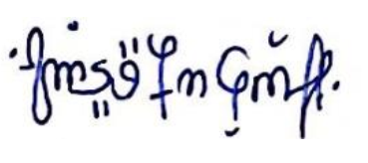
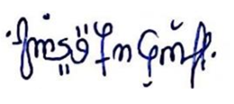

June 10th, 2023
Signature (Original) Date
(When these is more than one author, only one signature will so suffice)

P.S: The accepted manuscript cannot be processed for publication until the publisher has received this signed form. If the manuscript is not published in the Journal, this release will not take effect

