No | Revision | Before | After
1 | Abstraks: | This research has two objectives. First, this study aims to investigate the main effect, namely examining the effect of environmental performance, institutional ownership, and profitability on environmental disclosure. Second, this study investigates the moderating effect, namely examining the role of profitability in moderating the effect of environmental performance on environmental disclosure and the role of profitability in moderating the effect of institutional ownership on environmental disclosure. | This research aims to investigate the effect of environmental performance, institutional ownership, and profitability on environmental disclosure, with profitability as a moderating variable.
2 | - Introduction |  | Therefore, researchers are motivated to determine the level of environmental disclosure in the energy, raw goods, and primary consumer goods sectors.
3 |  | This study aims to examine the factors that influence environmental disclosure. | Researchers still find the phenomenon of environmental pollution in the energy, raw goods, and primary consumer goods sectors and inconsistencies in research results. Therefore, this study investigates the effect of environmental performance, institutional ownership, and profitability on environmental disclosure, with profitability as a moderating variable.
4 | Hyphotesis Development |  | Environmental Performance:  Research conducted by Cahyaningsih & Septyaweni (2022), Dewi & Yasa (2017), Ardyaningsih & Oktarina (2022), Zullaekha & Susanto (2021), Terry & Asrori (2021), and Hariyanto (2020) found that environmental performance has a positive effect on environmental disclosure.  Institutional Ownership:  Research conducted by Suprapti et al. (2019), Ginting (2022), and Terry & Asrori (2021) found that institutional ownership has a positive effect on environmental disclosure.  Profitability:  Nuskiya et al. (2021), Zullaekha & Susanto (2021), and Hilmi & Rinanda (2020) found that companies with higher profitability disclose more environmental information.
5 | Figure | 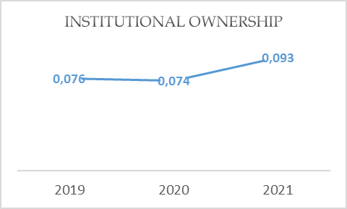  Figure 3. Institutional Ownership | 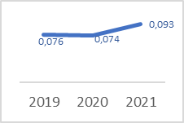  Figure 3. Institutional Ownership
6 | Discusssion | The first hypothesis is that environmental performance positively affects environmental disclosure. | Hypothesis has been deleted.  Results have been linked to theory.
7 | Effect of Environmental Performance on Environmental Disclosure |  | Table 6 shows that environmental performance positively affects environmental disclosure. Environmental performance is an activity carried out by a company to reduce the environmental impact due to the use of resources, organizational processes that affect the environment, restoration of product processing, environmental implications for services and products, and compliance with work environment regulations. Environmental performance is considered bad if the level of damage caused by the company's operational activities is high.  Companies that carry out environmental performance are responsible for mitigating or reducing environmental impacts from the company's operational activities. The company reports environmental performance in a sustainability or annual report, manifested in environmental disclosures. This environmental disclosure is a way for the company to communicate its role in protecting and preserving the environment for the welfare of society.  Companies that care about the environment produce environmental performance as a way for companies to maintain a positive image in the eyes of society. Investors will also see these results as one of the considerations for investing. Therefore, with the increasing number of environmental disclosures, the reports submitted by companies will be more transparent. On the other hand, a company that does less environmental performance will find it more challenging to get a positive image in the eyes of the public because not much environmental performance can be disclosed. Communities will think that companies do not care about environmental damage resulting from operational activities.  This result supports the social contract theory that companies should benefit society and the environment directly or indirectly as a form of long-term investment. This result supports research conducted by Cahyaningsih & Septyaweni (2022), Ardyaningsih & Oktarina (2022), and Dewi & Yasa (2017).
8 | Effect of Institutional Ownership on Environmental Disclosure |  | This study finds that institutional ownership positively affects environmental disclosure. Institutional ownership is crucial in minimizing agency conflicts between managers and shareholders. Institutional ownership has the professionalism to analyze information and can perform supervisory functions. The multiple composition of institutional ownership give them more authority to condition internal controls and act as organizational watchdogs (Syafira & Cahyaningsih, 2022). Institutional ownership in large numbers can better monitor every move made by managers and prevent managers from engaging in opportunistic behavior.  Effective supervision from the institution motivates management to show better performance. One way is to pressure managers to make more environmental disclosures. Institutional decisions to encourage managers to make environmental disclosures are for the sake of the company's sustainability in the future, to have a positive image in the eyes of investors, and as proof of the manager's responsibility to the institution.  This result supports the social contract theory that companies that are part of society in a larger environment have the same goals and seek to achieve these goals together. Companies and society influence each other because the existence of companies is very much determined by society. This result is in line with the research by Suprapti et al. (2019), Ginting (2022), and Terry & Asrori (2021).
9 | Effect of Profitability on Environmental Disclosure |  | This research finds that profitability does not positively affects environmental disclosure. This finding indicates that the level of profitability does not affect the level of environmental disclosure. Environmental disclosure has become an obligation for companies by Law No. 40 of 2007. Therefore, companies with high or low profitability and even get loss must continue to disclose environmental information. When companies have high profitability, companies still make environmental disclosures but not in large amounts. It is suspected that environmental disclosure is feared to obscure the company's financial performance information. Conversely, when a company has low profitability, information about the environment will be disclosed to cover up the decline in performance so that it still gets a positive image and attracts investors. Losing companies must also continue to disclose environmental disclosures because it has become a government regulation that every company whose business activities are related to nature must continue to disclose environmental disclosures.  This result does not support the social contract theory that companies have been unable to maintain harmony and balance, including with the environment. This result does not support the research conducted by Nuskiya et al. (2021), Zullaekha & Susanto (2021), and Hilmi & Rinanda (2020). However, this result aligns with the research of Hariyanto (2020).

