**Frequency Table**

|  |  |  |  |  |  |
| --- | --- | --- | --- | --- | --- |
| **Jenis Kelamin** | | | | | |
|  | | Frequency | Percent | Valid Percent | Cumulative Percent |
| Valid | Laki-laki | 230 | 56,8 | 56,8 | 56,8 |
| Perempuan | 175 | 43,2 | 43,2 | 100,0 |
| Total | 405 | 100,0 | 100,0 |  |

|  |  |  |  |  |  |
| --- | --- | --- | --- | --- | --- |
| **Usia** | | | | | |
|  | | Frequency | Percent | Valid Percent | Cumulative Percent |
| Valid | < 30 tahun | 20 | 4,9 | 4,9 | 4,9 |
| 30 - 40 tahun | 206 | 50,9 | 50,9 | 55,8 |
| 41 - 50 tahun | 106 | 26,2 | 26,2 | 82,0 |
| > 50 tahun | 73 | 18,0 | 18,0 | 100,0 |
| Total | 405 | 100,0 | 100,0 |  |

|  |  |  |  |  |  |
| --- | --- | --- | --- | --- | --- |
| **Pendapatan perbulan** | | | | | |
|  | | Frequency | Percent | Valid Percent | Cumulative Percent |
| Valid | < Rp. 5.000.000 | 46 | 11,4 | 11,4 | 11,4 |
| Rp. 5.000.000 – Rp. 15.000.000 | 210 | 51,9 | 51,9 | 63,2 |
| Rp. 15.000.000 – Rp.25.000.000 | 90 | 22,2 | 22,2 | 85,4 |
| > Rp. 25.000.000 | 59 | 14,6 | 14,6 | 100,0 |
| Total | 405 | 100,0 | 100,0 |  |

|  |  |  |  |  |  |
| --- | --- | --- | --- | --- | --- |
| **Formal** | | | | | |
|  | | Frequency | Percent | Valid Percent | Cumulative Percent |
| Valid | 1,00 | 142 | 35,1 | 100,0 | 100,0 |
| Missing | System | 263 | 64,9 |  |  |
| Total | | 405 | 100,0 |  |  |

|  |  |  |  |  |  |
| --- | --- | --- | --- | --- | --- |
| **Informal** | | | | | |
|  | | Frequency | Percent | Valid Percent | Cumulative Percent |
| Valid | 1,00 | 256 | 63,2 | 100,0 | 100,0 |
| Missing | System | 149 | 36,8 |  |  |
| Total | | 405 | 100,0 |  |  |

|  |  |  |  |  |  |
| --- | --- | --- | --- | --- | --- |
| **Tidak pernah** | | | | | |
|  | | Frequency | Percent | Valid Percent | Cumulative Percent |
| Valid | 1,00 | 74 | 18,3 | 100,0 | 100,0 |
| Missing | System | 331 | 81,7 |  |  |
| Total | | 405 | 100,0 |  |  |

PLS Algorithm

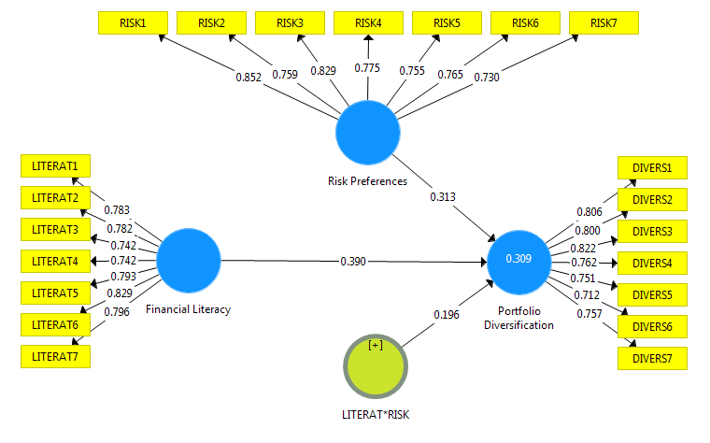

Bootstraping

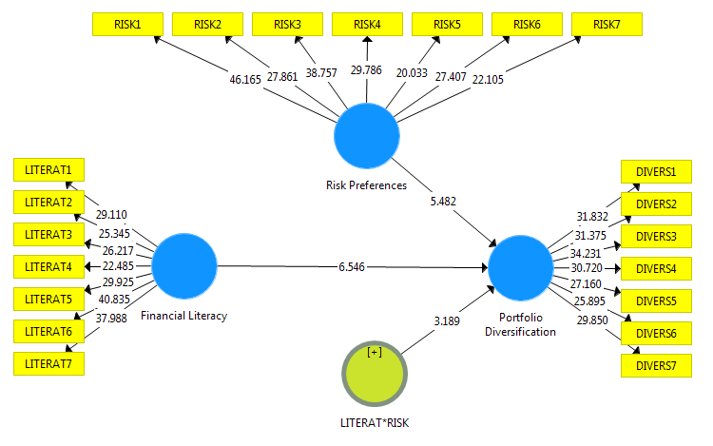

|  |  |  |  |  |  |
| --- | --- | --- | --- | --- | --- |
| Outer Loadings | |  |  |  |  |
|  |  |  |  |  |  |
|  |  |  |  |  |  |
| Mean, STDEV, T-Values, P-Values | | |  |  |  |
|  |  |  |  |  |  |
|  | **Original Sample (O)** | **Sample Mean (M)** | **Standard Deviation (STDEV)** | **T Statistics (|O/STDEV|)** | **P Values** |
| **DIVERS1 <- Portfolio Diversification** | 0,806 | 0,804 | 0,025 | 31,832 | **0,000** |
| **DIVERS2 <- Portfolio Diversification** | 0,800 | 0,798 | 0,025 | 31,375 | **0,000** |
| **DIVERS3 <- Portfolio Diversification** | 0,822 | 0,820 | 0,024 | 34,231 | **0,000** |
| **DIVERS4 <- Portfolio Diversification** | 0,762 | 0,763 | 0,025 | 30,720 | **0,000** |
| **DIVERS5 <- Portfolio Diversification** | 0,751 | 0,751 | 0,028 | 27,160 | **0,000** |
| **DIVERS6 <- Portfolio Diversification** | 0,712 | 0,712 | 0,027 | 25,895 | **0,000** |
| **DIVERS7 <- Portfolio Diversification** | 0,757 | 0,758 | 0,025 | 29,850 | **0,000** |
| **Financial Literacy * Risk Preferences <- LITERAT*RISK** | 1,374 | 1,365 | 0,101 | 13,590 | **0,000** |
| **LITERAT1 <- Financial Literacy** | 0,783 | 0,782 | 0,027 | 29,110 | **0,000** |
| **LITERAT2 <- Financial Literacy** | 0,782 | 0,780 | 0,031 | 25,345 | **0,000** |
| **LITERAT3 <- Financial Literacy** | 0,742 | 0,743 | 0,028 | 26,217 | **0,000** |
| **LITERAT4 <- Financial Literacy** | 0,742 | 0,740 | 0,033 | 22,485 | **0,000** |
| **LITERAT5 <- Financial Literacy** | 0,793 | 0,791 | 0,027 | 29,925 | **0,000** |
| **LITERAT6 <- Financial Literacy** | 0,829 | 0,827 | 0,020 | 40,835 | **0,000** |
| **LITERAT7 <- Financial Literacy** | 0,796 | 0,795 | 0,021 | 37,988 | **0,000** |
| **RISK1 <- Risk Preferences** | 0,852 | 0,850 | 0,018 | 46,165 | **0,000** |
| **RISK2 <- Risk Preferences** | 0,759 | 0,758 | 0,027 | 27,861 | **0,000** |
| **RISK3 <- Risk Preferences** | 0,829 | 0,827 | 0,021 | 38,757 | **0,000** |
| **RISK4 <- Risk Preferences** | 0,775 | 0,775 | 0,026 | 29,786 | **0,000** |
| **RISK5 <- Risk Preferences** | 0,755 | 0,754 | 0,038 | 20,033 | **0,000** |
| **RISK6 <- Risk Preferences** | 0,765 | 0,764 | 0,028 | 27,407 | **0,000** |
| **RISK7 <- Risk Preferences** | 0,730 | 0,730 | 0,033 | 22,105 | **0,000** |

|  |  |  |  |  |
| --- | --- | --- | --- | --- |
| Construct Reliability and Validity | | | |  |
|  |  |  |  |  |
|  | **Cronbach's Alpha** | **rho_A** | **Composite Reliability** | **Average Variance Extracted (AVE)** |
| **Financial Literacy** | **0,894** | **0,896** | **0,917** | **0,611** |
| **LITERAT*RISK** | **1,000** | **1,000** | **1,000** | **1,000** |
| **Portfolio Diversification** | **0,888** | **0,890** | **0,912** | **0,599** |
| **Risk Preferences** | **0,894** | **0,897** | **0,916** | **0,611** |

|  |  |  |  |  |
| --- | --- | --- | --- | --- |
| Discriminant Validity | | |  |  |
|  |  |  |  |  |
|  |  |  |  |  |
| Fornell-Larcker Criterion | | |  |  |
|  |  |  |  |  |
|  | **Financial Literacy** | **LITERAT*RISK** | **Portfolio Diversification** | **Risk Preferences** |
| **Financial Literacy** | 0,782 |  |  |  |
| **LITERAT*RISK** | -0,347 | 1,000 |  |  |
| **Portfolio Diversification** | 0,421 | 0,063 | 0,774 |  |
| **Risk Preferences** | 0,396 | -0,226 | 0,407 | 0,782 |
|  |  |  |  |  |
|  |  |  |  |  |
| Cross Loadings | |  |  |  |
|  |  |  |  |  |
|  | **Financial Literacy** | **LITERAT*RISK** | **Portfolio Diversification** | **Risk Preferences** |
| **DIVERS1** | 0,350 | -0,087 | 0,806 | 0,303 |
| **DIVERS2** | 0,361 | -0,096 | 0,800 | 0,278 |
| **DIVERS3** | 0,351 | -0,001 | 0,822 | 0,312 |
| **DIVERS4** | 0,343 | 0,097 | 0,762 | 0,330 |
| **DIVERS5** | 0,319 | 0,147 | 0,751 | 0,344 |
| **DIVERS6** | 0,232 | 0,218 | 0,712 | 0,296 |
| **DIVERS7** | 0,308 | 0,093 | 0,757 | 0,340 |
| **Financial Literacy * Risk Preferences** | -0,347 | 1,000 | 0,063 | -0,226 |
| **LITERAT1** | 0,783 | -0,338 | 0,322 | 0,297 |
| **LITERAT2** | 0,782 | -0,280 | 0,307 | 0,325 |
| **LITERAT3** | 0,742 | -0,146 | 0,360 | 0,377 |
| **LITERAT4** | 0,742 | -0,352 | 0,287 | 0,282 |
| **LITERAT5** | 0,793 | -0,327 | 0,319 | 0,330 |
| **LITERAT6** | 0,829 | -0,265 | 0,368 | 0,283 |
| **LITERAT7** | 0,796 | -0,219 | 0,326 | 0,271 |
| **RISK1** | 0,340 | -0,200 | 0,326 | 0,852 |
| **RISK2** | 0,321 | -0,166 | 0,352 | 0,759 |
| **RISK3** | 0,309 | -0,135 | 0,342 | 0,829 |
| **RISK4** | 0,304 | -0,145 | 0,335 | 0,775 |
| **RISK5** | 0,302 | -0,185 | 0,301 | 0,755 |
| **RISK6** | 0,296 | -0,212 | 0,287 | 0,765 |
| **RISK7** | 0,294 | -0,211 | 0,270 | 0,730 |

|  |  |  |
| --- | --- | --- |
| R Square | |  |
|  |  |  |
|  | **R Square** | **R Square Adjusted** |
| **Portfolio Diversification** | 0,309 | 0,304 |
|  |  |  |

|  |  |  |  |  |  |
| --- | --- | --- | --- | --- | --- |
| Path Coefficients | |  |  |  |  |
|  |  |  |  |  |  |
|  |  |  |  |  |  |
| Mean, STDEV, T-Values, P-Values | | |  |  |  |
|  |  |  |  |  |  |
|  | **Original Sample (O)** | **Sample Mean (M)** | **Standard Deviation (STDEV)** | **T Statistics (|O/STDEV|)** | **P Values** |
| **Financial Literacy -> Portfolio Diversification** | 0,390 | 0,391 | 0,060 | 6,546 | **0,000** |
| **LITERAT*RISK -> Portfolio Diversification** | 0,196 | 0,207 | 0,062 | 3,189 | **0,002** |
| **Risk Preferences -> Portfolio Diversification** | 0,313 | 0,314 | 0,057 | 5,482 | **0,000** |