Bibliometric Analysis for Mapping Future Research About Green Accounting Publications
Wildan Dwi Dermawan¹, Dedi Kusmayadi², Irman Firmansyah³
Accounting Department, Faculty of Economics, Siliwangi University
Jl. Siliwangi No.24, Kahuripan, Kec. Tawang, Kab. Tasikmalaya

ABSTRACT
Green accounting practice in companies is very important for environmental sustainability and concern for society. This triggers researchers to discuss the impact of green accounting on companies and examine green accounting issues, which have not been well mapped. This research aims to map publications regarding green accounting. The dimension.ai database was used to collect research data from 1984 to 2022. Using the data collection keyword, namely "green accounting," a total of 441 documents were obtained, consisting of articles, chapters, proceedings, preprints, edited books, and monographs. The software used is VOSViewer. The results of the research found that Business Strategy and the Environment is the best journal in terms of productivity. The most productive authors are Sonja Gallhofer and Jim Haslam. Environmental accounting information disclosure, information disclosure, mining, companies, and firm values appear to be closely related to this research. The findings of this research illustrate the importance of implementing green accounting in companies, which in turn motivates researchers to continue developing research on green accounting.
Keywords:
Green accounting;bibliometric.

ABSTRAK
Penerapan green accounting pada perusahaan sangat penting untuk kelestarian lingkungan dan kepedulian terhadap masyarakat. Hal ini memicu peneliti-peneliti untuk membahas dampak green accounting pada perusahaan dan mengkaji masalah green accounting namun belum dipetakan dengan baik. Riset ini bertujuan untuk memetakan publikasi mengenai green accounting. Data riset diambil dari database dimension.ai dimulai tahun 1984–2022. Menggunakan kata kunci pengambilan data yaitu green accounting, diperoleh sebanyak 441 dokumen yang terdiri dari artikel, chapter, proceeding, preprint, edited book dan monograph. Software yang digunakan adalah VOSViewer. Hasil riset menemukan bahwa Business Strategy and the Environment adalah jurnal yang paling baik dilihat dari sisi produktivitas, Penulis paling produktif adalah Sonja Gallhofer dan Jim Haslam, topik-topik yang banyak muncul yang berkaitan dengan riset ini adalah environmental accounting information disclosure, information disclosure, mining company, firm value. Penemuan riset ini menggambarkan pentingnya penerapan green accounting pada perusahaan sehingga memotivasi peneliti untuk terus menerus mengembangkan riset tentang green accounting.
Kata Kunci:
akuntansi hijau; bibliometrik.

PENDAHULUAN
A business entity is an organization that carries out business activities. Business activities, of course, process raw materials into finished products and goods. Due to the existence of these business activities, there are residual production results in the form of waste, which causes environmental pollution. Pollution of the environment will result in environmental damage. Therefore, companies are required not only to be oriented towards maximizing profits as an indicator of performance success but also to exist to maintain and care for their environment so that they can reduce environmental pollution resulting from production activities (Saragih & Sembiring, 2019). not only concerned with profit (the single bottom line), but also must pay attention to the environment (the planet), society (the people), and the growth of the business profit itself (profit), or what is commonly called the triple bottom line. The research results of Moreau and Parguel (2011) found that 54% of consumers considered more environmentally friendly companies when choosing products. Therefore, the company pays attention to the impact of its operations on the environment. This includes the science of accounting, which plays a role through voluntary disclosure in the company's annual report relating to environmental management, which is called green accounting or environmental accounting (Ikhsan, 2009).
On the other hand, the company's financial reporting continues to develop. In corporate financial reporting, one of the main concepts relates to the concept of measurement. The concept of measurement is a concept that explains that accounting, in its financial reporting, reports economic transactions that have a monetary value. Therefore, corporate financial reporting is closely related to economic activity. The purpose of financial reporting is to fulfill interested parties' responsibilities in running their businesses. Currently, there is a debate that this form of financial reporting only serves the interests of the government, shareholders, investors, and other users who have a direct financial interest in the company (Model, 2014). not social and environmental interests, causing companies to pay less attention to people (Sief, 2014).
Over time, research conducted by Wild et al. (2013) emphasized that annual reporting is not only in the form of financial data but also non-financial. The addition of non-financial reports forms a new global reporting standard called "green accounting." Green accounting is an important tool that contributes to environmental security and social welfare by caring for the community. Green accounting also provides data, promotes economic welfare, and focuses on the contribution of business companies through the inclusion of costs for environmental sustainability. Therefore, green accounting is increasingly important for companies because it affects the company's social and environmental performance (Michelon, 2012).
Research on green accounting began to emerge after most of the research on green reporting had been carried out in developed countries and then in developing countries such as Mauritius (Ramdhony, 2015), Bangladesh (Islam et al., 2008; Ahmad, 2012), South Africa (Marx et al., 2011; Van Zyl, 2013), India (Goswami, 2014; Ghosh, 2015), Malaysia (Saswani et al., 2010), and Indonesia (Mirfazli, 2008). Research conducted by Kurantin (2011) focuses on the integration of green accounting in Ghana. And there are many other studies related to green accounting around the world.
Green accounting is also a subtype of environmental accounting that provides an overview of the steps companies take to combine benefits and costs as important information in the decision-making process (Datta et al., 2012). Of course, the company's steps in implementing green accounting must be managed properly. Green accounting management collaborates between environmental costs and performance by collecting data on production costs, including inventory and waste treatment costs. Green accounting management is a combination of financial accounting data with cost accounting in order to increase material efficiency, reduce environmental risks, and reduce environmental protection costs (Le et al., 2019).
The significant development of research on green accounting, especially in developed countries recently, shows that green accounting research in the world of accounting is a topic that is very relevant and important to current conditions. Research Fusco et al. (2018) found that green accounting research will increase along with the interest of researchers in the future. Therefore, it is necessary to know its development in order to understand the dynamic development of accounting science. In order to form a certain pattern that shows the current situation of green accounting research, it is necessary to map research results sourced from articles, chapters, proceedings, preprints, edited books, and monographs. In this research, bibliometric analysis was used for several specific purposes. The questions from this research include:
Q1. What are the current trends and publications related to green accounting?
Q2. Which countries, journal publishers, and authors have been the most prolific and influential on the topic of green accounting?
Q3. Which green accounting theme is generally used by researchers?
Q4. Which articles are most influential on green accounting studies?
Q5. What about future research that examines green accounting?

METODE
The research method uses a bibliometric analysis approach. The reason for choosing bibliometric analysis is that this approach can show the development of previous research in the particular field being studied. This analysis tool relies on a list of journal articles that have been published (Komerio & Strozzi, 2019). Bibliometric analysis is an objective and precise method used in measuring article contribution, trend analysis, and performance. Bibliometric analysis is an objective and precise method used in measuring the contribution of an article by analyzing trends and article performance in a particular field of study for the progress of knowledge (Liu et al., 2014). Bibliometric analysis helps to gain a better understanding of developments in certain fields with the aim of finding research gaps and novelties as a basis for further research (Khitous et al. (2020); Herdianto et al. (2021); Donthu et al. (2021)).
In order to facilitate research on the development of green accounting, the authors use VOSviewer software. VOSviewer is software for building and visualizing bibliometric networks. The published article data was obtained from the dimensions.ai database. The dimensions.ai database makes it easy for researchers to access a large number of publications in a short time. The keywords used are "green accounting," which has been published. The documents obtained were 441 and consisted of Article 329 documents, Chapter 38 documents, Proceeding 25 documents, Preprint 2 documents, Edited Book 19 documents, and Monograph 9 documents. The keywords used are "digital accounting" in the publication period of 1984–2022.

HASIL
Based on data obtained from the dimension.ai database with the keyword "green accounting" and the field of accounting research from 1984–2022, in a total of 441 documents, research results will be discussed, which will answer research questions using bibliometric analysis.
Table 1. Research Data
Tahap Penelitian | Details
Time | Desember 2022
Database | Dimension AI
Keyword | Green Accounting
Research Area | Akuntansi
Research Category | Publication Year: 1984 - 2022
Outcomes | 441 Document
Source: Dimension.ai , 2022

Green accounting was first introduced by Peter Wood in the 1980s, and the practice of green accounting has existed since 1984 (Gallhofer et al., 1997). Therefore, the publication year data obtained by the authors began in 1984, when green accounting was introduced. Figure 1 depicts the total number of publications from 1984 to 2022.
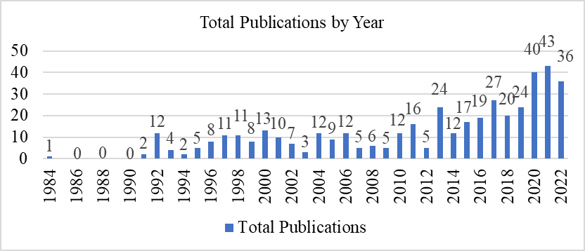

Figure 1. Total Publications by Year

Figure 1 shows the development of publications from year to year. It can be seen that from 1984 to 2003, the total number of publications on green accounting was no more than 20 per year. However, there has been an increase in total publications starting from 2013, where total publications increased exponentially. This means that the authors began to show interest in green accounting in that year.

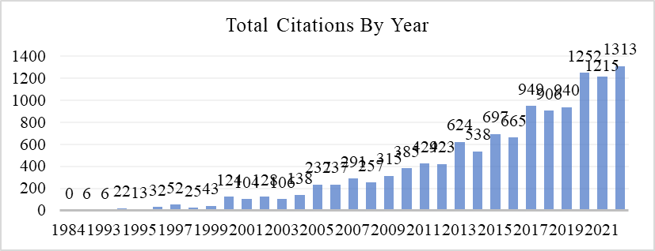

Figure 2. Total Citations by Year

Figure 2 illustrates that the total number of references cited became relevant in 2019 when citations reached nearly 1,000 documents per year. Furthermore, half of the total accumulated citations are concentrated in the last six years, from 2017 to 2022. Documents published in 2022 received the most citations (1,313). This shows that in 2022 many researchers are conducting studies on green accounting, and the most cited articles show that articles are categorized both in terms of quality and substance and the quality of the journals that publish them (Ebrahim et al., 2013).

Table 2. Top Five Productive Authors Based on The Number of Publications
Penulis | Negara | Jumlah Publikasi | Kutipan | Publikasi Pertama
Sonja Gallhofer | United Kingdom | 10 | 410 | 1997
Jim Haslam | United Kingdom | 10 | 391 | 1997
Glen Lehman | Australia | 9 | 330 | 1999
Rob Gray | United Kingdom | 6 | 390 | 1995
Ian Thomson | United Kingdom | 4 | 360 | 1995
Source: Processed data, 2022

Table 2 shows that four out of five productive writers are from the United Kingdom and one is from Australia. The most prolific authors are Sonja Gallhofer and Jim Haslam, who published 10 documents on green accounting. Next is Glen Lehman from Australia, with a total of nine publications. The difference between the two authors regarding green accounting, Sonja Gallhofer and Glen Lehman, is that Sonja Gallhofer focuses on the direction of green accounting policies while Glen Lehman focuses on green accounting and accountability practices. Table 2 also shows that writers from the United Kingdom are the most numerous compared to other countries in the world. In the 1980s, there was much discussion, and there was even an increase in reporting on green accounting in the United Kingdom (Gray et al., 2009). Australia comes in second place after the United Kingdom in terms of green accounting publications, with a percentage of publications equal to 23% of total publications.

Table 3. Top Five Journal
Jurnal | Kutipan | Publisher | Quartiles | H-Index
Critical Perspectives on Accounting | 2994 | Elsevier | Q1 | 74
Social and Environmental Accountability Journal | 1994 | Routledge | Q3 | 21
Business Strategy and the Environment | 1503 | John Wiley and Sons Ltd. | Q1 | 115
Accounting Auditing & Accountability Journal | 916 | Emerald Group Publishing Ltd. | Q1 | 105
Accounting Forum | 191 | Taylor and Francis Ltd | Q1 | 50
Source: Processed data, 2022

Table 3 shows the top five journals by citation with publications on green accounting. All journals publish and discuss the theory and practice of green accounting. The journal Critical Perspectives on Accounting is published by Elsevier and categorized as Quartile 1. The journal Critical Perspectives on Accounting has the most citations among other journals, with a total of 2994 citations. The number of citations is quite different from the journal that is in second place, namely the Social and Environmental Accountability Journal, which has 1994 citations. Meanwhile, the lowest order is the journal, while the lowest order with a total of 191 citations is the Accounting Forum. These journals are very productive, significant, and relevant, so they become a reference source for researchers when discussing green accounting. Next, an analysis of the types of documents that publish green accounting themes from 1984–2022 The following types of documents are presented in Figure 3.
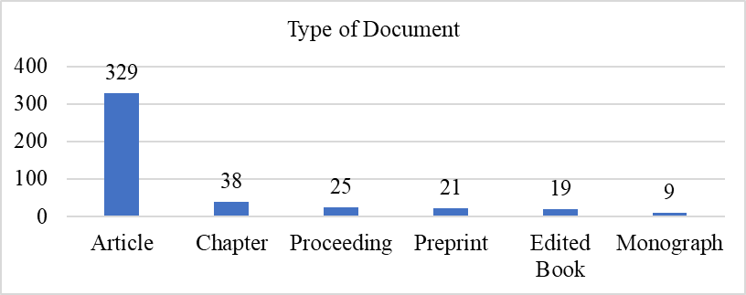

Figure 3. Type of Document

Figure 3 shows that the results of the analysis of document types consist of articles, chapters, proceedings, preprints, edited books, and monographs. Of the several types of documents, articles are the most common type of document that publishes topics regarding green accounting, as many as 329 documents, or as much as 75% of the total types of publications, while books are the type of document that publishes the fewest topics regarding green accounting. This means that the majority of researchers publish articles on topics related to green accounting.

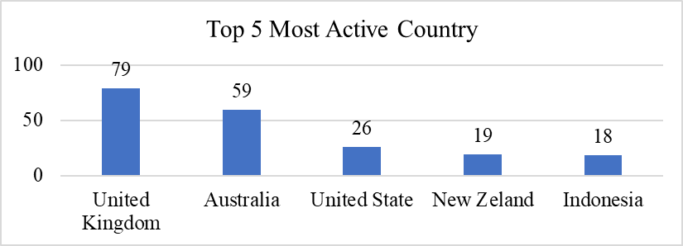

Figure 4. Top 5 Most Active Country

Figure 4 analyzes the countries that publish the most documents on green accounting. Several authors from various countries publish documents on green accounting. The results show that the country that has published the most green accounting research results is the United Kingdom, with the publication of 79 documents. The second position is occupied by the State of Australia, which published 39 documents on green accounting topics. The third and fourth positions are occupied by the United States and New Zealand, with their respective publications of 26 and 19 documents regarding green accounting. The last position is held by the State of Indonesia, which publishes 18 documents regarding green accounting. The results of the research based on the Top 5 Most Active Countries open opportunities for Indonesian researchers to study studies on green accounting and become motivated to conduct research on green accounting because green accounting is a recent topic that is being widely researched (Moorthy, 2013).
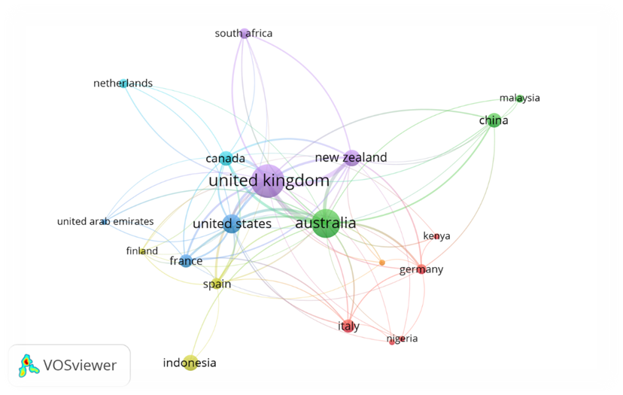

Figure 6. Co-Authorship Based on Countries

Figure 6 depicts the joint writing based on the countries that show joint collaboration between the two countries. Figure 6 shows that the United Kingdom has a strong network with other countries such as the United States, Canada, New Zealand, and Australia. However, the strongest network related to green accounting is between the United Kingdom and New Zealand.
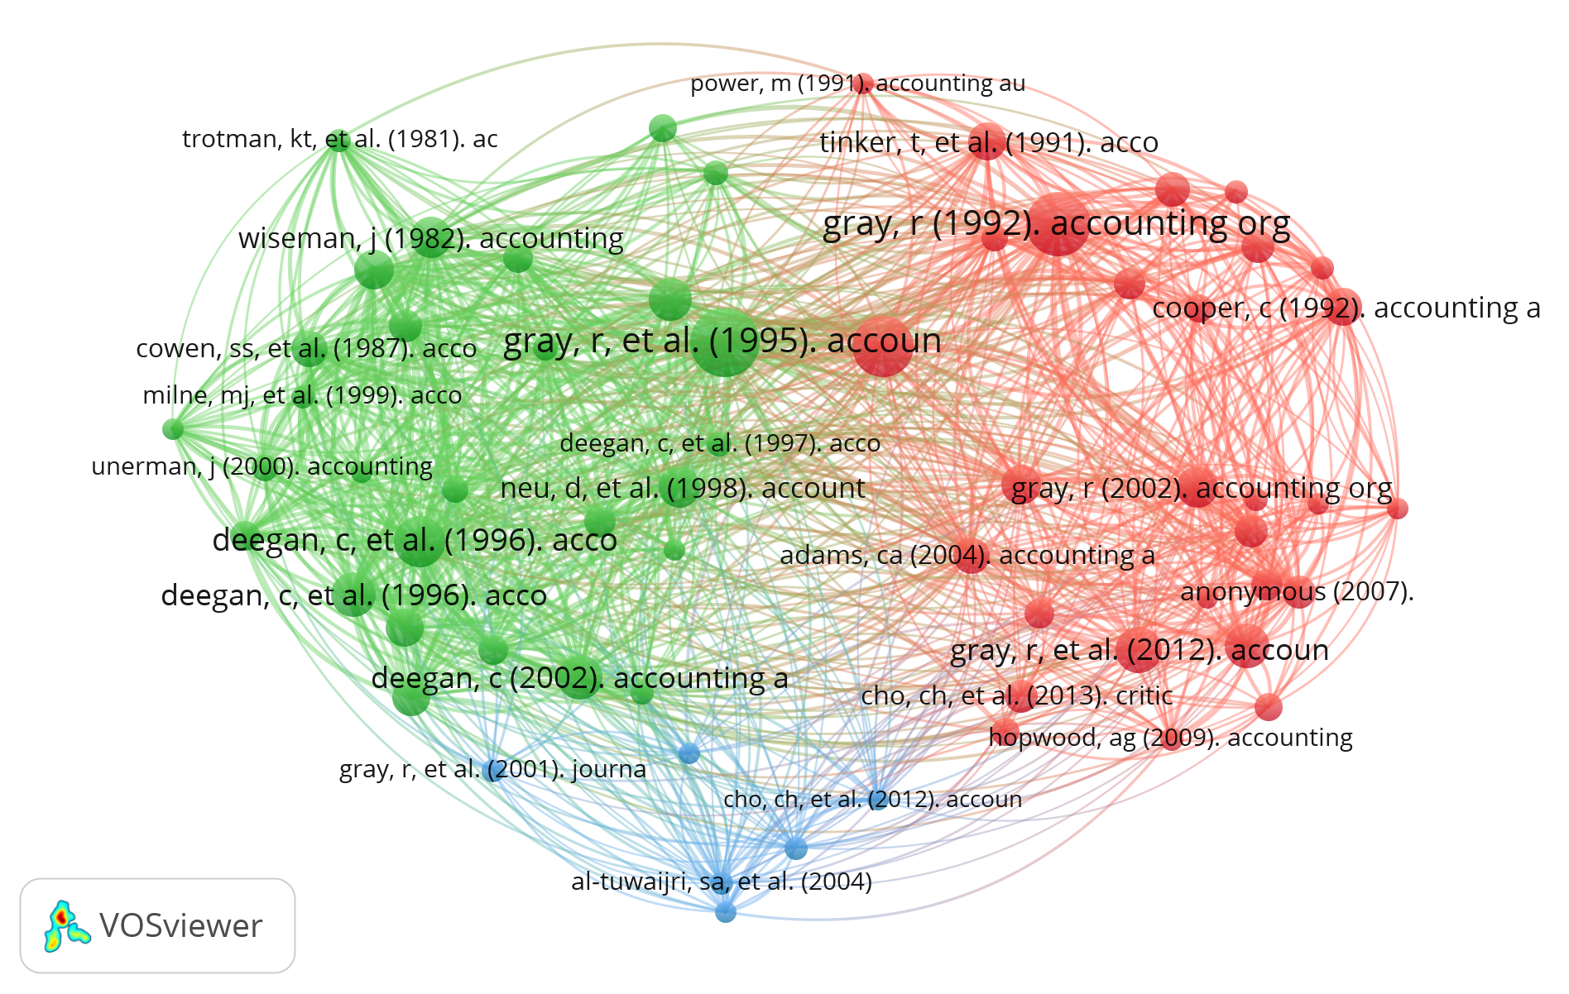
Figure 7. Co-citation map of cited references

Figure 7 relates to the analysis of shared citations processed using the VOSviewer software. The results of data processing identified three clusters of shared quotations that are in line with the main theoretical foundations of this research topic (Just et al., 2009). If seen in Figure 7, Gray et al. (1995) are the first authors to publish articles related to green accounting. The next analysis regarding keywords related to the green accounting theme will be presented in Figure 8.

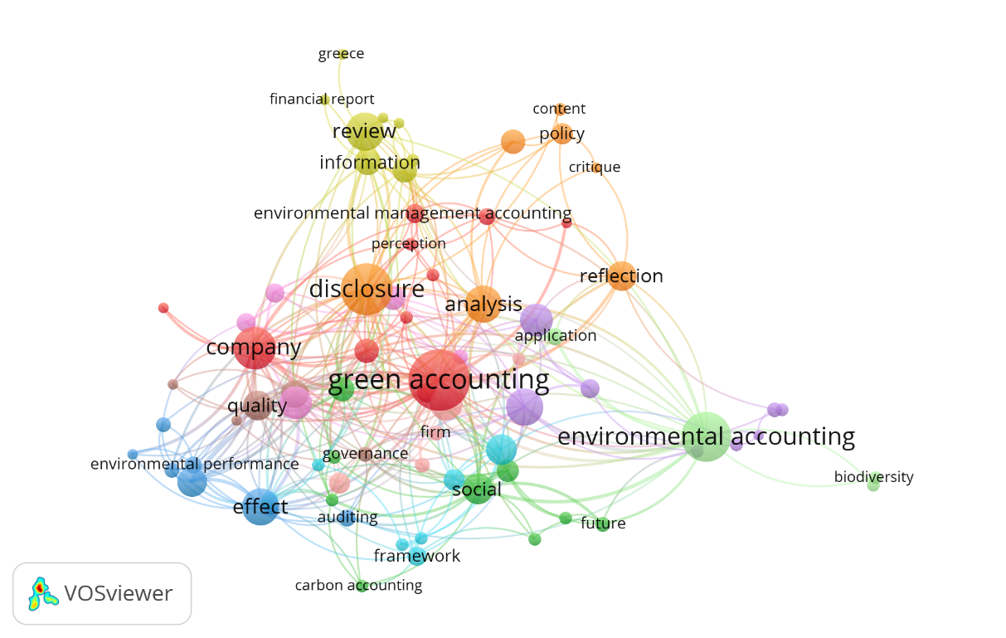

Figure 8. Co-occurrence of Outhor Keyword
Figure 8 analyzes occurrences along with keywords to find a general idea of the content of the research topic. The results of the co-occurrence of outhor Keyword analysis of the top 84 keywords from the 4 clusters studied explained that the keyword "green accounting" is clearly positioned in the middle of the map and is red, which means that green accounting is the main keyword. Furthermore, the keywords that are closely related to green accounting are disclosure and environmental, as research has been conducted by several researchers showing that, in general, companies that implement effective green accounting can enhance sustainable development through concern for the environment. Therefore, green accounting is closely related to the environment. Apart from that, the quality of disclosure of financial statements of companies that apply green accounting has a good quality of reporting social responsibility information (Bablu Kumar Dhar et al., 2021; Lusiana et al., 2021; Jundong Ma et al., 2019; Sepasi et al., 2015).
In contrast to the analysis of events with keywords, the following figure will analyze the development of themes related to green accounting from year to year from 2005 to 2022.

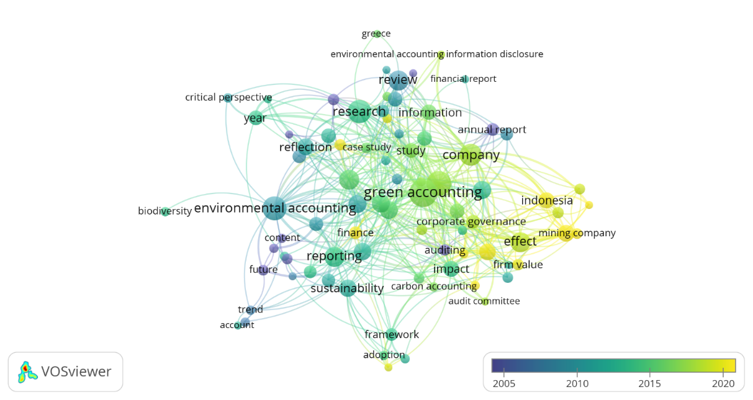

Figure 9. Co-occurrence of Outhor Keyword

Based on Figure 9, the latest theme related to green accounting is financial performance. This means that many authors publish books on green accounting themes that are associated with financial performance, both in the form of corporate green accounting practices and disclosures that have an impact on financial performance. As research has been conducted by Anggraeni et al. (2022), Amor et al. (2022), and Meidijati et al. (2022), results show that the application of green accounting improves a company's financial performance.
The research method uses a bibliometric analysis approach. The reason for choosing bibliometric analysis is that this approach can show the development of previous research in the particular field being studied. This analysis tool relies on a list of journal articles that have been published (Komerio & Strozzi, 2019). Bibliometric analysis is an objective and precise method used in measuring article contribution, trend analysis, and performance. Bibliometric analysis is an objective and precise method used in measuring the contribution of an article by analyzing trends and article performance in a particular field of study for the progress of knowledge (Liu et al., 2014). Bibliometric analysis helps to gain a better understanding of the development of certain fields with the aim of finding research gaps and novelties as a basis for further research (Khitous et al. (2020); Herdianto et al. (2021); Donthu et al. (2021)).
In order to facilitate research on the development of green accounting, the authors use VOSviewer software. VOSviewer is software for building and visualizing bibliometric networks. The published article data was obtained from the dimensions.ai database. The dimensions.ai database makes it easy for researchers to access a large number of publications in a short time. The keywords used are "green accounting," which has been published. The documents obtained were 441 and consisted of 329 article documents, 38 chapter documents, 25 proceeding documents, 2 preprint documents, 19 edited book documents, and 9 monograph documents. The keywords used are "digital accounting" in the publication period of 1984–2022.

discussion
Member countries of the United Nations (UN) are currently continuously campaigning for the application of the green accounting concept in various sectors, including the business sector. Business activities will have negative impacts, one of which is environmental damage. Therefore, it is necessary to apply the green accounting concept to business entities by including environmental costs in business activities (Singh, 2019). Green accounting is a way to use resources more effectively and efficiently in order to achieve corporate sustainability. In addition, the application of green accounting is also to increase the efficiency of environmental management, such as saving raw materials, land, and energy, so that environmental sustainability is maintained.
Writers around the world respond well to opportunities to publish related to green accounting by conducting research. This can be seen from the database dimensions, which show that publications related to green accounting are continuously increasing. In fact, at the end of 2022, the total number of publications will be quite high. So it is predicted that publications regarding green accounting will increase in 2023 and the following years.
Data was collected from the Dimension.ai database related to green accounting from 1984 to 2022, with a total of 441 publications. 2021 is the year with the most publications regarding green accounting, with a total of 43 publications. However, the most citations from publications related to green accounting occurred in 2022, with a total of 1,313 citations.
The number of writers who write about green accounting was discovered in this study, and the five most productive writers were identified based on the number of green accounting publications. The five writers are predominantly from the United Kingdom, such as Sonja Gallhofer, Jim Haslam, Rob Gray, and Ian Thomson, while Glen Lehman comes from Australia. Sonja Gallhofer and Jim Haslam are authors who are included in the ranks of researchers who have the most number of publications, with 10 publications, and are included in publications that have a major impact on research related to green accounting.
Research found the top five journals based on citations; Critical Perspectives on Accounting was the journal most cited by the authors with 2,994 citations. Critical Perspectives on Accounting is a journal that provides a forum for researchers related to accounting theory and practice, including environmental accounting or "green accounting." Elsevier is the publisher of this scientific journal and one of the publishers that continuously publishes the results of scientific research, including in the fields of accounting, engineering, and health. Another relevant publisher related to green accounting is Routledge, with the journal Social and Environmental Accountability. However, of the two journals, Business Strategy and the Environment is the best in terms of productivity and the impact of research published by researchers. This can be seen from the H-Index Business Strategy and the Environment Journal, which has the highest score compared to other journals, namely 115. In addition, the Business Strategy and the Environment Journal has the highest H-Index, indicating that researchers tend to choose the journal as reference material compared to other journals. The main reason for this being the case is that the source is more relevant and credible because it goes through a rigorous review process (Library, 2020).
Furthermore, the types of documents related to green accounting that are published are in the form of scientific articles in addition to chapters, proceedings, preprints, edited books, and monographs. Meanwhile, the country that is active and publishes the most about green accounting is the United Kingdom. This shows that the most prolific writers come from the United Kingdom. In addition to the types of documents and countries, this research also analyzes the distribution of words that appear most often in relation to green accounting. There are words that appear the most, including reporting, environmental accounting, firm value, carbon accounting, and other words. It is found that the words that appear most frequently in green accounting research indicate the importance of green accounting or environmental accounting practices in the company's financial statements. By setting aside environmental costs as a form of implementing green accounting, the company's financial statements become comprehensive. This will certainly improve the quality of the company's financial reports (Mene et al., 2018).
Based on developments regarding trending topics related to green accounting, related topics are, of course, quite diverse and have developed from year to year. For example, environmental accounting has been around since 2015 and will continue to be until 2021. In addition, many topics have emerged after 2020 or 2022 regarding environmental accounting information disclosure, information disclosure, mining companies, firm values, and others. Even environmental accounting information disclosure is a current research topic, and environmental accounting information disclosure must be implemented in companies.
Finally, this research shows the importance of implementing and disclosing green accounting in companies so that it can become the latest study material for world researchers. Green accounting is very important to be applied in companies to improve financial performance and will become the latest topic in the development of knowledge in the business world, as well as the subject of contributions from academics and researchers in the form of research results on green accounting.

simpulan Dan saran
The research was carried out based on data from the dimensions.ai database, and 441 documents on green accounting were obtained from 1984 to 2022. The data collected shows that the development of publications has increased from year to year; it's just that there will be a decrease in 2022, but the decrease is not too significant. Business Strategy and the Environment is the best journal in terms of productivity and the impact of research published by researchers. This can be seen from the H-Index Business Strategy and the Environment Journal, which have the highest score.
The most relevant and productive authors on green accounting are Sonja Gallhofer and Jim Haslam, who are authors who are included in the ranks of researchers who have the highest number of publications with 10 publications and are included in publications that have a major impact on research related to green accounting.
The developments regarding trending topics related to green accounting and related topics are, of course, quite diverse and have developed from year to year. Topics that have emerged after 2020 and 2022 are environmental accounting information disclosure, information disclosure, mining companies, firm values, and others. Even environmental accounting information disclosure is a current research topic, and environmental accounting information disclosure must be implemented in companies.
This research will provide implications for updating references and mapping, especially regarding green accounting. However, there are research limitations, especially with the database that is the basis for collecting research data only in the dimensions.ai database, even though there are many other databases for collecting research data so that the research data becomes more comprehensive.

daftar pustaka
A.C. Buehler Library. 2020. Source Evaluation and Credibility: Journals and Magazines. Accessed at: https://library.elmhurst.edu/credibility.
Amor, A., & Asrida, A. (2022, August). The Effect of Green Accounting on Financial Performance of Mining Companies Listed on the Indonesia Stock Exchange. In Proceedings of the 6th Batusangkar International Conference, BIC 2021, 11-12 October, 2021, Batusangkar-West Sumatra, Indonesia.
Anggraeni, A. A., & Dewi, H. P. (2022). Green Accounting and Corporate Social Responsibility Disclosure: Financial Performance of Mining Companies in Indonesia. Journal of Auditing, Finance, and Forensic Accounting, 10(1), 61-74.
Brooks, C., & Schopohl, L. (2020). Green accounting and finance: Advancing research on environmental disclosure, value impacts and management control systems. British Accounting Review, Forthcoming.
Cho, C. H., & Patten, D. M. (2013). Green accounting: Reflections from a CSR and environmental disclosure perspective. Critical Perspectives on accounting, 24(6), 443-447.
Datta, R., & Deb, S. K. (2012). Green accounting: What? Why? Where we are now and where we are heading – A Closer Look. European Journal of Business and Management, 4(4), 99–109.
Dhar, B. K., Sarkar, S. M., & Ayittey, F. K. (2022). Impact of social responsibility disclosure between implementation of green accounting and sustainable development: A study on heavily polluting companies in Bangladesh. Corporate Social Responsibility and Environmental Management, 29(1), 71-78.
Fusco, F. and Ricci, P. (2019), "What is the stock of the situation? A bibliometric analysis on social and environmental accounting research in public sector", International Journal of Public Sector Management, Vol. 32 No. 1, pp. 21-41. https://doi.org/10.1108/IJPSM-05-2017-0134.
Gallhofer, S. and Haslam, J. (1997), "The direction of green accounting policy: critical reflections", Accounting, Auditing & Accountability Journal, Vol. 10 No. 2, pp. 148-174.
Gray, R., Kouhy, R. and Lavers, S. (1995) Corporate Social and Environmental Reporting: A Review of the Literature and a Longitudinal Study of UK Disclosure. Accounting, Auditing & Accountability Journal, 8, 47-77. http://dx.doi.org/10.1108/09513579510146996.
Just, A.,. Schäffer, U. and Meyer, M. (2009), “The intellectual structure of accounting research - a bibliometric analysis”, Working Paper, available at: http://accounting.rutgers.edu/docs/ seminars/Just.Schaeffer.Meyer%20paper.pdf
Le, T., & Nguyen, T. (2019). Practice environmental cost management accounting: The case of Vietnamese brick production companies. Management Science Letters, 9(1), 105-120.
Lusiana, M., Haat, M. H. C., Saputra, J., Yusliza, M. Y., Muhammad, Z., & Bon, A. T. (2021). A review of green accounting, corporate social responsibility disclosure, financial performance and firm value literature. In Proceedings of the International Conference on Industrial Engineering and Operations Management (pp. 5622-5640).
Ma, J., & Ma, J. (2019, August). A research review of corporate green accounting information disclosure. In IOP Conference Series: Earth and environmental science (Vol. 310, No. 5, p. 052071). IOP Publishing.
Meidijati; Augustine, Yvonne. (2022). The Effect of Tax Accounting, Green Accounting, and Carbon Accounting on Environmental, Social, and Governance Performance: Moderated by Green Intellectual Capital. Technium Soc. Sci. J., 31, 371.
Mene, R.E., Karamoy, H., & Warongan, J.D.L. 2018. Pengaruh Pemanfaatan Teknologi Informasi Dan Penerapan Sistem Pengendalian Intern Pemerintah Terhadap Kualitas Laporan Keuangan Pemerintah Daerah Kabupaten Halmahera Utara. Jurnal Riset Akuntansi Going Concern, 13(3), 133-143.
Moorthy, K., & Yacob, P. (2013). Green accounting: Cost measures. Open Journal of Accounting, 2(1), 4-7.
Moreau, FB, & Parguel, B. (2011). Membangun ekuitas merek dengan komunikasi lingkungan: Investigasi empiris di Prancis. Jurnal Bisnis EuroMed 6(1), 100–116. doi: 10.1108 /14502191111130334.
Rob Gray, Jesse Dillard, Crawford Spence. 2009. Social Accounting Research as If The World Matters. Public Management Review 11, 545-573.
Sepasi, S., & Esmaili Kejani, M. (2015). Green Accounting: A Model for Environmental Disclosure. Journal of Health Accounting, 4(1), 1-19.
Singh, S., Singh, A., Arora, S., & Mittal, S. (2019, October). Revolution of green accounting: A conceptual review. In 2019 2nd International Conference on Power Energy, Environment and Intelligent Control (PEEIC) (pp. 481-485). IEEE.

