**Cross-Dialectal Influences on English Language Learning among Bangladeshi EFL Learners**

|  |
| --- |
| ***1Kaniz Fatema***  Department of English, Faculty of Humanities and Social Sciences, Pundra University of Science & Technology, Bogura-5800,  Bangladesh  Corresponding author: [**Kanizfatemabd32@gmail.com**](mailto:Kanizfatemabd32@gmail.com) |

**ABSTRACT**

*The phrase "Cross Linguistics," also known as "Translanguaging" in a broader sense, serves as the basis for this research’s core point of discussion. It is needless to describe the importance of the English language in Bangladesh, where it has gained the status of a second official language. The paper intends to unfold every possible kind of influence on Bangladeshi English Language Learners having different dialects while learning it as a Foreign Language. Researchers have surveyed around 45 tertiary-level language learners from some prominent universities in Bangladesh. Both qualitative and quantitative data collection methods have been followed, along with tools like interviews and surveys, on the selected samples for this research. The outcome of this research endeavor is expected to provide us with a clear focus on both the positive and negative effects of using cross-dialectal forms by English Language Learners.*

**Keywords:**

*Cross-Dialectal Influence, English Language Learning, Bangladeshi EFL learners, Translanguaging*

1. **Introduction**

Though the mother tongue of Bangladeshi people is Bangla, fortunately, or unfortunately every mother has a different style, tone, intonation, expression, lexical resources, coherence, and pronunciation while speaking the Bangla Language. This wide range of differences is very common in Bangladesh, where it can be spotted in people from different regions, ethical backgrounds, and from various social contexts. Languages go through a process of transformation, in a constantly varying, amorphous conglomeration of distinct yet interconnected languages. This variety consequentially creates smaller enclaves of varieties, more commonly termed dialects. Bangladesh has a total of 64 districts and 4 principal dialects covering the skills of language with numerous regional sub-dialects. As viewed by Shuchi (2013) they are: (1) North Bengal dialects, (2) Rajbanshi, the dialect of Rangpur (3) East Bengal dialects, and (4) South Bengal dialects. But today’s researchers show a very supportive attitude toward the nonstandard languages and dialects which can be used in education (Papapavlou & Pavlou, 2007). Similarly, language prioritized-students domestic language has often been undervalued in the classrooms whereas standard form is prioritized in the monolingual mainstream program (García, 2013; García & Kleifgen, 2010). Monolingualism has long been the typical pattern in classroom language teaching, under the influence of national ideologies and language policies across many countries (Blackledge, 2010; García, 2009; McMillan & Rivers, 2011; Igboanusi, 2014; Makalela, 2015). But these procedures have been questioned recently and as an alternative pedagogical method, bilingualism is a flexible, integrated system and a scaffolding tool to learn content and language

Cross-dialect is another alternative form of translanguaging, cross-linguistics, or bi-dialects. Particularly in the field of language education translanguaging is a rising term within the study of bilingualism (Blackledge & Creese, 2010; Creese & Blackledge, 2013; García, 2009; Wei, 2017; Williams, 1994). Translanguaging is a rapidly growing term as applied linguistics describes it as a method used for multilingual learners who practice bilingualism coming from a single linguistic repertoire (Garcıa and Wei 2014). Harris (1997) propounded that the translanguaging perspective represents a paradigm shift from the conventional focus on structural constraints and separate roles of various languages in learning to what some linguists call “integrational” approaches and more importantly, beyond the narrow focus on linguistic structures and the narrow concept of language. Some major factors can decide whether to use it in classrooms or not. The prominent factors could be teachers’ language proficiency, students’ attitude toward their native language, and most importantly classroom participation norm (Daniel et al., 2017).

In the present time, English is spoken as a first or native, or second language among 1.5 billion people all over the world (Statista Research Department, 2023).Bangladesh is not different from other countries; it is a developing country providing all the necessary educational facilities to cope with the global standard. The country provides English language education as a compulsory course until the A-level education is completed. All the books and classrooms in higher studies maintain the Standard English forms. So, automatically English is well used as a second or foreign language in Bangladesh. Usually, there comes a slight conflict between the first language Bangla and the second language English in terms of learning and using it. So, according to Efeoglu et al., (2019), Cross-linguistic influence (henceforth, CLI) can be termed as a lasting impact of existing linguistic knowledge on the acquisition of subsequent languages. DISA (2011) indicated that poor achievements in the field of education are related to many variables in language. For example, a student’s enthusiasm might quickly disappear if he/she does not comprehend what the teacher is talking about in class. Bilingualism, translanguaging, and cross-dialectal effects can build a strong relationship between language and culture, and between different ethnic groups (UNESCO, 1974). Several culturists maintain that preserving a language is a shield to preserving a culture that is fading away (Cummins, 2001).

Christian (1987) viewed that children having different backgrounds come to school speaking a wide variety of dialects. As per the opinion of Yule (1985), speech variation in language is a vital and well-recognized aspect of everyday life for language users in different regional and dialectal communities. It is not possible to omit the regional dialects and it is also not possible to deny the facts influencing English Language learning because of it. Uddin and Monjur (2015) opined English spreading worldwide as the world is constantly witnessing different varieties of English. The language has been encountering various forms of pronunciations influenced by dialects. Consequently, the native speaker does not hold English power like before. English is no longer a language of the British or the Americans; rather it is a language that is shared by today’s global population. Even the English of America is slightly different from Australia or Britain. Lemke (2002) argues that by separating language for the sake of keeping it clean, one cannot promote multilingualism. Moreover, along with the language two language codes are being separated from one another. ‘Along with norms of how “a language” can be used we find norms about who can use it, and to whom it belongs’ (Møller & Jørgensen, 2009).

Now English language learning is not only limited inside the classrooms, people learn from various open online sources, makes their small groups, and practice it according to their comfortable times. As Clarke and Hermens (2001) stated that online learning is student-centered since learners can self-dictate their learning pace, as well as activities preferring learning style. The matter of concern regarding learning is that, when a whole group comes from the same dialectal background, they will all make the same mistakes over and over again (Lodge et al., 2018). Another issue that can be arisen here is that, if the group of people comes from different dialectal backgrounds; there is a chance of making multiple mistakes or even can bring arguments while learning. As the English language has spread around the world as a global language, non-native English speakers have surpassed native English speakers, prompting scholars, educators, and politicians to reconsider English language education, particularly how English is taught, assessed, and integrated into the overall curriculum in schools.

Through the usage of English as a worldwide language, the sociolinguistic aspect of English has recognized the linguistic diversity of communication. It is natural for people to employ their varied linguistic, multimodal, and multi-semiotic resources in communication, where "native-speaker norms" are no longer seen as the panacea; in fact, they can even be challenged through "playfulness" with language use (Li, 2018). At the sociolinguistic level, and from the standpoint of English for international communication, English should not be viewed as the property of native speakers (Jenkins, 2007; Seidlhofer, 2011), as the focus of education has shifted from the traditional, monolingual perspective to multi/translingualism (Cenoz & Gorter, 2019). People are being compelled to learn English from every possible corner of the world, with all of their differences. If they are unable to learn or adjust to them correctly, they will suffer greatly in terms of conveying any messages or communicating with other people. Differences are needed to expand opportunities and it is also mentioned by many scholars, but there is hardly any research on the Bangladeshi context regarding cross-dialectal influences. With this paper, researchers hope that there will be a clear vision of both kinds of influences on the English language learning process because of dialectal effects.

The intended objectives of this paper are-

* To interpret the overall positive or negative effects of cross-dialectal influences on English Language Learning.
* To determine the causes or influences of poor articulation in oral English intonation, tone, and pronunciation.
* To show the cross-dialectal impacts not only on grammatical sources but also on psychological components like- attitude, positive or negative energy, fear of humiliation, or the possibility of being left out of the process of learning the English Language.

1. **Method**

At this point, here will be an overview of the chosen method for this paper. As the paper deals with the cross-dialectal influences on English language learning, the researchers needed to look deeper and observe and talk with people about their opinions, answers, and conditions. The qualitative research method was followed by the researchers, where both open-ended and closed-ended questions were asked. The research procedure was completed by collecting books, articles, and journals from different renowned online and offline sources.

**Population Sampling**

For population sampling, stratified population sampling was chosen by the researchers. Parsons (2014) stated that a stratified sampling population’s elements are divided into distinct groups, where within each stratum the elements are similar to each other with respect to select characteristics of importance to the survey. It is very common in Bangladesh to find different dialects within every 10 kilometers. Researchers chose 45 people from different parts of Bangladesh with different dialects who were learning English as a Foreign Language. The researchers went to different schools, colleges, and universities to collect data. Students from different classes were divided into different groups according to their regional, cultural, or social dialects, and then they are randomly picked for the interview session.

**Data Collection**

Both the survey method and the observation method were applied in this study by using open-ended and closed-ended questions as well. The instruments for the survey method were hand-printed questionnaires (offline) and Google document sheets (online), individual interviewees of different people with different dialectal backgrounds, and some classroom observations.

The researchers had distributed questionnaires through Google Docs because it was not possible to provide hand-printed paper everywhere. Around 45 people from all over the country responded to it willingly. In the case of observing people, the researchers had interviewed five people from different districts with different dialectal backgrounds who had been learning English as a foreign language. Moreover, they observed some classrooms at different levels in different places.

**Data Analysis Procedure**

Both qualitative and quantitative data were used in the data analysis. The core study issues were closely related to the questionnaire's questions, which underwent in-depth analysis. All the instructor questionnaires were evaluated after the data had been gathered. Each questionnaire's closed-ended questions were verified numerous times, and the data was computed to provide the desired outcome. A detailed analysis of open-ended questions was done to depict the qualitative outcome.

1. **Findings and discussion**

**Findings**

**Communication and Mobility**

English

Language

**International Language**

**For the purpose of Travel**

**To secure a good career**

**To know the World culture**

**To pass the Exams**

**For Higher studies**

**Figure 01:** Reasons behind the importance of the English language

The most common answers given on the importance of the English Language are- it is an international language, people need it for communication, for higher studies, for traveling purposes, for a good job, for knowing different cultures, for exams like IELTS, TOFEL, and GRE, and skill developments.

One of the collected answers states that he or she started learning English when he or she was in class 10. He or she considers English to be very important because it plays a significant role in communicating with each other and knowing different cultures to a great extent. It helps them communicate with people from English-speaking countries. He or she, in particular, found it to be a very prestigious language used not only for communication but also as a social marker in society. Apart from that, he or she found it very important for me due to its necessity in the world.

Most of the people started to learn English from the Primary level (class 1-5) and some from the Secondary level (class 6-10). But some people also started quite late; they had specific purposes for it.

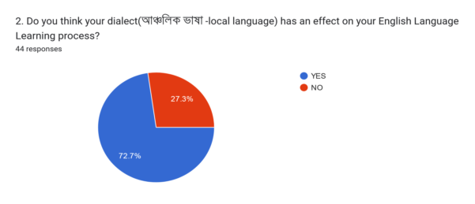

**Figure 02:** Dialectal Effect on English Language Learning

The majority of the answers are positive regarding the belief of a dialectal impact on the English language learning process. Some people also gave negative answers to the question.

**Helpful**

**Dialectal effects on English Language Learning Process.**

**Harmful**

**harmful and helpful**

**Not at all**

**Figure 03:**  Helpful or harmful effects of dialects in the English language learning process

Most people things dialectal effects are harmful while learning English as a foreign language. Whereas many people think it is a helpful tool because they can connect dialectal sounds with numerous English words and sounds. On the one hand, some said that dialectal effects can be both harmful and helpful; on the other hand, some people cannot find any relevance between dialectal inheritances with learning the English language process. The researchers would like to present some quoted answers to the question;

“Within a community, dialects may perform some very significant and beneficial tasks. Their use can foster a sense of community, dependability, and friendliness—all admirable qualities which is helpful in the case of learning English as a second language.”

“Pronunciations are very important to learn the English language. Dialects can play an important role in that. For example, Rickshaw is the proper pronunciation but in Bogura they used to speak “*Rishka*”. Most of the time dialects are harmful.”

“Neither helpful nor harmful. English is different from local languages. It has nothing to help or hamper learning English. That is why people all around the world can access and learn English if they want to regardless of their local language. However, I feel the dialect may affect the accent of the English when spoken. Such as French English has quite a different accent than British and American English.”

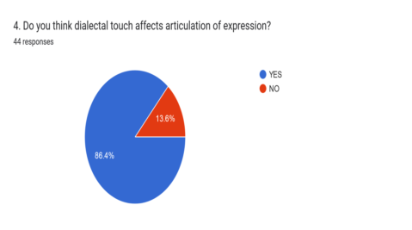

**Figure 04:** Dialectal impacts on word expressions

From the pie chart, it is clear that 8 out of 10 people think that dialectal touch strongly affects their English articulation of expression which can depend on the dialect they are habituated with. According to a minor number of people, dialects do not affect their articulations.

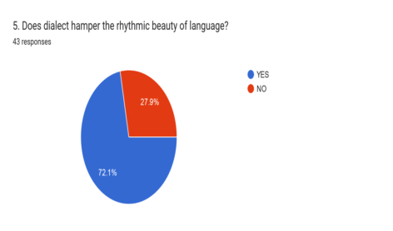

**Figure 05:** Dialectal impacts on rhythmic elegance of language

Language is ornamented in its presentation and melodious flow. Different people have different ways of presenting language; it can be their first or second language. Certainly, the effects of learning a first language are felt in every subsequent language a person learns. And here, most of the people confessed that dialect is a threat to their rhythmic flow of English language learning.

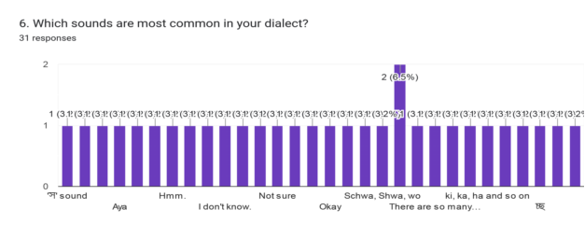

**Figure 06:** Missing sounds in different dialects

A small number of people were not able to track down the missing sound in their dialects, whereas others said no such sound was missing in their dialects. But many of them were able to identify the missing sound as follows:

“The *"র"- \r* sound though not always”, “perhaps /u/ sound”, “\Aa\ sound”, “Bengali has a voiced twin of / s / can be represented by / z /. But in Bangla language, / z / sound is borrowed from perso- Arabic origin. So it can't differ English / z / sound.

“*'ষ'-\sh* sound”, “Consonant”, “\ S\, \t\, \o\”, “-en, -eth”, “Kha,

Sha”, “Aya”, “\n\”, “no”.

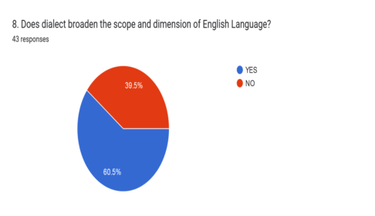

**Figure 07:** Dialect broadening the breadth and dimensions of the English language

A language is never limited in itself; it is furnished, rebuilt, and expanded over time with the help of another language. In Bangladesh, the number of dialects is quite rich, and according to 60% of the population, dialectal variation has broadened the scope and dimension of English language learning. The remaining 40% may believe dialect is a barrier.

**Figure 08:** Because of the dialect, people as to find reading, writing, listening, and speaking difficulties

59%- speaking, 23%- listening, 10%-reading, 8%-writing

The majority of people find speaking hard because of their dialectal effects. The second most difficult problem they face is listening to English. Reading and writing are comparatively less obscured because of the dialectal effects.

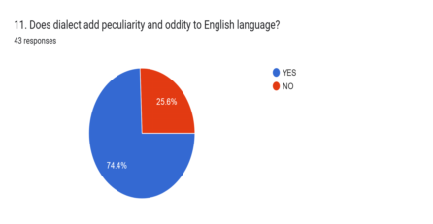

**Figure 09:** Adding peculiarities and oddities to the English language by dialects

The researchers have already mentioned that different dialects have different sounds and ways of expressing them. Some people cannot overcome the habituation of dialectal sounds, and it certainly leaves a remarkable effect while learning a second language. Almost one-fourth of the population has agreed that dialectal effects add peculiarity and oddity to English language learning. It leaves a noticeable impact on their speaking, listening, reading, and writing.

**Pronunciation**

**Lack of Confidence**

**Grammatical mistakes**

**Different tone and intonation because of dialectal effects**

**Nervousness or Shyness**

**Problems while speaking**

**English from different**

**dialectal background**

**Understanding them and capturing their Rhythm**

**Figure 10: Enco**untering some issues while speaking with various dialectal speakers of English

A great number of people face difficulty communicating with other people from different dialectal backgrounds because of their way of pronouncing words. Some faced problems with their interlocutor’s grammatical mistakes, tone, intonations, expression, and even attitude while communicating. For example, several statements are given below:

“The problem I face is they use their dialect instead of using the standard language and intonation. It is very irritating. The dialect prevents them from using the standard pronunciation.”

“I can't understand what the speaker is saying when I hear different dialects in her speaking.”

“Grammar mistakes Lack of confidence Shyness Nervous in speaking Fear of making mistakes.”

“Common grammar mistakes, nervous in speaking English, shyness in speaking, fear of making mistakes, lack of confidence, etc.”

A certain amount of people said that they had no problem communicating with people from different dialects.

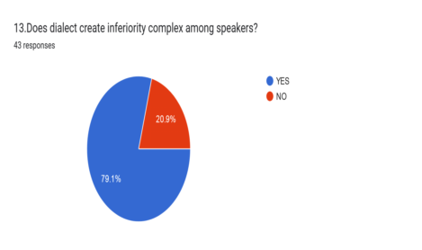

**Figure 11:** English speakers’ inferiority complex as an influential one for dialectal difference

Many people have stated that they have experienced inferiority complexes while speaking in English with a dialectal accent. Because they may sound different in terms of pronunciation, tone, intonation, and expression than someone who does not have dialectal influences. It can be the reason for humiliation, mockery, and even rejection because of their differences.

**Observation of Interviews**

The researchers conducted some personal interviews to better understand the deeper effects that dialects have on the process of learning English. A third-year student of the English department was asked about the difficulties or benefits he thinks he faces because of his dialectal effect. The student was raised in Noakhali where /f/ sounds are used instead of /p/ sounds for example; (People - *fifol*), *পানি ( pani)* is pronounced as *হানি( hani)* - Water, /hah/ sounds are used instead of /sh/ sounds, and /s/ sounds are used instead of /y/ sounds. Many tones and intonations are different from the actual English sounds, and for this reason he finds it hard to catch up with the speed of the class teacher, even after studying it for the past three years.

The same difficulties were also confronted by a corporate worker whose bosses always communicate in English and who finds it hard to understand them properly. She was born and raised in Barisal, where sounds like /sh/, /j/, /d/, and /sh/ are used as /h/, /jh/, /jh/, and /s/. She confessed that the problems are not only with her English but also with her standard Bengali because of the dialectal effects. In her regional area, they usually produce long sounds, even for short words; for example, they cannot accurately say "slow" (/sl/), and rather it sounds like "/sooloo/". Her coworkers find it exhausting to prepare things for her.

But when a primary school boy started to learn English, his cross-dialectal effects turned out to be helpful for him. He confessed that the sounds were similar to the dialect he speaks, and he can easily connect the English language with his mother tongue. He complained that sometimes it is hard for him to understand the lectures delivered by his teachers, and the researchers did a short interview with him. It turned out that the teacher's dialect was different from the student's as was his English pronunciation or way of expressing it.

**Discussion**

Language is affected by the regional areas we live in, the city we dwell in, and the country we were born in. Bangladeshi people undoubtedly have the effects of their dialects on the English language learning process. Most people believe the effects are a hindrance to learning English as they can alter the authentic meaning of words. To elaborate on the previous discussion, researchers have added some subsequent discussions for clarification. These are some sounds identified by the population as preventing them from understanding English:

“In my dialect, the *স, ষ, শ* all use the *"শ"* sound So I often mispronounce the English equivalent /s/ or /z/”, “Words that are complex like (Excitingly)”, “ha”, “The “b” and “v” sounds”, “Plosive”, “C, a, e”, “Colonialism”, “\a\”, “\Sha\” and “English natives sound”.

Sometimes the English language spoken in a Bangladeshi dialectal tone is called the "Banglish" form of English. Because of the missing sounds in their dialect and the distinct tone that dialect adds to their accurate tone of English, it makes people who can't understand English well have a negative attitude. Every person has their own way of speaking, which includes different tones, intonation, rhythm, vocabulary, and ways of expressing it. Because most common dialectal sounds are missing, the learning process of the English language among Bangladeshis is greatly hampered.

The conventional English language can be difficult for some people to hear, read, and write, and they feel awful when speaking their brand of Banglish English. It has shown a noticeable change in attitude toward learning the English language among cross-dialectal learners. They may abandon the learning process in the middle due to their inability to understand them or the humiliation they face. Because of the dialectal effects they had on English, a very small number of people never experienced such feelings or situations. Some even find it useful in their educational journey of English language learning. It depends on the regional effects of language, the attitude of the person who is learning, or the proper environment given to them despite the dialect they had after their birth. All students alike should have an equal opportunity to study the dialects in addition to the English language. Teachers could seek to advance their skills, particularly in the field of education, to comprehend contemporary teaching techniques. Instructors must have the skills to use a teaching strategy that keeps students motivated.

1. **Conclusion**

The results of this study's data shed light on several issues from the perspective of Bangladeshis, whose dialects make it difficult for them to hear, interpret, speak, read, write, and even communicate effectively in English. Though it is difficult to directly accuse the dialect, because many people find no effect of the dialect on their way of learning English as an EFL learner. Both favorable and unfavorable cross-dialectal effects are possible. For certain people, it might occasionally be neutral. Since the majority of people don't find it to be very useful, parents should take special care with it beginning with the very first learning environment, and our educational system should place a greater emphasis on English teaching methodology. Students should be especially conscious of their errors and confident enough to correct them with appropriate information. The research will be helpful for both the learners and teachers, because the learners will be able to identify their abilities and inabilities, while the teachers will be able to use the positive points in their favor and avoid or carefully handle the negative ones.

The research is based mostly on the learners' point of view, but the educators, authorities, education board, and further interested researchers will find an answer or clue for going the extra mile. The researchers anticipate that students will be both cautious and confident about their dialectal use and that teachers will be extra careful with the explained version, such as using both dialectal and actual pronunciation to teach the students correctly. Rather than discouraging students of different dialectal backgrounds from speaking English differently, they should accept it while teaching the accurate form of the words. More or less, the paper highlighted the effects of regional accents on Bangladeshi people, which can also be applicable to any country using English as their second language, on the important and international issue of learning the English language with all its diversities.

1. **References**

Blackledge, A., & Creese, A. (2010). *Multilingualism : a Critical perspective*. <https://doi.org/10.5040/9781474212281>

Cenoz, J., & Gorter, D. (2019, January). Multilingualism, Translanguaging, and Minority Languages in SLA. *The Modern Language Journal*, *103*(S1), 130–135. <https://doi.org/10.1111/modl.12529>

Christian, D. (1987). Vernacular dialects in U.S. schools*. ERIC Digest.* <http://eric.ed.gov/?id=ED289364>

Clarke, T., & Hermens, A. (2001). Corporate developments and strategic alliances in e‐learning. *Education + Training*, *43*(4/5), 256–267. <https://doi.org/10.1108/00400910110399328>

Creese, A., & Blackledge, A. (2011). 1. Ideologies and Interactions in Multilingual Education: What Can an Ecological Approach Tell Us about Bilingual Pedagogy? In C. Hélot & M. Ó Laoire (Ed.), *Language Policy for the Multilingual Classroom: Pedagogy of the Possible* (pp. 3-21). Bristol, Blue Ridge Summit: Multilingual Matters. <https://doi.org/10.21832/9781847693686-003>

Cummins, J. (2001).Bilingual Children’s Mother Tongue Why is it Important for Education? *Sprogforum, 7,* 15-20. - References - Scientific research Publishing. (n.d.). <https://www.scirp.org/reference/referencespapers?referenceid=3560915>

Daniel, S. M., Jiménez, R. T., Pray, L., & Pacheco, M. B. (2017). Scaffolding to make translanguaging a classroom norm. *TESOL Journal*, *10*(1). <https://doi.org/10.1002/tesj.361>

Diyarbakir Institute for Political and Social Research, (DISA). (2011). Dil Egitimi Modelleri ve Ulke Ornekleri. (Educational Language Models and Country Examples). Available at <http://www.ozgurcerkes.com/FileUpload/ds213192/File/onceanadili2.pdf>

Efeoglu, G., Yüksel, H. G., & Baran, S. (2019). Lexical cross-linguistic influence: a study of three multilingual learners of L3 English. *International Journal of Multilingualism*, *17*(4), 535–551. <https://doi.org/10.1080/14790718.2019.1620239>

García, O. (2009). *Bilingual Education in the 21st Century*. <http://books.google.ie/books?id=TvAEtAEACAAJ&dq=Bilingual+education+in+the+21st+century:+A+global+perspective.&hl=&cd=3&source=gbs_api>

García, O., & Kleifgen, J. A. (2010). Bilingualism for equity and excellence in minority education: The United States. In K. Van den Branden, P. Van Avermaet, & M. Van Houtte (Eds.), *Equity and excellence in education* (pp. 166–189). New York: Routledge.

García, O. (2013). From diglossia to transglossia: Bilingual and multilingual classrooms in the 21st century. In C. Abello-Contesse, P. M. Chandler, M. D. López-Jiménez, & R. Chacón-Beltrán (Eds.), *Bilingual and multilingual education in the 21st century: Building on experience* (pp. 155–175).Bristol, UK: Multilingual Matters.

Garcı́A, O., & Wei, L. (2014). Language, bilingualism and education. In *Palgrave Macmillan UK eBooks* (pp. 46–62). <https://doi.org/10.1057/9781137385765_4>

Harris, R. J. (1997). 12 from an integrational point of view. In *Amsterdam studies in the theory and history of linguistic science. Series 4, Current issues in linguistic theory* (p. 229). <https://doi.org/10.1075/cilt.148.16har>

Igboanusi, H. (2013). The English-only language education policy in The Gambia and low literacy rates. *International Journal of Bilingual Education and Bilingualism*, *17*(5), 558–569. <https://doi.org/10.1080/13670050.2013.851642>

Jenkins, J. (2007, July 26). *English as a Lingua Franca: Attitude and Identity*. Oxford University Press, USA. <http://books.google.ie/books?id=46EmAQAAIAAJ&q=English+as+a+Lingua+Franca:+Attitude+and+Identity.&dq=English+as+a+Lingua+Franca:+Attitude+and+Identity.&hl=&cd=1&source=gbs_api>

Lemke, J. (2002). Becoming the village: Education across lives. In G. Wells & G. Claxton (Eds.), *Learning for life in the 21st Century* (pp. 34–45). Oxford: Blackwell.

Lodge, J. M., Kennedy, G., Lockyer, L., Arguel, A., & Pachman, M. (2018). Understanding Difficulties and resulting Confusion in Learning: An Integrative review. *Frontiers in Education*, *3*. <https://doi.org/10.3389/feduc.2018.00049>

Makalela, L. (2015). Moving out of linguistic boxes: the effects of translanguaging strategies for multilingual classrooms. *Language and Education*, *29*(3), 200–217. <https://doi.org/10.1080/09500782.2014.994524>

McMillan, B., & Rivers, D. J. (2011). The practice of policy: Teacher attitudes toward “English only.” *System*, *39*(2), 251–263. <https://doi.org/10.1016/j.system.2011.04.011>

Møller, J. S., & Jørgensen, J. N. (2009). From language to languaging: changing relations between humans and linguistic features. *Acta Linguistica Hafniensia*, *41*(1), 143–166. <https://doi.org/10.1080/03740460903364185>

Papapavlou, A., & Pavlou, P. (2009, March 26). *Sociolinguistic and Pedagogical Dimensions of Dialects in Education*. Cambridge Scholars Publishing. <http://books.google.ie/books?id=3_MYBwAAQBAJ&pg=PA101&dq=THE+INTERPLAY+OF+BIDIALECTALISM,+LITERACY.&hl=&cd=1&source=gbs_api>

Parsons, V. (2014). Stratified sampling. *Wiley StatsRef: Statistics Reference Online*. <https://doi.org/10.1002/9781118445112.stat05999>

Sánchez, M. T., Garcı́A, O., & Solorza, C. (2017). Reframing language allocation policy in dual language bilingual education. *Bilingual Research Journal*, *41*(1), 37–51. <https://doi.org/10.1080/15235882.2017.1405098>

Seidlhofer, B. (2011). *Understanding English as a Lingua Franca*. OUP Oxford. <http://books.google.ie/books?id=MnjnAQAACAAJ&dq=Understanding+English+as+a+Lingua+Franca&hl=&cd=2&source=gbs_api>

Shuchi, S. (2013). The effect of Bangla dialect on English language teaching: teachers' perspectives and attitudes.  <https://www.semanticscholar.org/paper/The-effect-of-Bangla-dialect-on-English-language-%3A-Shuchi/d7959aa5853ade0d548f6b8846e42f421a2407c3>.

*The most spoken languages worldwide 2022 | Statista*. (2023). Statista. <https://www.statista.com/statistics/266808/the-most-spoken-languages-worldwide/#:~:text=In%202022%2C%20the>

UNESCO. (1974). Recommendation concerning education for international understanding, co-operation and peace and education relating to humanrights and fundamental freedoms. Adapted by the General Conference at its Eighteenth Session, Paris, 17 October-23 November.

<http://unesdoc.unesco.org/images/0011/001140/114040e.pdf#page=144>

Uddin, N. & Monjur, S. (2015). The Influence of Regional Bangla Dialects on English Pronunciation of Bangladeshi EFL (English as a Foreign Language) Learning: A Review.*International journal of Arts,Humanities and ManagementStudies.01*(12).pp123. <http://ijahms.com/upcomingissue/03.12.20151.pdf>

Wang, D. (2016). Translanguaging in Chinese foreign language classrooms: students and teachers’ attitudes and practices. *International Journal of Bilingual Education and Bilingualism*, *22*(2), 138–149. <https://doi.org/10.1080/13670050.2016.1231773>

Wei, L. (2017). Translanguaging as a practical theory of language. *Applied Linguistics*, *39*(1), 9–30. <https://doi.org/10.1093/applin/amx039>

Woodley, H., & Brown, A. (2016). Balancing windows and mirrors: Translanguaging in linguistically diverse classroom. In O. Garcia & T. Kleyn (Eds.), *Translanguaging with multilingual students: Learning from classroom moments* (pp. 83–99). New York. <https://doi.org/10.4324/9781315695242>

Yule, G. (2010). *The Study of Language*. Cambridge University Press. <http://books.google.ie/books?id=EYIwL-Gr0XIC&printsec=frontcover&dq=The+Study+of+Language.&hl=&cd=1&source=gbs_api>