STATEMENT OF ORIGINALITY

To:
Editor-in-chief
EnJourMe (English Jurnal of Merdeka): Culture, Language, and Teaching of English

We, the paper authors: (1) Veni Nella Syahputri; (2) Meta Keumala; and (3) Zahratul Idami, hereby certify that the manuscript entitled, Error Analysis on Auxiliary Verbs Do/Does,Have/Has, And Had, has been approved by the co-authors to be published in EnJourMe (English Jurnal of Merdeka), does not contain plagiarism as a whole or in parts, and is not currently being submitted or processed in other journals. We will also be able to accomplish the whole process of publishing our paper in the Journal.

Authors
Veni Nella Syahputri, S.Pd., M.Pd
Meta Keumala, S.Pd., M.Pd
Zahratul Idami, S.Pd., M.Pd

Meulaboh, November 4th, 2021
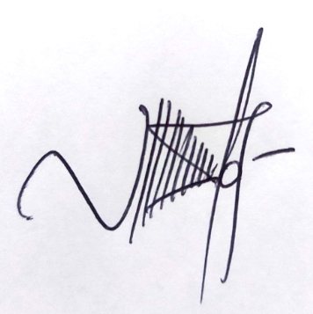

Veni Nella Syahputri, S.Pd., M.Pd

