Beyond Brand Image: Why Customer Satisfaction is the Real Key to Loyalty at Superindo
Maulana Kemal Ertiasaniy^{1*}
¹Magister Management, University of Merdeka Malang, Indonesia
*Corresponding author: emailsaniy@gmail.com
Abstract.
The retail industry in Indonesia is characterized by fierce competition, requiring robust strategies to retain customers. This study aims to analyze the structural relationship between Brand Image and Customer Loyalty, with Customer Satisfaction serving as a mediating variable, specifically within the context of Superindo supermarkets. The research addresses the critical need to understand how brand perception translates into sustainable behavioral loyalty. Using a quantitative research approach, primary data were collected from customers at a Superindo outlet. The collected data were analyzed using Partial Least Squares Structural Equation Modeling (PLS-SEM) to test the hypothesized direct and indirect relationships. The empirical results demonstrate that Brand Image has a positive and significant direct impact on Customer Loyalty (β = 0.540). Furthermore, Brand Image significantly influences Customer Satisfaction (β=0.700), which, in turn, positively affects Customer Loyalty (β=0.382). A pivotal finding of this research is the confirmation of a significant partial mediation effect (β = 0.267), in which Customer Satisfaction bridges the relationship between Brand Image and Customer Loyalty. The proposed model exhibits substantial explanatory power, explaining 72.5% of the variance in Customer Loyalty. These findings imply that relying solely on a strong brand image is insufficient; retail managers must simultaneously prioritize operational strategies that enhance customer satisfaction to effectively validate the brand promise and secure long-term loyalty.
Keywords: Brand Image, Customer Satisfaction, Customer Loyalty, Retail Management, Partial Mediation.

Introduction
In the modern era, the retail industry has evolved rapidly alongside societal and economic changes. Retail is no longer just about selling products but involves complex business activities related to selling products and services to individual consumers. In Indonesia, particularly in Malang City, the retail sector has shown significant growth post-COVID-19, driven by an increase in consumption and purchasing power (Fan, 2020). Malang City, as a hub for education and tourism, presents a dynamic market with fluctuating but promising economic growth, recorded at 6.07% in 2023 (BPS Malang, 2024).
Superindo, a major player in the Indonesian supermarket sector with its motto "Fresher, Cheaper, Closer," faces intense competition from other modern retailers like Hypermart and Transmart, as well as e-commerce platforms. To sustain market share, Superindo must offer greater value and customer satisfaction than its competitors (Kotler & Armstrong, 2018). While Brand Image is a crucial asset that creates value and distinguishes a company from its competitors (Firmansyah Anang, 2019)Previous studies indicate mixed results regarding its direct impact on loyalty. Some studies affirm a strong link (Chang, 2020; Rastogi et al., 2024; Semuel & Wibisono, 2019), while others suggest that brand image alone may not guarantee loyalty without the presence of satisfaction (Taqi & Muhammad, 2020).
This research addresses this gap by investigating the mediating role of Customer Satisfaction. According to Oliver (1999), loyalty is a deeply held commitment to rebuy, but this commitment is often preceded by satisfaction—an emotional response to a product or service evaluation (Tjiptono, 2007). Specifically, this study focuses on Superindo consumers in Malang City, examining whether a positive brand image directly drives loyalty or whether customer satisfaction serves as a necessary bridge.

Method
This study employed a quantitative, explanatory research design. Quantitative methods were selected because the study aims to examine and explain the causal relationships among Brand Image, Customer Satisfaction, and Customer Loyalty. Explanatory research is particularly suitable for testing theoretical relationships and evaluating the direct and indirect effects among variables through statistical analysis.
The research was conducted at two Superindo outlets in Malang City, East Java, Indonesia, namely Superindo Jl. Raya Langsep and Superindo Jl. Bendungan Sutami. These locations were selected purposively to represent different customer characteristics. The Jl. Raya Langsep outlet primarily serves residential and family-based consumers, while the Jl. Bendungan Sutami outlet is located near several universities and predominantly serves students and young consumers. The inclusion of these two outlets was intended to provide a broader representation of Superindo customers in Malang City and capture variations in consumer perceptions and shopping behavior.

Population and sample
The population in this study consisted of all registered Superindo members who actively shop at Superindo outlets in Malang City. Registered members were selected as the target population because they have previous shopping experience and are more likely to provide reliable evaluations regarding the supermarket’s brand image, service quality, and overall shopping experience.
The sampling technique used was purposive sampling, a non-probability sampling method that allows researchers to select respondents based on specific criteria relevant to the research objectives. The criteria for respondent selection were: (1) being a registered Superindo member, (2) having made purchases at least twice within the last month, and (3) being at least 17 years old to ensure sufficient purchasing decision-making experience.
The sample size was determined according to recommendations for Partial Least Squares Structural Equation Modeling (PLS-SEM). According to the "10-times rule" and recommendations from previous studies, the minimum sample size should be at least ten times the largest number of structural paths directed at a latent construct. Considering the complexity of the proposed model and to improve statistical power, a total of 150 respondents were selected. This sample size exceeds the minimum requirement for PLS-SEM analysis and is considered adequate to produce stable and reliable parameter estimates (Adnyana & Primasari, 2020; Semuel & Wibisono, 2019).

Research variable
This study examines three main variables: Brand Image (X), the mediating variable Customer Satisfaction (Z), and the endogenous variable Customer Loyalty (Y). All variables were measured using indicators adapted from established studies to ensure content validity and theoretical consistency.
- Brand Image was measured using indicators adapted from (Rastogi et al., 2024): Strength, Favorability, and Uniqueness.
- Customer Satisfaction was measured using indicators from (Semuel & Wibisono, 2019): Product Quality Satisfaction, Emotion, Price, and Cost/Convenience.
- Customer Loyalty was measured using indicators from Kotler & Keller (2012): Continued Use, Retention (resistance to competitors), and Suggestions (Word of Mouth).

Data collection
Primary data were collected through a structured questionnaire distributed directly to Superindo customers who met the predetermined sampling criteria. Prior to the main survey, the questionnaire was reviewed to ensure clarity and relevance of the measurement items.
The questionnaire consisted of two sections. The first section gathered respondents’ demographic information, including gender, age, occupation, and shopping frequency. The second section measured the research variables using statements adapted from previous studies.
Responses were measured using a five-point Likert scale, ranging from 1 = Strongly Disagree to 5 = Strongly Agree. The Likert scale was chosen because it is widely used in consumer behavior research and facilitates the measurement of perceptions, attitudes, and satisfaction levels.
Data collection was conducted during operating hours at both Superindo outlets. Respondents completed the questionnaire voluntarily after receiving an explanation regarding the purpose of the study. Confidentiality and anonymity were maintained throughout the research process

Result and Discussion

Result
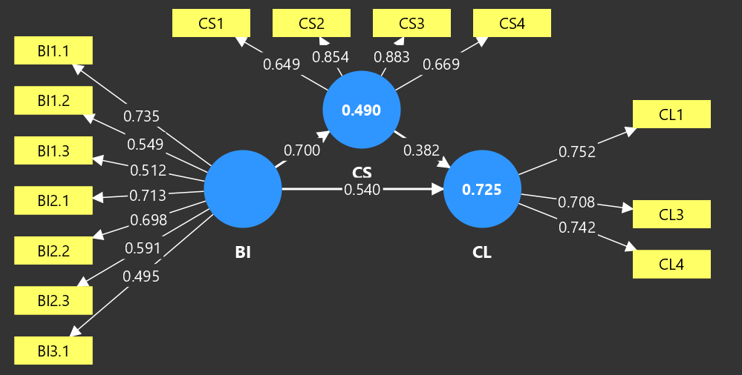
The structural model assessment reveals significant relationships between all tested variables. Figure 1 illustrates the path analysis results derived from the PLS-SEM algorithm.
Figure 1. Path Analysis
Source: Primary Data Processed (2024)


Figure 2. Model Results
Source: Primary Data Processed (2024)

Direct Effects
The statistical analysis confirms that Brand Image plays a pivotal role in shaping consumer perceptions and behaviors within the retail sector. The results indicate that H1 is supported, as Brand Image has a strong positive and significant influence on Customer Satisfaction ($β = 0.700, p < 0.001$). This finding suggests that consumers who perceive Superindo as a reliable, distinctive, and trustworthy retail brand are more likely to experience greater satisfaction with their shopping experience. A favorable brand image creates positive expectations regarding product quality, service performance, pricing, and overall shopping convenience. When these expectations are met or exceeded, customers tend to evaluate their experiences more positively, leading to greater satisfaction. This result is consistent with previous studies that highlight the important role of brand image in enhancing customer evaluations and satisfaction levels (Dash et al., 2021; Mohammed & Rashid, 2018).
Furthermore, the findings demonstrate that H2 is also supported, as Brand Image exerts a direct and significant influence on Customer Loyalty ($β = 0.540, p = 0.001$). This result implies that customers who hold a positive perception of Superindo are more likely to maintain long-term relationships with the retailer, regardless of other factors. A strong brand image helps establish trust, emotional attachment, and confidence in the company, encouraging customers to repeatedly choose the same retailer over competitors. In the highly competitive retail environment, brand image functions as a strategic asset that differentiates a company from rival supermarkets and strengthens customer retention. The finding supports previous research suggesting that a strong, favorable brand image directly contributes to customer loyalty (Chang, 2020; Nguyen & Pham, 2021).
In addition, H3 is supported, indicating that Customer Satisfaction has a positive and significant effect on Customer Loyalty ($β = 0.382, p = 0.027$). This finding confirms that satisfied customers are more likely to become loyal customers who continue purchasing from the same retailer, recommend it to others, and resist switching to competing brands. Satisfaction reflects customers’ overall evaluation of their shopping experiences, including product quality, service performance, pricing, and convenience. When consumers consistently receive positive experiences that meet their expectations, they develop stronger behavioral and attitudinal loyalty toward the retailer. This result reinforces the widely accepted view that customer satisfaction is one of the most important antecedents of customer loyalty in the retail industry (Alberto et al., 2019; Eddine et al., 2023).

Mediation Analysis
The specific indirect effect analysis was conducted to test the mediating role of Customer Satisfaction. The result shows that the path Brand Image -> Customer Satisfaction -> Customer Loyalty is significant ($ β=0.267$, $ p=0.044$). Since both the direct effect (BI -> CL) and the indirect effect are significant, this study confirms the existence of partial mediation (Achmad & Solekah, 2022; Taqi & Muhammad, 2020).

Model Fit (R-Square)
The model's explanatory power is substantial. The R-Square value for Customer Loyalty is 0.725, meaning that 72.5% of the variance in loyalty can be explained by the combination of Brand Image and Customer Satisfaction. Meanwhile, the R-Square for Customer Satisfaction is 0.490.

Discussion
Table 1. Summary of Hypothesis Testing
Hypothesis Path | Original Sample (O) | T Statistics | P Values | Result
Brand Image -> Customer Loyalty | 0.540 | 3.477 | 0.001 | Supported
Brand Image -> Customer Satisfaction | 0.700 | 7.991 | 0.000 | Supported
Customer Satisfaction -> Customer Loyalty | 0.382 | 2.251 | 0.027 | Supported
Indirect Effect: BI -> CS -> CL | 0.267 | 2.039 | 0.044 | Supported
Source: Primary Data Processed (2024)
The findings support the premise that while Brand Image is a powerful driver, Customer Satisfaction is the key mechanism that amplifies loyalty. The partial mediation result implies that Superindo cannot rely solely on marketing campaigns (Brand Image). The "Brand Promise" made through image must be validated by the "Service Delivery" (Satisfaction). When customers perceive a good brand image and subsequently experience satisfaction during their store visit, the probability of loyalty increases significantly. The high R-Square value (72.5%) further validates that these two variables are the primary determinants of consumer retention in the grocery retail sector.

Conclusion
This study concludes that Customer Satisfaction is a vital mediator in the relationship between Brand Image and Customer Loyalty at Superindo. While Brand Image directly fosters loyalty, its impact is significantly reinforced when mediated by satisfaction. Managerially, this suggests that Superindo must implement a synchronized strategy: maintaining a strong brand reputation through marketing while simultaneously investing in store operations (service quality, product availability, and ambiance) to ensure high customer satisfaction. Neglecting the satisfaction component would undermine the potential loyalty gains from brand investments. Future research is recommended to expand the model by incorporating other variables such as Price Perception or Service Quality to explore the remaining variance in loyalty

Acknowledgment
The authors would like to thank the respondents and the management of Superindo for their cooperation during the data collection process.

References
Achmad, R., & Solekah, N. A. (2022). How the Customer Trust and Customer Satisfaction Mediate Brand Image and Service Quality on Customer Loyalty in Islamic Microfinance Institutions. Al Tijarah, 7(2), 103–114. https://doi.org/10.21111/tijarah.v7i2.6881
Adnyana, I. M., & Primasari, A. H. (2020). Analysis of the Effect of Service Quality on Customer Loyalty in Mediation by Customer Satisfaction at Loka Supermarket Cibubur. 2(4), 147–158.
Alberto, E., Watanabe, D. M., & Torres, C. V. (2019). The impact of culture , evaluation of store image and satisfaction on purchase intention at supermarkets. 26(3), 256–273. https://doi.org/10.1108/REGE-12-2017-0009
Chang, W. (2020). Experiential marketing , brand image and brand loyalty : a case study of Starbucks. https://doi.org/10.1108/BFJ-01-2020-0014
Dash, G., Kiefer, K., & Paul, J. (2021). Marketing-to-Millennials : Marketing 4 . 0 , customer satisfaction and purchase intention. Journal of Business Research, 122(February 2020), 608–620. https://doi.org/10.1016/j.jbusres.2020.10.016
Eddine, A., Moussaoui, E., Benbba, B., & Andaloussi, Z. El. (2023). Impact of logistics performance on the store image , consumer satisfaction and loyalty : a quantitative case study. 226–239. https://doi.org/10.1108/AGJSR-09-2022-0201
Fan, Y. (2020). Research on the Influencing Factors of Customer Loyalty in Offline Supermarket under New Retail Model. 216–220.
Firmansyah Anang, 141 2019. (2019). Pemasaran Produk dan Merek (Planning dan Staregy). Manajemen Pemasaran, 336.
Kotler, P., & Armstrong, G. (2018). Marketing (17e ed.). Pearson.
Mohammed, A., & Rashid, B. (2018). Kasetsart Journal of Social Sciences A conceptual model of corporate social responsibility dimensions , brand image , and customer satisfaction in Malaysian hotel industry. Kasetsart Journal of Social Sciences, 39(2), 358–364. https://doi.org/10.1016/j.kjss.2018.04.001
Nguyen, C. Q., & Pham, N. (2021). The Determinants of Customer Loyalty : The Case Study of Saigon Co . op Supermarkets in Vietnam. 5, 61–68.
Rastogi, T., Agarwal, B., & Gopal, G. (2024). Exploring the nexus between sustainable marketing and customer loyalty with the mediating role of brand image. Journal of Cleaner Production, 440(January), 140808. https://doi.org/10.1016/j.jclepro.2024.140808
Semuel, H., & Wibisono, J. (2019). Brand Image , Customer Satisfaction Dan Customer Loyalty. 13(1), 27–34. https://doi.org/10.9744/pemasaran.13.1.27
Taqi, I., & Muhammad, G. (2020). Brand Loyalty and the Mediating Roles of Brand Image and Customer Satisfaction. Market Forces College of Management Sciences, 15(1), 101–119.

