**Supplementary Files**

1. Reseach Instrument

The population in this study were all students using TikTok in Indonesia. In this study a sample of 300 respondents with a sampling technique using purposive sampling with the following criteria:

1) College students

2) Have a TikTok account

3) Knowing Jiniso products

4) Have you ever seen a Jiniso product appear in a user's FYP (For Your Page) TikTok account at least once

) Have purchased Jiniso products at least once

1. Data sets, which comply with the terms of the study research ethics review

Table Comparison of the number of followers on the TikTok application with similar competitors.

|  |  |  |  |  |
| --- | --- | --- | --- | --- |
| Name of TikTok Account | Total Number of Followers on December 2021 | Total Number Of Followers on February 2022 | Total Likes on December 2021 | Total Likes on February 2022 |
| @jiniso.id | 664.000 | 1.200.000 | 22.600.000 | 37.200.000 |
| @warpathofficial | 151.200 | 207.000 | 312.800 | 587.700 |
| @vierlinn | 39.800 | 42.400 | 243.100 | 259.600 |
| @18.town | 28.400 | 30.300 | 545.000 | 594.100 |
| @esrocte | 2.201 | 2.571 | 13.300 | 14.900 |

Source: : Data Processed (2021)

Table Loading Factor Value of All Variables After Re-Estimation

|  |  |  |  |  |
| --- | --- | --- | --- | --- |
| Variables | Item Code | Purchasing Decision | Online Consumer Review | Social Media Marketing |
| Purchasing Decision | KP2 | 0.876 |  |  |
| KP8 | 0.834 |  |  |
| KP9 | 0.881 |  |  |
| Online Consumer Review | OCR2 |  | 0.792 |  |
| OCR3 |  | 0.821 |  |
| OCR4 |  | 0.718 |  |
| OCR9 |  | 0.752 |  |
| Social Media Marketing | SMM3 |  |  | 0.827 |
| SMM7 |  |  | 0.812 |
| SMM8 |  |  | 0.843 |

Source: Data Processed (2022)

Table Latent Variables

|  |  |  |  |
| --- | --- | --- | --- |
| Variable | Purchasing Decision | Online Consumer Review | Social Media Marketing |
| Purchasing Decision | 0.864 |  |  |
| Online Consumer Review | 0.720 | 0.772 |  |
| Social Media Marketing | 0.539 | 0.645 | 0.827 |

Source: Data Processed (2022)

Table . Cross Loading

|  |  |  |  |
| --- | --- | --- | --- |
| Item Code | Purchasing Decision | Online Consumer Review | Social Media Marketing |
| KP2 | 0.876 | 0.649 | 0.393 |
| KP8 | 0.834 | 0.571 | 0.511 |
| KP9 | 0.881 | 0.642 | 0.495 |
| OCR2 | 0.592 | 0.792 | 0.394 |
| OCR3 | 0.653 | 0.821 | 0.414 |
| OCR4 | 0.436 | 0.718 | 0.618 |
| OCR9 | 0.505 | 0.752 | 0.638 |
| SMM3 | 0.437 | 0.519 | 0.827 |
| SMM7 | 0.452 | 0.532 | 0.812 |
| SMM8 | 0.447 | 0.550 | 0.843 |

Source: Data Processed (2022)

Table Result Reliability Test

|  |  |  |  |
| --- | --- | --- | --- |
| Variable | Cronbach’s Alpha | Composite Reliability | Average Variance Extracted (AVE) |
| Purchasing Decision (Y) | 0.832 | 0.898 | 0.746 |
| Online Consumer Review (X2) | 0.791 | 0.854 | 0.595 |
| Social Media Marketing (X1) | 0.769 | 0.867 | 0.685 |

Source: Data Processed (2022)

Table R Square

|  |  |  |
| --- | --- | --- |
| Item | R Square | R Square Adjusted |
| Purchasing Decision | 0.527 | 0.524 |

Source: Data Processed (2022)

Table Loading Factor Value of All Variables After Re-Estimation

|  |  |  |  |  |
| --- | --- | --- | --- | --- |
| Variables | Item Code | Purchasing Decision | Online Consumer Review | Social Media Marketing |
| Purchasing Decision | KP2 | 0.876 |  |  |
| KP8 | 0.834 |  |  |
| KP9 | 0.881 |  |  |
| Online Consumer Review | OCR2 |  | 0.792 |  |
| OCR3 |  | 0.821 |  |
| OCR4 |  | 0.718 |  |
| OCR9 |  | 0.752 |  |
| Social Media Marketing | SMM3 |  |  | 0.827 |
| SMM7 |  |  | 0.812 |
| SMM8 |  |  | 0.843 |

Source: Data Processed (2022)

Tabel . F Test

|  |  |  |  |  |
| --- | --- | --- | --- | --- |
| Variables | F statistics | F table | Sig. | Notes |
| X1 dan X2 ➝Y | 165.723 | 3.03 | 0.006 | Ha Accepted, HO Rejected |

Source: Data Processed (2022)

The data analysis method used is Partial Least Square (PLS) with the following steps:

**1. Assessing outer models or measurement models**

There are three criteria in the use of data analysis techniques with smartPLS to assess the outer model, namely convergent validity, discriminant validity and composite reliability

1) Convergent Validity

Measurement models with indicator reflections are assessed based on the correlation between estimated score items and PLS software. Individual reflexive measures are said to be high if they correlate more than 0.70 with the construct measured.

2) Discriminant Validity

This is done to ensure that each concept of each latent variable is different from the other variable. The model has a good discriminant validity if each loading factor value of each latent variable has the largest loading value with other loading values against other latent variables.

3) Composite Reliability

Validity and reliability criteria can also be seen from the reliability value of a construct and the Average Variance Extracted (AVE) value of the construct. Constructs are said to be of high reliability if the value is 0.70 and the AVE is above 0.50.

**2. Structural Model Testing (Inner Model)**

Inner model testing is performed to see the relationship between the construct, the value of significance and the R-square of the research model. The structural model is evaluated using R-square for the dependent construct of the t test as well as the significance of the coefficient of structural path parameters.

1) T test (partially)

The significance of the estimated parameters provides very useful information about the relationship between the waiting variables.

2) Test F (simultaneously)

The F sta\tistic test basically shows whether all the free variables (X) consisting of social media marketing TikTok (X1) and online consumer review (X2) included in the model have a shared influence on variables bound to purchasing decisions (Y).

**Partial Least Square Analysis**

1) Outer Model Evaluation

1. Convergent Validity

Figure 1. Outer Model Test Result

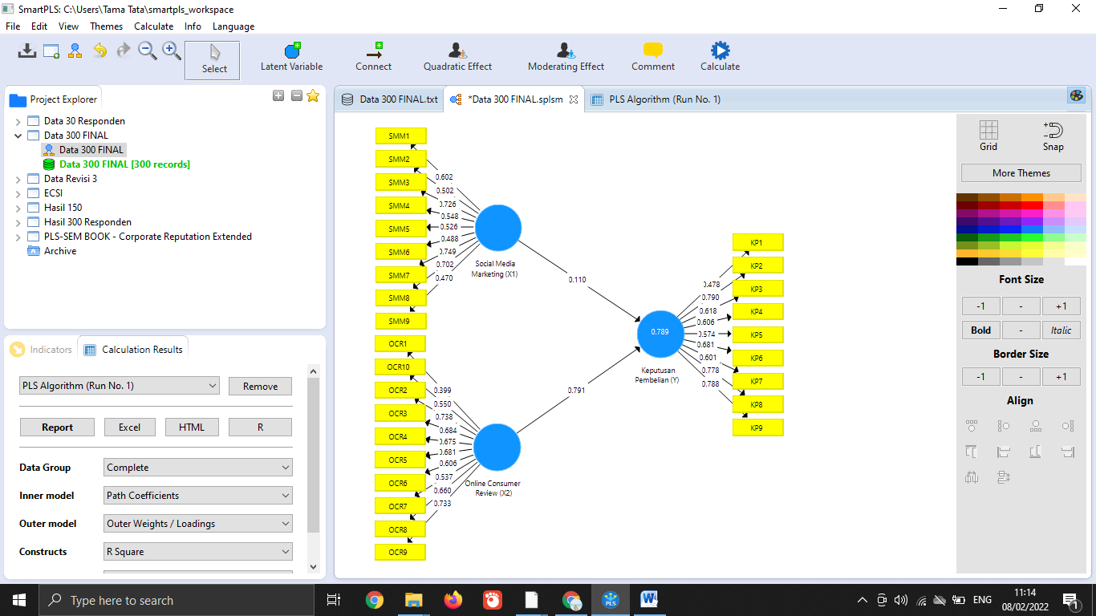

Source : Output SmartPLS V.3 (2022)

Source: Data Processed (2022)