**Navigating the E-Commerce Temptation: an In-Depth Analysis of Impulse Buying in Shopee with Inflation as a Moderator**

Irma Nina Fauziah Ritonga

Master of Management, Postgraduate, Muhammadiyah University of North Sumatra

irmaninafr@gmail.com

Satria Tirtayasa

Master of Management Lecturer, Postgraduate, Muhammadiyah University of North Sumatra

satriya

**\***Irma Nina Fauziah Ritonga1 is a student at the Master of Management Study Program at the Muhammadiyah University of Sumatra (UMSU). Satria Tirtayasa2 is a lecturer at the Master of Management Study Program at Muhammadiyah University of Sumatra (UMSU).

**How to cite:**

Biondo, AE, Bonaventura, L. 2017. Agricultural resources allocation and environmental sustainability. Journal of Applied Economic Sciences, Volume XII, Spring, 1(23): 105 – 113.

**Abstract:**

The purpose of this study was to systematically analyze the influence of Hedonic Shopping Motivation, Brand Image, and Fashion Involvement on Impulse Buying behavior within the context of Shopee e-commerce. Moreover, this research aimed to assess the moderating role of Inflation as a crucial variable in shaping the relationships. To achieve this, the study employed a population determined by the Lemeshow formula, resulting in a sample size of 384 respondents selected through purposive sampling. Data collection was conducted via an online questionnaire distributed through Google Forms. Hypothesis testing was carried out using established statistical methods, including tests for classical assumptions, multiple regression analysis, and hypothesis testing with the aid of SPSS software. The findings of this study revealed significant relationships between the individual factors of Hedonic Shopping Motivation, Brand Image, and Fashion Involvement with Impulse Buying. Notably, Hedonic Shopping Motivation and Brand Image displayed significant effects on Impulse Buying behavior. Additionally, the research discerned that Inflation acted as a moderator, significantly influencing the relationship between Hedonic Shopping Motivation and Impulse Buying. However, Inflation did not exhibit a moderating effect on the relationship between Brand Image and Impulse Buying. These results contribute to a deeper understanding of consumer behavior dynamics within the Shopee e-commerce platform, offering valuable insights for both academic discourse and practical implications in the realm of online retailing.

**Keywords:** **Brand Image; Fashion Involvement; Hedonic; Inflation; Shopping Motivation**

**1. Background**

In the contemporary era characterized by globalization, the rapid advancement of technology and science has become an essential constituent of consumer lifestyles. Present-day consumers are presented with an array of sophisticated technological conveniences, most notably within the realm of e-commerce, which has emerged as a pivotal arena for purchasing decisions. This paradigm shift is particularly conspicuous in the Indonesian context, where the burgeoning e-commerce sector reflects the increasing reliance on information technology by consumers. As expounded by O'Brien, e-commerce encompasses the multifaceted processes of buying, selling, marketing, and servicing products, services, and information facilitated through diverse computer networks. This transformation in consumer behavior is substantiated by the findings of the "Indonesia e-commerce Mapping 2018" study conducted by Katadata Insight Center (KIC), underscoring the prevalence of e-commerce transactions, with a substantial majority (75.77%) emanating from Java, the most populous island in Indonesia. West Java, in particular, demonstrated a noteworthy share of 21.21%, signifying the extensive penetration of e-commerce within the region.

The rapid expansion of e-commerce in Indonesia can be attributed, in part, to the extensive internet usage among Indonesian consumers. As the internet continues to evolve as a pervasive medium for communication and commerce, companies have seized the opportunity to streamline their operations through online platforms, thereby facilitating rapid marketing and communication, irrespective of geographical distances. In tandem with this digital transformation, fashion, an integral facet of personal expression, has exhibited remarkable growth and dynamism within Indonesia. This progression is underpinned by multiple factors, including the burgeoning potential of local designers, an upward economic trajectory, and the robust development of the retail sector. Notably, the online sector has played a pivotal role in this narrative, with Shopee, an e-commerce giant introduced in Indonesia in December 2015, serving as a quintessential exemplar. Since its inception, Shopee Indonesia has experienced exponential growth, boasting over 100 million downloads and garnering more than 10 million user ratings and reviews as of August 2022.

The ubiquity of e-commerce in Indonesia renders it accessible to both businesses and consumers, establishing a dynamic marketplace. Within this context, this research endeavors to scrutinize the existence and resilience of the Shopee online platform in the face of intense competition and the prevailing economic condition of inflation. It further explores the burgeoning phenomenon of Impulse Buying, which has proliferated in tandem with the growing user base of the internet in Indonesia. It is notable that a significant portion of online shoppers, particularly women, exhibit impulsive shopping behavior, often devoid of meticulous planning. The concept of hedonic value in consumption is integral to understanding this phenomenon. Hedonic value encapsulates the experiential dimensions of consumption, encompassing emotions, fantasies, pleasure, and sensory stimuli, thereby profoundly impacting individuals' emotional states. The quest for hedonic value during shopping endeavors can manifest as Impulse Buying, characterized by spontaneous, immediate, and unplanned purchases. Impulse Buying tendencies are contingent upon individual traits that respond to external stimuli. Moreover, Brand Image is a pivotal factor influencing impulsive purchasing behavior. In a diverse marketplace offering a plethora of foreign and domestic fashion brands, strong brand images can assert a significant competitive advantage, exerting an influential pull on consumers.

Fashion involvement emerges as another noteworthy stimulus for Impulse Buying. According to O'Cass (2020) and Zaichkowsky (as cited in Japarianto and Sugiharto, 2011), involvement signifies the motivational and relational facets generated by a particular stimulus or context, influenced by personal characteristics, needs, values, and interests. In the context of fashion, many individuals, particularly women, demonstrate a high degree of involvement, investing substantial resources, both temporal and financial, in keeping up with the latest trends. This facet of involvement in fashion is instrumental in predicting various behavioral variables, including product involvement, purchasing behavior, and consumer characteristics. In light of these prevailing dynamics, this study aims to empirically investigate the interplay among Hedonic Shopping Motivation, Brand Image, and Fashion Involvement in relation to Impulse Buying behavior. Additionally, it seeks to explore the moderating effect of Inflation on these relationships, thereby contributing to a deeper comprehension of consumer behavior within the context of Shopee e-commerce. This research endeavors to elucidate the multifaceted dimensions of contemporary consumer behavior, offering insights with both academic and practical implications in the realm of online retailing.

**2. Research Methods**

The type of research is quantitative research with survey methods. The aim of this method is to obtain information about the matter to be researched from a number of respondents who are considered to represent a population. This research focuses on consumers in Medan City who make purchases on Shopee E-commerce. Since the exact population size is unknown and quite extensive, a purposive sampling method, which falls under non-random sampling, was employed. Since the precise population size was unknown, the study utilized the Lemeshow formula for calculation purposes:

$$n= \frac{{1,96}^{2} 0,5(1-5)}{{0,05}^{2}}$$

$$n=\frac{3,8416 . 0,25}{0,0025}$$

$$n=384,16=384 konsumen Shopee$$

The study determined a sample size of 384 respondents based on the calculations mentioned. It investigated three independent variables: hedonic shopping motivation (X1), brand image (X2), and fashion information (X3), along with one moderator variable, inflation (Z), and one dependent variable, impulse buying (Y). Data collection was conducted through a questionnaire, and data analysis was performed using SPSS.

**3. Results and Discussion**

**Data analysis**

**Normality test**

The following are presented the results of the Normality testing that was carried out in this research:

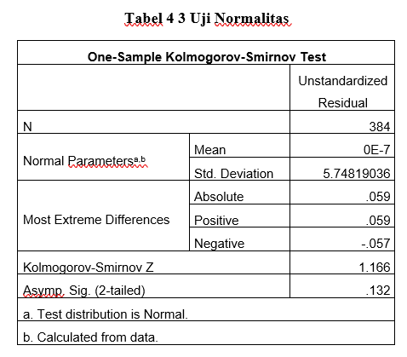

Based on the output results in table 3.1, it shows that the significance value is above 0.05, namely 0.132. This means that the residual data is normally distributed. This means that the residual data is normally distributed. This can also be explained by the results of graphic analysis, namely the Normal Probability plot graph as follows:

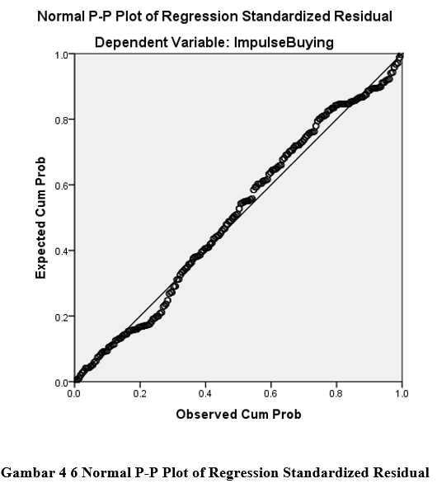

The image shows that the data distribution in the figure 3.1 is said to be spread around the diagonal line (not spread far from the diagonal line). These results indicate that the data to be regressed in this study is normally distributed or it can be said that the data normality requirements can be met.

**Multicollinearity Test**

**Multicollinearity Test Table**

The output results in Table 3.2 demonstrate that none of the variables in this study exhibit multicollinearity issues. This conclusion is based on the VIF (Variance Inflation Factor) values, which are all below 10, and the tolerance values, which significantly exceed 0.1. These findings affirm that within this regression model, there are no concerns regarding multicollinearity among the independent variables.

**Heteroscedasticity Test**

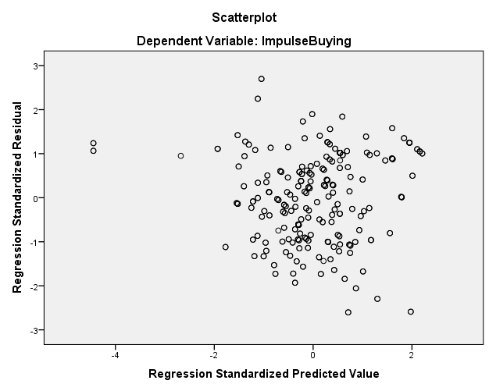

By looking at figure 3.2 the scatterplot above, you can see that the points are spread randomly, and are spread both above and below the number 0 (zero) on the Y axis. So it can be concluded that there are no symptoms of heteroscedasticity in the regression model used, from these results It can be said that the variables that will be tested in this research are homoscedastic.

**I****nflation Moderating Regression Results on the Effect of Hedonic Shopping on Impulse Buying**

The presented test results indicate the following significant findings: First, in testing Hypothesis 1 (Regression Model 1), a t-value of 15.659 and a significance level (t.significant) of 0.000 (p < 0.05) confirm a strong positive and statistically significant influence of hedonic. The presented test results indicate the following significant findings: First, in testing Hypothesis 1 (Regression Model 1), a t-value of 15.659 and a significance level (t.significant) of 0.000 (p < 0.05) confirm a strong positive and statistically significant influence of hedonic shopping motivation on impulse buying, leading to the acceptance of H1. Second, in examining Hypothesis 2, which investigates the moderating role of inflation (Regression Model 2), the R² value rises from 0.391 to 0.673. Subsequently, when introducing inflation as an interaction term (Regression Model 3), the R² further increases to 0.680. This augmentation in R² suggests an improved model fit. Furthermore, the t-test for the interaction effect, with a t-value of 0.004 (p < 0.05), confirms the existence of a positive and statistically significant influence of inflation as a moderator on the relationship between hedonic shopping motivation and impulse buying. Consequently, H2 is accepted, signifying that inflation indeed plays a significant and positive moderating role in shaping the impact of hedonic shopping motivation on impulse buying within the research context.).

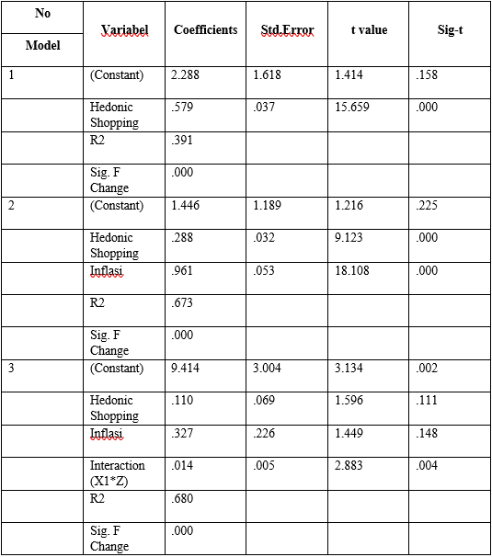

**Regression Results Moderating Inflation, Influence of Brand Image on Impulse Buying**

The table provided reveals the following significant findings: Firstly, in the evaluation of Hypothesis 3 (Regression Model 1), a t-value of 14.670 and a significant t-statistic of 0.000 (p < 0.05) demonstrate a substantial and statistically significant positive influence between brand image and impulse buying, leading to the acceptance of H3. Secondly, to investigate Hypothesis 4, which explores the moderating role of inflation (Regression Model 2), the R² value increases markedly from 0.360 to 0.715. However, when introducing inflation as an interaction term (Regression Model 3), the R² remains at 0.715, indicating no significant change in model fit. Further assessment of the interaction effect (the influence of brand image on impulse buying with inflation) through the t-test reveals a t-value of 1.062 with a significance level of 0.289 (p > 0.05), indicating a lack of statistical significance. Consequently, H4 is not supported, suggesting that inflation does not exert a significant moderating influence on the relationship between brand image and impulse buying within the context of the study.

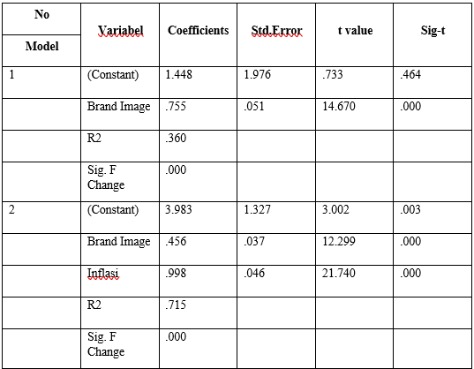 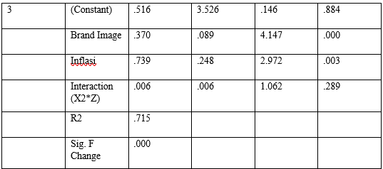

Based on this test, it can be concluded that the influence of inflation as a moderator variable is not significant on the influence of brand image and impulse buying (H4 is rejected).

**Inflation Moderating Regression Results on the Effect of Fashion Involvement on Impulse Buying**

From the test results to test H5 (regression model1) it was found at value of 15.797 and a significant t-statistic of 0.000 (p < 0.05) indicate a substantial and statistically significant positive influence between fashion involvement and impulse buying, leading to the acceptance of H5. Secondly, in the examination of Hypothesis 6, which explores the moderating role of inflation (Regression Model 2), the R² value increases notably from 0.395 to 0.692. Subsequently, when inflation is included as an interaction term (Regression Model 3), the R² further increases to 0.695, signifying an improved model fit. However, the assessment of the interaction effect (the influence of fashion involvement on impulse buying with inflation) via the t-test yields a t-value of 1.739 with a significance level of 0.083 (p > 0.05), indicating a lack of statistical significance. Consequently, H6 is not supported, suggesting that inflation does not exert a significant moderating influence on the relationship between fashion involvement and impulse buying within the context of the study.

1. Top of Form

.

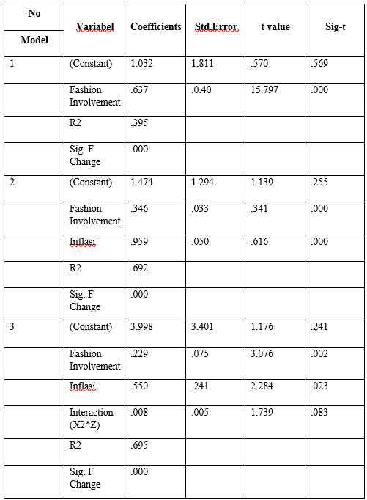

Based on this test, it can be concluded that the influence of inflation as a moderator variable is not significant on the influence of fashion involvement and impulse buying (H5 is rejected).

**F Statistical Test**



In the F test of this research, it is known that the independent variable has a p-value of 0.000, where this probability value is below 0.05. Thus, in accordance with the provisions in the test criteria, if the probability value is <0.5, it can be concluded that hedonic shopping motivation, brand image and fashion involvement simultaneously influence impulse buying.

**Determination Coefficient (R-Square)**

Based on this table, it shows that the coefficient of determination (Adj. R2) is 0.470. This means that the contribution of hedonic shopping motivation, brand image and fashion involvement to impulse buying is 47%, while the remaining 53% is explained by hedonic shopping motivation, brand image and fashion involvement which was not revealed in this research.

**DISCUSSION**

**The Influence of Hedonic Shopping Motivation on Impulse Buying on Shopee e-commerce**

Based on the SPSS output and subsequent analysis, it is evident that the significant p-value for the hedonic shopping motivation variable is 0.000, which falls below the predefined alpha value of 0.05. Consequently, the research findings support H1, indicating that the hedonic shopping motivation variable exerts a statistically significant effect on impulse buying. In other words, hedonic shopping motivation has a discernible impact on impulsive purchasing behavior. The descriptive analysis further elucidates that a notable percentage of respondents (49.7%) align with the statement "When consumers shop at Shopee, consumers will find new and interesting products," within the agree category. This response is indicative of the hedonic shopping motivation variable, specifically reflecting consumers' inclination to shop in pursuit of the latest and enticing products. This finding is corroborated by the data on the impulse buying variable, which suggests that consumers frequently engage in spontaneous purchases on Shopee. Hence, it can be inferred that consumers who actively follow the latest fashion trends exhibit a propensity for impulsive buying, affirming the notion that heightened hedonism within consumers contributes to this behavior.

**The Influence of Brand Image on Impulse Buying on Shopee e-commerce**

The SPSS output results clearly indicate the significance of the influence of Brand Image on Impulse Buying, with a p-value of 0.000, falling below the predefined alpha value of 0.05. Consequently, the research findings affirm the acceptance of H2 for the brand image variable, suggesting that brand image has a statistically significant effect on Impulse Buying. In other words, brand image plays a discernible role in shaping impulsive purchasing behavior. The descriptive analysis further illuminates that the statement "The very varied models or designs of fashion products with the various offers offered by Shopee make these products more attractive to consumers" within the agree category garners the highest percentage (53.9%) in enhancing Shopee's brand image. This response signifies an indicator of the brand image variable, specifically reflecting consumer perceptions related to packaging design or product models. The more attractive the design or model, the greater its appeal to consumers, leading to enhanced brand image and improved recall among consumers. This finding aligns with the data on the impulse buying variable, which suggests that consumers are inclined to shop when special offers are available, underlining the role of an appealing brand image in driving impulse buying behavior.

**The Influence of Fashion Involvement on Impulse Buying on Shopee e-commerce**

The data gleaned from the SPSS output strongly indicates the significance of Fashion Involvement's influence on Impulse Buying, as evidenced by a p-value of 0.000, which is smaller than the predetermined alpha level of 0.05. Consequently, the research findings firmly support the acceptance of H3 for the fashion involvement variable, suggesting that fashion involvement exerts a statistically significant effect on Impulse Buying. In essence, fashion involvement plays a substantial role in shaping impulsive purchasing behavior. The descriptive analysis further illuminates that the statement "Fashion with a model that is different from the others will be highly sought after and liked," falling within the agree category, garners a notable percentage (48.2%) in defining Shopee's fashion involvement. This response serves as an indicator of the fashion involvement variable, particularly reflecting consumers' propensity to own clothing items featuring the latest models or trends. This observation aligns with the data pertaining to the impulse buying variable, which suggests that consumers tend to make rapid purchasing decisions when shopping for fashion products on Shopee, underscoring the influence of fashion involvement on impulse buying behavior. In conclusion, it can be deduced that consumers are inclined to make impulsive purchases when presented with fashion products featuring distinct or the latest models (trends), thereby confirming the significant impact of fashion involvement on impulse buying.

.

**Infalsi Moderates the Relationship between Hedonic Shopping Motivation and Impulse Buying on Shopee e-commerce**

The SPSS output underscores the significance of the moderating effect of inflation on the relationship between the hedonic shopping motivation variable and impulse buying, with a significance value of 0.004, which is below the predefined alpha level of 0.05. This outcome substantiates the acceptance of H4 for the hedonic shopping motivation variable, indicating that inflation can indeed strengthen the influence of hedonic shopping motivation on impulse buying. The descriptive analysis reveals a pivotal aspect of Shopee's hedonic shopping motivation, with a prominent percentage (49.7%) aligned with the statement "When consumers shop at Shopee, consumers will find new and interesting products," within the agree category. This response signifies an indicator of the hedonic shopping motivation variable, reflecting consumers' propensity to shop in pursuit of the latest fashion trends. This aligns with data pertaining to the impulse buying variable, suggesting that consumers frequently engage in impromptu purchases on Shopee. Moreover, the statement associated with the inflation variable, "consumers will continue to shop even though the price of fashion products has increased," further reinforces the notion that consumers are inclined to make purchases even when prices rise. In summary, the findings indicate that consumers are willing to make purchases even in the face of price increases, especially when driven by hedonic shopping motivation. The presence of inflation serves to intensify this influence, underscoring the complex interplay between hedonic shopping motivation, impulse buying, and economic factors.

**Infalsi Moderates the Relationship of Brand Image to Impulse Buying on Shopee e-commerce**

The SPSS output analysis highlights that the significance value for the moderating effect of inflation on the relationship between the brand image variable and impulse buying is 0.289, surpassing the predetermined alpha level of 0.05. Consequently, the research findings lead to the rejection of H5 for the brand image variable, implying that inflation does not have the capacity to strengthen the influence of brand image on impulse buying within the context of this study. The descriptive analysis further reveals a significant aspect of Shopee's brand image, with a considerable percentage (46.1%) aligning with the statement "consumers buy products not only because they are famous but because of good quality and price," within the agree category. This response signifies an indicator of the brand image variable, specifically reflecting consumer perceptions related to pricing. This aligns with data pertaining to the impulse buying variable, which suggests that consumers are inclined to make purchases when special offers are available.In summary, the findings suggest that consumers' purchasing decisions are influenced by a combination of factors, including not only brand image but also quality and price considerations. In this context, inflation does not appear to play a significant role in enhancing the impact of brand image on impulse buying behavior.

**Infalsi Moderates the Relationship of Fashion Involvement to Impulse Buying on Shopee e-commerce**

The SPSS output analysis reveals that the significance value for the moderating effect of inflation on the relationship between the fashion involvement variable and impulse buying is 0.083, exceeding the predetermined alpha level of 0.05. Consequently, the research findings lead to the rejection of H5 for the fashion involvement variable, suggesting that inflation does not have the capacity to strengthen the influence of fashion involvement on impulse buying within the context of this study. The descriptive analysis further underscores an important facet of Shopee's fashion involvement, with a significant percentage (47.4%) associating with the statement "fashion with the latest models will be very popular," within the agree category. This response serves as an indicator of the fashion involvement variable, specifically reflecting consumers' inclination to possess clothing items featuring the latest models or trends. This observation aligns with data pertaining to the impulse buying variable, which indicates that consumers often purchase fashion products even when there is no immediate necessity. In summary, the findings suggest that consumers' decisions regarding fashion purchases are influenced by factors such as the appeal of the latest models, regardless of actual need. However, inflation does not appear to significantly amplify the influence of fashion involvement on impulse buying behavior in this specific research context.

**4. Conclusion**

Based on the research discussions and conclusions, the following recommendations are provided:

1. **Hedonic Shopping Motivation**: The empirical evidence strongly supports the assertion that hedonic shopping motivation exerts a positive and statistically significant impact on impulse buying within the context of Shopee e-commerce. Therefore, it is advisable for businesses operating on Shopee to recognize and leverage the influence of hedonism in consumer behavior. A proactive approach involving the cultivation of hedonic experiences, the introduction of novel and captivating products, and tailored marketing strategies can serve to attract and engage consumers characterized by hedonic shopping motivation. By fostering an environment that resonates with hedonistic inclinations, businesses can anticipate a corresponding increase in unplanned online purchases.
2. **Brand Image**: The research outcomes affirm the substantial role played by brand image in shaping impulse buying behavior on Shopee e-commerce. Consequently, it is recommended that businesses on Shopee prioritize the enhancement and reinforcement of their brand image. Achieving this objective entails a comprehensive commitment to delivering high-quality goods or services, offering exceptional customer experiences, and effectively conveying the unique value propositions associated with their brands. Establishing a robust, trustworthy, and appealing brand image can instill confidence in consumers, thereby encouraging impromptu purchasing decisions.
3. **Fashion Involvement**: The empirical findings affirm the positive and significant relationship between fashion involvement and impulse buying within the Shopee e-commerce platform. Businesses, particularly those specializing in fashion products, should proactively engage consumers by offering the latest fashion trends, exclusive collections, and interactive fashion-related content. Leveraging social media platforms and collaborating with fashion influencers and trendsetters can amplify consumer engagement and participation. By nurturing an environment that aligns with consumers' interest in fashion, businesses can anticipate heightened levels of unplanned online purchases.
4. **Inflation Considerations**: It is noted that inflation, while not directly strengthening the influence of brand image and fashion involvement on impulse buying, may have a moderating effect on consumer buying behavior. Consequently, it is advisable for businesses to remain vigilant regarding inflationary pressures and their potential impact on consumer preferences. During periods of inflation, companies should carefully assess their pricing strategies, explore cost-effective supply chain management solutions, and contemplate the implementation of discounts or promotional campaigns to mitigate potential decreases in consumer interest. Additionally, educational initiatives aimed at elucidating the enduring value and quality of products can assist in preserving consumer trust and loyalty amidst rising prices.

.

**References**

Ade Tiara Yulinda, RR (2022). The Influence of Shopping Lifestyle and Fashion Involvement on Impulse Buying among Bengkulu City Employee Mnatan Store Consumers. Economic Journal, 1-12.

Adnan. (2018). The Influence of Consumer Behavior on Morinaga Milk Purchasing Decisions in Lhokseumawe City. Visionary & Strategy Journal, 1-9.

Agnes Hidiani, TS (2021). The Influence of Hedonic Shopping Motivation, Shopping Lifestyle and Visual Merchandising on Impulse Buying of Fashion Products for Puwokerto Muhammadiyah University Students. Journal of Business Economics, 1-10.

Annisa Savira Alifia, CH (2021). The Influence of Store Atmosphere and Brand Image on Impulsive Buying Behavior in Fashion Retail Consumers. Psychology and Mental Health Research Bulletin, 1-12.

Awalludin Fajar, SM (2020). The Effect of Service Quality, Perceived Value and Mediating Effect of Brand Image on Brand Trush. Journal of Management and Entrepreneurship, 1-12.

Binar Utami, AU (2017). The Influence of Hedonic Shopping Value on Impulse Buying with Positive Emotions as an intermediary variable among Customers at Ambarukmo Plaza Yogyakarta. 1-11.

Dian Sukma Andriyanto, IS (2016). The Influence of Fashion Involvement and Positive Emotion on Impulse Buying. Journal of Business Administration, 1-8.

Dita Amanah, SP (2015). The Influence of Sales Promotion and Hedonic Shopping on Impulsive Buying of Matahari Plaza Medan Fair Products. Quanomic Journal, 1-9.

Edwin Japarianto, SS (2012). The Influence of Shopping Lifestyle and Fashion Involvement on the Impulse Buying Behavior of High Income People in Surabaya. 1-15.

Fadilla, HA (2018). Islamic Views and the Influence of the Exchange Rate, BI Rate on Inflation. ISNN: 2540-816X, 1-15.

Hadi, JA (2022). The Effect of Financial Leverage on Sharia Stock Prices with Inflation as a Moderating Variable. Indonesian Journal of Social Science, 1-12.

I Made Willy Setiadi, IG (2015). The Influence of Fashion Involvement on Impulse Buying of Fashion Consumers Mediated by Positive Emotion in Denpasar City. Unud Management e-Journal, 1-21.

Martiana Wulandari, AL (2019). The Influence of Shopping Lifestyle, Discounts and Fashion Involvement on the Impulse Buying of Transmart Carrefour Bandung Visitors. MEA Scientific Journal, 1-14.

Muhammad Khirul Rizal Surbakti, GW (2022). The Influence of Influencers, Lifestyle and Brand Image on Impulse Buying in E-commerce among the Millennial Generation in Pekanbaru City. Journal of Applied Social Humanities, 1-8.

Rafidah Salma Mardhiyah, LS (2021). The Influence of Hedonic Shopping Motivation and Shopping Lifestyle on Impulse Buying with Positive Emotions as Intervening Variables on Shopee Shopee e-commerce. Journal of Business Analytics, Social Economy and Politics, 1-13.

Rahmat Hidayat, IK (2018). The Influence of Fashion Involvement and Shopping Lifestyle on Impulsive Buying of Batam State Polytechnic Students. Journal of Applied Business Administration, 1-7.

Ridwan Maronrong, KN (2017). The influence of inflation, interest rates and exchange rates on share prices. Case studies of automotive manufacturing companies listed on the Indonesian Stock Exchange 2012-2017. STEI Journal of Economics, 1-19.

Sari, R. (2021). The Influence of Paylater Users on the Impulse Buying Behavior of E-commerce users in Indonesia. Journal of Business and Investment Research, 1-14.

Satria Tirtayasa, HK (2021). The Role of Technology in Moderating the Influence of Internal Networking on the Performance of Small and Medium Industrial Enterprises During the Covid 19 Pandemic. Journal of Business and Management, 1-7.

Satria Tirtayasa, IN (2021). Technology-moderated Marketing Strategy for Improving MSME Performance during the Covid-19 Pandemic. Scientific Journal of Management and Business, 1-17.

Satria Tirtayasa, MN (2020). The Influence of Hedonic Shopping Motivation, Shopping Lifestyle and Fashion Involvement on Impulse Buying among Zalora Customers in Medan City. Junal Salman (Social and Management), 1-12.

Satria Tirtayasa, Y. (2022). The Influence of Product Quality, Price and Innovation on Marketing Performance Moderated by Consumer Purchasing Power in Boba Drink MSMEs in Medan Marelan District. UMSU Journal, 1-24.

Satria Tirtayasa, YA (2021). The Influence of Marketing Mix on the Marketing Performance of Small and Medium Industries in the Welding Workshop Construction Sector in Moderating Government Policy during the Covid 19 Pandemic. Master of Management Scientific Journal 4, 1-17.

Styadi, RD (2018). The Influence of Brand Image, Hedonic Shopping Motivation and Fashion Involvement on Impulse Buying. Journal of Management Science and Research, 1-17.

Sucidha, I. (2019). The Influence of Fashion Involvement, Shopping Lifestyle, Hedonic Shopping Value and Positive Emotion on Impulse Buying Fashion Products among Duta Mall Banjar Masin Customers. Management Scientific Journal, 1-10.

Supriyadi, YF (2016). The Influence of Product Quality and Brand Image on Purchasing Decisions. Journal of Business Management, 1-10.

Suyati, S. (2015). The Influence of Inflation, Interest Rates and the Rupiah / US Dollar Exchange Rate on Property Stock Returns listed on the Indonesian Stock Exchange. UNTAG Semarang Scientific Journal, 1-17.

Ummi Mardhotus Sholihah, NA (2017). The Influence of Shopping Lifestyle, Fashion Involvement, Hedonic Shopping Motivation and Sales Promotion on Impluse Buying in Malang Town Square and Olympic Garden Mall. e-Journal of Management Research, 1-17.

Yunaida, E. (2017). The Influence of Brand Image on Consumer Loyalty for Evalube Lubricating Oil Products in Langsa City. Journal of Financial Management, 1-10.

Yusniar. (2021). The Phenomenon of Impulse Buying (Unplanned Purchases) in Online Shopping Practices is Reviewed from a Sharia Economic Perspective. 1-23.