**LAMPIRAN**

Dana pihak ketiga periode 2015-2018 (milyar rupiah)

|  |  |  |  |  |
| --- | --- | --- | --- | --- |
| Bulan | Periode | | | |
| 2015 | 2016 | 2017 | 2018 |
| Januari | 164.291 | 173.230 | 205.783 | 239.318 |
| Februari | 163.159 | 173.834 | 208.429 | 239.258 |
| Maret | 165.034 | 174.779 | 213.199 | 244.820 |
| April | 164.400 | 174.135 | 218.944 | 244.779 |
| Mei | 164.375 | 174.354 | 220.392 | 241.995 |
| Juni | 162.817 | 177.051 | 224.420 | 241.073 |
| Juli | 165.378 | 178.768 | 228.080 | 240.596 |
| Agustus | 164.561 | 178.934 | 225.440 | 239.804 |
| September | 166.433 | 198.976 | 232.349 | 251.483 |
| Oktober | 165.857 | 199.462 | 229.957 | 250.949 |
| Nopember | 167.150 | 202.332 | 232.756 | 250.755 |
| Desember | 174.895 | 206.407 | 238.225 | 257.606 |

*Non performing financing* periode 2015 – 2018 (milyar Rupiah)

|  |  |  |  |  |
| --- | --- | --- | --- | --- |
| Bulan | Periode | | | |
| 2015 | 2016 | 2017 | 2018 |
| Januari | 8.118 | 8.303 | 8.112 | 9.720 |
| Februari | 8.504 | 8.484 | 8.351 | 9.766 |
| Maret | 8.078 | 8.180 | 8.217 | 8.673 |
| April | 7.659 | 8.415 | 8.591 | 9.243 |
| Mei | 8.057 | 9.606 | 8.580 | 9.364 |
| Juni | 7.676 | 8.990 | 8.294 | 7.270 |
| Juli | 7.903 | 8.332 | 8.268 | 7.486 |
| Agustus | 7.915 | 8.693 | 8.272 | 7.623 |
| September | 7.763 | 8.033 | 8.212 | 7.592 |
| Oktober | 7.754 | 8.315 | 9.141 | 7.850 |
| Nopember | 7.737 | 8.168 | 9.816 | 7.850 |
| Desember | 7.456 | 7.835 | 9.030 | 6.597 |

Data pembiayaan periode 2015 – 2018 (milyar rupiah)

|  |  |  |  |  |
| --- | --- | --- | --- | --- |
| Bulan | Periode | | | |
| 2015 | 2016 | 2017 | 2018 |
| Januari | 179.126 | 189.360 | 223.650 | 186.508 |
| Februari | 180.527 | 191.131 | 224.284 | 187.448 |
| Maret | 179.929 | 193.071 | 231.553 | 190.064 |
| April | 179.989 | 192.212 | 234.806 | 191.042 |
| Mei | 181.496 | 192.632 | 236.669 | 192.749 |
| Juni | 180.094 | 195.071 | 240.529 | 189.677 |
| Juli | 180.299 | 197.506 | 242.207 | 191.149 |
| Agustus | 180.273 | 197.216 | 240.412 | 192.929 |
| September | 185.152 | 219.771 | 246.392 | 198.536 |
| Oktober | 183.122 | 220.622 | 244.546 | 198.678 |
| Nopember | 184.962 | 224.303 | 247.126 | 199.819 |
| Desember | 192.642 | 230.035 | 255.236 | 202.298 |

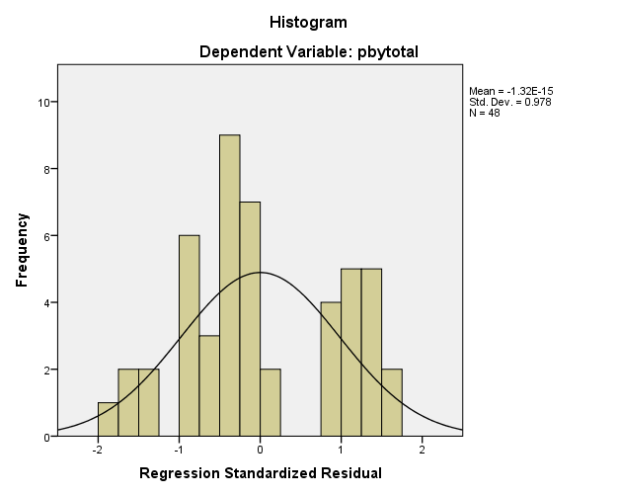

Kinerja bank umum syariah periode 2015 – 2018