Design and Implementation of Stepper 28BYJ-48 and Servo MG996R as a Roasting Arm Robot in an Arduino Uno-based Automatic Satay Grill Tool
Angga Muhammad Satria Nugroho ^{a,1,*}, Rahmat Hidayat ^{b,2}, Arnisa Stefanie ^{b,3}
ª Department of Electrical Engineering, University of Singaperbangsa Karawang
JL. HS. Ronggo Waluyo, Puseurjaya, Kec. Telukjambe Tim., Karawang Regency, West Java 41361, Indonesia
¹ angga.muhammadsn16025@student.unsika.ac.id*; ² rahmat.hidayat@staff.unsika.ac.id.;
³ arnisa.stefanie@staff.unsika.ac.id

 |  | ABSTRACT
Keywords  Automation  Satay  Arduino  Robotic Arm |  | In industry, almost all factories use an automation system, because faster results and better quality are certainly the main factors in using this automation system. However, in home industries such as satay stalls, it is rare to find the use of this automation technology. Generally, satay stalls still use the traditional (manual) method when grilling satay. So we need a tool that is capable of baking the satay automatically. The solution was obtained by creating a roasting arm robot using the Arduino Uno microcontroller. This research is a qualitative research, quantitative and experimental experiments. Data were collected by direct observation of the tools and interviews with traders. The results show that the roasting arm robot is able to carry out its function according to the duration of each type of meat selected.

Introduction
Technological developments have affected everyday life. The effect is that almost all circles do not escape the use of technology, because technology has the ability to ease the work of the user, both in terms of time and energy efficiency. Current technology cannot be separated from a control system to control a process in order to get optimal results, or we can also call it an automation system.
In the industrial world, almost all factories use an automation system, because the results are faster and the quality is better, of course the main factors in the utilization of this automation system. However, in home industries such as satay stalls, it is rare to find the use of this automation technology. In general, satay stalls still use the traditional (manual) method when grilling satay, which of course takes a lot of time and energy as a grilling satay.
This research aims to solve the problem, namely that there are still many satay stalls that still use traditional concepts in the grilling process. The problem faced is that the grill has to turn the satay back and forth then remove it after cooking it manually, so it takes more time and effort for the grill. Therefore, an automation system is designed for the automatic roasting process.
This automation system is made with a specially designed system for controlling the roasting arm robot. Different from previous studies where the drive mechanism can only rotate the satay 360 °. This research has the advantage, namely the mechanism in this study, namely every time the satay is cooked, the driving mechanism will automatically lift the satay, and also the movement of turning the satay will occur 180 ° for a certain time, so that the grilling process will automatically be in accordance with traditional grilling of satay.

Method
  - Research Flow
This research was conducted based on 5 stages, the first was conducting a case study by reading previous research and interviewing the informants. Second, designing the roasting arm robot mechanism. Then in the third stage implement the design that has been made. After implementing the design as expected, the next step is to test the roasting arm robot. Then in the fifth stage, data collection and discussion of the design results are carried out.

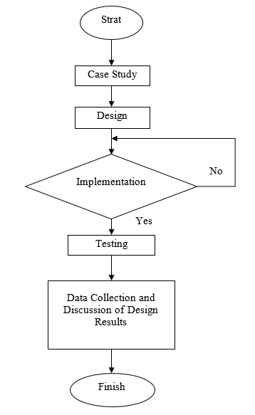
- Research Methodology Flowchart

  - Design
- The Roasting Arm Robot Model Diagram
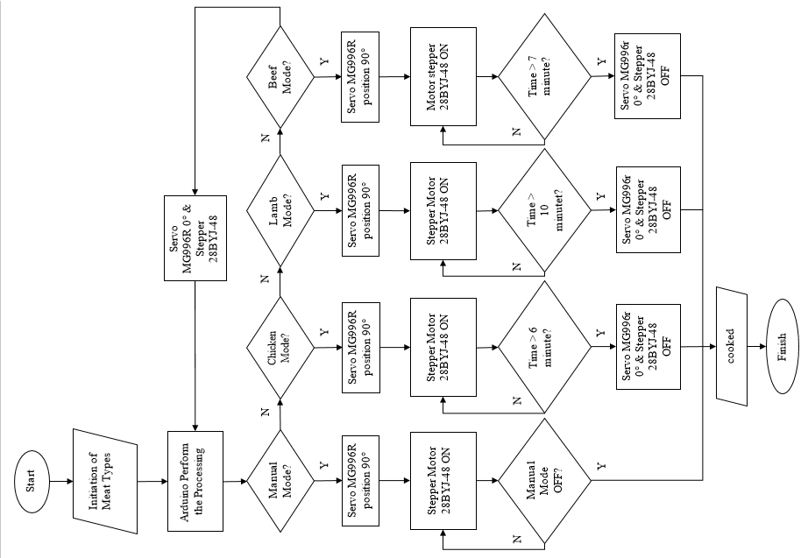
- Flowchart of Design System
- Hardware Design
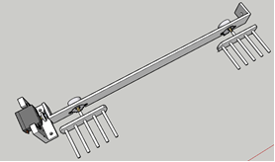
- Roasting Arm Robot design
Fig.3 shows the design of the baking arm system. The design of the holder for the 28BYJ-48 stepper motor is made horizontally lengthwise so that it can be applied to rotate two stepper motors, where the two stepper motors are in charge of turning the grilled satay. At the end of each stepper motor connected with aluminum to grip the satay, each stepper motor can flip five skewers. The position of the MG996r servo motor is made to support the stepper motor mount, this is so that the servo motor is able to lift and lower the satay according to the working principle of the grilling arm system that has been previously described.
- Roasting Arm Robot Circuit Schematic
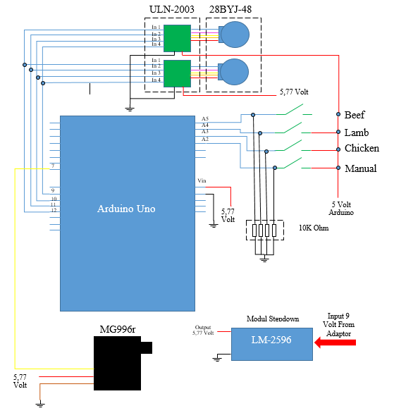
- Roasting Arm Robot Circuit

Results and Discussion

  - Implementation of the Roasting Arm Robot
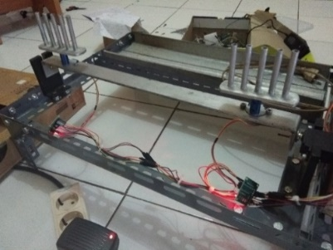
- The Physical Shape of the Roasting Arm Robot
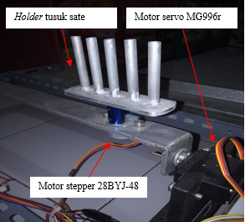
- Toaster Arm Robot Component Layout
  - Testing
- 28BYJ-48 Stepper Motor Rotation ​​Testing
The rotation test of the 28BYJ-48 stepper motor is carried out to determine the performance of the stepper motor, whether it is as desired or not. Testing is done by the method of observation. The parameters observed in the stepper motor test include rotation angle, pause duration, and rotation speed. From these observations, the following results were obtained:
- Stepper Motor Rotation ​​Test Results.
Motor Stepper 28BYJ-48 | Angle of Rotation | Pause Duration (Minute) | Rotation Speed (Sec.)
Stepper Motor 1 | 180° | 1 | 1.74
Stepper Motor 2 | 180° | 1 | 1.74

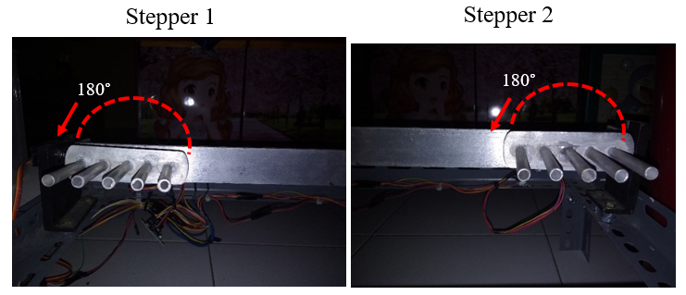
- Stepper motor rotation angle

- Testing Current and Voltage on Stepper Motor 28BYJ-48
This test is done to determine the amount of power consumption on the stepper that is not working and when the stepper is working. Here are the results:
- Stepper Motor Power Requirements Testing.
Stepper Condition | Current (mA) | Voltage (Volt) | Power (Watt)
Before turning | 0.05 | 5.77 | 0.00028
1st Round | 0.20 | 5.17 | 0.00103
2nd Round | 0.20 | 5.17 | 0.00103
3rd Round | 0.20 | 5.17 | 0.00103

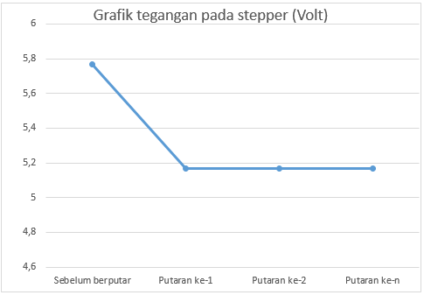
- Stepper Motor Voltage Graph
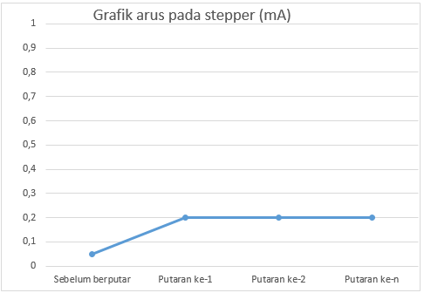
Stepper Motor Current Graph

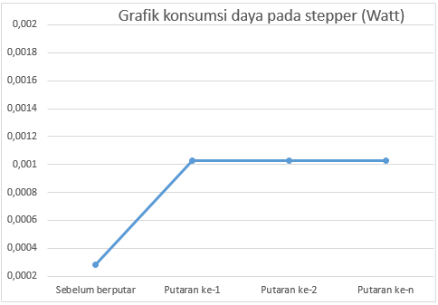
Stepper Motor Power Graph
Based on the tests presented in the graph above, it shows that the voltage has decreased after the stepper rotates. Voltage stabilizes after the first turn. The voltage drop occurs because when the stepper starts rotating there is an increase in the amount of power consumption.
The voltage drop when there is an increase in power in one of the components will result if two or more components are connected in parallel to a voltage source that has internal resistance.

- Testing the Angle of Rotation of the MG996R Servo Motor
This test is conducted to determine the rotation angle of the servo motor. Testing is done by the method of observation. Observations were made in three conditions. The conditions observed included, before the appliance carried out the grilling process, when the appliance was grilling, and when the appliance finished baking. From the observations, the following results were obtained:
- MG996R Servo Turning Angle.
Tool Condition | Servo (0°-90°) | Skewer Holder (0°-90°)
Before baking | 0 | 90
baking | 90 | 0
After baking | 0 | 90

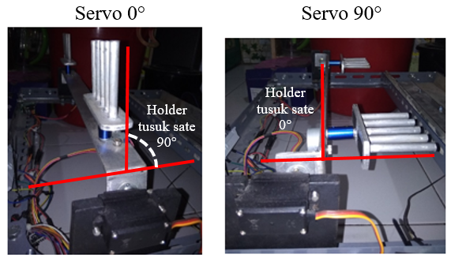
- MG996R Servo Turning Angle

- Servo Angle Graph
- Testing Servo MG996R Current and Voltage
This test was conducted to determine the power requirements of the MG996R servo motor. testing is done by measuring using a multimeter. From the measurement results, the following results were found:
- Servo power consumption when the stepper is not rotating
- Servo power consumption when the stepper is not rotating
Servo Status | Current (mA) | Voltage (Volt) | Power (Watt)
Not turning | 0.34 | 5.77 | 0.0019
When spinning without satay | 0.51 | 5.77 | 0.0029
When rotating with satay (minimum amount) | 0.51 | 5.77 | 0.0029
When rotating with satay (maximum amount) | 0.51 | 5.77 | 0.0029

- Servo power consumption after the stepper rotated
- Servo power consumption when the stepper is not rotating
Servo Status | Current (mA) | Voltage (Volt) | Power (Watt)
Not turning | 0.30 | 5.17 | 0.0015
When spinning without satay | 0.45 | 5.17 | 0.0026
When rotating with satay (minimum amount) | 0.45 | 5.17 | 0.0026
When rotating with satay (maximum amount) | 0.45 | 5.17 | 0.0026

From the results of this test, it was found that the power consumed by the servo motor has changed. The change in power is caused by the voltage starting to change when the stepper motor starts rotating. But overall the power on the servo motor is stable, that is, the servo is not affected by the load it is lifting (in this case satay). The following is a graph of the comparison of the power currents in the servo motor before and after the stepper motor rotates:

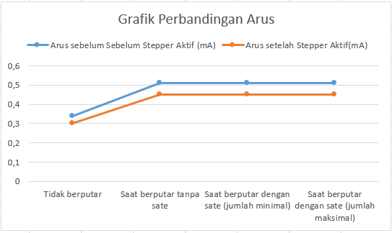
- Servo Current Ratio

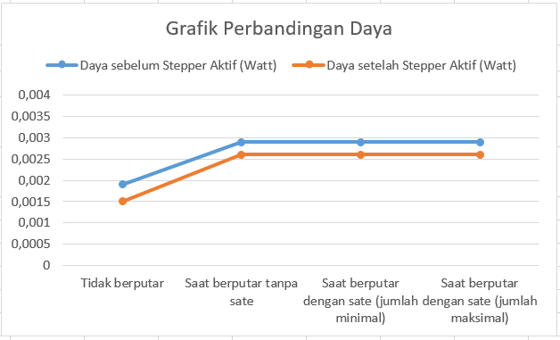
Servo Power Ratio

- Baking Process Testing
This test aims to determine whether the satay is cooked according to the specified duration. Based on interviews conducted with satay traders, the following data were found:
- Result of Interview with Resource Persons
Kind of Meat | Minutes 0f Ripeness
Chicken | ± 6 minute
Lamb | ± 10 minute
Beef | ± 7 minute

Based on the data obtained from the informants, it was found that mutton was a meat that took longer to cook than chicken and beef. Goat meat takes longer to cook because the texture of the meat is tighter than chicken and beef.

To ensure whether the data obtained from the source is correct, testing is carried out, following the test results:
- Chicken meat
- Chicken Meat Testing
duration (Minute) | Information | Status
2 | Raw | Information In accordance with the data from the source
3 | Raw
4 | Almost ripe
5 | Amlost ripe
6 | Mature
7 | Mature
8 | Too ripe

- Lamb
Lamb Testing
duration (Minute) | Information | Status
6 | Mentah | Information In accordance with the data from the source
7 | Mentah
8 | Mentah
9 | Hampir matang
10 | Matang
11 | Matang
12 | Terlalu matang

- Beef
Beff Testing
duration (Minute) | Information | Status
3 | Raw | Information In accordance with the data from the source
4 | Almost done
5 | Almost done
6 | Almost done
7 | Mature
8 | Mature
9 | Too ripe

- Validate the Success of the System
Validation aims to present the test results on several parameters tested to determine whether the system is working successfully or not. The success of the system is based on the maturity level of the satay. The maturity of the meat with a duration that matches the grilling mode is a reference for the success of the roasting arm robot system. Here's the explanation:
- Roasting Arm Robot Validation
Mode | Baking Duration | Is the satay cooked? | Status
Manual | Baking ends when the reset button is pressed | adjust | It works
Chicken meat | 6 minutes | Yes | It works
Lamb | 10 minutes | Yes | It works
Beef | 7 minutes | Yes | It works

Based on the above validation, it was concluded that the entire system was as expected. The success is based on the control response carried out by Arduino after pressing one of the grilling mode switches and also the maturity of the satay according to the predetermined duration. However, apart from the duration of grilling, the level of maturity of the satay is also influenced by the temperature of the coals. The temperature of the coals must be just right in the grilling process. The temperature accuracy is found by the automatic fan control system which is part of the Arduino Uno based automatic satay grill.

Conclusion
Based on the research that has been done, it can be concluded that:
- Motor setepper dan motor servo mampu bekerja sama dengan baik sehingga menciptakan mekanisme berupa gerakan lengan memanggang sate.
- Putaran motor servo tidak terpengarus oleh beban maksimal kapasitas sate
- Dua motor stepper yang dirangkai secara paralel mampu menghasilkan gerakan yang sama
- Tegangan pada sumber akan berkurang jika salah satu komponen mengalami kenaikan konsumsi daya
- Sate matang sesuai durasi yang sudah ditentukan
- Kematangan sate tidak hanya didasari oleh durasi memanggang namun juga didasari oleh vaktor suhu bara api

References

Syahwil, Muhammad.2013. “Panduan Mudah Simulasi & Praktek Mikrokontroler”
Kadir, A.2017. “Pemrograman Arduino Menggunakan Ardublock”. Yogyakarta Penerbit Andi
Nababan, R.Y.2020. “Rancang Bangun Alat Pemanggang Sate Otomatis Dengan Merode PWM Berbasis Mikrokontroler”. Jurnal. Program Studi Teknik Informatika, STMIK Pelita Nusantara, Medan
Hilal, Ahmad.2013. “Pemanfaatan Motor Servo Sebagai Penggerak CCTV Untuk Melihat Alat-Alat Monitor Dan Kondisi Pasien Di Ruang ICU”. Jurnal. Program Studi Diploma 3 Teknik Elektro, Fakultas Teknik, Universitas Diponegoro
Ramdhani, Irwan.2012. “Aplikasi Driver Relay ULN-2003 Sebagai Penggerak Konveyor Otomatis Pengelompokan Buku Menggunakan Inisialisasi Barcode”
Alassar, A. Z.2010. “modeling and control of 5DOF Robot Arm Using Supervisory Control. The Islamic University of Gaza”. Electrical Engineering. Library IU Gaza.
Hartopo. 1.2018. “Pengembangan Media Pembelajaran Lengan Robot 3 DOF pada Mata Pelajaran Perekayasaan Sistem Kontrol”. Program Keahlian Teknik Elektronika Industri di SMK Negeri 2 Wonosari. Universitas Negeri Yogyakarta.
Arismarjito.2011.AUTOMATIC ROBOT ARM AS SEPARATOR OBJECT BASED ON COLOUR USING ATMEGA8533.Program Studi Teknik Elektro Fakultas Sains dan Teknologi Universitas Santana Dharma Yogyakarta.

