Hybrid System of Dual Axis Photovoltaic Tracking System Using PID-CES-ACO

Machrus Ali a,1,*, Rukslin a,2, Cholil Hasyima3

a Universitas Darul Ulum, Jalan Gus Dur 29A, Jombang 61481, Indonesia

1 machrus7@gmail.com*; 2 rukslin05@gmail.com; cholil.ts@undar.ac.id

* Machrus Ali

|  |  |  |  |
| --- | --- | --- | --- |
|  |  | ABSTRACT |  |
| **Keywords**  Ant Colony Optimization  CES  Photovoltaic  Hybrid System |  | In this paper, the efficiency of photovoltaic panels is improved by adding two solar tracking systems. The solar tracking system is used to track the sun so that the photovoltaic always faces the sun. This system uses a dual axis consisting of a horizontal rotation axis and a vertical rotation axis. The motion of the horizontal axis of rotation follows the sun's azimuth angle from north to south. The motion of the vertical axis of rotation following the sun's azimuth angle from east to west is the vertical axis motion. Both types of movement are controlled using PID and Fuzzy controllers which are optimized with an artificial intelligence approach, namely Ant Colony Optimization (ACO). Experiments with PID control approach and CES control were optimized using the ACO method (Hybrid PID-CES-ACO method). In this research, PID-CES-ACO was the best model, obtained on the horizontal axis of overshot 1328 pu, the smallest undershot was 0.116, and the fastest settling time was 0.183 s, on the vertical axis the smallest overshot was 1.246 pu, the smallest undershot was 0.044, the fastest settling time was 0.163 s. |  |
|  |  |

# Introduction

The development of science and the use of solar energy is very fast and growing[1]. Solar energy is very promising to be used as a source of energy by converting solar energy into electrical energy. Several optimization methods have been carried out to obtain optimal electrical energy[2][3]. The dual-axis tracking mechanism is designed using Capacitive Energy Storage (CES). CES have the ability to provide power compensation, thereby reducing or even eliminating frequency oscillations caused by changes in the customer's electrical power load. CES provide energy storage and release systems that operate quickly and automatically[4][5]. To get good attenuation, it is necessary to optimize the CES parameters.[6]. Several artificial intelligence methods have been carried out to obtain optimization of various systems, optimization of micro hydro[4], wind turbines[7][8], water level control[9], vehicle steering control[10][11], and other system optimizations. Artificial intelligence methods that are often used include Fuzzy Logic[12], Firefly Algorithm[13], Ant Colony Optimization (ACO)[14], Bat Algorithm (BA)[2], Imperalis Competitive Algorithm (ICA)[15], and Particle swarm Optimization (PSO)[16]. Using Power Point Tracking (MPPT). in a photovoltaic system to track the maximum power point of a PV system using a Fuzzy Logic Controller[17][18]. Another method is also used to obtain electricity, namely by adding a tracking control system to the solar panel or photovoltaic (PV) system[19][20]. PV requires tracking control of the sun's position so that it always precisely follows the sun's position. This solar tracking system is used to track the horizontal axis of rotation and the vertical axis of rotation[21]. The horizontal axis is the axis used to track the sun's elevation angle and the vertical axis is the axis that follows the sun's azimuth angle[22]. Control optimization is needed so that it is positioned exactly as desired.

# Dual Axis Tracking Photovoltaic

## **Tracking System**

The horizontal axis of rotation tracks the position of the sun's movement from north to south. Vertical rotation axis to track the position of the sun's movement from east to west. The solar azimuth elevation tracking can be shown in Figure 1.[20]. The movement of latitude and time of year and has an equation such as equation 1.[23]. The angle of movement of the sun at latitude and time of year is as in equation 2.

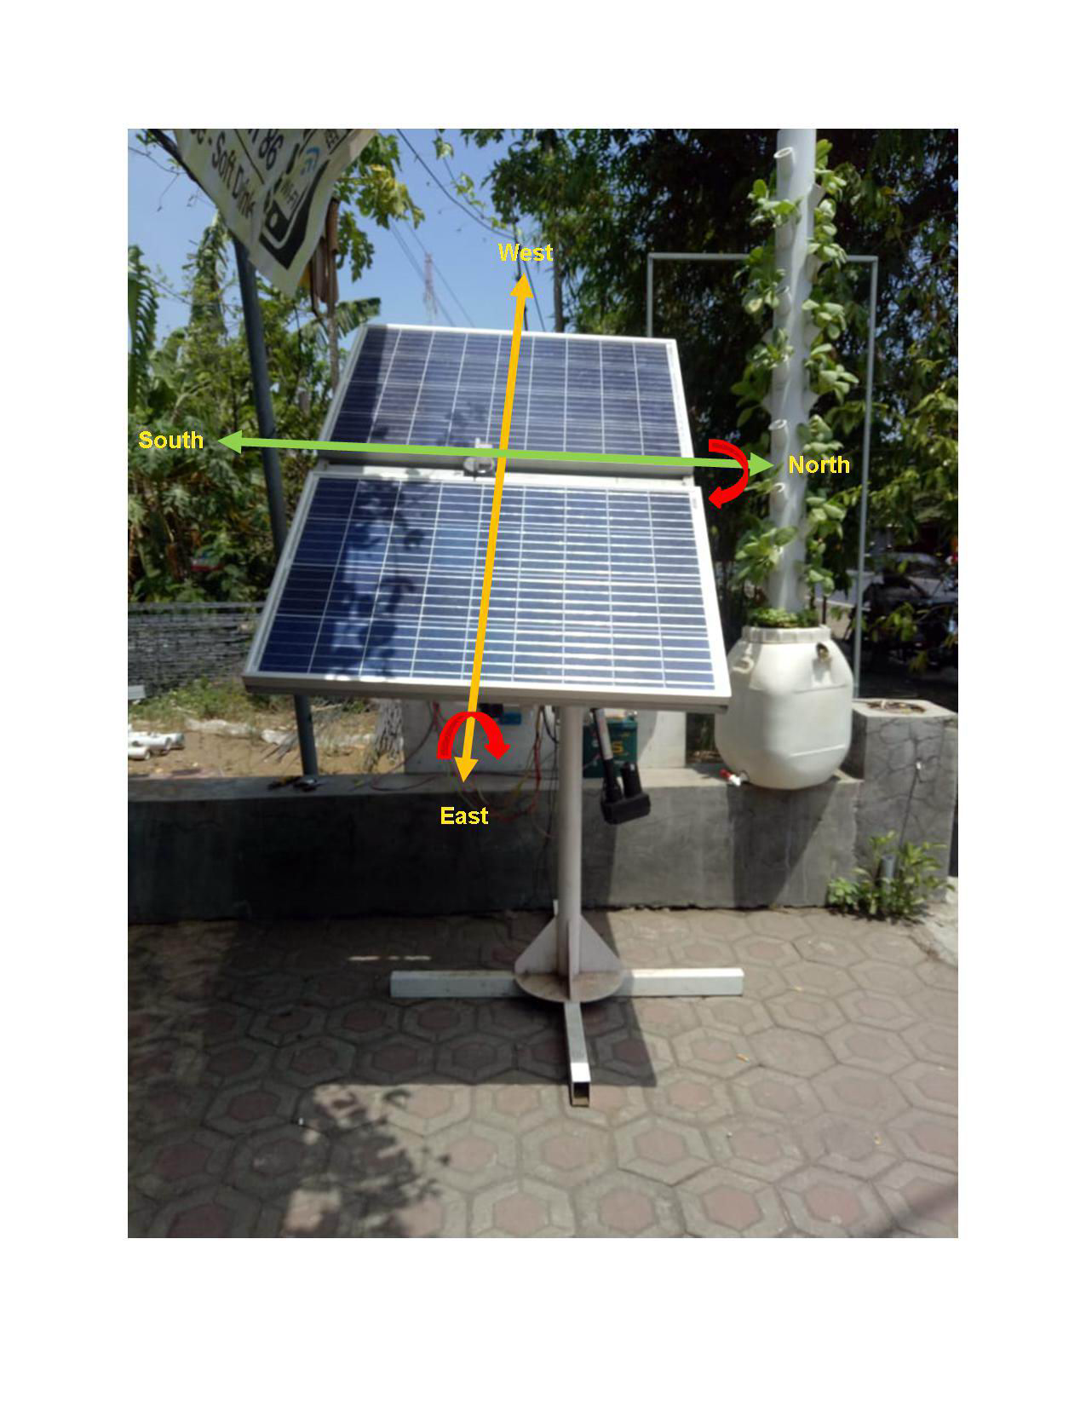

1. Dual-Axis Solar Tracking System[9]

$y=arc\cos{}\left\{\frac{\sin{δ\cos{φ-\cos{δ\sin{φ\operatorname{icos}{HRA }}}}}}{i\cos{a}}\right\}$ (1)

𝛼 = 𝑎𝑟𝑐isin (sin 𝛿 sin 𝜑i− cos 𝛿 cos 𝜑𝑐𝑜𝑠(𝐻𝑅𝐴)) (2)

**2.1.1. Horizontal Axis Solar Tracking System Model**

Equation 6 is the moment of inertia of the horizontal axis of rotation of the sun on the horizontal axis

$J_{1}=\frac{1}{2}m_{pv}L^{2}{(\frac{N_{2}}{N_{1}})}^{2}$ [ $kg.m^{2}]$ (3)

$J_{T1}=J_{st}+J_{1}$ [ $kg.m^{2}]$ (4)

$J_{T1}=2.71684x{10}^{-5}+J_{1}$ [ $kg.m^{2}]$ (5)

$\frac{(s)}{V(s)}i=\frac{K}{s(\left(JT1s+b\right)\left(Ls+R\right)+K^{2})}$ (6)

$\frac{(s)}{V(s)}i=\frac{0.0274}{6.375875{x10^{-9}s}^{3}+0.009274s^{2}+0.0007647308s}$ (7)

**2.1.2. Vertical Axis Solar Tracking System Model**

In equation 8 represents the moment of inertia of the vertical axis of rotation, equation 12 represents the moment of inertia of the vertical axis of rotation, and equation 15 represents the transfer function.

$J_{1}=\frac{1}{2}m_{pv}{(L}^{2}+W^{2}){(\frac{N_{2}}{N_{1}})}^{2}$ [ $kg.m^{2}]$ (8)

$J_{T2}=J_{st}+J_{2}$ [ $kg.m^{2}]$ (9)

$J_{T2}=2.71684x{10}^{-5}+J_{2}$ [ $kg.m^{2}]$ (10)

$\frac{(s)}{V(s)i}=\frac{K}{s(\left(JT2s+b\right)\left(Ls+R\right)+K^{2})}$ (11)

$\frac{(s)}{V(s)i}=\frac{0.0274}{6.126285{x10^{-8}s}^{3}+9.646175x10^{-6}s^{2}+0.00075076s}$ (12)

## **PID controller**

The PID controller has three controller parameters, namely Kp as a proportional constant, Ki as an integral constant, and Kd as a derivative constant. PID controllers are often used in system optimization because they are easy to set up and operate.[3][24].[2]

## **Capacitive Energy Storage (CES)**

CES is a component that can be used to release and store power (in the form of an electric field) simultaneously. CES consists of two parts, namely the Power Conversion System (PCS) and Storage Capacitors. [14].



1. Capacitive Energy Storage

The loss of leakage and dielectric bank capacitors at CES can be modeled by the resistance R which is connected in parallel with the capacitor. Storage capacitors are connected to the mesh through a 12-pulse Power Conversion System (PCS). PCS consists of rectifier to DC and DC to AC inverter. The thyristor bypass serves to provide a path for the current (Id) when the converter fails. The dc breaker allows the current Id to be diverted to the resistor point (R) of the resistor (Rd) if the converter fails. Apart from the drawbacks, the bridge voltage (Ed) is like an equation;

 (3)

 (4)

If the capacitor voltage is too low, more energy will be taken from the capacitor which can cause damage to the control. To overcome this problem, the lower limit for the voltage of the capacitor, taken 30% of the rating value (Ed). Therefore;

 (5)

The CES voltage must return to its initial value quickly. So that CES units are ready to work for the next load disturbance. The voltage deviation of the capacitor is used as a negative feedback signal in the CES control loop, so that fast voltage recovery is achieved.



1. CES Block diagram [4]

## **Ant Colony Optimization (ACO)**

The ACO algorithm is based on ant behavior. ACO provides the relevant data partition without the initial cluster center knowledge. Randomly moving ant agents. In the ACO algorithm, the grid consists of two dimensions that are randomly distributed. In the ACO algorithm, the grid size depends on the number of objects. Ant agent will pick up objects and drop by object similarity and density[25]. The standard ACO parameters used are shown in Table 1.

Table 1. ACOiParameters

|  |  |
| --- | --- |
| **ACO Parameters** | **Value** |
| Node | 100 |
| Max_It | 50 |
| Alpha*(α)* | 1 |
| Beta(β) | 2 |
| rho | 0.1 |
| c | 100 |
| Kph_aco, Kpv_aco | 0-300 |
| Kih_aco, Kiv_aco | 0-100 |
| Kdh_aco,Kdv_aco | 0-100 |

Max iterations are 50, constants alpha, beta, and rho with default values, Kp max is 300, ki max is 100, and k d max is 100.

# Results and Discussion

The declination of the sun is the angle between the equator and the line drawn from the center of the earth to the center of the sun. The sun's declination results in four seasons in the subtropical regions of both the northern and southern hemispheres.

The transfer function is made into the Matlab Simulink equation as follows can be seen in figure 4. The design uses several methods as comparison, PID auto, CES, PID-ACO, PID-CES, and PID-CES-ACO can be seen in Figure 5.

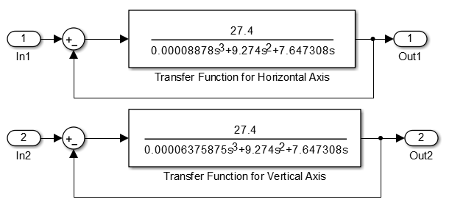

1. Design The transfer function for Dualiaxis simulation

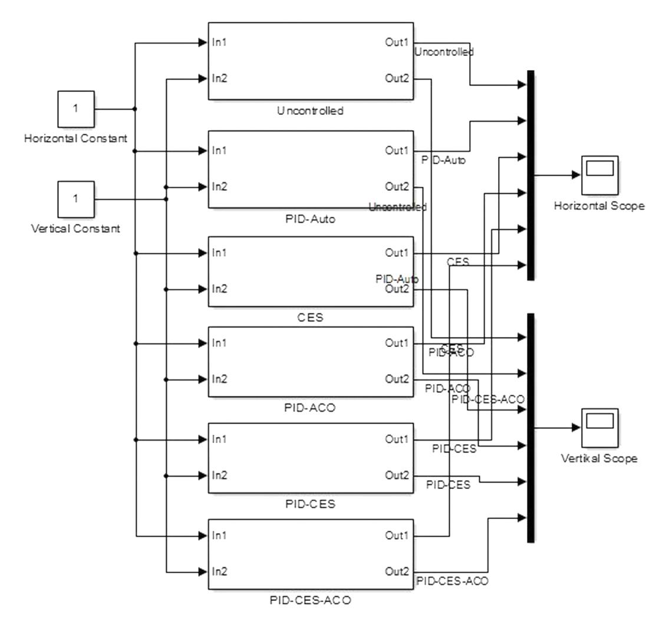

1. Design PID Controller for Dual axis simulation

The results of the horizontal axis response for PID auto, CES, PID-ACO, PID-CES, and PID-CES-ACO can be seen in Figures 6, 7, 8, and Table 2.



1. Horozontal Axis Respons



1. Overshot Horozontal Axis Respons



1. Undershot Horizontal Axis Respons

Table 2 :Horisontal Axis Results

|  |  |  |  |  |  |  |
| --- | --- | --- | --- | --- | --- | --- |
|  | **Unc** | **PID-Auto** | **CES** | **PID-ACO** | **PID-CES** | **PID-CES-**  **ACO** |
| **Overshoot (pu)** | 6.120 | 1.476 | 1.377 | 1.359 | 1.383 | 1.328 |
| **Undershoot (pu)** | 0.311 | 0.218 | 0.138 | 0.125 | 0.152 | 0.116 |
| **Settling time (s)** | 7.370 | 0.304 | 0.289 | 0.253 | 0.294 | 0.183 |

From table 2 shows that; the largest overshot on uncontrolled and the smallest overshot on PID-CES-ACO was 1,328 pu. The biggest undershot on uncontrolled and the smallest undershot on PID-CES-ACO was 0.116. longest settling time on uncontrolled and fastest on PID-CES-ACO was 0.183. This shows that the best model design was in PID-CES-ACO.

The results of the vertical axis response for PID auto, CES, PID-ACO, PID-CES, and PID-CES-ACO can be seen in Figures 9, 10, 11, and Table 3.



1. Vertical Axis Respons



1. Overshot Vertical Axis Respons

Figure 12 shows a comparison of overshot results on the vertical axis of the model design; PID-Auto, CES, PID-ACO, PID-CES, and PID-CES-ACO. It is shown that the most suitable result for reference (1) is the PID-CES-ACO model.



1. Undershot Vertical Axis Respons

Figure 13 shows a comparison of undershot results on the vertical axis of the model design; PID-Auto, Fuzzy Logic, CES, PID-ACO, and CES-ACO. It is shown that the most suitable result for reference (1) is the CES-ACO model.

Table 3. Vertical Axis Results

|  |  |  |  |  |  |  |
| --- | --- | --- | --- | --- | --- | --- |
|  | **Unc** | **PID-Auto** | **CES** | **PID-ACO** | **PID-CES** | **PID-CES-**  **ACO** |
| **Overshoot (pu)** | 7.342 | 1.473 | 1.362 | 1.348 | 1.411 | 1.246 |
| **Undershoot (pu)** | 0.214 | 0.208 | 0.147 | 0.143 | 0.152 | 0.044 |
| **Settling time (s)** | 5.844 | 0.264 | 0.275 | 0.231 | 0.252 | 0.163 |

From table 3 shows that; the largest overshot on uncontrolled and the smallest overshot on PID-CES-ACO was 1,246 pu. The biggest undershot on uncontrolled and the smallest undershot on PID-CES-ACO was 0.044. longest settling time on uncontrolled and fastest on PID-CES-ACO was 0.163 s. This shows that the best model design was in PID-CES-ACO.

# Conclusion

From the results of the horizontal axis simulation, it can be concluded that; the smallest overshot on the PID-CES-ACO was 1328 pu. the smallest undershot on PID-CES-ACO was 0.116 pu. fastest settling time on PID-CES-ACO was 0.183s . The results of the vertical axis simulation can be concluded that; the smallest overshot on the PID-CES-ACO was 1,246 pu. The smallest undershot on PID-CES-ACO was 0.044. The fastest settling time on PID-CES-ACO was 0.163 s. This shows that the best model design was the PID-CES-ACO.

# References

[1] M. Ali, H. Nurohmah, Budiman, J. Suharsono, H. Suyono, and M. A. Muslim, “Optimization on PID and ANFIS Controller on Dual Axis Tracking for Photovoltaic Based on Firefly Algorithm,” in *ICEEIE 2019 - International Conference on Electrical, Electronics and Information Engineering: Emerging Innovative Technology for Sustainable Future*, 2019, pp. 53–57.

[2] M. Ali, T. Fahmi, D. W. Khaidir, and H. Nurohmah, “Optimizing Single Axis Tracking for Bat Algorithm-based Solar Cell,” *J. FESPE*, vol. 2, no. 2, pp. 1–5, 2020.

[3] W. Cahyono, M. Ali, and H. Nurohmah, “Ant Colony Optimazation sebagai Tuning PID pada Single Axis Tracking Photovoltaic,” *Sinarfe7-2*, vol. 2, no. 1, pp. 455–458, 2019.

[4] M. Ali, M. R. Djalal, M. Fakhrurozi, Kadaryono, Budiman, and D. Ajiatmo, “Optimal Design Capacitive Energy Storage (CES) for Load Frequency Control in Micro Hydro Power Plant Using Flower Pollination Algorithm,” in *2018 Electrical Power, Electronics, Communications, Controls and Informatics Seminar, EECCIS 2018*, 2018, pp. 21–26.

[5] Kadaryono, Askan, Rukslin, A. Parwanti, M. Ali, and I. Cahyono, “Comparison of LFC optimization on micro-hydro using PID, CES, and SMES based firefly algorithm,” in *International Conference on Electrical Engineering, Computer Science and Informatics (EECSI)*, 2018, vol. 2018–Octob, pp. 204–209.

[6] A. M. S. Yunus and M. Saini, “Overview of SMES units application on smart grid systems,” in *Proceeding - 2016 International Seminar on Intelligent Technology and Its Application, ISITIA 2016: Recent Trends in Intelligent Computational Technologies for Sustainable Energy*, 2017, pp. 465–470.

[7] M. Ali, Budiman, A. R. Sujatmika, and A. A. Firdaus, “Optimization of controller frequency in wind-turbine based on hybrid PSO-ANFIS,” *IOP Conf. Ser. Mater. Sci. Eng.*, vol. 1034, no. 1, p. 12070, 2021.

[8] M. Arrohman, R. Fajardika, M. Muhlasin, and M. Ali, “Optimasi Frekuensi Kontrol pada Sistem Hybrid Wind-Diesel Menggunakan PID Kontroler Berbasis ACO dan MFA,” *J. Rekayasa Mesin*, vol. 9, no. 1, pp. 65–68, 2018.

[9] Muhlasin, Budiman, M. Ali, A. Parwanti, A. A. Firdaus, and Iswinarti, “Optimization of Water Level Control Systems Using ANFIS and Fuzzy-PID Model,” in *2020 Third International Conference on Vocational Education and Electrical Engineering (ICVEE)*, 2020, pp. 1–5.

[10] M. Ali, Muhlasin, H. Nurohmah, A. Raikhani, H. Sopian, and N. Sutantra, “Combined ANFIS method with FA, PSO, and ICA as Steering Control Optimization on Electric Car,” in *2018 Electrical Power, Electronics, Communications, Controls and Informatics Seminar, EECCIS 2018*, 2018, pp. 299–304.

[11] M. Ali, F. Hunaini, I. Robandi, and N. Sutantra, “Optimization of active steering control on vehicle with steer by wire system using Imperialist Competitive Algorithm (ICA),” in *2015 3rd International Conference on Information and Communication Technology, ICoICT 2015*, 2015, pp. 500–503.

[12] R. Firmansyah, M. Ali, D. Ajiatmo, A. Raikhani, and M. Siswanto, “Optimization of AVR in Micro-hydro Power Plant Using Differential Evolution (DE) Method,” *J. FESPE; Front. Energy Syst. Power Eng. Front. Energy Syst. Power Eng.*, vol. 2, no. 1, pp. 1–6, 2020.

[13] M. Ali, H. Nurohmah, Budiman, H. Suyono, M. A. Muslim, Y. M. Safarudin, and A. A. Firdaus, “Determining firefly ideal parameter for tuning Kp, Ki, And Kd parameter in photovoltaic application,” *IOP Conf. Ser. Mater. Sci. Eng.*, vol. 1034, no. 1, p. 12078, 2021.

[14] M. Dripoyono, Henrdo; Candra, Dwi, Septa; Ajiatmo, Dwi;, Budiman, Budiman; Ali, “Penggunaan ACO dan FA Dalam Mengoptimalkanasikan Kontroler PID Untuk Shading Parsial pada Photovoltaic,” *SinarFe7*, vol. 1, no. 1, pp. 35–39, 2018.

[15] M. Ali, A. Raikhani, B. Budiman, and H. Sopian, “Algoritma Persaingan Imperialis Sebagai Optimasi Kontroler PID dan ANFIS Pada Mesin Sinkron Magnet Permanen (Imperialist Competitive Algorithm As PID Optimization and ANFIS Controller at Permanent Magnet Synchronous Machine),” *JEEE-U (Journal Electr. Electron. Eng.*, vol. 3, no. 1, p. 57, 2019.

[16] M. Ibrahim, D. Ramadhan, and M. Ali, “Optimasi Kontroler Putaran Motor Permanent Magnet Syschronous Machine ( PMSM ) menggunakan PSO-ANFIS ( Studi Kasus di Perumdam Tirta Kencana ),” *Jurna; El-Sains*, vol. 2, 2020.

[17] D. Ajiatmo and I. Robandi, “Modeling and simulation performance of photovoltaic system integration battery and supercapacitor paralellization of MPPT prototipe for solar vehicle,” 2017, vol. 1818, p. 20076.

[18] D. Ajiatmo and I. Robandi, “A Hybrid fuzzy logic controller-firefly algorithm (FLC-FA) based for MPPT photovoltaic (PV) system in solar car,” in *2016 IEEE International Conference on Power and Renewable Energy, ICPRE 2016*, 2017, pp. 606–610.

[19] S. Aksungur and T. Koca, “Solar tracking system with PID control of solar energy panels using servo motor,” *Int. J. Energy Appl. Technol.*, pp. 127–130, 2018.

[20] P. K. B, S. Jonnalagadda, M. Srihari, and H. Bonothu, “DUAL-AXIS SOLAR TRACKER,” *Int. J. Recent Sci. Res.*, vol. 8, no. 2, pp. 15598–15603, 2017.

[21] A. Barbón, J. A. Fernández-Rubiera, L. Martínez-Valledor, A. Pérez-Fernández, and L. Bayón, “Design and construction of a solar tracking system for small-scale linear Fresnel reflector with three movements,” *Appl. Energy*, vol. 285, 2021.

[22] N. Sharma and B. Sharma, “An Analysis of Automatic Dual Axis Sun Tracking Solar System,” *Int. J. Innov. Res. Electr. Electron. Instrum. Control Enginering*, vol. 4, no. December, pp. 45–47, 2016.

[23] S. Shaher-Soulayman, “Solar Azimuth Angle in the Tropical Zone,” *J. Sol. Energy Res. Updat.*, vol. 4, no. 1, pp. 1–8, 2017.

[24] M. A. Y. Alghifrani, H. Nurohmah, D. Ajiatmo, and M. Ali, “Bat Algorithm Sebagai Optimasi PID Controller Pada Turbin Angin,” *Sinarfe7-2*, vol. 2, no. 1, pp. 447–451, 2019.

[25] M. Dorigo and T. Stützle, “The Ant Colony Optimization Metaheuristic,” in *Ant Colony Optimization*, 2018.