Monitoring System of Temperature and Body Weight for Baby Incubator Design Using BASCOM-AVR

Manggar Sari a,1,*, Dewi Cahya Febrina a,2, Singgi Anggi Dwi b,3

a University of Bhayangkara Surabaya, Jl. Ahmad Yani 114, Surabaya - 60231, Indonesia

1 dewifebrina@ubhara.ac.id*

|  |  |  |  |
| --- | --- | --- | --- |
|  |  | ABSTRACT |  |
| **Keywords**  Baby Incubator Design  Monitoring System  Microcontroller  BASCOM-AVR |  | Baby incubator is a tool for maintaining the warmth of the baby after birth so they are able to adapt with external environment. The main feature of incubator is setup room temperature for maintaining baby’s temperature to avoid hypothermia. However, for premature babies it is not only strict temperature regulation, but also many procedures, such as monitoring their body weight regularly as the indicators to determine the development of baby’s health. Baby incubator with temperature and baby weight control system is needed to make it easier for paramedics to monitoring the baby’s progress while in the incubator. System design of incubator is designed with the room temperature controller ON-OFF system in the range of 30oC – 35oC and wight scale system in the range of 0 kg – 5 kg. Incubator box will be installed using blower 12VDC and heater driver. Temperature and weight controller system is designed using BASCOM-AVR software. This research is hoped that this simple incubator design can be applied to small-scale baby health centers, such as baby clinics and community health centers. |  |
|  |  |

# Introduction

Low birth weight of baby is a problem in the world because they cause morbidity and death during the newborn period. So that, the baby must be placed in an incubator to help maintain its normal body temperature. Detailed monitoring of the incubator temperature is required to monitor the stabilization of the temperature received by the baby and the baby's body weight as a reference for setting the incubator temperature.

The lack of availability of incubators in birthing clinics or community health centers is due to the unaffordable price of high-tech incubators and problems with distribution to remote areas in Indonesia causing a decline in the quality of services in caring for newborns. One of the problems that might be said to determine the Infant Mortality Rate is the economic problems of the patient's family. Therefore, it is necessary to realize the existence of incubators at affordable prices (without reducing the appropriate aspects) by adapting several technological advantages from foreign-made incubators, so that these incubators can be used by all groups and are expected to help reduce the Infant Mortality Rate in Indonesia.

In this research, the design of a simple baby incubator with a temperature and weight monitoring system with electrical power and investment costs is not too large, so that it can be realized in birth clinics or health centers. The incubator box in this research was designed with a 12VDC blower, a heater as a temperature controller for the incubator, and used BASCOM-AVR software.

# The Proposed Method

## **Baby Incubator**

Baby incubator is a tool used to care for premature babies or babies with low birth weight by providing stable temperature and humidity and oxygen requirements according to the conditions in the mother's womb. The baby incubator lowers the temperature slowly so that the baby feels comfortable. The temperature in the incubator is lowered slowly.

The use of a baby incubator must comply with specified rules, including cleaning it regularly, emptying the water in the reservoir, setting the incubator temperature according to the baby's weight and age. This is done to maintain the baby's immune system, as well as to avoid the appearance of bacteria in the baby's body. Temperature in incubator has a system setting that is adjusted as the baby’s age and their weight, such as table below:

Table 2.1 System Setting of Incubator Temperature

|  |  |  |
| --- | --- | --- |
| **Weight of baby** | **Age of Baby** | **Incubator Temperature** |
| < 1,5 Kg | 1 – 10 days | 35⁰C |
| 11 days – 3 weeks | 34⁰C |
| > 5 weeks | 32⁰C |
| 1,5 – 2 Kg | 1 – 10 days | 34⁰C |
| 11 days – 4 weeks | 33⁰C |
| > 4 weeks | 32⁰C |
| 2,1 – 2,5 Kg | 1 – 2 days | 34⁰C |
| 3 days 3 weeks | 33⁰C |
| > 3 weeks | 32⁰C |

## **ATMEGA-16 Microcontroller**

ATMEGA 16 is an 8-bit CMOS microcontroller which has 32 general-purpose registers, timer/counter with compare method, external and internal interrupts, serial UART, programmable Watchdog Timer, ADC and internal PWM. one of the AVR products that has high speed, with low power. The ATMEGA 16 microcontroller has 32 I/O channels, namely port A, port B, port C, and port D. The CPU consists of 32 registers.

## **LM-35 Temperature Sensor**

The LM35 temperature sensor is a simple sensor shaped like a transistor with three legs and each leg functions as input and output, these legs function as VCC – OUPUT – GND. The LM35 sensor works by converting temperature quantities into voltage quantities

The ideal voltage coming out of the LM35 has a ratio of 100°C which is equivalent to 1 volt. This sensor has self-heating of less than 0.1°C, can be operated using a single power supply and can be interfaced to a control circuit very easily.

## **Heater**

Heater is an electric heating element that is widely used in everyday life, or in industrial machine equipment. The working principle of a heater is that if current flows through an element with high resistance, the flow acting on this element will produce heat. If the current is off, the element slowly cools. The shape and type of heater are adjusted to the function, installation location and media to be heated. The heat produced by the heater comes from a wire or high resistance wire (Resistance Wire) which carries an electric current at both ends and is coated with an electrical insulator which is able to transmit heat well.

## **Software BASCOM-AVR**

BASCOM is a programming language that is classified as high-level programming. This programming language is easy, fast and reliable, compared to C, C++. This programming language is often used for microcontroller programming, using a compiler that supports this type of programming language. BASCOM-AVR provides options that can simulate programs. This simulation program aims to test an application that is created by moving the LED on the simulation screen and can also be seen directly on the LCD, if you create an application related to the LCD.

# Method

## **Hardware Design**

Hardware design is needed so that it can work according to the program that will be created later, there needs to be compatibility so that errors do not occur in the hardware. The hardware design block diagram can be seen in Figure 3.1 below

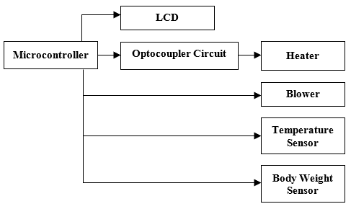

Figure 3.1 Blok Diagram of Hardware Design

## **Mechanical Design**

The mechanical design for making an incubator consists of a baby box and a box for placing electronic components made from acrylic material with a thickness of 5mm. The size of this box is 80cm x 50cm x 50cm. The front of the box has 2 holes with a diameter of 12 cm whose function is to move the baby's position. Meanwhile, two small holes on the right and left sides with a diameter of 3 cm are used as air circulation holes in the incubator.

## .

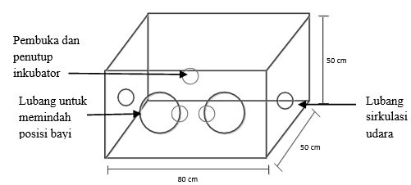

Incubator opening and closing

Hole gap for shifting the baby

Hole gap for air circulation

Figure 3.2 Incubator Box Design



Figure 3.3 Incubator Box Interior Design

## **Power Supply Design**

Power supply is hardware that functions to supply voltage directly to components that require voltage, for example motherboards, hard disks, fans, etc. The power supply used in making this tool is made into 2 output voltages, namely 12V and 5V. The 12V output voltage is used for fans, heaters. Meanwhile, the 5V output voltage is used for the ATMega16 microcontroller, LCD, LM35 temperature sensor, weight sensor. The following is a schematic image and realization of the power supply circuit shown in Figure 3.4, and Figure 3.5 below:

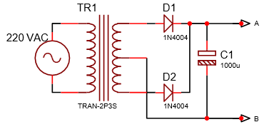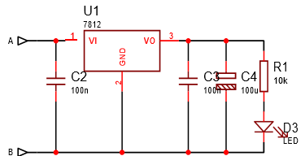

Figure 3.4 Transformer Circuit and

Figure 3.5 Voltage Regulator Circuit

## **Temperature Sensor Design**

The temperature sensor used in making this tool is the LM35 temperature sensor. The LM35 sensor produces an output in the form of voltage. This LM35 sensor has an output voltage of 10mV/ °C, so that the voltage can be read, the LM35 sensor is connected to the ADC circuit on the microcontroller. So, for every 10mV increase, the temperature increases by 1°C.

When making the LM35 temperature sensor, the input leg is connected to port A.0 of the microcontroller, while the other 2 legs are connected to ground and a voltage of 5V from the microcontroller. LM35 circuit is shown in Figure 3.6

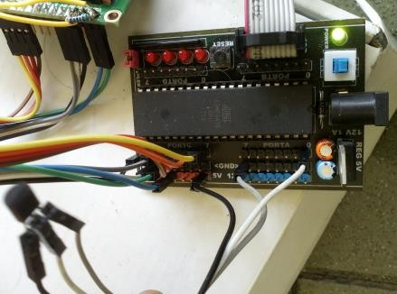

Figure 3.6 Realization of Temperature Sensor using LM35

## **Incubator Scale Design**

In designing the scale, it does not use a load cell or Force Resistor Sensor (FSR) but uses a sliding potentiometer. A sliding potentiometer is a type of variable resistor whose resistance value can be changed by moving the sliding knob on the potentiator. The way it works is to apply force to the scale springs by placing a weight on the scale. This force causes a shift in the variable resistor to produce electricity that is easy for the microcontroller to read

* 1. **Optocoupler Design**

Optocoupler is a component built from an opto transmitter and opto receiver which is used to couple a signal so that the control part and the controlled part are not connected directly or electrically so that if there is damage to the controlled part it does not cause damage to the control part. The use of an optocoupler depends on your needs. The optocoupler used in making this incubator uses a MOC 3020 type optocoupler. Schematic of the optocoupler circuit can be seen in Figure 3.7

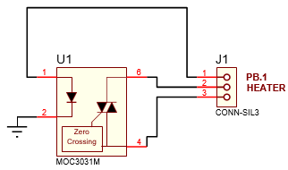

Figure 3.7 Optocoupler Circuit

* 1. **Driver Design**

This fan driver circuit is used to push hot air from the heating element (heater) in the incubator room towards the exit. This circuit uses a 12 Volt DC source. Figure 3.8 shows a schematic image of a 12 Volt DC fan driver circuit. Figure 3.8 shows a realized image of the DC fan driver circuit that has been created. The fan driver will turn on at the same time the heater is active, so that the hot air produced by the heater will be pushed out by the fan.

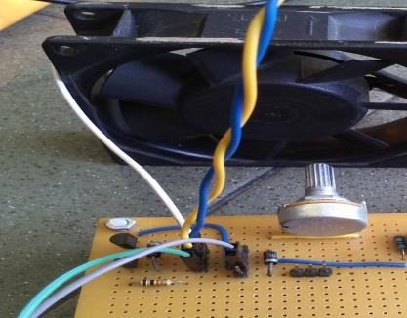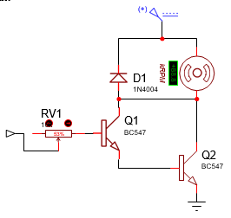

(b)

(a)

Figure 3.8 (a) Fan Driver Circuit and (b) Realization of Fan Driver

* 1. **Heater Design**

The heater circuit or heater driver uses the MOC 3020 Opto-isolator as a line voltage separator from the microcontroller. The MOC 3020 is controlled by Port D of the ATMEGA16, while the Triac controls the on-off of the heating element.

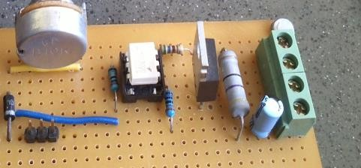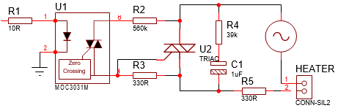

(a)

(b)

Figure 3.9 (a) Incubator Heater Circuit and (b) Realization of Heater

**3.10. Software Design**

This part of the design functions to control the entire system of the tool. This software contains a program which will be stored in the microcontroller, so that the microcontroller carries out its commands automatically according to the program sequence created. To support this design the author used BASCOM-AVR IDE software [1.11.9.5] with the language used, namely BASIC. The following is an image of the program flow chart for running the system from the tool.

The program begins with start. What is meant by start here is when the on button on the device is activated. Then proceed with the initialization of the ADC and LCD, the condition that is read during initialization is that the room temperature shows a temperature of 32oC, so that the LCD will display a temperature of 32oC. Next is the process of reading ADC0 and ADC1, ADC0 is for body weight, while ADC1 is for temperature. Some of readable conditions are as follows:

* If ADC0 reads of < 1.5 kg then ADC1's condition is 35oC
* If ADC1 reads of 35oC then heater and blower 1 are OFF and blower 2 is ON, if not then heater and blower 1 are ON and blower 2 is OFF
* If ADC1 reads of 33oC then the heater and blower 1 are OFF and the blower 2 is ON, if not then the heater and blower 1 are ON and the blower 2 is OFF
* If the ADC0 reading is not of <1.5 kg and not >2.5 kg then the condition of ADC1 is 34oC
* If ADC1 reads of 34oC then the heater and blower 1 are OFF and the blower 2 is ON, if not then the heater and blower are 1 ON and the blower 2 is OFF

# Results and Analysis

## **Power Supply Testing and Analysis**

The Power supply circuit used to provide a DC output voltage of 12V and 5V. This testing was carried out using 2 analog AVO meters and digital as a comparison of the measured voltage values. Measurements were carried out at several measuring test points on the power supply. Testing on the power supply produces data as shown in Table 4.1 and Table 4.2 below:

Table 4.1 Power Supply Test Result

|  |  |  |  |  |  |
| --- | --- | --- | --- | --- | --- |
| **Point of Test** | **Test Result** | | **Point of Test** | **Test Result** | |
| **I** | **II** | **I** | **II** |
| TP1 | 14,6VAC | 14,9VAC | TP4 | 19,4 VDC | 19,5 VDC |
| TP2 | 11,7VAC | 14,9VAC | TP5 | 12,2 VDC | 11,9 VDC |
| TP3 | 30VAC | 30VAC | TP6 | 4,96 VDC | 4,95 VDC |

From the data above, shows that if measurements using different instruments, the measurement results will also be different because it has different resistances. Measurements on TP1 and TP2 show that the results are not the same as the values ​​stated on the transformer. Measurements at TP3 show the results of adding TP1 to TP2 and the result is 30VAC. Measurements on TP4 approaching 20VDC, the measuring instrument error is only 0.5 VDC. Measurements at TP5, the expected result is 12VDC using measuring instrument I, the result exceeds 12 VDC, but using measuring instrument II the result is below 12 VDC. The measurement results at TP6 are close to 5VDC.

## **LM35 Temperature Sensor Testing and Analysis**

The LM35 temperature sensor plays a role in monitoring conditions temperature in the incubator. Whit an accuracy level of 0,5oC. Table 4.2 shows the comparison of LM35 and AVO temperature.

Table 4.2 Comparison Test Result of LM35 and AVO Temperature

|  |  |  |  |
| --- | --- | --- | --- |
| **Range** | **LM35 Temperature** | **AVO Temperature** | **LM35 Voltage** |
| 1 cm | 46oC | 50oC | 0,46 |
| 2 cm | 43oC | 50oC | 0,43 |
| 3 cm | 43oC | 48oC | 0,43 |
| 4 cm | 42oC | 48oC | 0,42 |
| 5 cm | 41oC | 46oC | 0,41 |

From the Table 4.2, shows that the level of accuracy LM35 temperature error is very large when compared with temperature measurement using AVO thermometer and the measurements at the LM35 leg voltage corresponds to the temperature read by the LM35.

* 1. **DC Fan Testing and Analysis**

This fan testing is using 12 Volt DC. This fan functions as a blower in the incubator. Potentiometer output adjusted until shows the value of 5V, 8V, 10V, and 12V using power supply that adjusted for 12V. Test result data of DC fan show that the fan is operated from 8V – 12V. The data of test result is shown in Table 4.3 below:

Table 4.3 Test Result Data of DC Fan

|  |  |
| --- | --- |
| **Output Voltage of**  **Power Supply** | **Fan Operation** |
| 5V | Not Active |
| 8V | Active |
| 10V | Active |
| 12V | Active |

* 1. **Scales Testing and Analysis**

Potentiometer acts as a weight sensor to monitor the baby's weight in the incubator. The weight sensor test is carried out by measuring the resistance on the sliding potentiometer when a load is applied. Weight measurements based on body weight scales compared to resistance on the potentiometer can be seen in Table 4.4

Tabel 4.4 Result Data of Scales

|  |  |
| --- | --- |
| **Weight** | **Potentiometer Resistance** |
| 0.3 kg | 0Ω |
| 0.5 kg | 1.6Ω |
| 1 kg | 2.3Ω |
| 1.5 kg | 3Ω |
| 2 kg | 4.5Ω |
| 2.5 kg | 5.2Ω |
| 3 kg | 6.1Ω |

##### **Tools Testing of Incubator**

Testing the tool as a whole is by observing the program when the incubator is turned on and given a load according to the program settings made and connecting the controls and mechanics. The following is the overall equipment testing data listed in Table 4.7 below.

Table 4.3 Test Result Data of DC Fan

|  |  |  |
| --- | --- | --- |
| **Weight (Kg)** | **LM35 Temp. on LCD (oC)** | **Weight on LCD (grams)** |
| 0 | 32 | 0 |
| 1 | 35 | 1000 |
| 1,5 | 35 | 1600 |
| 2 | 34 | 2000 |
| 2,5 | 33 | 2500 |
| 3 | 33 | 3000 |

From the data in Table 4.7, it shows that the display of weight on the LCD is displayed in grams, not kg. The room temperature without weight shows a temperature of 32oC. Baby weight <1.5 kg was tested with a weight of 1 kg and 1.5 kg showed a temperature of 35oC. The reading for a weight of 1.5 kg on the LCD is displayed as 1600 grams, it should be 1500 grams. Figure 4.4 shows a weight >2.5 kg tested with a maximum weight of 3 kg showing a temperature of 33oC and Figure 4.3 shows a weight between 1.5 kg and 2.5 kg shown with a weight of 2 kg showing a temperature of 34oC.

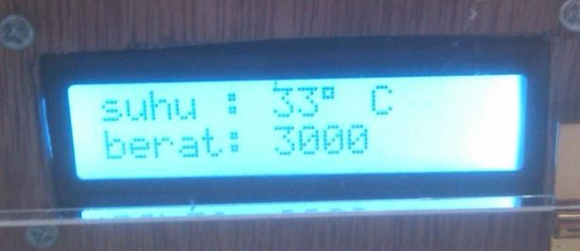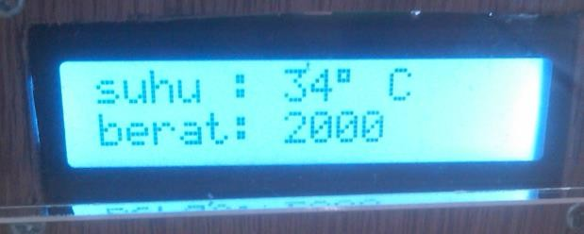

Figure 4.1 Display of Weight and Temperature on LCD

##### **5. Conclusion**

Determine the temperature between 33oC to 35oC at incubator based on baby's weight between <1.5 kg up to >2.5 kg. So, the tool will automatically deliver temperature appropriate to the baby's weight put in an incubator.

Based on tool testing that has been carried out, that room temperature in a baby incubator with a sensor the LM35 temperature has been reached according to the weight condition <1.5kg then the room temperature is 350C. If the weight is >2.5kg then the room temperature is 330C. At 1.5 kg weight < 2.5 kg then the room temperature is 340C. Although there are slight temperature difference with the measuring device temperature.

##### **References**

1. G. Eason, B. Noble, and I.N. Sneddon, “On certain integrals of Lipschitz-Hankel type involving products of Bessel functions,” Phil. Trans. Roy. Soc. London, vol. A247, pp. 529-551, April 1955. (*references*)
2. J. Clerk Maxwell, A Treatise on Electricity and Magnetism, 3rd ed., vol. 2. Oxford: Clarendon, 1892, pp.68-73.
3. I.S.