AuditRaya Mobile Information System (Siramo) at Kspps Raya Banda Madani Using Cobit 5

Siti Nur Salehah a,1,*, Sigit Auliana b,2, Eris Dwi Purnama b,3

a,b,c Universitas Bina Bangsa, JL Raya Serang - Jakarta, KM. 03 No. 1B, Panancangan, Kec. Cipocok Jaya, Kota Serang, Banten 42124, Kota Serang 42124, Indonesia

1 *sitinursolehahh060@gmail.com; 2 sigit.auliana@binabangsa.ac.id; 3 eris.dwi.purnama@binabangsa.ac.id

* corresponding author

|  |  |  |  |
| --- | --- | --- | --- |
|  |  | ABSTRACT |  |
| **Keywords**  Information System Audit  COBIT 5  Data Security  System Reliability  KSPPS  Mobile Information System |  | The use of information technology at KSPPS RAYA BANDA MADANI, particularly through the Raya Mobile Information System (SIRAMO), is essential to support operations and member services. However, a thorough audit is required to ensure the security, reliability and compliance of the system to IT governance standards such as COBIT 5. This research aims to assess these aspects through an audit using COBIT 5, as well as provide recommendations for improvement.This research uses a case study method with a qualitative approach. Data was collected through interviews, questionnaires, observation, and document analysis. The results showed weaknesses in data security, information accuracy, and compliance with COBIT 5 standards, although SIRAMO supports mobile operations effectively. Recommendations for improvement include enhancing security controls, validating data, and developing more effective monitoring mechanisms. The result of this study is that audits using COBIT 5 can identify areas that need improvement to enhance the performance and security of SIRAMO at KSPPS RAYA BANDA MADANI, as well as improve operational efficiency and member satisfaction. |  |
|  |  |

# Introduction

Sharia Savings and Loan and Financing Cooperative (KSPPS) RAYA BANDA MADANI is one of the financial institutions that utilise information technology to improve operational efficiency and services to its members. The Raya Mobile Information System (SIRAMO) is a mobile application developed to facilitate members in accessing financial services online. However, with the increasing use of this technology comes the challenge of ensuring the security, reliability and effectiveness of the information system. Therefore, an information system audit is needed to evaluate and improve the quality of the existing system, using a proven framework such as COBIT 5 [1]. This information system audit will later make the COBIT 5 Framework as a reference. Because COBIT 5 itself is the latest standard for auditing for COBIT, the author chose COBIT 5 because COBIT 5 is audit material that has been studied for 2 semesters, therefore the knowledge to discuss COBIT 5 is more available than other information system audit standards. The definition of COBIT 5 itself is a framework or framework that provides services to enterprises, be it a company, organisation, or government in managing and managing IT assets or resources to achieve the goals of the enterprise The methodological approach used in this research is an information systems audit based on the COBIT 5 framework. COBIT 5 provides comprehensive guidance for IT governance and management, covering all aspects from strategic planning to implementation and management monitoring of information systems [2]. This methodology is appropriate because it provides a structured and widely accepted framework in the industry for evaluating and improving the effectiveness of information systems.

KSPPS RAYA BANDA MADANI is a sharia-based financial institution. This institution serves the financial needs of its members through various products and services that are in accordance with sharia principles. One of the innovations implemented by this KSPPS is the development of the SIRAMO mobile application, which allows members to conduct transactions and obtain financial information in real time through mobile devices. With this innovation, KSPPS RAYA BANDA MADANI is an interesting object for information systems audit research[3].

The results of this study are expected to provide valuable recommendations for KSPPS RAYA BANDA MADANI in improving the quality and security of the SIRAMO application. In addition, this research can be a reference for other financial institutions that want to adopt or improve their mobile information systems. Academically, this research can add to the literature regarding the application of COBIT 5 in auditing information systems in the Islamic financial environment in Indonesia [4]. The title "Audit of Raya Mobile Information System (SIRAMO) at KSPPS RAYA BANDA MADANI Using COBIT 5" was chosen because it reflects the main focus of the research, which is to conduct an in-depth evaluation of the mobile information system used by KSPPS. The use of COBIT 5 as an audit framework indicates a structured and international standards-based approach, which is expected to produce accurate and useful findings and recommendations. This title also emphasizes the relevance of the research to the field of information systems auditing studies which is the author's concentration[5].

The system that emphasizes the procedure is defined by Jerry Fitz Gerald. According to him, the system can be defined as a network of work consisting of interconnected procedures, then gathered together to carry out or complete activities and achieve a certain goal According to Azhar Susanto (2002: 18) that, "The system is a collection or group of sub-systems or parts or components of anything both physical and non-physical that are interconnected with each other and work together harmoniously to achieve certain goals According to Abdul Kadir (2003) in his book entitled Introduction to Information Systems, namely: "An information system is a framework that coordinates resources (humans, computers) to convert inputs (inputs)[6].

According to Ageng et al in the CCIT Journal (2015: 134-146), "The system is a network of interconnected procedures gathered together to carry out an activity or to complete an activity or to complete a specific goal or purpose." Information system is a framework in which resources (humans, computers) are coordinated to convert input data into output information in order to achieve company goals." (Wilkinson. And C.Kneer, 1993. Page 2) Definition of the system according to Marshall B. Romney and Paul John Steinbart in his book entitled Accounting Information Systems reveal "The system (system) is a series of two or more components that are interrelated and interact to achieve goals. From the definitions above, the system can be concluded as a network of procedures or components that are interconnected and work together harmoniously to achieve certain goals. This system can consist of physical and non-physical sub-systems, and often coordinates resources, both human and computer, to convert inputs into outputs in the form of information to achieve predetermined goals. According to Jogiyanto Hartono, systems have two main characteristics[7]

Complexity: A system is a collection of elements or components that interact with each other to achieve a specific goal. This complexity describes how the components are interconnected and function in an integrated manner. Interaction: The components of the system interact with each other to support the functioning and purpose of the system. This interaction ensures that changes to one component will affect other components and the entire system According to Tata Sutabri, systems have two main characteristics: Goals and Objectives: Every system has goals and objectives to achieve. These goals provide a clear direction and function for all components in the system. Openness: The system has an openness that allows interaction with the external environment. This openness allows the system to receive input from outside and produce outputs that interact with its environment. The conclusion of the two system characteristics put forward by Jogiyanto Hartono and Tata Sutabri shows a complementary view in understanding the nature and dynamics of the system. Jogiyanto Hartono emphasizes complexity and interaction between components as the key to understanding the system as an integrated unit. While Tata Sutabri highlights the purpose and openness of the system, which describes how the system functions to achieve certain goals and interact with its environment[8].

# Method

## The research approach used is descriptive qualitative. This research aims to describe systematically, factually, and accurately about the facts and nature of certain objects, namely the Raya Mobile (Siramo) information system at KSPPS RAYA BANDA MADANI. UML (Use Case Diagram) of the Running System The following is a use case diagram of the running system:

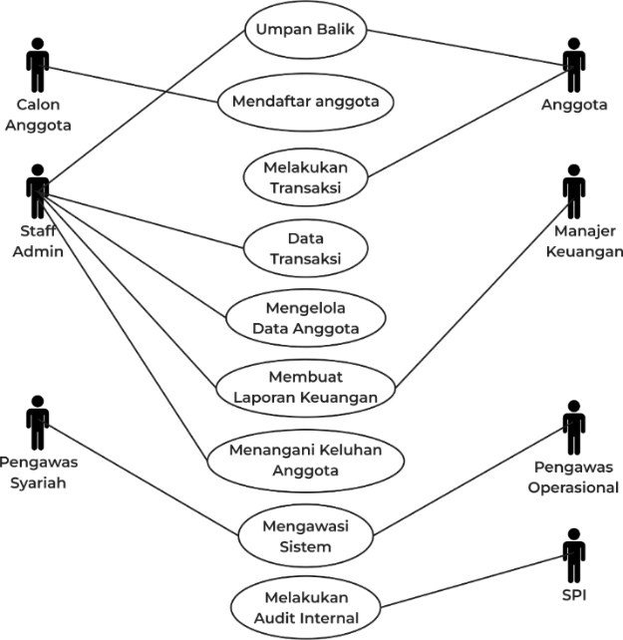

**Fig.1**. UML (Use Case Diagram) Running System

**2.1 UML Description**

1. Member Registration: Prospective members fill out the registration form and the data is verified by the admin staff.
2. Making Transactions: Members make deposits or withdrawals, and transactions are recorded by admin staff.
3. Managing Member Data: Member data is updated and managed by admin staff.
4. Generating Financial Reports: The admin staff and finance manager create and evaluate monthly and annual financial reports.
5. Supervising the System: Supervision is carried out by operational and sharia supervisors to ensure compliance with SOPs and sharia principles.
6. Conduct Internal Audits: SPI conducts internal audits to identify areas of improvement and ensure compliance with standards.
7. Handling Member Complaints: Member grievances are logged and resolved by admin staff, with resolution action taken by the relevant manager.
8. Providing Feedback: Members are given feedback on the resolution of their grievances by admin staff.

**2.2 Activity Diagram of Member Registration and Financial Transactions The following is an activity diagram of the member registration procedure that runs**

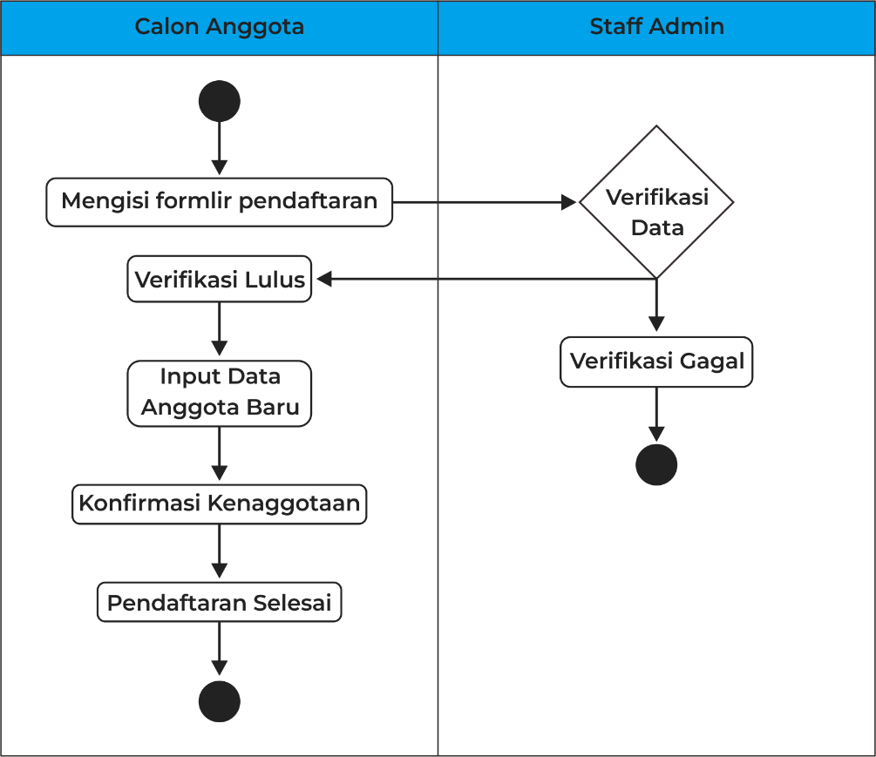

**Fig.2**. Member Registration

Member Registration

1. Prospective Members Fill in the Registration Form: Prospective members fill out the registration form with personal data.
2. Admin Staff Verify Registration Data: Admin staff verifies the data that has been filled in by prospective members.
3. Verification Passed: If the verification passes, the admin staff inputs the new member data into the system.
4. Verification Failed: If the verification fails, the registration process is stopped.
5. Membership Confirmation: After the new member data is inputted, the admin staff confirms the membership.
6. Enrollment Completed: The registration process is complete.

# Results and Discussion

## COBIT 5 is a framework that can be applied to all parts of the company to maximize its value to the company. The framework takes governance and risk management of the company as a whole, not just focusing on IT. COBIT 5 is an integrated framework that covers all divisions, employees and teams within the company[9]. COBIT combines the needs and processes of organizations and IT management with corporate governance. This integrated framework helps identify potential threats to the company and improve processes so that operations run more efficiently. Its ability to meet the needs of stakeholders. As we know, stakeholder needs are always a company priority. Because, this goal is only successful if all stakeholder needs are met.Stakeholders have certain requirements that are regulated in the COBIT 5 framework by properly managing all IT operations throughout the company[10]. This will directly impact customer satisfaction as one of the goals of the business itself. The responsibility of governance of all applications and systems should be transferred from the management team to the IT operations team. This is because they are the ones best equipped to manage them. If IT governance and corporate governance are combined with the help of COBIT 5, and the whole process becomes much easier and simpler. COBIT 5 is more than just an IT department for a company. The framework provides an integrated and holistic approach to improving operational processes to maximize efficiency. When a company implements the COBIT 5 framework in their organization, teams can focus on being more productive and producing outputs that are valuable to customers[11].

## COBIT 5 has 5 process domains namely DSS, MEA, BAI, EDM and APO. Here are the definitions:

## EDM (Evaluate, Direct and Monitor). There are stages in evaluation and monitoring.

## APO (Align, Plan and Organize). It is a process of aligning, planning and organizing IT in an organization/company.

## BAI (Build, Acquire and Implement). BAI is a stage in the process of building or designing and implementing a governance.

## DSS (Deliver, Service and Support). DSS is the process of delivering, providing services and support.

## MEA (Monitor, Evaluate, Assess). Monitor, evaluate and assess

## The domain division image that COBIT 5 has is as follows:

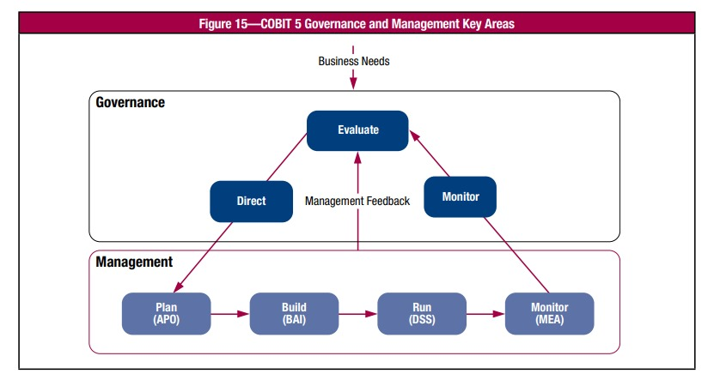

**Fig.2.** COBIT 5 Process Reference Model

This mapping aims to show how the company or organization's objectives are supported or translated into IT-related objectives in COBIT 5:

**Fig.3.** Enterprise Goals Mapping 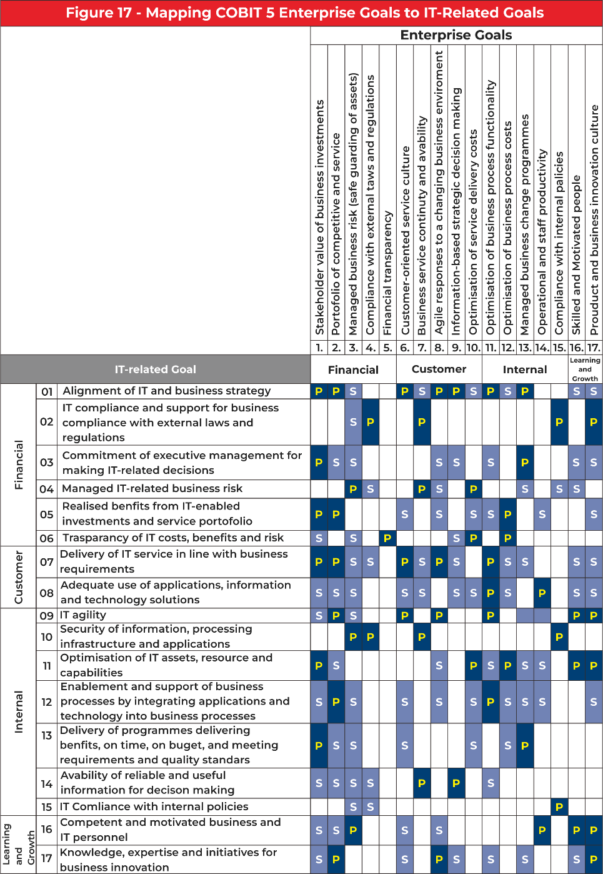

P : Primary

S : Secondary

##### COBIT 5 provides guidelines for mapping and selecting domains and processes so that the assessment is in accordance with the needs of the research being carried out, which of course refers to the strategic objectives of the object of research in terms of optimizing the Raya Mobile (SiRAMO) information system at KSPPS RAYA Banda Madani.

##### **Table.1**. Enterprise Goals

| **Figure – *Cobit 5 Enterprise Goals*** | | | | |
| --- | --- | --- | --- | --- |
| BSC  Dimension | Enterpise Goals | Relation to Governance Objective | | |
| Benefits  Realisation | Risk  Optimisation | Resource  Optimisation |
| Financial | 1. Stakeholder value of business investments | **P** |  | **S** |
| 2. Portfolio of competitive products and services | **P** | **P** | **S** |
| 3. Managed business risk (safeguarding of assets) |  | **P** | **S** |
| 4. Compliance with external laws and regulations |  | **P** |  |
| 5. Financial transparency | **P** | **S** | **S** |
| Customer | 6. Customer-oriented service culture | **P** |  | **S** |
| 7. Business service continuity and availability | **P** | **P** |  |
| 8. Agile responses to a changing business environment | **P** | **P** | **S** |
| 9. Information-based strategic decision making | **P** | **P** | **P** |
| Internal | 10. Optimisation of service delivery costs | **P** |  | **P** |
| 11. Optimisation of business process functionality | **P** |  | **P** |
| 12. Optimisation of business process costs | **P** |  | **P** |
| Learning and Growth | 13. Skilled and motivated people | **P** |  | **P** |
| 14. Culture of innovation and collaboration | **P** |  | **P** |
| 15. Knowledge, expertise and skills | **P** |  | **P** |
| 16. IT agility | **P** | **P** | **S** |
| 17. Product and business innovation | **P** |  | **S** |

Description

P : Primary

S : Secondary

**Tabel.2. *IT-Related Goals***

| **Figure 5 – *IT Related Goals*** | |
| --- | --- |
| **IT BSC Dimension** | **IT – Related Goals** |
| **Financial** | 1. Alignment of IT and business strategy |
| 2. IT compliance and support for business compliance |
| 3. Commitment of executive management to make IT-related decisions |
| **Customer** | 4. Managed IT-related business risk |
| 5. Realised benefits from IT-enabled investments |
| 6. Transparency of IT costs, benefits and risk |
| **Internal** | 7. Delivery of IT services in line with business requirements |
| 8. Adequate use of applications, information, and technology |
| 9. IT agility |
| **Learning and Growth** | 10. Security of information and processing infrastructure |
| 11. Optimisation of IT assets, resources and capabilities |
| 12. Enablement and support of business processes through IT |
| 13. Availability of reliable and useful information for decision making |
| 14. IT compliance with internal policies |
| 15. Skilled and motivated IT personnel |

Based on the mapping table above, it can be seen that to achieve goals in using the Raya Mobile (SiRAMO) information system at KSPPS RAYA Banda Madani effectively, the enterprise goals that will be selected are as follows:

**Table.3 Hasil Pemetaan *Enterprise Goals***

|  |  |  |  |  |
| --- | --- | --- | --- | --- |
| **Figure – Cobit 5 *Enterprise Goals*** | | | | |
| BSC  Dimension | Enterpise Goals | Relation to Governance Objective | | |
| Benefits  Realisation | Risk  Optimisation | Resource  Optimisation |
| Financial | 1. compliance-oriented service culture | **P** |  | **P** |
| Customer | 2. Customer-oriented service culture | **P** |  | **S** |
| 3. Business service continuity and availability | **P** | **P** |  |
| 4. Information-based strategic decision making | **P** |  | **S** |
| Internal | 5. Compliance with internal policies | **P** |  |  |

From the enterprise goals table above, the next step will be adjusted to the appropriate IT Related Goals. From the enterprise goals table above, the next stage will be adjusted to the appropriate IT Related Goals[12]. The results of mapping enterprise goals with IT Related Goals can be seen in the following information:

The symbol "P" is called primary, which means that it is prioritized to be selected, among others:

* 1. Compliance-oriented service culture (compliance with external laws and regulations)
  2. Custemer-oriented service culture.
  3. Business service continuity and availability
  4. Information-based strategic decision making.
  5. Compliance with internal policies

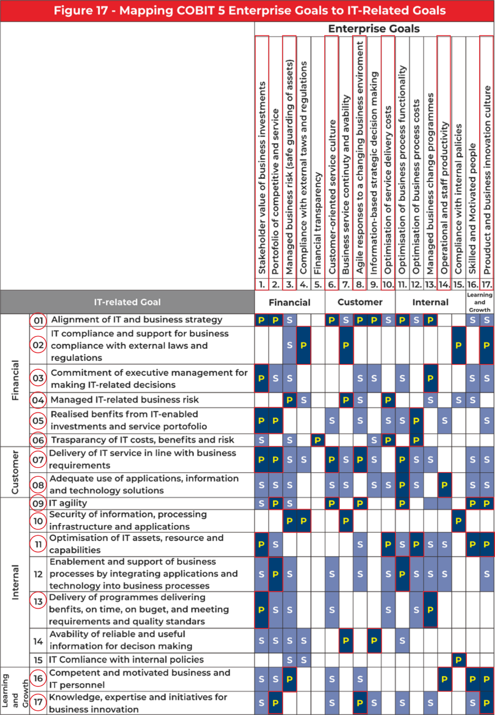

Fig.4 Hasil Pemetaan *Enterprise Goals to IT-Related Goals*

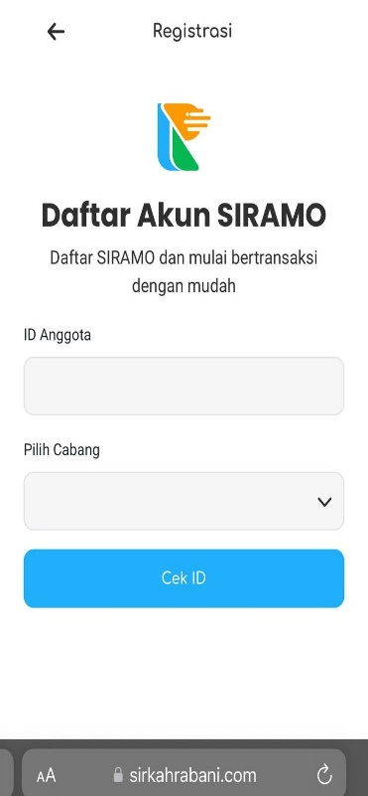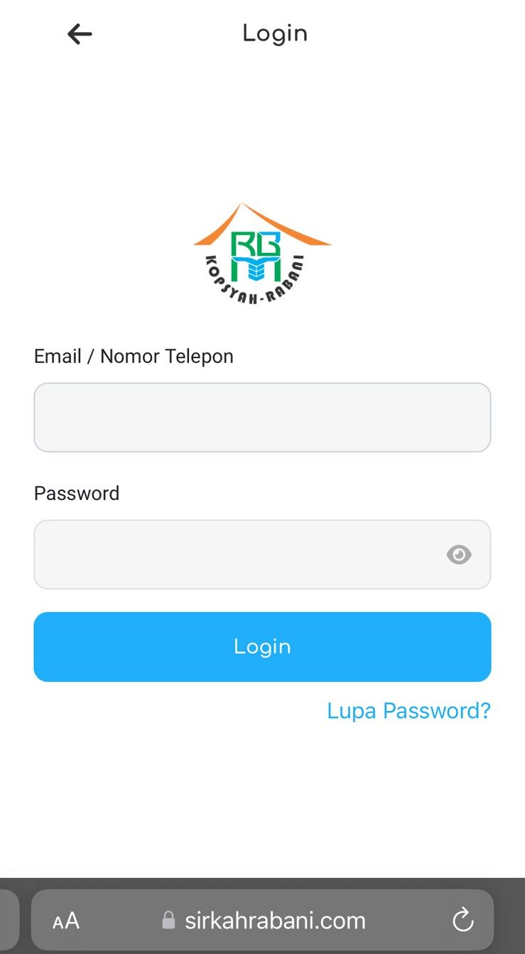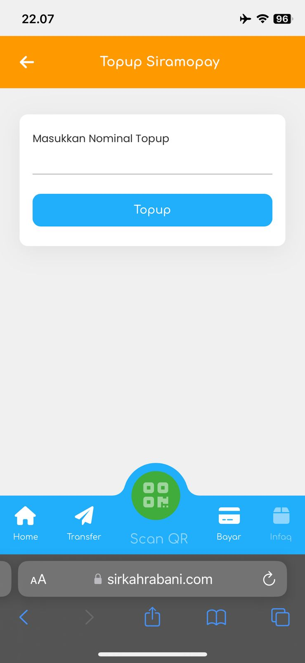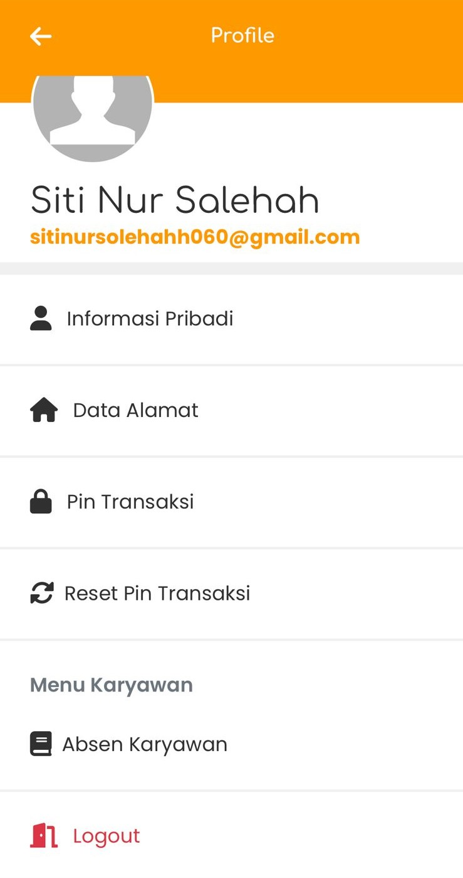

Fig.5. Profile menu in the SIRAMO application

# conclusion

Based on the research that has been conducted on the Raya Mobile Information System (SIRAMO) audit at KSPPS Raya Banda Madani using the COBIT 5 framework, the following conclusions can be drawn: Implementation of COBIT 5: The results showed that the use of the COBIT 5 framework was effective in identifying and evaluating the strengths and weaknesses of the SIRAMO information system. Through mapping and evaluation using COBIT 5 processes, areas that require improvement to increase system capability and efficiency were found. System Weaknesses and Strengths: Some weaknesses were found in the documentation and implementation of some processes, such as DSS02 (Managing Services) and DSS03 (Managing Problems). These weaknesses include the lack of use of data analysis tools and lack of staff training. On the other hand, system strengths were seen in high capability in several other processes, indicating that SIRAMO has a strong foundation but needs to be further improved. Recommendations for Improvement: Recommendations for improvement include improving the quality of documentation, using integrated information systems, and staff training. The implementation of these recommendations is expected to improve the existing gaps in the DSS02 and DSS03 processes, thereby achieving a higher level of capability in accordance with the COBIT 5 Process Capability model[13].

##### **References**

[1] T. Rahayu, N. Matondang, and B. Hananto, “Audit Sistem Informasi Akademik Menggunakan Metode Cobit 5,” *J. Teknol. Inf. dan Pendidik.*, vol. 13, no. 1, pp. 117–123, 2020, doi: 10.24036/tip.v13i1.305.

[2] P. P. Thenu, A. F. Wijaya, and C. Rudianto, “Analisis Manajemen Risiko Teknologi Informasi Menggunakan Cobit 5 (Studi Kasus: Pt Global Infotech),” *J. Bina Komput.*, vol. 2, no. 1, pp. 1–13, 2020, doi: 10.33557/binakomputer.v2i1.799.

[3] D. Pasha, A. thyo Priandika, and Y. Indonesian, “Analisis Tata Kelola It Dengan Domain Dss Pada Instansi Xyz Menggunakan Cobit 5,” *J. Ilm. Infrastruktur Teknol. Inf.*, vol. 1, no. 1, pp. 7–12, 2020, doi: 10.33365/jiiti.v1i1.268.

[4] O. Purwaningrum, B. Nadhiroh, and S. Mukaromah, “Literature Review Audit Sistem Informasi Menggunakan Kerangka Kerja Cobit 5,” *J. Inform. dan Sist. Inf.*, vol. 2, no. 3, pp. 587–595, 2021, doi: 10.33005/jifosi.v2i3.409.

[5] R. R. Suryono, D. Darwis, and S. I. Gunawan, “Audit Tata Kelola Teknologi Informasi Menggunakan Framework Cobit 5 (Studi Kasus: Balai Besar Perikanan Budidaya Laut Lampung),” *J. Teknoinfo*, vol. 12, no. 1, p. 16, 2018, doi: 10.33365/jti.v12i1.38.

[6] A. P. Rabhani *et al.*, “Audit Sistem Informasi Absensi Pada Kejaksaan Negeri Kota Bandung Menggunakan Framework Cobit 5,” *J. Sisfokom (Sistem Inf. dan Komputer)*, vol. 9, no. 2, pp. 275–280, 2020, doi: 10.32736/sisfokom.v9i2.890.

[7] P. A. Pratama, G. R. Dantes, and G. Indrawan, “Audit Sistem Informasi Universitas Pendidikan Ganesha Dengan Framework Cobit 5,” *JST (Jurnal Sains dan Teknol.*, vol. 9, no. 2, pp. 153–161, 2020, doi: 10.23887/jstundiksha.v9i2.25948.

[8] J. Sihotang, E. Setiawan Panjaitan, R. Yunis, M. Teknologi Informasi, and S. Miskroskil, “Evaluation of Information Technology Governance by Using CobIT 5 Framework at Higher Education,” *J. Mantik*, vol. 4, no. 3, pp. 2194–2203, 2020, [Online]. Available: https://iocscience.org/ejournal/index.php/mantik

[9] A. Hanif, M. Giatman, and A. Hadi, “Evaluasi Tata Kelola Teknologi Informasi Di Dinas Komunikasi Dan Informatika Menggunakan Framework Cobit 5,” *JST (Jurnal Sains dan Teknol.*, vol. 9, no. 1, pp. 94–101, 2020, doi: 10.23887/jstundiksha.v9i1.28401.

[10] A. Nurdin and M. Lubis, “The IT Governance Measurement using Cobit 5 Framework in Quality Assurance Department,” *J. Inform. dan Rekayasa Perangkat Lunak*, vol. 5, no. 1, p. 80, 2023, doi: 10.36499/jinrpl.v5i1.7963.

[11] O. Purwaningrum, “Studi Literatur : Framework Cobit 5 Pada Tata Kelola Teknologi Informasi,” *SCAN - J. Teknol. Inf. dan Komun.*, vol. 16, no. 2, 2021, doi: 10.33005/scan.v16i2.2598.

[12] M. Muthmainnah, S. Safwandi, M. Jannah, and V. Ilhadi, “Evaluasi Tata Kelola Teknologi Informasi Menggunakan Framework Cobit 5 Proses Dss03 Dan Mea01 Di Universitas X,” *Sisfo J. Ilm. Sist. Inf.*, vol. 5, no. 1, pp. 1–12, 2021, doi: 10.29103/sisfo.v5i1.4848.

[13] N. Lediwara, “Analisis IT Governance Menggunakan Framework Cobit 5 Domain DSS, MEA dan BAI,” *Pseudocode*, vol. 7, no. 2, pp. 97–104, 2020, doi: 10.33369/pseudocode.7.2.97-104.