[1]

Analysis and Implementation of Ubuntu and Mikrotik Based Server

Januardi Nasir

Department of.Technique,  
Universiti Putera Batam  
Batam, Indonesia

[januardinasir@gmail.com](mailto:januardinasir@gmail.com),

*Abstract*— Internet is a primary requirement in this modern era because it is one of the information’s media and communication. Due to its rapid advancement, internet is now a main infrastructure which must be possessed by an organization, institution (education, government, service provider and others). Besides internet, other infrastructure which is also a primary requirement in an institution is a centralized storage or server. Regarding internet’s availability and server, PT Indonesia Terbit Media faces some setbacks such as the unavailability of sufficient bandwidth management and unavailability of centralized information storage. To solve those setbacks, a MikroTik router is offered to be implemented in the company’s network. Before doing research, observation is held in the company to gather information’s regarding current network. Along with observation, focus group discussion is held with the staffs. After information’s are gathered, current network is analyzed then a new topology is proposed. After the proposal is approved, testing phase is initiated to know the contributions of newly proposed network in solving the mentioned setbacks. Results from the implementation are such as bandwidth management is applied in new network which is resulting in stable internet’s speed even though a user is downloading a quite large file and Ubuntu-based centralized server.

***Keywords:* internet ; server ; ubuntu ; MikroTik ; bandwidth management**

# Introduction

Batam is one of the industrial cities, which needs fast and accurate information. PT Indonesia Terbit Media is one of the companies, which is engaged in journalism and provides information about Batam and it is served in the format of a website. Fast internet connection is required to support those necessities. Besides the internet, other infrastructure, which is the main requirement in a company, is a centralized storage or usually called as server. A large scaled company or business entity usually use a physical server as its centralized storage. Whereas for the small to intermediate-scaled company mostly uses PC as the centralized storage because it is fairly cheaper than the physical server (which is usually more expensive). Server is usually used by the staff or workers to keep important information related to company’s privacy such as data, transaction and others. Each staff or worker is usually given permission according to their own department so no one from certain department can get an access through other department’s data. The operating system, which is commonly used by server, is Windows because it is easy to operate. There are few servers, which uses Linux as their operating system because it is more secure.

# LITERATURE REVIEW

PT Indonesia Terbit Media is currently subscribed to Telkom Speedy to provide internet connection, which is used to upload daily news every day. Star Topology is used as the company’s network topology with some devices included such as server, switch, wireless router, and four laptops. PT Indonesia Terbit Media is currently facing a few setbacks in its computer’s network such as unavailability of bandwidth management which is resulting in when one of the staff does some activities which require large bandwidth, the internet connection on the other’s devices will slow down even when they are just browsing and the unavailability of the centralized storage. To answer these problems mentioned above, the writer suggests the implementation of a MikroTik router with a bandwidth management feature in the computer’s network. In addition of the router’s implementation, the writer will also install Ubuntu Server operating system into the implemented server as the centralized storage.

1. *Server*

Server is a system which processes the data, provide certain services and promoting sharing of information’s in a computer’s network. Server also runs administrative software which control access to network and the resources within.[1]

1. *MikroTik Router*

Router is created to manage a network by connecting multiple networks into a unified wider network.[2]

MikroTik are tools (i.e. routers, switches, antenna, and other supporting devices) and software (MikroTik RouterOS, a router operating system which regulates the network activities) based on Linux created by John Tully and Arnis Riekstins in 1996 which serve for internet connectivity.[3]

MikroTik Routers turns a computer into a network router and implements various additional features, such as firewall, virtual private network (VPN) service, bandwidth management, wireless access point, captive-portal-based hotspot system and other commonly used features when interconnecting networks.*[4]*

1. *Queue Tree*

Queue tree is a one-way queue configuration menu on routers to perform bandwidth management for complex network scenarios.[5]

1. *Ubuntu*

Ubuntu is a Debian-based Linux distribution which uses GNOME graphical user interface as its desktop environment where All of the versions of Ubuntu are built and distributed in the same way, and simply target different groups of users. Aside from their target audience, the only real differences between them are how they are installed, the set of applications that they provide when they are first installed, and how the Linux operating system itself is pre-configured for each. [6]

1. *Quality of Service (QoS)*

Quality of Service (QoS) is a mechanism which provides a guarantee in network’s performance (delivery’s speed and reliability of various types of data in a communication system).[7]

QoS parameters which affect the performance of the network are packet loss, delay (latency) and throughput.[7]

1. Packet Loss is the failure of the transmission of IP packets to its destination which occurs when packets are broken and discarded, or when the capacity of the network components exceeds the limit, resulting in the packet is discarded.
2. Delay (Latency) is the time delay caused by the transmission from one point to another point which becomes the goal.
3. Throughputis the actual bandwidth measured in a particular time and in a certain network conditions which are used to transfer files of a certain size.
4. *SSH* (*Secure Shell Server*)

Secure Shell (SSH) is a protocol for secure network communications designed to be relatively simple and inexpensive to implement, provides general client/server capability and can be used for such network functions as file transfer and e-mail.[8]

SSH is organized as three protocols which typically run on top of TCP shown as figure below.[8]

1. Transport Layer Protocol, provides server authentication, data confidentiality and data integrity with forward secrecy.
2. User Authentication Protocol, authenticates the user to the server.
3. Connection Protocol, multiplexes multiple logical communications channels over a single, underlying SSH connection.

# 

**Fig. 1** SSH Protocol Stack

1. *Mail Server*

Mail server is an application which retrieves incoming e-mail from local users (users within certain domain) and remote sender ; and forwarding outgoing e-mail to be sent.[9]

1. *Web Server*

Web server is a software which accept request through HTTP or HTTPS protocol from clients and sending it back in a form of web page (typically in HTML format) or rejecting the request if the web page is not available.[10]

1. *DNS Server*

DNS (DomainNameSystem) is a directory lookup service which translates a non-routable domain name into the IP address of a server hosting the resource client wants to access*.*[11]

DNS is comprised in four elements such as:[12]

1. *Domain Name Space,* which is used by the DNS to identify resources on the Internet.
2. *DNS Database,* each node and leaf in the name space tree structure names a set of information (IP address, type of resource, etc.) that is contained in a resource record (RR). The collection of all RRs is organized into a distributed database.
3. *Name Servers,* are server programs which hold information about a portion of the domain name tree structure and the associated RRs.
4. *Resolvers,* are programs which are extracting information from name servers in response to client requests. A typical client request is for an IP address corresponding to a given domain name.
5. *Bandwidth Management*

Bandwidth management is a method used to create a fast, flexible and stable access of internet connection by preventing bandwidth from over limit condition so all clients will get a fairly divided amount of bandwidth.[13]

1. *WinBox*

Win Box is configuration utility that can connect to the router via MAC Address or IP Address.[4]

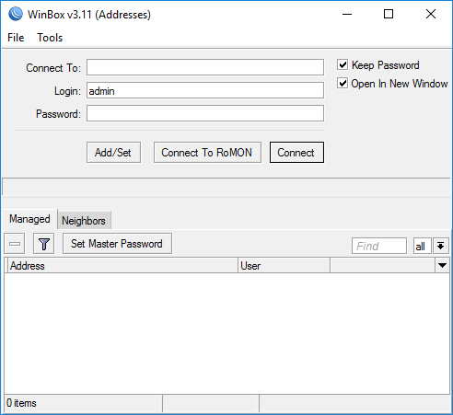

**Fig. 2** Win Box

1. *PuTTY*

Putty is a console application used for network file transfer due to its free and open source feature and its network supporting protocols such as SCP, rlogin, Telnet, SSH and raw socket connection.[14]

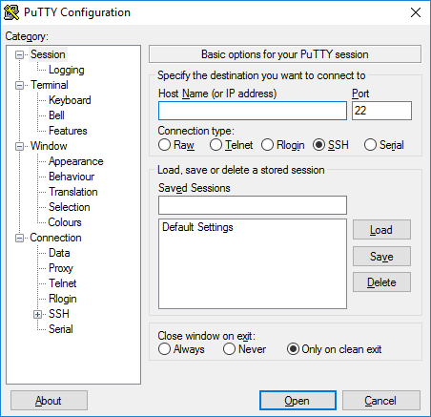

**Fig. 3** Putty

1. *Wireshark*

Wireshark is one of the mostly used network analyser tools by network administrator due to its easy-to-operate feature, graphical user interface and its ability to capture data packages or information which went through network where all kind of information in any protocol formats would be easily captured and analysed.[15]

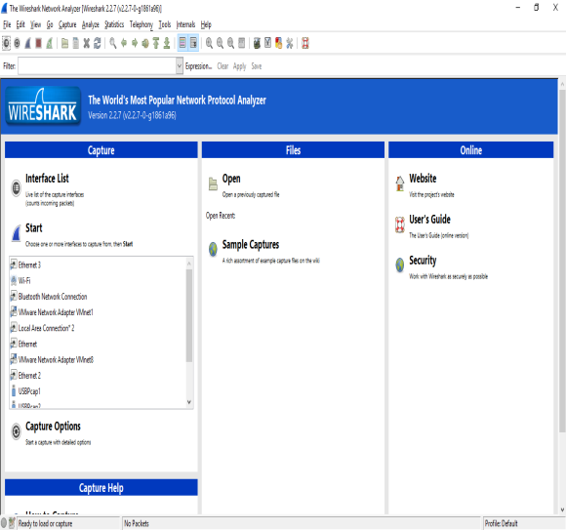

**Fig. 4** Wireshark

# Research Method

1. *Current Network Topology*

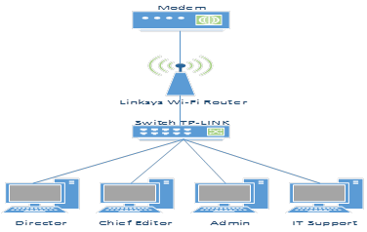

**Fig. 5** Current Network Topology

Star topology is currently being used in the company’s network. End devices consist of four laptop computers which are used respectively by director, chief editor, admin and IT support and all. Linksys Wi-Fi router is being used as wireless device with WAP/PSK authentication.

1. *Proposed Network Topology*



**Fig. 6** Proposed Network Topology

1. . MikroTik RB-750-R2 router is directly connected to modem (internet connection from ISP). Wi-Fi router and server are connected to MikroTik router where bandwidth management will be implemented for both local network and wireless network. Local network consists of four laptop computers and a shared printer which are connected to a TP-LINK switch.
2. Results and Analysis
3. *SSH (Secure Shell)*

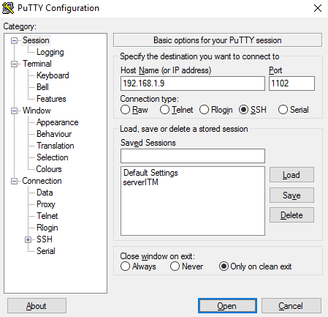

**Fig. 7** Remote login to server using PuTTY

Figure shown above is the initial display when PuTTY is opened. In *Host Name or IP Address*section, type the desired server’s IP address and the port number. Choose *SSH* in *Connection type*and press enter.

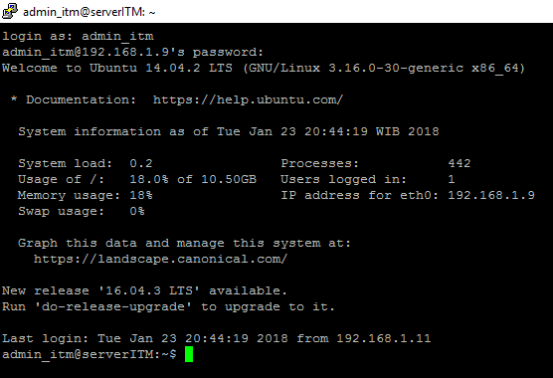

**Fig. 8** Remote login to server established

Figure shown above is PuTTY’s display when the remote login has been established and now the server can be accessed remotely from a client’s computer.

1. *Mail Server*

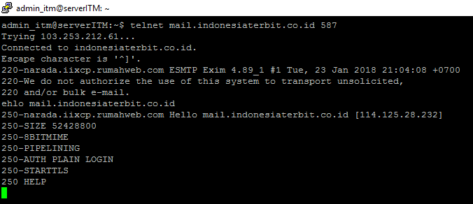

**Fig. 9** Testing web server using wget command

***Wget*** command is used to send request to webpage of www.indonesiaterbit.co.id and after a few seconds, the request is accepted or responded by the web page.

1. *Web Server*

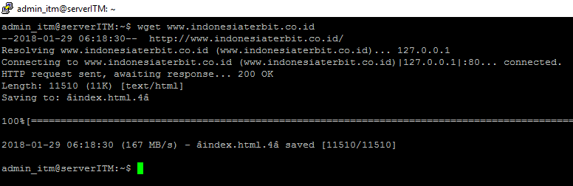

**Fig. 10** Testing web server using wget command

*Wget*command is used to send request to webpage of www.indonesiaterbit.co.id and after a few seconds, the request is accepted or responded by the web page.

1. *DNS Server*

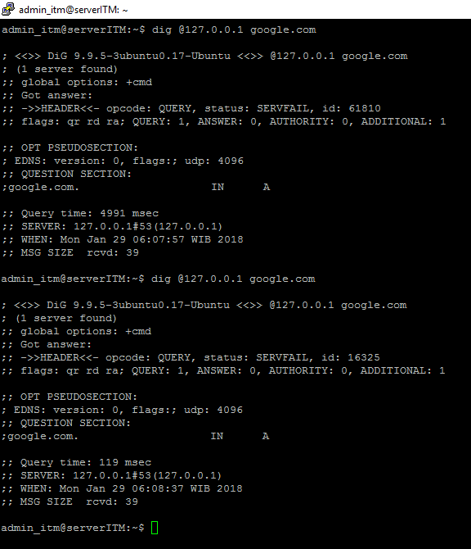

**Fig. 11** Testing DNS server using dig command

*Dig*commandis used to check the query time of a certain domain. For the first *dig*, the query time is 4991 msec. After trying the second *dig*, the query time is increasing to 119 msec.

1. *MikroTik-based Bandwidth Managemen*

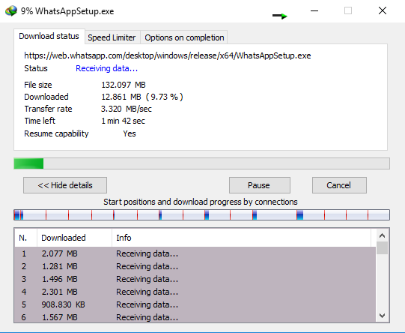

**Fig. 12** *Download* speed before bandwidth management

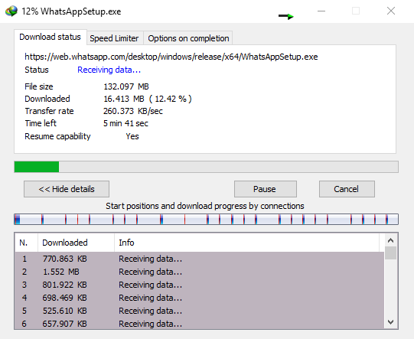

**Fig. 13** *Download* speed after bandwidth management

Figure 13 above shows the download speed using Internet Download Manager is reaching up to 3 Mbps which causes this situation to slow down the browsing, streaming, upload and download process in other devices. But after bandwidth management is implemented, download speed is limited up to 260 kbps as shown in figure 14, resulting in other devices are not experiencing excessive delay during browsing, streaming, upload and download.

1. CONCLUSIONS

Implementation of Ubuntu as a centralized storage or server succeed and works like it supposed to be and MikroTik-based bandwidth management with queue tree method effectively increases the quality of service in network’s traffic by limiting bandwidth for each device within the network.

REFERENCES

[1] H. S. Oluwatosin, “Client-Server Model,” *IOSR J. Comput. Eng.*, vol. 16, no. 1, pp. 57–71, 2014.

[2] A. L. I. A. A. RAMADHAN *et al.*, “Analysis of Effectiveness of Using Simple Queue With Per Connection Queue (Pcq) in the Bandwidth Management (a Case Study At the Academy of Information Management and Computer Mataram (Amikom) Mataram),” *Journal of Theoretical and Applied Information Technology*, vol. 83, no. 3. 2016.

[3] A. Rahman and Haviluddin, “Implementation of Bandwidth Management Authentication,” *Int. J. Comput. Informatics*, vol. 1, no. 1, pp. 1–8, 2016.

[4] P. Mollick, S. Biswas, A. Halder, and M. R. Salmani, “Mikrotik Router Configuration using IPv6,” *Int. J. Innov. Res. Comput. Commun. Eng.*, vol. 4, no. 2, pp. 2001–2007, 2016.

[5] I. Perwira and Liantoni, “Queue Tree Implementation for Bandwidth Management in Modern Campus Network Architecture,” vol. 3, no. 1, pp. 17–26, 2018.

[6] W. Von Hagen, *Ubuntu 8.10 Linux ® ®*. Indianapolis: Wiley Publishing, Inc., 2009.

[7] W. Sugeng, J. E. Istiyanto, K. Mustofa, and A. Ashari, “The Impact of QoS Changes towards Network Performance,” *Int. J. Comput. Networks Commun. Secur.*, vol. 3, no. 2, pp. 48–53, 2015.

[8] W. Stallings, *Network Security Essentials : Applications and Standards Fourth Edition*, 4th (Fourt. Upper Saddle River, New Jearsey: Pearson Education, Inc., 2011.

[9] A. Lockhart, *Network Security Hacks, Second Edition*, Second Edi. California: O’Reilly Media, Inc., 2009.

[10] D. J. Barrett, R. E. Silverman, and R. G. Byrnes, *SSH The Secure Shell*, Second Edi. California: O’Reilly Media, Inc., 2005.

[11] H. Hours, E. Biersack, P. Loiseau, A. Finamore, and M. Mellia, “A Study of the Impact of DNS Resolvers on CDN Performance Using a Causal Approach,” *Comput. Networks*, vol. 109, pp. 200–210, 2016.

[12] W. Stallings, *Data and Computer Communications (Eighth Edition)*. New Jersey: Pearson Education, Inc., 2007.

[13] M. D. L. Siahaan, M. S. Panjaitan, and A. P. U. Siahaan, “MikroTik Bandwidth Management to Gain the Users Prosperity Prevalent,” *Int. J. Eng. Trends Technol.*, vol. 42, no. 5, pp. 218–222, 2016.

[14] V. Negi *et al.*, “Network Security in Embedded System Using TLS,” *Int. J. Secur. its Appl.*, vol. 10, no. 2, pp. 375–384, 2016.

[15] M. A. Zulkifli and U. A. Dahlan, “Live Forensics Method for Analysis Denial of Service ( DOS ) Attack on Routerboard,” *Int. J. Comput. Appl.*, vol. 180, no. 35, pp. 23–30, 2018.

1.