TEMPERATURE AND HUMIDITY CONTROL BASED ON FUZZY LOGIC ON HATCHING EGG
Dian Efytra Yuliana
Jurusan Teknik Elektro Fakultas Teknik Universitas Islam Kadiri-Kediri, jl. Sersan Suharmaji No.38 Manisrenggo Kecamatan Kota, 64128, Kediri, Indonesia
dianefytra@uniska-kediri.ac.id
* corresponding author
 |  | ABSTRACT
Keywords  Arduino  DHT 11  LCD  Blower  Heater |  | In quail DOQ cultivation after the quail eggs hatch, DOQ (Day Old Quail) quail puppies need a warm place as a substitute for the mother to maintain the temperature of the body, because in this phase quail puppies have not been able to adjust to room temperature. If the temperature is not suitable, it will cause quail death. From these problems, a quail DOQ cage quail control system was made using a microcontroller. This system consists of a DHT11 sensor as a detector of temperature and humidity, and Arduino as a controller of the system. The heat source in the DOQ room uses a DC bulb equipped with a blower to spread the heat, the signal from the sensor is used as a parameter controlling the temperature and humidity of the cage by adjusting pwm on arduino when the temperature in the cage is too hot or too hot and the humidity is too humid. To display the temperature in the border space, 16x2 LCD displays are used. From the fuzzy logic test results obtained an error percentage of 1%, humidity of 2% and a mortality rate of 0% and without using fuzzy logic a mortality rate of 20%.

Pendahuluan

Breeding is an attempt to breed living things, one of which is quail. In the hatching with a considerable amount need to be used a tool to hatch the eggs. After the quail eggs hatch, DOQ (Day Old Quail) quail puppies need a warm place as a substitute for its mother to maintain its body temperature, because in this phase quail puppies have not been able to adjust to the room temperature of 25 ° C-30 ° C. In this process the quail puppies need approximately 10 days to be able to adjust the ambient temperature. At the age of 10 days feathers on quails have grown almost evenly.
The temperature needed by the quail DOQ is in accordance with the development of growing quails, i.e. the older the temperature in the cage will be higher, because the density of quails in the cage will affect the temperature in the cage. When the quail is more than 10 days old, the quail puppies are able to adjust to the ambient temperature, so that the quails do not need to be warmed up anymore, and are ready to enter the next stage, which is an enlarged or laying cage.
In this cultivation many farmers have used tools to warm quail seeds after the hatching process. But still in a manual way, which utilizes the effect of heat from incandescent lamps, by using a thermometer as a indicator of the temperature. Not infrequently they experience losses due to the large number of quail seeds that die due to jostling when the temperature in the cage is not appropriate, ie too hot or not too hot. In this case the breeder feels confused because when using incandescent lamps, that is difficult in getting incandescent lamps with the appropriate temperature effect, and when the temperature is not high enough the breeder must use a large incandescent bulb or increase the number of incandescent bulbs so that the temperature is what is needed by the seeds quail.
To simplify all this, a quail DOQ cage control system using a microcontroller is made. This system consists of a DHT11 sensor as a detector of temperature and humidity, and Arduino as a controller of the system. The heat source in the DOQ room uses a DC bulb equipped with a blower to spread the heat, the signal from the sensor is used as a parameter controlling the temperature and humidity of the enclosure by adjusting pwm on arduino when the temperature in the cage is too hot or too hot and the humidity is too humid. To display the temperature of the border space, a 16x2 LCD display is used. The temperature used at the age of 0-10 days at manual temperature control is approximately 34 ° C - 38 ° C, with humidity between 40% RH - 70% RH.

The Proposed Method/Algorithm
In architectural design begins with hardware design. The overall hardware design block diagram is as shown in Figure 2.1.

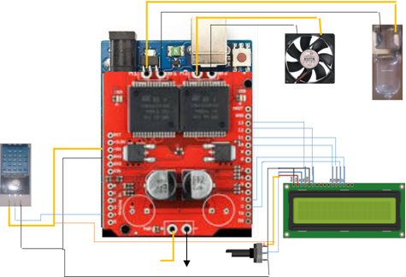
Figure 2.1 Arduino Uno pin connection with other devices

DHT 11 sensor functions to provide input temperature and humidity readings in the cage to Arduino. Heater and Blower As Outputs whose function is to regulate temperature and humidity in the cage according to the input values ​​that have been set. heater and blower will be regulated by PWM through the motor driver. The LCD functions as a data displayer (displaying) the temperature and humidity inside the cage.

Method

Fuzification process after reading the temperature and humidity sensor values ​​in the cage chamber. Conversion of digital data to decimal in the form of voltage is used for input to control the work of the heater and blower through the driver.

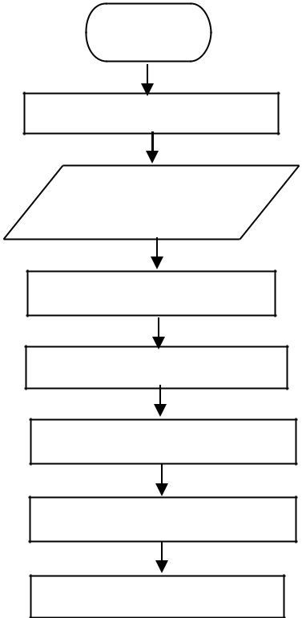
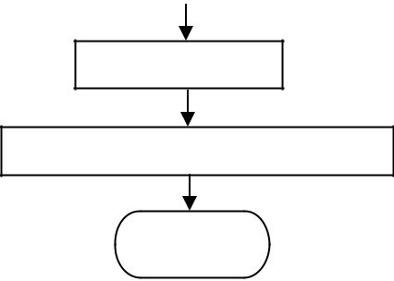
start

Sensor initialization

Read temperature and
humidity

Fuzzyfication of
temperature

Fuzzyfication of humidity

Fuzzy rule base

inferensi

defuzzyfikasi

Set pwm driver

Turn on the heater and blower

stop

Figure 3.1. Fuzzy logic flowchart
3.1 Fuzzyfikasi
In the fuzzyfication process the membership function in the form of temperature has 3 linguistic values, namely warm, moderately hot, and hot
Figure 3.2 Fuzyfication temperature curve.

Whereas the membership function in the form of humidity also has 3 linguistic values, namely dry, rather dry, and normal

Figure 3.3 Fuzyfication humidity curves

3.2 Rule Base Fuzzy
At this stage each output from the fuzzyfication stage in the form of the temperature and humidity sensor membership membership will be combined using rule evaluation
3.3 Defuzzyfikasi
Figure 3.4 Figure Membership Function Output

Results and Discussion

DHT11 sensor calibration data

Table 4.1 Sensor calibration table dht 11
No | termometer | DHT 11 |  | Hygrometer |  | Eror
No | analog | humidity temperature | humidity temperature | humidity temperature | humidity temperature | humidity temperature | humidity temperature
1 | 25⁰C | 25⁰C | 40%RH | 25⁰C | 45%RH | 0⁰C | 1%RH
2 | 26⁰C | 26⁰C | 41%RH | 27⁰C | 42%RH | 0⁰C | 2%RH
3 | 27⁰C | 26⁰C | 43%RH | 28⁰C | 41%RH | 3⁰C | 4%RH
4 | 28⁰C | 27⁰C | 45%RH | 28⁰C | 45%RH | 3⁰C | 0%RH
5 | 29⁰C | 28⁰C | 47%RH | 30⁰C | 46%RH | 3⁰C | 2%RH
6 | 30⁰C | 29⁰C | 49%RH | 31⁰C | 47%RH | 3⁰C | 4%RH
7 | 31⁰C | 31⁰C | 50%RH | 31⁰C | 49%RH | 0⁰C | 2%RH
8 | 32⁰C | 32⁰C | 52%RH | 32⁰C | 52%RH | 0⁰C | 0%RH
9 | 33⁰C | 32⁰C | 55%RH | 34⁰C | 53%RH | 3⁰C | 3%RH
10 | 34⁰C | 33⁰C | 58%RH | 34⁰C | 58%RH | 2⁰C | 0%RH
11 | 35⁰C | 35⁰C | 60%RH | 35⁰C | 60%RH | 2⁰C | 0%RH
12 | 36⁰C | 36⁰C | 63%RH | 36⁰C | 62%RH | 0⁰C | 1%RH
13 | 37⁰C | 37⁰C | 65%RH | 36⁰C | 62%RH | 0⁰C | 4%RH
14 | 38⁰C | 38⁰C | 68%RH | 38⁰C | 64%RH | 0⁰C | 5%RH
15 | 39⁰C | 39⁰C | 70%RH | 40⁰C | 70%RH | 2⁰C | 0%RH
16 | 40⁰C | 40⁰C | 72%RH | 42⁰C | 70%RH | 2⁰C | 2%RH
Average |  |  |  |  |  | 1⁰C | 2%RH

Based on the calibration test temperature and humidity generated error values ​​from the DHT11 sensor that is for a temperature of 1% and 2% humidity for.

4.2 Research Results by using manual cages without tools

Table 4.2 results of a manual cage experiment
Day | 07.00 |  | 12.00 |  | 17.00 |  | total  quail
Day | Humidity temperature | Humidity temperature | Humidity temperature | Humidity temperature | Humidity temperature | Humidity temperature | total  quail
1 | 34⁰C | 37%RH | 36⁰C | 38%RH | 38⁰C | 35%RH | 10
2 | 32⁰C | 38%RH | 36⁰C | 37%RH | 38⁰C | 34%RH | 10
3 | 34⁰C | 36%RH | 39⁰C | 36%RH | 38⁰C | 34%RH | 10
4 | 38⁰C | 39%RH | 35⁰C | 39%RH | 38⁰C | 35%RH | 9
5 | 36⁰C | 37%RH | 37⁰C | 37%RH | 38⁰C | 36%RH | 9
6 | 36⁰C | 35%RH | 38⁰C | 38%RH | 38⁰C | 34%RH | 9
7 | 32⁰C | 36%RH | 38⁰C | 36%RH | 38⁰C | 35%RH | 9
8 | 34⁰C | 37%RH | 38⁰C | 37%RH | 38⁰C | 36%RH | 8
9 | 32⁰C | 39%RH | 36⁰C | 38%RH | 38⁰C | 37%RH | 8
10 | 32⁰C | 35%RH | 37⁰C | 36%RH | 38⁰C | 38%RH | 8

In a manual study the temperature and humidity in a cage tend to change because it is influenced by outside temperatures and the size of the ventilation space of the cage, breeders must actively control the temperature and humidity in the cage to be maintained. In this trial quail deaths reached 2 of the total number of 10 quails within 10 days of the experiment. Quail death caused by too high cage room temperature in the second session, at 12.00 WIB. The temperature at this hour is also influenced by a fairly high outside temperature.

4.3 Overall Research Results for enclosures with automatic temperature
Research by controlling temperature and humidity automatically the temperature is set between 32°C-38°C ie when the temperature is less than 32°C then the pwm will be fully regulated ie 255 with an output voltage of 12 V and when the temperature is more than 38°C then the pwm at set 0. And in the humidity control, humidity is set between 40% RH-70% RH, i.e. when the humidity is low or below 40% RH then the pwm will be set with pwm 0, and when the humidity is high or greater than 70% RH the pwm is set full ie 255
Table 4.3 Results of temperature and humidity control of the cage at 07.00 a.m.
07.00
No. | Suhu | PWM | kelembapan | PWM
1 | 32⁰C | 217,22 | 60%RH | 178,33
2 | 32⁰C | 212,69 | 54%RH | 201,33
3 | 33⁰C | 214,35 | 51%RH | 299,00
4 | 34⁰C | 209,00 | 51%RH | 209,00
5 | 32⁰C | 215,52 | 45%RH | 212,83
6 | 33⁰C | 214,35 | 53%RH | 299,00
7 | 33⁰C | 226,25 | 36%RH | 226,25
8 | 31⁰C | 255,00 | 37%RH | 209,00
9 | 33⁰C | 212,65 | 53%RH | 203,25
10 | 32⁰C | 235,36 | 44%RH | 239,67

In the results of the second temperature and humidity control data, which is 12.00 hours. The temperature tends to be higher than the first data, because during the day the outside temperature tends to be higher and unstable, so the temperature and humidity in the cage are also higher between 32 ° C - 37 ° C with humidity of 35% RH - 58% RH due to being affected outside temperature.
Table 4.4 results of temperature and humidity control of the cage at 12.00 pm
12.00
No. | temperature | PWM | humidity | PWM
1 | 34⁰C | 206,28 | 56%RH | 195,20
2 | 33⁰C | 217,18 | 49%RH | 214,75
3 | 34⁰C | 206,17 | 55%RH | 197,50
4 | 34⁰C | 209,48 | 49%RH | 210,58
5 | 33⁰C | 212,65 | 53%RH | 203,25
6 | 34⁰C | 206,28 | 56%RH | 195,20
7 | 36⁰C | 182,77 | 56%RH | 194,63
8 | 35⁰C | 197,50 | 50%RH | 206,17
9 | 32⁰C | 214,20 | 58%RH | 186,35
10 | 34⁰C | 226,25 | 41%RH | 179,89

On the results of taking data control temperature and humidity at 17:00. The temperature in the cage tends to be lower between 32 ° C - 33 ° C with humidity between 35% RH - 60% RH because in the afternoon the outside temperature tends to be stable and not too hot. This temperature and humidity also lasted until the next day. The difference with a manual cage that must monitor temperature and humidity at all times.

Table 4.5 results of the temperature and humidity control of the cage at 05.00 pm
17.00
No. | temperature | PWM | humidity | PWM
1 | 32⁰C | 217,22 | 60%RH | 178,33
2 | 33⁰C | 212,23 | 54%RH | 200,38
3 | 33⁰C | 213,36 | 58%RH | 188,88
4 | 32⁰C | 213,26 | 57%RH | 189,83
5 | 33⁰C | 213,39 | 58%RH | 188,89
6 | 33⁰C | 219,03 | 48%RH | 217,63
7 | 33⁰C | 188,38 | 57%RH | 192.00
8 | 33⁰C | 209,00 | 50%RH | 209,00
9 | 32⁰C | 235,36 | 44%RH | 239,67
10 | 32⁰C | 255,00 | 35%RH | 0

4.4 The development of quails by using an automatic temperature device

4.4.1 Quail first day
On the first day the quail enters the bording cage is an adjustment phase, namely from the hatchery cage enters the bording cage. for a good quail reaction, tends to spread in the cage room, indicating that the temperature in the cage matches what is needed by quail seedlings. When the temperature is too high, the quail is more lazy or passive and inactive, at this stage the quail tends to be lazy.

Figure 4.1 quail first day

4.4.2 Quail day 7

On the seventh day the feathers on the quail have grown almost evenly. In this phase the quail is more resistant to temperature changes

Figure 4.2 development of the 7th quail

4.4.3 Quail 10 days

After the ten-day-old quail the feathers on the body of the quail have grown almost perfectly. In this phase the quail is able to adjust the temperature of the room, so the quail is ready to be moved in the next phase which is the cage without any more warmers.
Figure 4.3 Development of quail 10th day
In temperature and humidity control experiments automatically, temperature tends to be more controllable, and temperature is more stable than manual temperature control. The success of the cage with temperature control automatically is higher than the temperature control manually, namely from the number of test samples of 10 quails within 10 days, the level of quail life is perfect or successful, namely 10 tails.

Conclusion
Based on the design and testing that has been done, it can be concluded that:
  - The application of fuzzy logic for determining temperature and humidity systems for hatching quail eggs is done by writing the arduino program code which is arranged according to the rules of fuzzy logic calculation and test results for DHT sensors obtained an average percentage error for temperatures of 1% and 2% humidity.
  - Overall the system can work well, namely the death rate of quails using fuzzy logic for temperature control, the mortality rate is 0% and without using fuzzy logic the mortality rate is 20%

References

- R. Hidayat Rahim, Arthur M. Rumagit, Arie S. M. Lumenta, “Rancang Bangun Alat Penetas Telur Otomatis Berbasis Mikrokontroler ATMega8535,” E-Journal Teknik Elektro dan Komputer, Vol. 13, ISSN : 2301-8402, 2015.
- M. Zainur Rodhi1, Dahnial S, G. Edhi Setyawan. “Sistem Penentu Suhu Dan Kelembaban Incubator Telur Unggas Berdasarkan Berat Dan Warna Telur Menggunakan Metode Fuzzy,” Universitas Brawijaya Jurnal Pengembangan Teknologi Informasi dan Ilmu Komputer e-ISSN: 2548-964X Vol. 2, No. 12, Desember 2018, hlm. 7302-7311. 2018

- A. Khoirunnas, J. Rohman, I. Ashar, “Design Waypoint Drone Hexacopter Model Using Sugeno Fuzzy Logic,” JEEMECS (Journal of Electrical Engineering, Mechatronic and Computer Science ISSN 2614-4859 Vol. 3, No. 1, February 2020, pp. 81-90, 2020.

- Harjanto, Tri S. Si, “PUYUH,” Delta Media. Solo,2009

- Heri, Andrianto dan Darmawan, Aan. “Arduino Belajar cepat dan pemrograman,” Informatika Bandung, 2016

- Listiyowati, E. Dan Kinanti R., 2009. Beternak Puyuh Secara Komersial. Panebar Swadaya, Jakarta, 2009.

- Lubis, S, “Pengelolaan Penetasan Dan Pemeliharaan Burung Puyuh. Fakultas Politeknik Pertanian. IPB, Bogor, 1990.

- Muin, A, “Kepadatan Kandang Puyuh. Poultry Indonesia,” No. 63. Jakarta, 1985.
.

