APPLICATION OF LEARNING MATHEMATICS USING WEB BASED LEARNING METHOD
M. Ichsan Alfajri ^{a,1,*}, Yusli Yenni ^{b,2}
ª Universitas Putera Batam, Jl. R. Soeprapto Muka Kuning, Batam 29434, Indonesia
^{b} Universitas Putera Batam, Jl. R. Soeprapto Muka Kuning, Batam 29434, Indonesia
¹ daily.alfajri37@gmail.com*;*; ² yusliany10@gmail.com

 |  | ABSTRACT
Keywords  Mathematic  Web based learning |  | Mathematics is one branch of science that we have learned from an early age. Mathematics is the science of quantity, structure, space and change. Mathematicians find patterns from rigorous conclusions drawn from consistent axioms and definitions, propose new conjectures and construct truth. The problem that we often encounter is a learning approach that becomes a problem in the real world as a context for learning by thinking more critically and skillfully in problem solving, as well as knowledge and concepts from the material to be learned. The success of a learning can be seen from the results of learning.  Therefore, learning methods related to technology are indispensable for practical activities with the object of study that cannot be separated from theoretical learning. Learning theory makes us bored compared to the practice done directly in front of the computer with existing technology at the moment. One such technology is Web Based Learning (WBL). Using the Web Based Learning (WBL) method is expected to help develop its capabilities.

Introduction
The development of computer technology from year to year has increased. One of them is the development of technology in the field of application[1]. Application designed to help humans to complete a job. With the development of applications, human performance has improved from before which had to be done manually. One type of application developed is a learning application[2]. Learning applications are media or tools in the form of software to facilitate teaching and learning. In addition to simplifying the learning process, this application makes students able to learn wherever and whenever. Because we can access learning applications anywhere. Learning applications are good and useful breakthroughs in the world of education[3]
Mathematics is one branch of science that we have learned from an early age. Mathematics is the science of quantity, structure, space, and change. Mathematicians find patterns from rigorous conclusions drawn from consistent axioms and definitions, propose new conjectures and construct truth. The problem that we often encounter is a learning approach that becomes a problem in the real world as a context for learning by thinking more critically and skillfully in problem solving, as well as knowledge and concepts from the material to be learned. The success of a learning can be seen from the results of learning[4]
In addition, there is no system to help students learn mathematics, so students are not independent. As a result, students are less interested in teacher lectures, so they soon forget. In addition to interactive classroom learning, solutions in the form of additional study time are also needed. One of them is using an educational application. Web Based Learning (WBL) is a learning system using Internet facilities, so that it can carry out learning activities wherever and whenever. By applying this method, a system built by one person or company can be used by many people, because not only people who have this application can use it. But anyone who can connect to the Internet can use it.
Therefore it is made learning applications with web-based learning methods, so as to attract students' interest in learning mathematics. With mathematics as the variable. This research aims to make students' interest increase and more enthusiasm in learning mathematics.

Method
In this study, the method used in data collection is by interview, observation, and literature study. The research was carried out using several stages. The research design can be seen as follows:
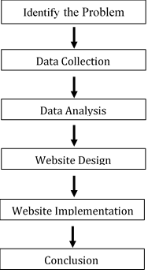
Figure 1. Research Design
The following explanation from the research picture above:
2.1.Identify the Problem
Identifikasi masalah dalam penelitian ini adalah pembelajaran secara konvensional yang masih relatif sulit untuk pada pahami khususnya pada mata pelajaran matematika. Anggapan matematika menjadi mata pelajaran yang menakutkan, sulit dan membosankan. Kurangnya perilaku mandiri pada mengerjakan soal karena takut jawabannya salah dan kurangnya motivasi anak dalam mengulang konsep yg sudah disampaikan sang Guru sebagai akibatnya cepat lupa. Penggunaan pembelajaran multimedia pada proses belajar matematika biasanya masih sangat sporadis ditemui pada berbagai sekolah menengah pertama yang menyebabkan kreatifitas anak tidak terlaksana dengan baik dan tidak sanggup berkembang.
2.2.Data Collection
Collecting data in the form of problems that are not infrequently experienced by students at school in learning mathematics through interviews with a mathematics teacher at SMPN 43 Batam & literature study on the problems of students who have a relationship with learning mathematics through web-based learning applications as well as all theories needed to support this research
2.3.Data Analysis
Analyze data collected from interviews and library research for website design.
2.4.Website Design
Starting from the website design that will be created as well as material or education that will be included on the web such as the introduction of mathematics and learning mathematics (addition, subtraction, multiplication and division)[5]. This application is designed using Notepad ++ and the programming language that supports the creation of applications, namely the html, php, and css languages.
2.5.Website Implementation
learning applications that have been designed subsequently applied to SMPN 43 Batam which is useful to know the effect of learning applications on children's values ​​and motivation in learning mathematics.
2.6.Conclusion
The results obtained from the research design can be concluded as follows:
- With the application of web-based learning applications in junior high schools can help teachers in the teaching process so that students understand more about mathematics, and learning is not boring.
- Mathematics learning application is expected to be able to contribute to junior high schools which previously the school has never used a theory like this and implemented directly with practice so that students quickly grasp knowledge and are not easily forgotten.

Results and Discussion
3.1.System design
In making this learning application, researchers used the Unified Modeling Language (UML) model. UML that is used is as follows:
- Use Case Diagram
Use case is an external view of the system that we made the model[6]. The use case model can be described in the use case diagram, but the diagram is not indicative of the model because the model is wider than the diagram. Use cases must be able to describe the sequence of actors that produce measurable values. The model of use case diagram made can be seen in the following figure:
Figure 2. Use Case Diagram

- Activity Diagram
Activity Diagram is a system activity in the form of a collection of actions how the action starts, the decision that might occur until the end of the action[7]. This application includes two menu choices, including material, and assignments / quiz. Therefore it is divided into three parts for activity diagrams, including:
Figure 3. Activity Diagram of Material
Figure 4. Activity Diagram of Task/Quiz
- Sequence Diagram
Sequence diagram is a diagram that illustrates the interaction between objects and communication between these objects[8]. This diagram shows a series of messages exchanged by an object that will perform a task. Therefore it is divided into three parts for the segregation diagram, including:
Figure 5. Sequence Diagram of Material
Figure 6. Sequence Diagram of Task/Quiz
3.2.Implementation
After completing the research, the results of the research by the researcher can be obtained. Following is the appearance of the Web Based Learning Application Learning Method:
a) Initial Display
This display is the first time the user login to the website:
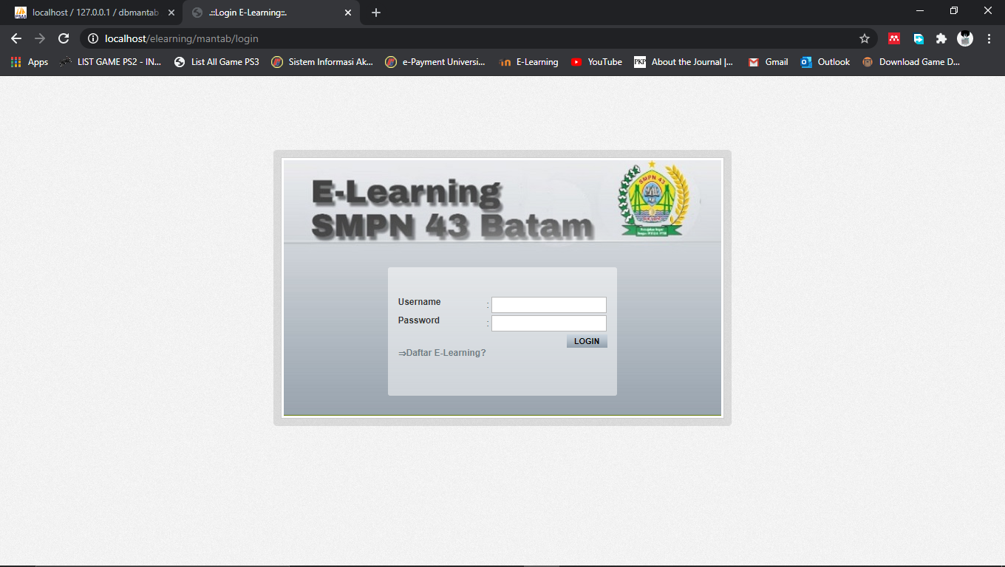
Figure 7. Initial Display
The picture above is the initial appearance of the website. Registered users are asked to log in first. And for those who have not been able to choose the E-learning list menu.

b) Menu Display
After logging in, a menu display from the website appears. Here is how it looks:
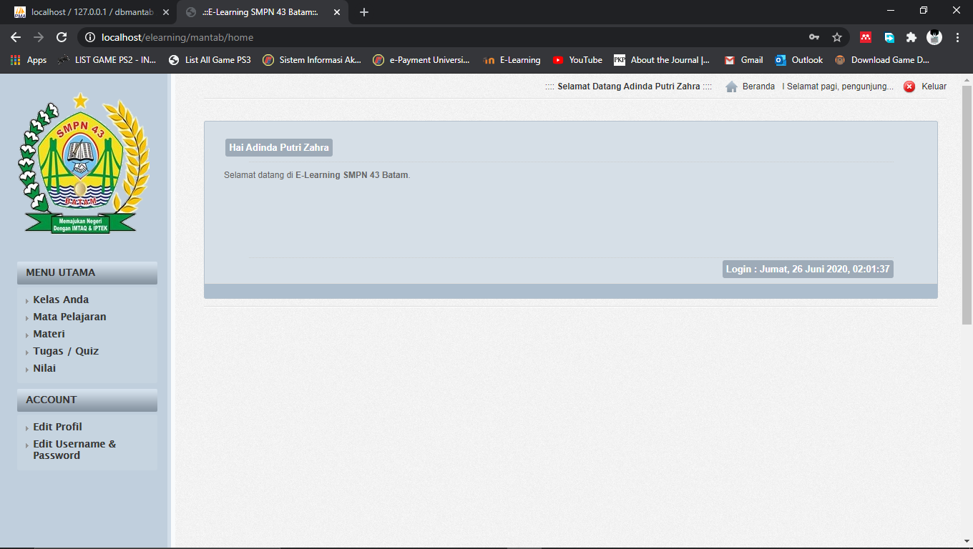
Figure 8. Menu Display

In this menu display, there are two menus and several sub-menus that researchers provide, including:
1. Main course (Menu Utama)
a) Your Class (Kelas Anda)
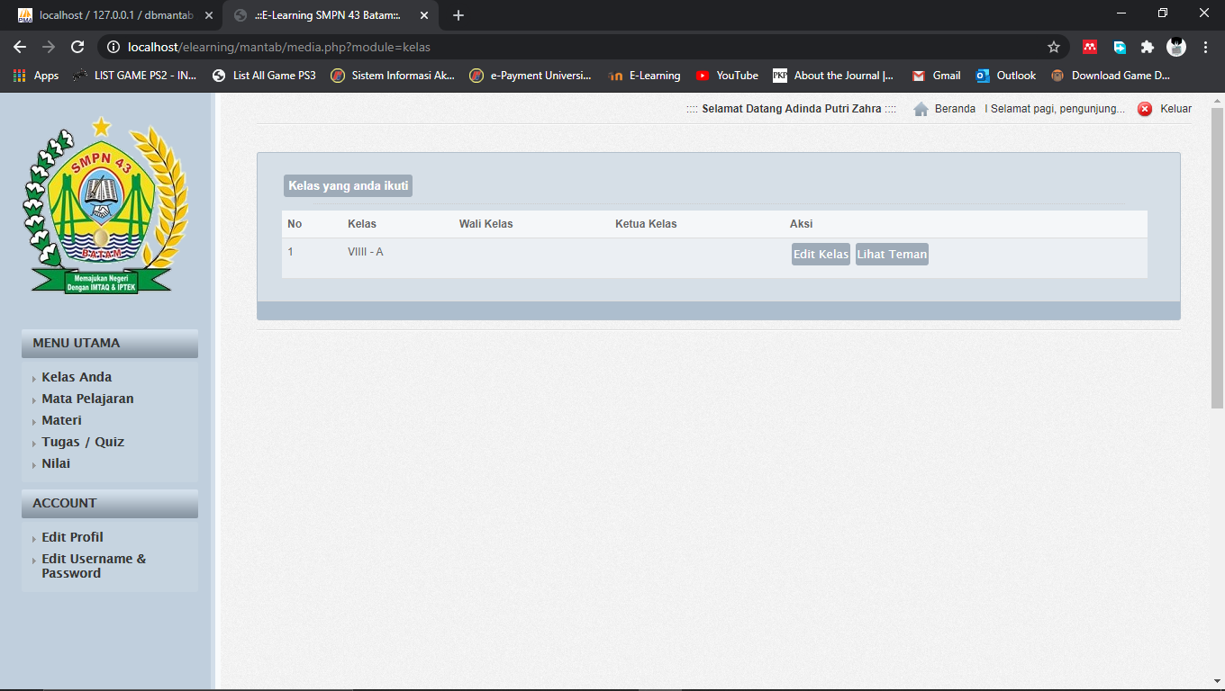
Figure 9. Display Your Class Menu (Kelas Anda)
In this menu the user can see the classes that are followed. In this menu the user can also edit classes and see friends in the class.

b) subjects (Mata Pelajaran)
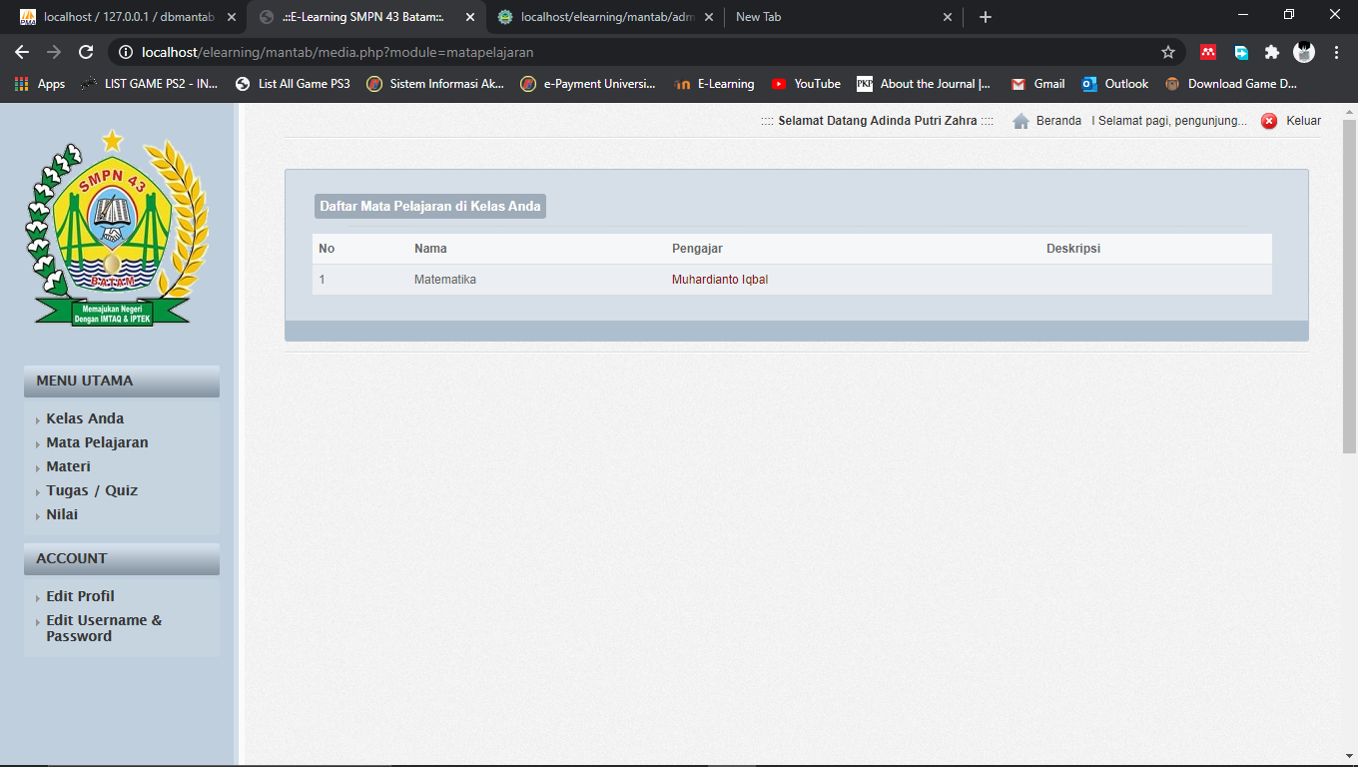
Figure 10. Display Menu Subject (Mata Pelajaran)
In this menu the user can see what subjects are in that class.
c) Material (Materi)
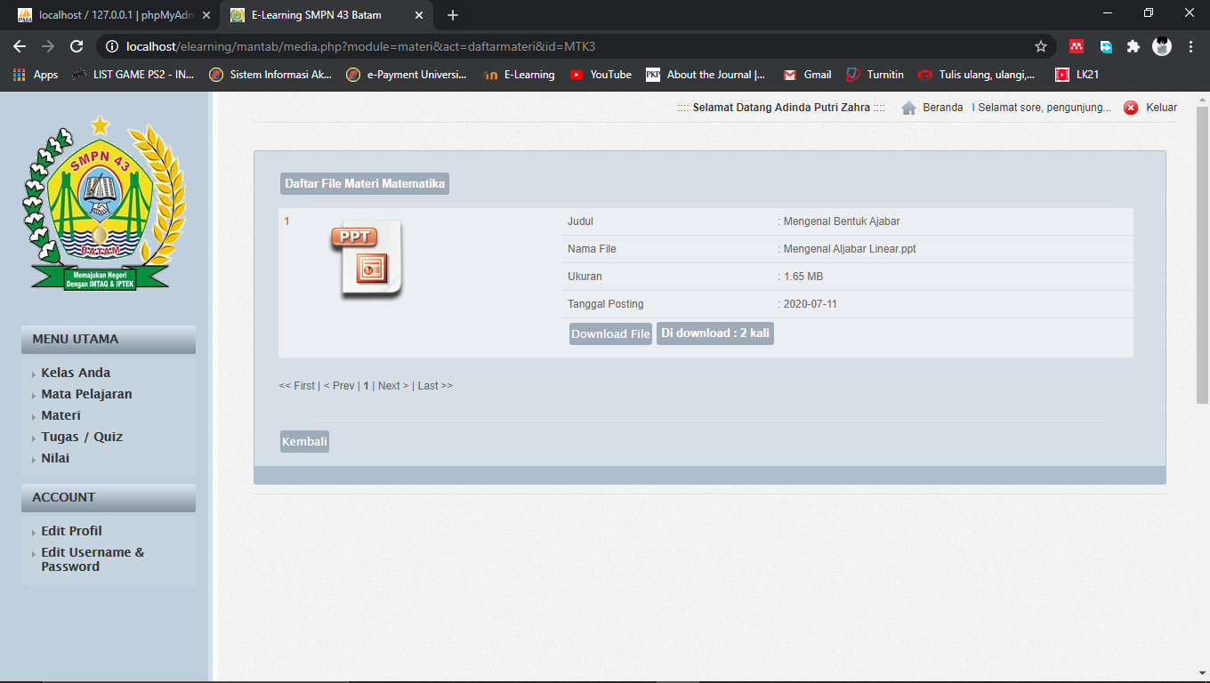
Figure 11. Display Menu Material (Materi)
In this menu the user can see the subject matter to be learned. The material can be downloaded also to be studied by the user.

d) Task/Quiz
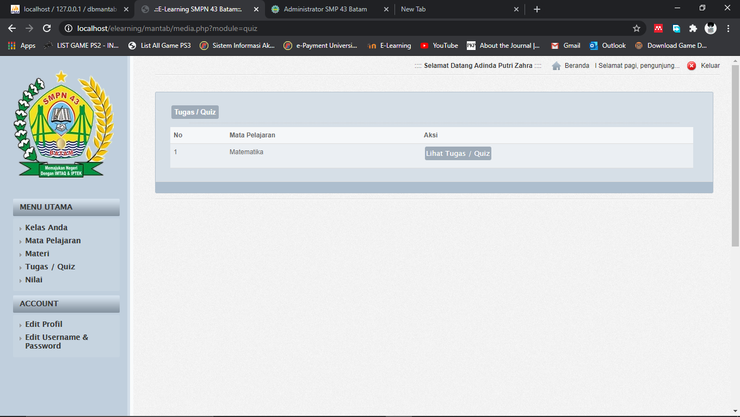
Figure 12. Display Menu Task/Quiz
This menu is a menu where users work on assignments or quizzes given by the teacher.
e) Score (Nilai)
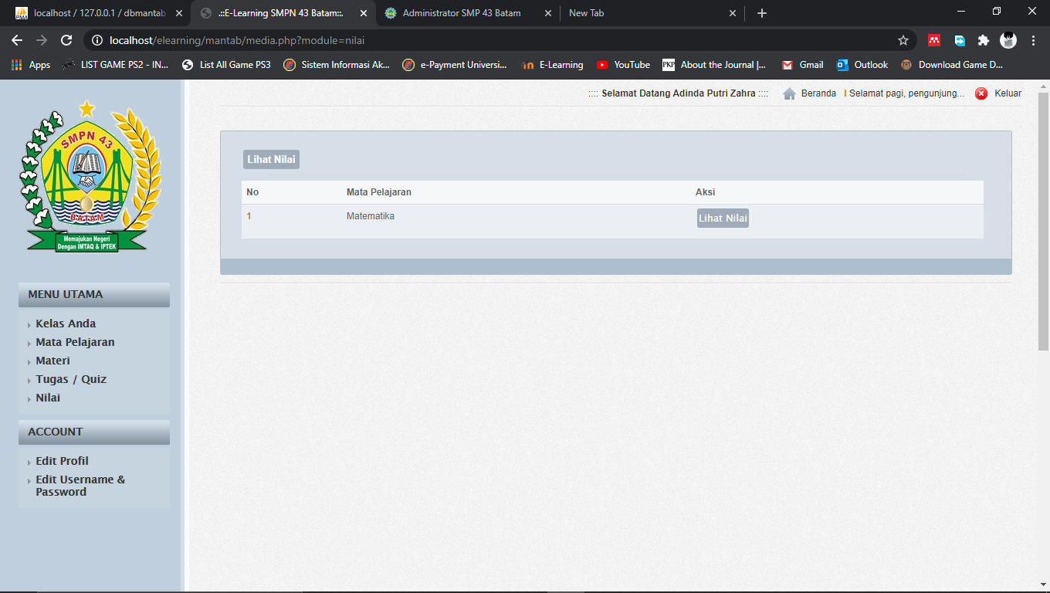
Figure 13. Display Menu Score (Nilai)
In this menu the user can see the value of the task or quiz that has been done.
2. Account

a) Edit Profile
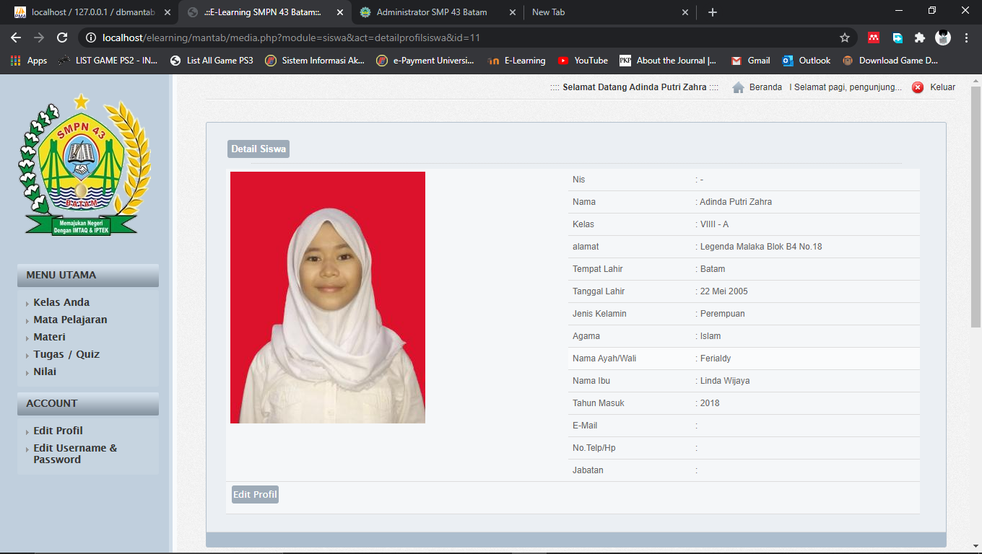
Figure 14. Display Edit Profile
In this menu the user can change the user's personal data.
b) Edit Username & Password
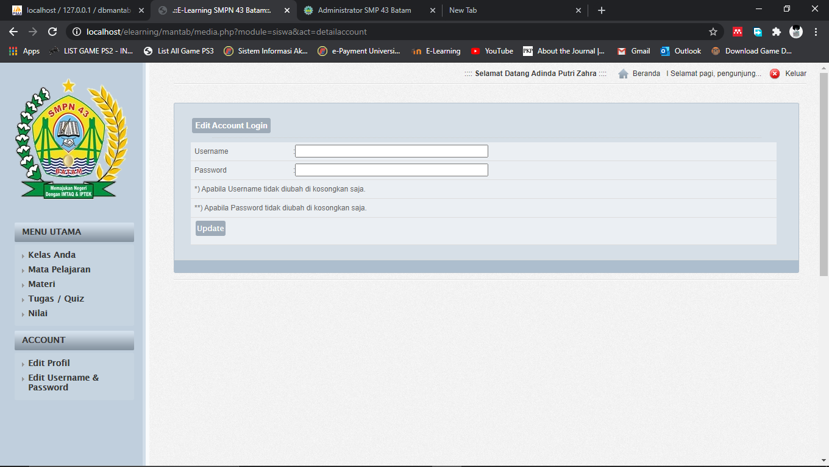
Figure 15. Display Menu Edit Username & Password
In this menu the user can change the username and password.
3.3.Reseach Result
From the results of the research above explained that the application has been tested and made using web-based learning methods, which method is useful to assist students in teaching and learning processes in addition to using conventional learning techniques. Because with this application students can learn anywhere and anytime so that students can better understand the material being studied and do not feel difficult or even afraid to do assignments. The following explanation is made in detail in the table below:

a) Main Menu Display
Input | Proses | Ouput
Press your class menu | Displays your class menu | Success
Press the subject menu | Displays your class menu | Success
Tekan menu materi | Press the material menu | Success
Press the Tasks/Quiz Menu | Displays the task / quiz menu | Success
Press the value menu | displays the value menu | Success
Table 1. Main Menu Display
In the table above it is explained that when the main menu is tested and run.
b) Display Menu Account
Input | Proses | Ouput
Press the profile edit menu | Display the profile edit menu | Success
Press the edit menu for username & password | Display the edit menu for username & password | Success
Table 2. Display Menu Account
The table above explains that when the account menu is run.

Conclusion
At the end of this study, researchers summarize all the research that has been done, then it can be concluded as follows:
1. With this application, it can be expected as a tool for the learning process of students in learning mathematics.
2. With this application, the teaching and learning process is not boring and makes students more confident in working on the problems.
3. Can be used as a tool for teachers and parents in guiding and teaching mathematics with this application.

References
[1] R. Sujanem, I. N. P. Suwindra, and I. K. T. Tika, “Pengembangan Modul Fisika Kontekstual Interaktif Berbasis Web Untuk Siswa Kelas,” J. Pendidik. dan Pengajaran, vol. 42, no. 2, pp. 97–104, 2009.
[2] S. Bakti, nelly astuti Hasibuan, lince tomoria Sianturi, and ronda deli Sianturi, “Perancangan Aplikasi Pembelajaran Coreldraw X3 Mengunakan Metode WEB Based Learning (WBL),” Peranc. Apl. Pembelajaran Coreldraw X3, vol. 3, no. 4, pp. 32–35, 2016.
[3] J. Gunawan, “Perancangan Aplikasi Pembelajaran Aljabar Dengan Menerapkan Metode Web Based Learning ( Wbl ),” pp. 90–93, 2014.
[4] N. I. Fajariyah et al., “Unnes Journal of Mathematics Education,” Ujme, vol. 1, no. 2, 2012.
[5] R. Firmansyah and I. Saidah, “Perancangan Web Based Learning Sebagai Media Pembelajaran Berbasis Ict,” Informatika, vol. 3, no. September, pp. 176–182, 2016.
[6] H. Gomaa, “Use Case Modelling,” Softw. Model. Des., pp. 71–89, 2011.
[7] A. A. Cholid, H. Elmunsyah, and S. Patmanthara, “Pengembangan Model Web Based Learning Pada Mata Pelajaran Jaringan Dasar Paket Keahlian Tkj Pada Smkn Se-Kota Malang,” J. Pendidik. - Teor. Penelitian, dan Pengemb., vol. 1, no. 5, pp. 961–970, 2016.
[8] Suendri, “Implementasi Diagram UML (Unified Modelling Language) Pada Perancangan Sistem Informasi Remunerasi Dosen Dengan Database Oracle (Studi Kasus: UIN Sumatera Utara Medan),” J. Ilmu Komput. dan Inform., vol. 3, no. 1, pp. 1–9, 2018.

