PID Controller Design for Heating Furnace Temperature Based on Bat Algorithm (BA)

Budiman a,1, Machrus Ali a,2,*

a Universitas Darul Ulum, Jl Gus Dur 29A, Mojongapit, Jombang 61413, Indonesia

1 budimanjombang1@gmail.com; 2 machrus7@gmail.com *

* corresponding author

|  |  |  |  |
| --- | --- | --- | --- |
|  |  | ABSTRACT |  |
| **Keywords**  Bat Algorithm  Heating Furnace  PID Controller  Artificial Intelligence |  | A furnace is a tool for heating materials, oil, and others. Furnaces use gas, coal, and oil as fuel. Temperature is the main parameter that needs to be controlled to remain stable, and precise and improve fuel efficiency. As technology develops, several methods can be used to control temperatures that are more reliable than conventional controls. The technology is a Proportional Integral Derivative (PID) controller. PID controllers have been proven and widely used in the industry, but determining the gain of the PID value is still not accurate. This can affect temperature stability, and slow response to reach the desired set point. Therefore, it is necessary to optimize the control system. Optimizing by looking for a better PID gain value with the artificial intelligence tuning method. The Artificial Intelligence method is Bat Algorithm(BA). The simulation results and discussion show that the best design is PID-BA with an overshoot of 0.0429, non undershoot, and the fastest settling time of 16.9 seconds. |  |
|  |  |

# Introduction

The rapid development of technology requires meeting the high demand for automation-based industries. A reliable control system is required to ensure system reliability and improve efficiency. The control of the heating process in a furnace system is an important example of industrial automation. Process control needs to be considered to produce products with high added value. The adjustment of process control parameters must be ensured to make the system performance meet the operating objectives[1-2]. Optimization is needed to produce good temperature control results because it offers more stable and efficient results compared to conventional controls. Intelligent control based on Artificial Intelligence has developed a lot to improve conventional control[3-4]. PID controllers with artificial intelligence tuning have been proven to improve control system optimization[5][6].

Intelligent control based on Artificial Intelligence has been developed a lot to improve the control system. Many control systems have been used; including conventional control systems, PID controls, Fuzzy controls, Adaptive Neuro-Fuzzy Inference Systems (ANFIS), and other types of controllers[7][8]. PID controllers with artificial intelligence tuning have been used in Imperialist Competitive Algorithm (ICA), Particle Swarm Optimization (PSO) Method, Firefly Algorithm (FA) Method, Imperialist Competitive Algorithm (ICA) Method, Ant Colony Optimization (ACO) Method, and Bat Algorithm (BA). Each method has its advantages and disadvantages[9][10].

# Temperature Control System

## **Furnace Temperature Control System**

The furnace as shown in Figure 1 is a tool used to raise the temperature of an object using burning fuel. The function of the furnace is to produce heat energy and produce combustion. The fuel used can be in the form of liquid fuel and gas fuel mixed by the burner to create combustion. A burner is a tool that supplies or regulates the fuel and air to be burned. This tool works by using a balanced mixture of gas and air composition. One of its uses is to mix air and fuel to create good combustion and increase combustion efficiency. Generally, the burner is divided into two parts: the pilot burner and the main burner. The pilot burner is used as the starting point for the ignition process, then after ignition, it will be continued with the main burner until it reaches a state where the burner consumes more gas and air. Heating is produced by distributing the fuel through tubes or pipes arranged as best as possible in the furnace. Heat transfer occurs in three ways, namely convection, conduction, and radiation.

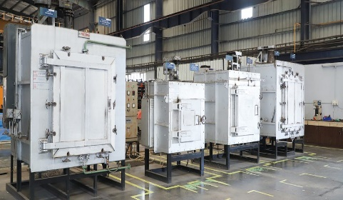

Figure 1 Furnace for the Combustion Process

## **Sistem Cascade**

The furnace temperature control system considered in this paper is shown in Fig.2. T1C represents the main controller, T2C represents the secondary controller, T1T is for a collection of material temperature measurement points, and T2T is for furnace temperature measurement.

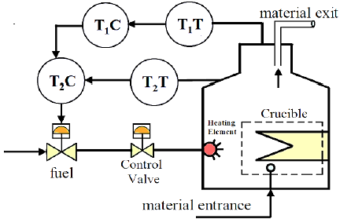

Figure 2. Furnace Temperature System [11]

The output of the main controller (T1C) becomes the set point for the second controller (T2C). T2C is used to control fuel flow. In the heating process, the material is placed in a container to be heated to a certain temperature. Three components must be controlled in the combustion chamber, from fuel control to raw material export control. These components are furnaces, fireplaces, and heated raw materials.

## **Control System Modeling**

To represent the schematic of the heating furnace temperature system shown in Fig.2, the transfer function equations given in (1) and (2) will be used in the simulation using the MATLAB Simulink software.

$G_{1}(s)=\frac{1/90}{\left(s+1/30\right)\left(s+1/3\right)}$ (1)

$G_{2}(s)=\frac{1/10}{\left(s+1/10\right)\left(s+1\right)}$ (2)

One controller that is still considered reliable in the control model is the PID controller. The controller has been widely used and proven to be able to optimize a control system correctly and precisely. The reason for using a PID controller is that the controller is simple, easy to design, stable, and provides a fast response. However, in its use, there is often an offset or difference between the set point value and the result variable value, and there are still quite large oscillations or response waves.

To control the values of the PID constants (Kp, Ki, and Kd) it is necessary to remove the offsets properly. If not controlled it can result in a large deviation value with a very long response time compared to conventional methods. Derivative control also needs to be done so that the control rate can be controlled because it can reduce or eliminate excessive oscillations. The offset that occurs is usually caused by an integral control that is too large.

# Metode

## **PID Controller Design**

PID control has been widely used in industry, especially control applications because of its simple structure, comprehensive control algorithm, and low cost. The following schematic model of the PID control is shown in Figure 3 as follows:

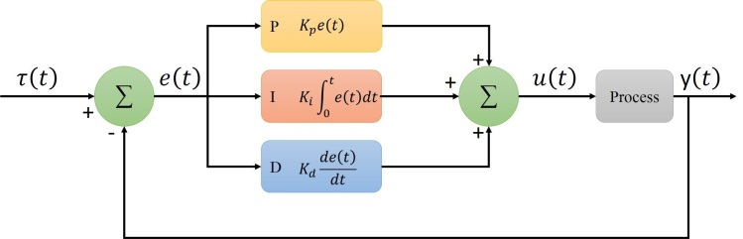

Figure 3 Proportional Integral Derivative (PID) control system

The value of PV is calculated as PV = y(t) : e(t) = τ(t) – y(t), and the corrective action is applied based on the proportional, integral, and deviation rules. This controller takes corrective actions by adjusting the control variable (CV) u(t). Several PID Controller tuning methods are used to find the constant values of kp, ki, and kd, including using the Ziegler Nichols method, the auto-tuning by Matlab method, and the artificial intelligence method[12]. Adjusting the controller gain based on the factory model or factory data is known as auto PID tuning. Use the PID auto-tuning technique to tune real-time PID gain to a physical plant, or use Simulink Control Design to fine-tune PID acquisition in Simulink models[13].

## **Bat Algorithm(BA)**

Bat Algorithm (BA) is an algorithm inspired by the behavior of bats (Bat Behavior). This algorithm was introduced by Xin-She Yang in 2010[14]. BA simulates the behavior of bats. For convenience, these behavioral characteristics of bats are divided into 3 rules: All bats use echolocation to sense distance, and they also know. The difference between food or prey and background obstacles in some miraculous way, Bats fly randomly with attention to speed, position and frequency, different wavelengths, and loudness to find prey. They can automatically adjust the wavelength (or frequency) of their emitted pulses and adjust the emission pulse rate depending on the proximity of their target. Although loudness can vary in many ways, we assume that it varies from a maximum to a minimum magnitude[15]. The pseudo code of the Bat Algorithm (BA) can be seen in Figure 4.

*Objective function* f(x), x = (x1, ..., xd)T

*Initialize the bat population* xi (i = 1, 2, ..., n) *and* vi

*Define pulse frequency* fi *at* xi

*Initialize pulse rates* ri *and the loudness* Ai

while *(*t <*Max number of iterations)*

*Generate new solutions by adjusting frequency,*

*and updating velocities and locations/solutions [equations (2) to (4)]*

if *(rand* > ri*)*

*Select a solution among the best solutions*

*Generate a local solution around the selected best solution*

end if

*Generate a new solution by flying randomly*

if *(rand* < Ai & f(xi) < f(x_)*)*

*Accept the new solutions*

*Increase* ri *and reduce* Ai

end if

*Rank the bats and find the current best* x_

end while

*Postprocess results and visualization*

Figure 4. Bat algorithm pseudo code (BA).

# Results and Discussion

## **Desain Simulink**

#### The Simulink design consists of 4 designs, namely Simulink transfer function without a controller, with a conventional PID controller (PID-konv), with a Matlab Autotuned PID controller (PID-Auto), and with a BA-tuned PID controller (PID-BA). Each design is given a set point value equal to 1. In awarding a set point there are 2 types, namely linear (switching to position 1) and gradual (switching to position 2) can be seen in Figure 4.

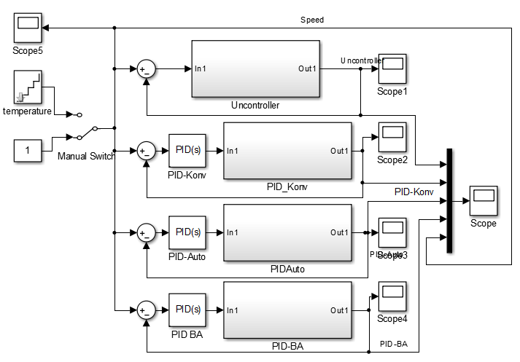

Figure 4. Response of the heating furnace temperature control at position 1 switch

## **Simulink Response Results**

At switch position 1, the Simulink design without a controller, with a conventional PID controller (PID-konv), with a Matlab Auto tuning PID controller (PID-Auto), and with a BA tuned PID controller (PID-BA), can be seen in Figure 5. (a) and 5(b)



5(a)



5(b)

Figure 5(a) and 5(b). Response of furnace temperature control at switch 1 position

At switch position 2, the Simulink design is without a controller, with a conventional PID controller (PID-konv), with Matlab Auto tuning PID controller (PID-Auto), and with a BA tuned PID controller (PID-BA), can be seen in Figure 6



Figure 6. Response of the heating furnace temperature control at switch 2 position

Table 2. Response of each controller to changes in temperature

|  |  |  |  |  |
| --- | --- | --- | --- | --- |
|  | Uncontrolled | PID-Konv | PID-Auto | PID-BA |
| Kp | - | 1 | 8.3004 | 5.5220 |
| Ki | - | 1 | 0.1337 | 0.3032 |
| Kd | - | 0 | 0.2523 | 0.1616 |
| Overshoot | - | 0.3482 | 0.0456 | 0.0429 |
| Undershoot | 0.478 | 0.0431 | 0.0408 | - |
| Settling time | ∞ | 75 | 50 | 16.9 |

From the simulation results described in Figures 5(a), 5(b), and Table 2, it is found that the design without control has an undershoot of 0.0478 with an infinite settling time. This shows that the design without control will not reach a steady state. In the conventional PID design (PID-konv), the overshoot value is 0.3482, the undershoot is 0.0431, and the setting time is 75 seconds. In Matlab's Autotuning PID control design (PID-Auto) the value of Kp = 8.3004, Ki = 0.1337, Kd = 0.2523 results in an overshoot value of 0.0456, an undershoot of 0.0408 and a settling time of 50 seconds. In the PID-BA design, Kp = 5.5220, Ki = 0.3032, Kd = 0.1616 with an overshoot value of 0.0429, no undershoot, and a settling time of 16.9 seconds.

# Conclusion

From the simulation results and discussion, it can be concluded that the best design is PID-BA with an overshoot of 0.0429, no undershoot, and the fastest settling time of 16.9 seconds. Even though the uncontrolled has the smallest overshoot value, the uncontrolled design cannot touch the setpoint. Simulation results can be used in setting the PID on the actual plan. And will be researched with other methods to find the best optimization design.

# References

[1] T. L. Mien, V. Van An, and B. T. Tam, “A Fuzzy-PID controller combined with PSO algorithm for the resistance furnace,” *Adv. Sci. Technol. Eng. Syst.*, vol. 5, no. 3, pp. 568–575, 2020, doi: 10.25046/aj050371.

[2] S. Wang, N. Li, and F. Yang, “Resistance furnace temperature system on fuzzy PID controller,” *J. Inf. Comput. Sci.*, vol. 9, no. 9, pp. 2627–2634, 2012.

[3] M. Al-Amin and M. S. Islam, “Design of an Intelligent Temperature Controller of Furnace System using the Fuzzy Self-tuning PID Controller,” in *Proceedings of International Conference on Electronics, Communications and Information Technology, ICECIT 2021*, 2021. doi: 10.1109/ICECIT54077.2021.9641467.

[4] G. Chen, M. Li, and J. Zhang, “Application of fuzzy PID improved algorithm in thermogravimetric analysis of furnace temperature control,” *Beijing Jiaotong Daxue Xuebao/Journal Beijing Jiaotong Univ.*, vol. 43, no. 5, pp. 94–101, 2019, doi: 10.11860/j.issn.1673-0291.20180158.

[5] M. Ali, A. N. Afandi, A. Parwati, R. Hidayat, and C. Hasyim, “DESIGN OF WATER LEVEL CONTROL SYSTEMS USING PID AND ANFIS BASED ON FIREFLY ALGORITHM,” *JEEMECS (Journal Electr. Eng. Mechatron. Comput. Sci.*, vol. 2, no. 1, Feb. 2019, doi: 10.26905/jeemecs.v2i1.2804.

[6] Kadaryono, Rukslin, M. Ali, Askan, A. Parwanti, and I. Cahyono, “Comparison of LFC Optimization on Micro-hydro using PID, CES, and SMES based Firefly Algorithm,” in *2018 5th International Conference on Electrical Engineering, Computer Science and Informatics (EECSI)*, Oct. 2018, pp. 204–209. doi: 10.1109/EECSI.2018.8752733.

[7] Muhlasin, Budiman, M. Ali, A. Parwanti, A. A. Firdaus, and Iswinarti, “Optimization of Water Level Control Systems Using ANFIS and Fuzzy-PID Model,” in *2020 Third International Conference on Vocational Education and Electrical Engineering (ICVEE)*, Oct. 2020, pp. 1–5. doi: 10.1109/ICVEE50212.2020.9243229.

[8] M. Ali and M. Muhlasin, “Kontrol Kecepatan Putaran Permanent Magnet Synchronous Machine (PMSM) Menggunakan PID, FLC Dan ANFIS,” *J. Elektro*, vol. 4, no. 1, p. 253, Apr. 2019, doi: 10.30736/je.v4i1.302.

[9] D. H. Kusuma, M. Ali, and N. Sutantra, “The comparison of optimization for active steering control on vehicle using PID controller based on artificial intelligence techniques,” in *2016 International Seminar on Application for Technology of Information and Communication (ISemantic)*, Aug. 2016, pp. 18–22. doi: 10.1109/ISEMANTIC.2016.7873803.

[10] M. Ali *et al.*, “The comparison of dual axis photovoltaic tracking system using artificial intelligence techniques,” *IAES Int. J. Artif. Intell.*, vol. 10, no. 4, p. 901, Dec. 2021, doi: 10.11591/ijai.v10.i4.pp901-909.

[11] Y. V. P. K. Y V Pavan Kumar, “Cascaded PID Controller Design for Heating Furnace Temperature Control,” *IOSR J. Electron. Commun. Eng.*, vol. 5, no. 3, pp. 76–83, 2013, doi: 10.9790/2834-0537683.

[12] M. Ali and M. Muhlasin, “Auto-Tuning Method for Designing Matlab DC Motor Speed Control With PID (Proportional Integral Derivative),” *ADRI Int. J. Sci. Eng. Technol.*, vol. 1, no. 2, pp. 5–8, 2017, [Online]. Available: https://index.pkp.sfu.ca/index.php/record/view/856960

[13] S. Zhao, S. Liu, R. De Keyser, and C. M. Ionescu, “The application of a new PID autotuning method for the steam/water loop in large scale ships,” *Processes*, vol. 8, no. 2, 2020, doi: 10.3390/pr8020196.

[14] X. S. Yang, “Bat algorithm for multi-objective optimisation,” *Int. J. Bio-Inspired Comput.*, vol. 3, no. 5, pp. 267–274, 2011, doi: 10.1504/IJBIC.2011.042259.

[15] M. Ali, T. Fahmi, D. W. Khaidir, and H. Nurohmah, “Optimizing Single Axis Tracking for Bat Algorithm-based Solar Cell,” *J. FESPE*, vol. 2, no. 2, pp. 1–5, 2020.