Appendix
Appendix 1. Picture 1: Multivariate Normality Test using Kolmogorov-Smirnov test.
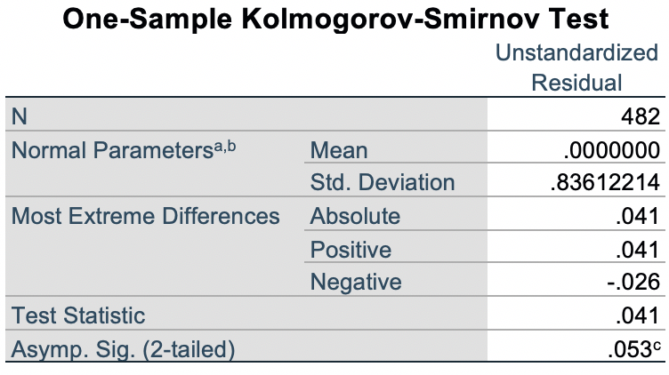

Appendix 2. Picture 2: Multicollinearity Test.

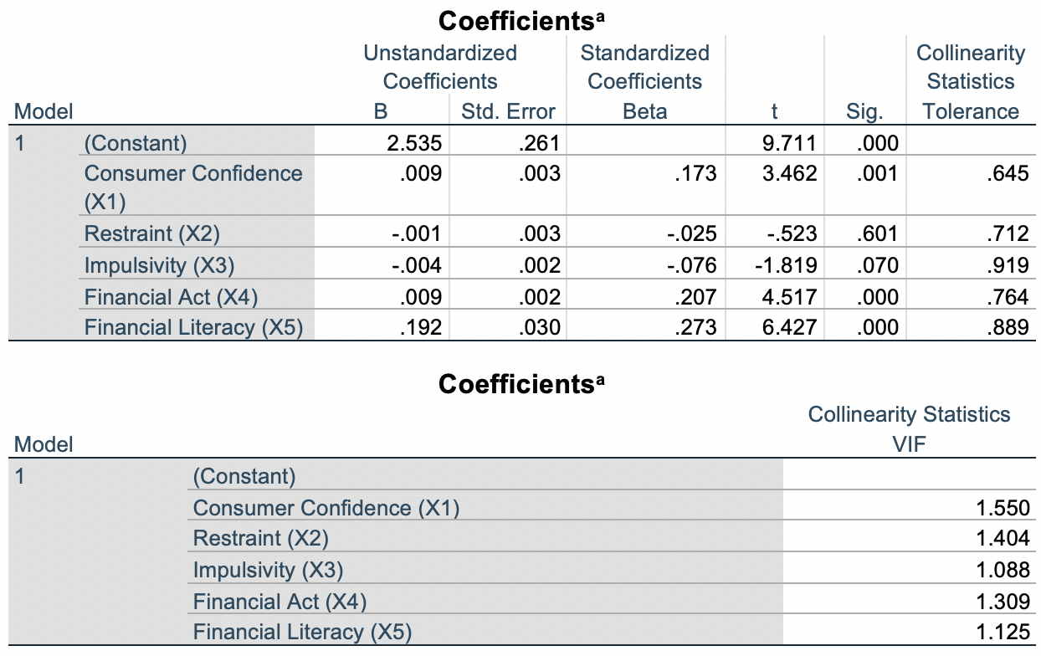

Appendix 3. Picture 3: Heteroscedasticity Test using Spearman’s Rank Test.

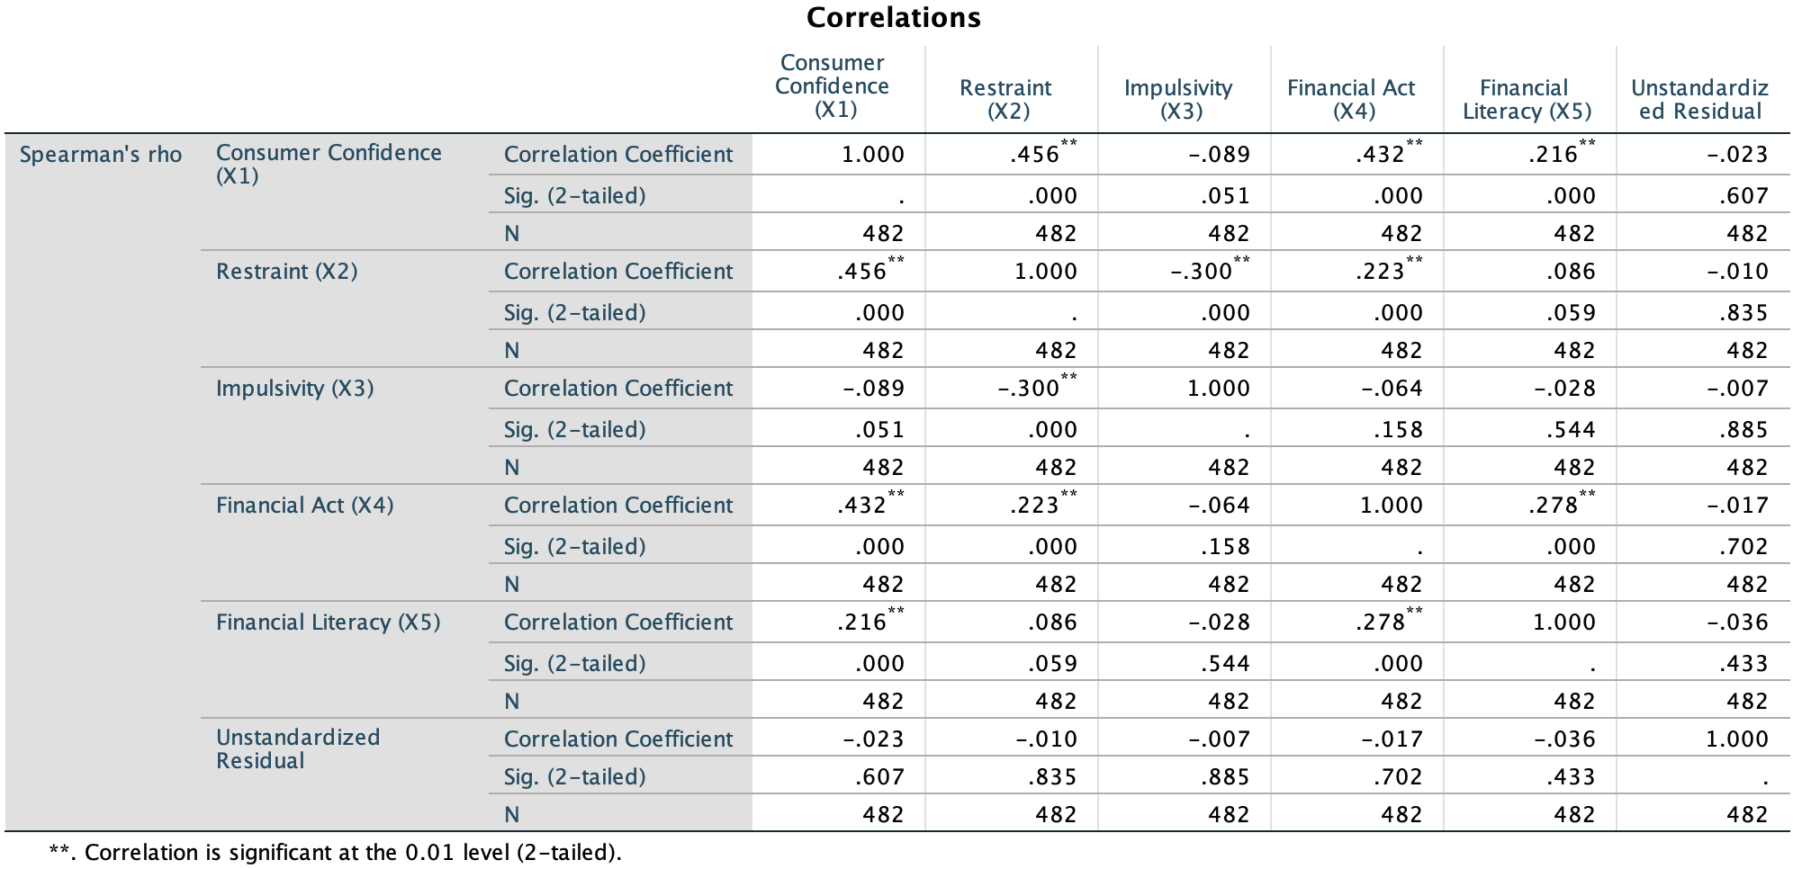

Appendix 4. Picture 4: Multivariate Regression.

