|  |  |
| --- | --- |
| PUBLISIA: Jurnal Ilmu Administrasi Publik  <http://jurnal.unmer.ac.id/index.php/jkpp> | ISSN:  2541-2515(p), 2541-2035(e)  Volume: xx (xx) xxxx:  p. …. - …..  DOI: Prefix 10.26905 |

**Analysis of Post-Pandemic Border Opening Policy on Immigration Services: Case Study of Immigration Office Class I Non-Checkpoint Pati**

**…….**

**…….**

Email: ……..

|  |  |
| --- | --- |
|  | **Abstract** |
| Article Histori:  Submited: ……….  Review: ……….  Editing: ……….  Publish: ………. | *Immigration services are one of the services for people affected by the COVID-19 pandemic. However, as the handling got better, the vaccination program became more widespread and the spread became lower, the Government began to provide some leeway including the opening of borders. People who want to travel between countries begin to prepare themselves by applying for a passport. Immigration Office Class I Non-Checkpoint Pati as an Immigration Technical Implementation Unit faces fluctuations in applications for passport issuance during this pandemic. Issues and information as well as announcements from the government influence people to apply for passports. Improving passport services must also consider service quality. Internal surveys and also Google Review analysis as a form of external service evaluation is important to do to determine the quality of services provided. Immigration Office Class I Non-Checkpoint Pati in the period December 2021 to May 2022 obtained a positive service quality assessment from the immigration service user community.* |
|  |  |
| **Keyword***: Pandemic, Immigration, Passport, Service Quality.* | |

1. **INTRODUCTION**

The COVID-19 pandemic has affected many sectors of Indonesian society over the past few years. Since it was declared a national disaster on Monday, April 13, 2020 through Presidential Decree Number 12 of 2020 concerning the Determination of the 2019 Coronavirus Disease (COVID-19) Non-Natural Disaster, the government has been very careful in determining a policy that has a broad impact on society. Various provisions and regulations are made in order to reduce the impact of the spread of COVID-19 including large-scale restrictions carried out both at the national level and at the provincial or district / city level. The aim is to suppress the spread and reduce the number of victims infected with this deadly virus.

The COVID-19 pandemic has caused a decrease in mobility by citizens. This decrease has not only occurred within the country but also cross-border travel has also experienced the same thing. The closure of border gates by certain countries as part of preventive efforts to prevent the spread is one of the reasons. This decline will certainly affect many other sectors of life such as transportation and accommodation services. In the end, it will broadly affect both regional and national economic movements as people tend to be cautious in traveling across and between countries.

After more than 2 (two) years of grappling with the conditions of the COVID-19 pandemic, at the beginning of 2022 there was a very significant change with the lower level of spread and the wider national vaccination program launched by the government. This happened not only in Indonesia, but in general the conditions for handling the COVID-19 pandemic in various countries showed encouraging results. Economic movement has started to run, many countries have opened borders even with strict health protocols, various travel destinations with diverse purposes such as business and tourism have begun to develop. National and international events that allow crowds to occur have obtained approval for implementation but still with strict health protocols. This condition encourages the mobility of citizens to travel increasingly. Not only domestic travel but also travel between countries.

The development of the mobility of people traveling between countries is closely related to the country's policy towards traveling in and out of its territory. Malaysia and Singapore only opened their borders and allowed foreigners to enter the country on April 1, 2022 (Maliana, 2022). Both countries previously only allowed their own citizens to enter their territory and restricted and tended to refuse foreign nationals to enter, especially citizens from countries with high transmission rates and conditions for the spread of COVID-19. Australia first opened its borders by reopening international flights to and from all states in Australia (Hafizhah, 2022). This was done after 2 (two) years of Australia establishing a very strict policy in order to prevent the spread of COVID-19 in the country.

People who want to travel between countries need travel documents. Travel documents are official documents issued by authorized officials of a country, the United Nations, or other international organizations to carry out travel between countries that contain the identity of the owner (*Undang-Undang Nomor 6 Tahun 2011 Tentang Keimigrasian*, 2011b). In Indonesia, this travel document is better known as the Passport of the Republic of Indonesia or commonly referred to as a passport. Passports consist of Ordinary Passports issued by the Directorate General of Immigration as well as Diplomatic Passports and Service Passports issued by the Ministry of Foreign Affairs (*Undang-Undang Nomor 6 Tahun 2011 Tentang Keimigrasian*, 2011a).

Ordinary passports are the type of travel document most widely used by the public to travel between countries. Ordinary passports are obtained from applications both manually and electronically through the Immigration Office or representatives of the Republic of Indonesia abroad (*Peraturan Menteri Hukum Dan Hak Asasi Manusia Nomor 8 Tahun 2014 Tentang Paspor Biasa Dan Surat Perjalanan Laksana Paspor*, 2014). Requirements for passport applications generally consist of e-KTP, Family Card, Birth Certificate / Marriage Certificate / Diploma / baptism letter, and other requirements in accordance with statutory provisions. Passports issued by the Directorate General of Immigration have a validity period of 5 (five) years and can be submitted for replacement at least 6 (six) months before the validity period expires. Submitting a passport application currently uses an application called M-Passport which is a development of the Online Passport Queue Application (APAPO).

Immigration Office Class I Non-Checkpoint Pati is one of the Immigration Technical Implementation Units in Central Java Province. Immigration Office Class I Non-Checkpoint Pati oversees 4 (four) working areas namely Pati Regency, Rembang Regency, Blora Regency and Jepara Regency. In relation to passport applications for Indonesian citizens, applicants can come from any region and the application process is not based on domicile. Fulfillment of the application requirements is the main thing as well as suitability for the purpose and purpose of the passport application made. Because it is located in a very religious area but developing socio-economic conditions, the purpose of applying for a passport at the Immigration Office Class I Non-Checkpoint Pati varies, among others, in order to carry out Umrah or Hajj worship, work, study, travel or even medical treatment abroad.

The COVID-19 pandemic has made the government in general provide restrictions on public services, including passport application services. This is reasonable because the services provided require direct interaction between passport applicants and Immigration officers. On several occasions, passport applications are only served for applicants with urgent and unforeseeable purposes. Of course, such restrictions lead to different perceptions of urgency for each passport applicant. These restrictions led to a decline in applications for passport services. Therefore, it is interesting to discuss when the government began to relax domestic and foreign travel, what effect was obtained by the Immigration Office as the institution responsible for issuing passports. The passport not only functions as a travel document abroad but also attaches state responsibility in the context of protecting its citizens abroad so that supervision by the government is a very possible thing to do (Abdullah, 2019).

1. **LITERATURE REVIEW**

The restrictions imposed by the Government of the Republic of Indonesia for Indonesian citizens and foreigners to travel in and out of Indonesia affect many sectors of life. The government must consider the long-term socio-political effects obtained in the context of managing its borders, especially with regard to handling during the COVID-19 pandemic (O’Connor et al., 2021). This of course also affects the targets and achievements of several state institutions that have been set previously. The government through the Ministry of Investment / BKPM targets an increase in state revenue from the tourism sector of 30 billion dollars and an increase in tourist travelers to 400 million tourists by 2024 (Lahadalia, 2021). In addition, pandemic conditions affect economic movements globally because many countries are affected economically and financially.

The International Monetary Fund (IMF) in its report on the impact of the COVID-19 pandemic on the tourism sector emphasizes 4 (four) preventive measures, including (1) strengthening education through an understanding of tourism management during the pandemic, (2) improving telecommunications facilities to support information dissemination, (3) reducing short-term policies that put the image of tourism in the spotlight, and (4) dynamizing the role of tourism workers in responding to the pandemic (Goretti et al., 2021). However, it should be considered that border opening policies are not always related to increasing tourism competitiveness and economic movement alone (Indrady, 2021). Humanitarian and health aspects as one of the considerations for opening borders also need serious consideration.

On the economic aspect, the policy of restricting international and domestic mobility has a direct impact on slowing and stopping economic activities (Budisusila & Dharma, 2022). The Asian Development Bank (ADB) noted that industrial and economic sectors directly related to human interaction such as transportation, hotels, restaurants, and small and medium enterprises have been impacted by the pandemic to a great extent (Xin, 2020).

In conducting a policy impact evaluation, Arifin Tahir (Tahir, 2018)emphasizes 3 (three) things that need attention, namely:

1. Policy evaluation aims to provide valid data and information on policy performance;
2. Policy evaluation is an effort to assess the certainty of goals and objectives and targets with the problems faced; and
3. Policy evaluation is a methodological tool because it is concerned with recommendations for judgment.

The problem that has become a public spotlight related to passport issuance services is the passport queue registration process (Poltekim, 2020). The development and development of public policies in immigration services will always be related to the development of Information Technology, therefore improving the quality and ability to keep up with the development and dynamism of information technology is something that must be done (Wilonotomo & Aji, 2018). Discussions about the procedures for applying for passport queues, problems with applications, complexity in the process and uninformative stages have become negative sentiments for the Directorate General of Immigration (Syahrin, 2019). The online queuing application is expected to encourage effectiveness and efficiency in the passport application process (Chaharani et al., 2020). The complexity of running an online queue application to obtain immigration services, limiting the number of queue quotas that can be accessed through the application and requirements that are considered incomplete so that the applicant cannot continue the passport application stage are some of the problems often faced by passport applicants (Triyanto et al., 2022). Furthermore, Tutik Rachmawati (Rachmawati & Nasution, 2015)emphasizes 3 (three) important aspects in measuring immigration public services, including (1) friendly, respectful, polite and selfless services related to Service Officers, (2) service timeframes related to service facilities, and (3) service transparency and accountability.

1. **METHOD**

This paper uses a qualitative descriptive approach to explain the effect of the opening of the country's borders on Immigration services, especially those that occur at the Pati Class I Non-Checkpoint Immigration Office. The discussion will be more specifically related to services for the issuance of passports for Indonesian citizens who apply at the Immigration Office. The data used is data obtained from reports submitted on social media Instagram and also Google Review of Immigration Office Class I Non-Checkpoint Pati. The data is the main data analyzed with the help of secondary data from journals, news and literature related to the topic discussed. The data analysis technique uses Discourse Analysis, which tries to find and explain the relationship between the data obtained and the topic of discussion that is the center of analysis.

1. **RESULT AND DISCUSSION**

The number of passport issuances at the Pati Non-Checkpoint Class I Immigration Office has experienced a very significant development. The development in the number of applicants is certainly related to information about the progress of handling the spread of the COVID-19 pandemic which is getting better. In addition, various information about the opening of the borders of several countries that are the destinations for the Umrah and Hajj pilgrimages such as Saudi Arabia, Indonesian Migrant Worker placement countries such as Singapore, Malaysia, Japan, Korea, Taiwan, Hong Kong and several European countries, as well as access to several large countries such as America and Australia which provide opportunities for Indonesian citizens to visit, are factors driving the increase in the number of passport applications.

The development of passport issuance at the Pati Non-Checkpoint Class I Immigration Office in the period December 2021 to May 2022 is shown in the table 1.

|  |  |  |  |  |  |  |  |
| --- | --- | --- | --- | --- | --- | --- | --- |
| ***Table 1. Passport Issuance Data of Immigration Office Class I Non-Checkpoint Pati Period December 2021 to May 2022*** | | | | | | | |
| ***No.*** | ***Passport Type*** | ***2021*** | ***2022*** | | | | |
| ***December*** | ***January*** | ***February*** | ***March*** | ***April*** | ***May*** |
| 1. | 48-Page Passport | 725 | 763 | 1.416 | 2.109 | 2.419 | 1.904 |
| 2. | 24-Page Passport | 61 | 70 | 74 | 88 | 78 | 90 |
| 3. | Damaged / Lost  Passport | 20 | 46 | 39 | 71 | 60 | 83 |
| *Source: processed from data on Immigration Service and Law Enforcement Reports on Instagram Immigration Office Class I Non-Checkpoint Pati* | | | | | | | |

**Condition in January 2022**

Comparison of the number of applications for 48 Page passports in December 2021 with applications in January 2022 is relatively sloping. This is due to the fact that there is no valid information regarding the opening of state borders and the process of entering and exiting Indonesian territory must show negative PCR results and upon returning from an overseas trip, must follow COVID-19 prevention procedures by quarantining. For information, a 48-page passport is a passport used by Indonesian citizens for various purposes abroad. Unlike the 24- page passport which is intended for prospective Indonesian migrant workers who have just applied for a passport, the 48-page passport is in larger numbers.

The data in table 1 shows that the application for a 24-page passport submitted by prospective Indonesian Migrant Workers (CPMI) has increased in quantity although it is not very significant. This can be understood because the 24- page passport is only intended for CPMI who have just applied for a passport while for Indonesian Migrant Workers who have been abroad and want to apply for a passport replacement, then the person concerned is given a 48-page passport as a replacement passport.

Replacement of passports due to damage or loss has increased very significantly. From the previous 20 (twenty) applications in December 2021, it almost doubled to 46 applications in the January 2022 period. This can be understood that there has been a lot of information obtained by the public that the development of the spread of COVID-19 has begun to be well resolved, the national vaccination process has been running according to the specified target, several countries in Asia and Europe have opened their borders for travelers between countries. The information received by the public has caused the urge to apply for a passport due to loss or damage to be high.

**Condition in February 2022**

The data in Table 1 shows a very significant increase as indicated by the number of applications for 48-page passports in February 2022 doubling from the previous month. From 763 applications in January, it increased dramatically to 1,416 applications in February. This increase in the number of applications, in addition to information about the better handling of COVID-19 prevention, is also specifically information about the opening of the Saudi Arabian border. The opening of the border in the context of the Umrah pilgrimage and preparation for the Hajj pilgrimage in 2022 is a breath of fresh air that is highly anticipated by the Indonesian people.

Improved conduciveness also encourages many Indonesians to be able to travel abroad. People tend to prepare themselves by preparing the administrative needs of traveling abroad, one of which is by applying for a passport. During this period, applications for 24-page passports and passport replacements due to damage or loss did not experience a significant increase. The number of applications tends to be sloping and there is no significant spike.

**Condition in March 2022**

In this period, there was a very significant increase compared to the previous 2 (two) months. Almost all application indicators have increased. The number of applications for 48-page passports experienced a very significant increase from 1,416 in February to 2,109 applications in March. The increase in the number of applications also occurred in 24-page passport applications. Although the number is not very significant, it shows that information related to the opening of borders of countries that are the destination of migrant workers has a very big influence. A very large increase was also shown in the number of passport applications due to loss or damage. There were only 39 applications in February and then a sharp increase in March with 71 applications.

**Condition in April 2022**

During this period, the 48-page passport application still experienced a significant increase. In April, there were 2,419 passport issuances for immigration service applicants. The large number of applications this month can be understood because several countries in the Southeast Asian region such as Malaysia and Singapore have begun to open their borders. In addition, information about the implementation of the Hajj pilgrimage, which has been delayed for 2 (two) years, is one of the factors in increasing the number of applicants for 48-page passports. The number of passport issuances during this period was the largest compared to the previous period because it could be the culmination of the 48-page passport application. The public has begun to believe that post-COVID-19 pandemic conditions are getting better, many countries in the Southeast Asian region have opened their borders, the implementation of Umrah and Hajj pilgrimages has returned to normal even though it remains with strict health supervision and procedures, as well as the facilities provided by the state to no longer require PCR and quarantine as a mandatory part of travelers between countries.

During this period, applications for 24-page passports and passport replacement due to damage or loss decreased compared to the previous period. The decline is not too significant and can still be said to be normal because it tends to be stable compared to the January-February period which experienced a significant spike. The number of 24-page passport applications and passport replacements due to loss or damage is also an indicator that conditions have returned to normal after the COVID-19 pandemic attack.

**Condition in May 2022**

In mid-May 2022, the world community was again confronted with information about the development of mutated COVID-19 with virus codes ba4 and ba5. This virus mutation causes sufferers to experience worse respiratory problems than several other types of COVID-19 mutations. Despite this, people tend to still think that the condition has returned to normal. Although there was a decrease in the number of applicants for 48-page passports in May compared to the previous month, the number of applicants for 24-page passports and replacements for damaged or lost passports increased. But in general, conditions have begun to stabilize in terms of the number of applicants applying for passport issuance services.

**Quality of Service based on IKM and GPA scores**

The quality of service at the Immigration Office Class I Non-Checkpoint Pati can be seen from the Community Satisfaction Index (IKM) and Corruption Perception Index (IPK) reports which are regularly reported through social media. This service quality measurement is a form of evaluation of the Immigration service process that has been implemented. From the report submitted, data showed at Table 2.

|  |  |  |  |  |
| --- | --- | --- | --- | --- |
| **Table 2. Data on Community Satisfaction Index (IKM) and Corruption Perception Index (IPK) at Immigration Office Class I Non-Checkpoint Pati period December 2021 to May 2022** | | | | |
| No. | Month | IKM Score/Status | GPA/Status | Respondents |
| 1. | December 2021 | 19.74 /A (Very Good) | 14.85/A (Very Good) | 49 |
| 2. | January 2022 | 19.93/A (Very Good) | 14.97/A (Very Good) | 40 |
| 3. | February 2022 | 19.66/A (Very Good) | 14.97/A (Very Good) | 35 |
| 4. | March 2022 | 20/A (Very Good) | 15/A (Very Good) | 34 |
| 5. | April 2022 | 19.66/A (Very Good) | 14.71/A (Very Good) | 36 |
| 6. | May 2022 | 19.68/A (Very Good) | 14.85/A (Very Good) | 34 |
| *Source: processed from Corruption Perception Index (IPK) and Community Satisfaction Index (IKM) Report data on Instagram Immigration Office Class I Non-Checkpoint Pati* | | | | |

Based on the assessment report data above, it can be seen that the Community Satisfaction Index (IKM) and Corruption Perception Index (IPK) on services at the Pati Non-Checkpoint Class I Immigration Office are very good. The value obtained is always maximum. Including when at the assessment in March 2022, the assessment given by the respondent was perfect in the value of the IKM and IPK obtained. This assessment illustrates that the quality of Immigration services provided has fulfilled the aspects of public desire and has a high level of accountability. However, what should still get attention is the representation of the number of respondents who participated in the survey. Note that in the future, the number of respondents who participate in filling out and providing an assessment of the quality of service and perceptions of corruption at the Immigration Office Class I Non-Checkpoint Pati can be even more so that it can represent the overall picture of the quality of service provided.

**Quality of Service by Google Review**

The point of view of assessing the quality of service internally can be seen from the Corruption Perception Index (CPI) and Community Satisfaction Index (SMI) reports which are internally managed by the agency. However, it is also necessary to look at one of the internal satisfaction indicators that can be accessed online through reviews on Google Review from the Pati Non-Checkpoint Class I Immigration Office. This is important to synchronize the report data submitted internally with the reviews or reviews provided by the immigration service applicant. The goal is to find common ground and improve the quality of service at the Immigration Office of Class I Non-Checkpoint Pati.

The Google Review on the Pati Non-Checkpoint Class I Immigration Office page has an overall score of 4.7 from 563 reviews given by immigration service applicants. Data from this Google Review will then be analyzed for the last 6 (six) month period, from December 2021 to May 2022. The reviews submitted will be selected based on the level of satisfaction or dissatisfaction, the quantity of applicants in conducting the review and also the description of the input given in the review. As for some of the findings that are the subject of analysis, as follows:

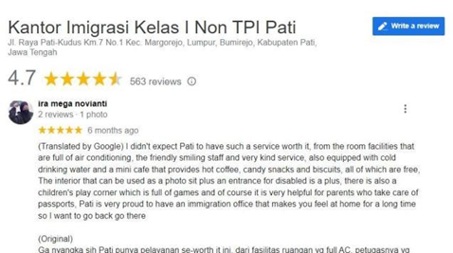

Review by Ira Mega Novianti

Source: Google Review of Immigration Office Class I Non-Checkpoint Pati

The picture above shows a review of the services provided by the Pati Non-Checkpoint Class I Immigration Office in December 2021. The review focuses on service officers who provide good service and also facilities in the service room to support the needs of immigration service applicants. The reviewer explains in detail some of the facilities provided and the advantages obtained. For example, it is mentioned that the mini café is free or the children's playground. Reviewers also attach photos to support the explanation given. The review ends with an acknowledgment of the services and facilities provided. The review value for the service provided is positive.

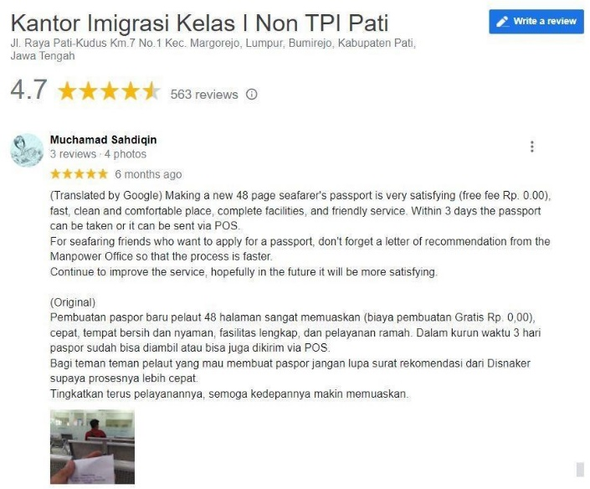

Review by Muchamad Sahdiqin

Source: Google Review of Immigration Office Class I Non-Checkpoint Pati

The review given by Muchamd Sahdiqin focuses more on the service process at the Immigration Office Class I Non-Checkpoint Pati. The reviewer conveyed information about service fees, speed of service and available facilities. In addition, the reviewer also emphasized for certain groups of people, in this case seafarers, to apply for a passport at the Immigration Office of Class I Non-Checkpoint Pati by first preparing a work recommendation from the Manpower Office. The value of this review is positive because the reviewer expresses his satisfaction with the services received and is also willing to share information with others regarding the experience gained.

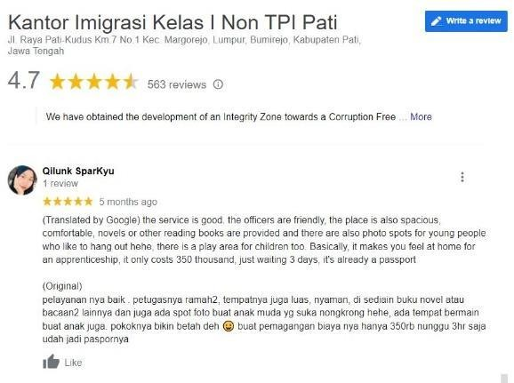

Review by Qilunk SparKyu

Source: Google Review of Immigration Office Class I Non-Checkpoint Pati

The review conducted by Qilunk SparKyu is a review made 5 (five) months ago or in January 2022. The reviewer expressed a positive response to the services provided by explaining the good quality of service, friendly officers, a comfortable place and several service support facilities available in the service room. In addition, the reviewer also provided additional information about the application fee and the passport completion period. The value of this review is positive because in addition to giving 5 (five) stars as a sign of satisfaction with the service, the reviewer is also willing to share his experience when applying for a passport at the Pati Non-Checkpoint Class I Immigration Office.

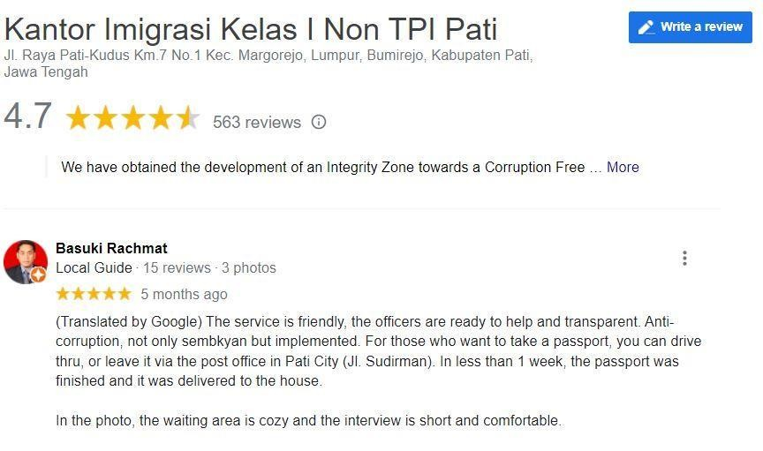

Review by Basuki Rachmat

Source: Google Review of Immigration Office Class I Non-Checkpoint Pati

The review given by Basuki Rachmat is a positive review because it explains about friendly service, swift officers and transparency in service. In addition, the reviewer also provided information about the collection mechanism through Drive-thru or using Post Office services. The reviewer also conveyed the period of passport completion which was considered fast and did not need to be complicated to go back and forth because the passport was simply waited for and delivered to the house concerned. This reviewer has done 15 (fifteen) Google Reviews in different places and tends to be critical to provide an assessment of the performance or service at the place visited.

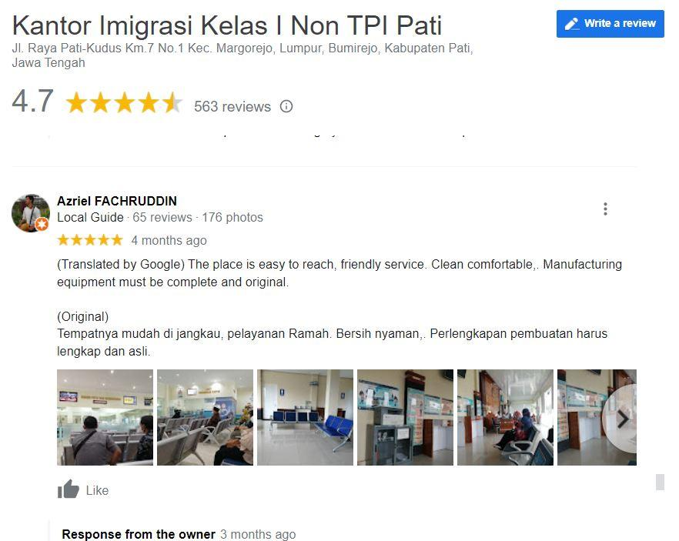

Review by Azriel FAchruddin

Source: Google Review of Immigration Office Class I Non-Checkpoint Pati

The review given by Azriel Fachruddin attached several photos of the conditions and facilities in the passport service room at the Pati Non-Checkpoint Class I Immigration Office. This review was conducted by him in February 2022 and is the umpteenth review out of a total of 65 (sixty-five) reviews he has done. In addition to conveying about the access to the Immigration Office that is easily accessible, the person concerned also conveyed about the quality of service, friendliness of officers and comfort of facilities. In addition, he/she provided information to bring complete and original documents when submitting the application. The score of this review is positive.

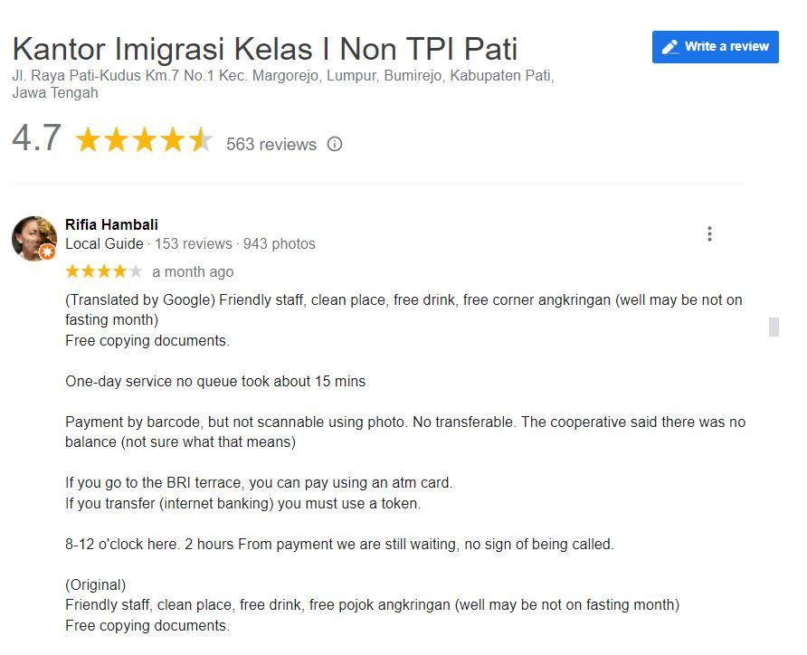

Review by Rifia Hambali

Source: Google Review of Immigration Office Class I Non-Checkpoint Pati

Rifia Hambali, based on information provided by Google, often reviews the places or facilities he visits. This can be seen from the information that he has done 153 (one hundred and fifty-three) reviews. The person concerned gave 4 stars as a form of assessment to show that the services and facilities provided were good enough. The person concerned still critically provides input on several service mechanisms that need improvement including supporting facilities in the service area. In addition, the person concerned also gave a warning because within a certain period of time they were not immediately served. This was a positive review despite the feedback and suggestions given. It is important to get feedback like this so that the institution understands which sides should get attention for future improvement.

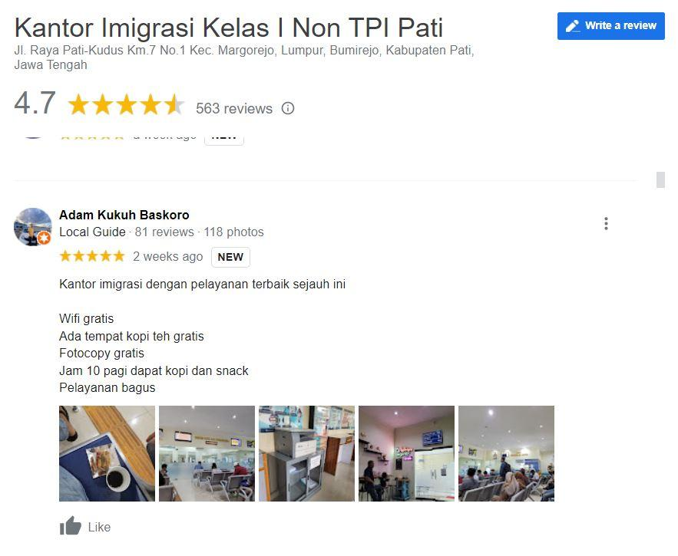

Review by Adam Kukuh Baskoro

Source: Google Review of Immigration Office Class I Non-Checkpoint Pati

The review given by Adam Kukuh Baskoro is a very effective review because he provides information about existing facilities and emphasizes good service. In addition, the reviewer also provided an attachment in the form of a photo of the service room to complement the explanation given. The reviewers have given 81 (eighty-one) reviews and most of them also attached photos as a complement. This review is a positive review because the reviewer gave a good response to the services provided.

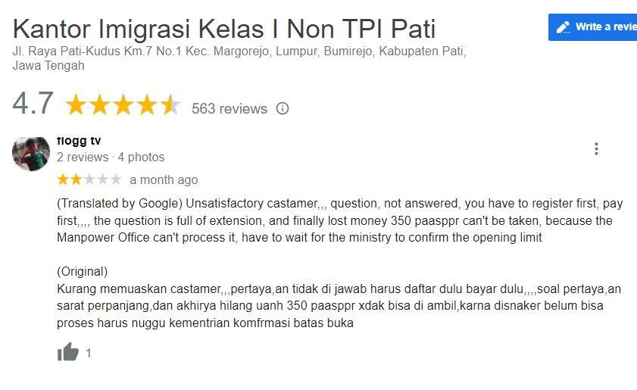

Review by tlogg tv

Source: Google Review of Immigration Office Class I Non-Checkpoint Pati

The review given by tlogg tv is a negative review of the services provided by the Pati Non-Checkpoint Class I Immigration Office. This is indicated by giving an assessment with a 2-star score. The reviewer felt that he was not well served because he was considered unable to serve the applicant properly. The reviewer's question about the passport application mechanism that requires paying in advance did not get a good answer from the officer. Interestingly, the officer did not respond to the reviews given. In contrast to some of the previous reviews, the Google account manager admin of the Pati Non-Checkpoint Class I Immigration Office did not respond so that the reviewer got a better point of view and explanation. This should be a separate note from the service officer and the Google account manager of the Immigration Office of Class I Non-Checkpoint Pati to be more empathetic to the complaints and input given by the applicant.

In general, the reviews given by reviewers on Google Review of Immigration Office Class I Non-Checkpoint Pati during the period December 2021 to May 2022 are positive. However, it is necessary to check the lowest score value given by the reviewer to measure and compare the quality of service and the completeness of the facilities provided. From the Google Review, the following data was obtained:

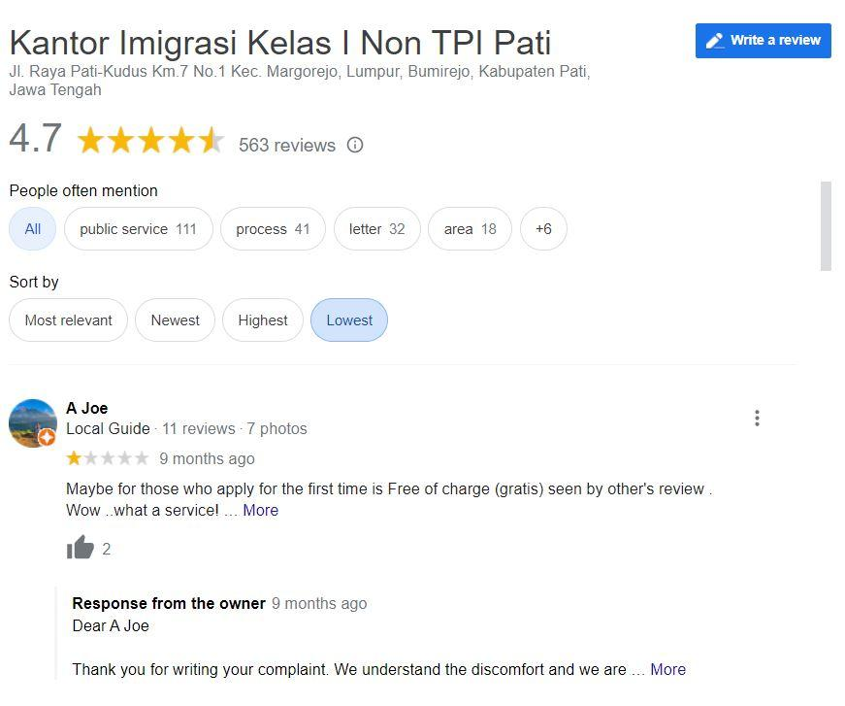

Review by A Joe

Source: Google Review of Immigration Office Class I Non-Checkpoint Pati

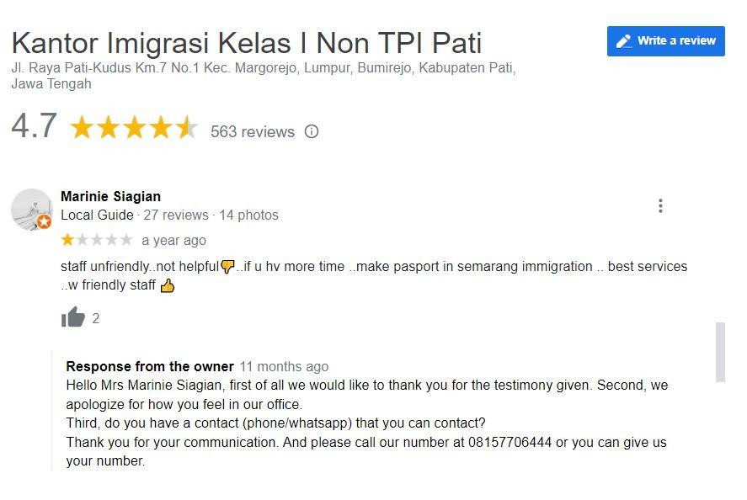

Review by Marine Siagian

Source: Google Review of Immigration Office Class I Non-Checkpoint Pati

The review given by A Joe was given about 9 (nine) months ago while the review given by Marinie Siagian was given about a year ago. Both often give reviews of places or facilities visited. The reviews given are negative because both give the lowest score (1 star) on the reviews given. In addition, both also provide critical feedback on the services provided. Interestingly, the Google account admin of the Immigration Office Class I Non-Checkpoint Pati provides a fairly good response in responding to complaints submitted. The input given becomes a whip for improvement and enhancement of service quality. This can be seen from the reviews given in the last 6 (six) months period are mostly positive reviews.

1. **CONCLUSION**

Policy changes after the lower level of COVID-19 spread and the wider national vaccination program launched by the government have affected many sectors of people's lives. The Government's policy to open border gates and provide leeway for inter-country travelers to enter and exit Indonesian territory has a huge impact on the living conditions of the community. One of the affected sectors is immigration services. As one of the institutions that provide services for the issuance of Travel Documents between countries in the form of passports, the Directorate General of Immigration and all Immigration Technical Implementation Units under it try to provide the best service response to the community.

Immigration Office Class I Non-Checkpoint Pati as one of the Immigration Technical Implementation Units that carries out passport issuance service procedures for the community experiences fluctuations in the number of applications. Developing issues, news delivered and information provided by the government related to travel between countries and various concessions provided, encourage an increase and decrease in the number of applicants for passport issuance. In the last 6 (six) months, it appears that the influence of information obtained by the public on the effectiveness of policies implemented by the government is a very important study to be discussed. Especially in passport issuance services, the Pati Non-Checkpoint Class I Immigration Office can accommodate the surge in passport issuance applications well.

The quality of service provided in the context of passport issuance services is in line with the increasing number of applications. The comprehensive management of Immigration officers and the provision of various supporting facilities that facilitate and make the applicant comfortable, make the value of service quality also increase. The Community Satisfaction Index (IKM) and Corruption Perception Index (IPK) which are one of the indicators of immigration service satisfaction carried out by the Pati Class I Non-Checkpoint Immigration Office generally have an A grade, namely Very Good. In addition, there are also indicators of public satisfaction in the form of reviews on Google Review which shows that the level of public satisfaction with Immigration services at the Immigration Office of Class I Non-Checkpoint Pati is very high.

The ability of Immigration Office Class I Non-Checkpoint Pati to be adaptive and accommodating as well as the quality of services that are getting better in order to respond to changes in policies decided by the government, must continue to make material in the framework of the evaluation process for policies and strategic steps taken. The higher level of public satisfaction with immigration services and the expectation of a better passport issuance service process are challenges that must be answered with real performance. Various steps, breakthroughs and innovations are needed in order to continue to develop services that are able to answer the various needs of the community. Increased capability and supervision of Officers must continue to get a balanced proportion. The provision of better, organized and affordable facilities for service applicants is one form of evaluation of the services that have been provided.

1. **REFERENCES**

Abdullah, R. R. (2019). Urgensi dan Inovasi dalam Pembaharuan Peraturan Teknis mengenai Paspor Biasa. *Jurnal Ilmiah Kebijakan Hukum*, *13*(1), 51. https://doi.org/10.30641/kebijakan.2019.v13.51-68

Budisusila, A., & Dharma, U. S. (2022). *TRANSFORMASI EKONOMI INDONESIA PASCA PANDEMI : PENDEKATAN* (Issue December 2021).

Chaharani, N. A., Adi, T. P., & Hasmi, D. L. (2020). PENERAPAN APLIKASI PENDAFTARAN ANTRIAN PASPOR ONLINE (APAPO) DALAM PERSPEKTIF E-GOVERNMENT. *Jurnal Kebijakan Publik*, *11*(2), 83. https://doi.org/10.31258/jkp.11.2.p.83-88

Goretti, M., Leigh, L., Babii, A., Cevik, S., Kaendera, S., Muir, I., Nadeem, S., & Salinas, G. (2021). *Tourism in the Post-Pandemic World* (Issue 21).

Hafizhah, H. (2022). *Australia Sudah Membuka Kembali Penerbangan Internasional*. Republika.Co.Id. https://www.republika.co.id/berita/r7nipw330/australia-sudah-buka-kembali-penerbangan-internasional#:~:text=REPUBLIKA.CO.ID%2C SYDNEY,internasional untuk mencegah virus corona.

Indrady, A. (2021). Neoliberaslime Versus Kebijakan Selektif Keimigrasian: Korelasi Komponen “International Openness” Dengan Rezim Bebas Visa Di Indonesia. *Jurnal Ilmiah Hubungan Internasional*, *17*(2), 153–171. https://doi.org/10.26593/jihi.v17i2.3609.153-171

*Undang-Undang Nomor 6 tahun 2011 tentang Keimigrasian*, (2011) (testimony of Kementerian Hukum dan Hak Asasi Manusia Republik Indonesia).

Lahadalia, H. E. B. (2021). *Indonesia Investment* (I). Kementerian Investtasi/ BKPM. https://www.indonesia-investments.com/id/keuangan/angka-ekonomi-makro/produk-domestik-bruto-indonesia/item253

Maliana, I. (2022). *Singapura dan Malaysia Buka Perbatasan Darat 1 April 2022, Wisatawan Tidak Perlu Tes COVID dan Karantina*. Tribunnews.Com. https://www.tribunnews.com/internasional/2022/03/25/singapura-dan-malaysia-buka-perbatasan-darat-1-april-2022-wisatawan-tak-perlu-tes-covid-karantina

*Undang-undang nomor 6 tahun 2011 tentang Keimigrasian*, (2011) (testimony of Menteri Hukum dan Hak Asasi Manusia).

*Peraturan Menteri Hukum dan Hak Asasi Manusia Nomor 8 Tahun 2014 tentang Paspor Biasa dan Surat Perjalanan Laksana Paspor*, (2014) (testimony of Menteri Hukum dan Hak Asasi Manusia republik Indonesia).

O’Connor, C., O’Connell, N., Burke, E., Dempster, M., Graham, C. D., Scally, G., Zgaga, L., Nolan, A., Nicolson, G., Mather, L., Barry, J., Crowley, P., & Darker, C. D. (2021). Bordering on crisis: A qualitative analysis of focus group, social media, and news media perspectives on the Republic of Ireland-Northern Ireland border during the ‘first wave’ of the COVID-19 pandemic. *Social Science and Medicine*, *282*(June), 114111. https://doi.org/10.1016/j.socscimed.2021.114111

Poltekim, P. D. (2020). *Pelayanan Paspor RI Di Era Birokrasi Digital* (Issue August 2020).

Rachmawati, T., & Nasution, S. J. (2015). Nilai Demokrasi dalam Pelayanan Publik: Studi Kasus Kantor Imigrasi Bandung. *JKAP (Jurnal Kebijakan Dan Administrasi Publik)*, *19*(2), 133. https://doi.org/10.22146/jkap.8166

Syahrin, M. A. (2019). Audit Hukum Regulasi Aplikasi Pendaftaran Antrian Permohonan Paspor Secara Online (Apapo) Dalam Pelayanan Paspor Ri Berbasis E-Government: Studi …. *Lex Librum: Jurnal Ilmu Hukum*, *December 2019*. https://doi.org/10.5281/zenodo.3600656

Tahir, A. (2018). *Kebijakan publik dan good governancy*. 1–174.

Triyanto, D., Kismartini, K., Aprianty, H., & Novelia, P. (2022). Penerapan Aplikasi Pendaftaran Antrean Paspor Online dalam Upaya Meningkatkan Pelayanan Publik di Bengkulu. *Perspektif*, *11*(2), 527–532. https://doi.org/10.31289/perspektif.v11i2.5876

Wilonotomo, W., & Aji, K. P. (2018). Pelayanan Pembuatan Paspor dalam Kajiannya Terhadap Teori Manfaat Teknologi Informasi. *Jurnal Ilmiah Kebijakan Hukum*, *12*(2), 163. https://doi.org/10.30641/kebijakan.2018.v12.163-178

Xin, L. (2020). Rising from the pandemic. In *Physics World* (Vol. 33, Issue 8). https://doi.org/10.1088/2058-7058/33/8/16