STORIES IN ECOTOURISM: HOW TO SUSTANAIBLE DEVELOPPE TOURISM DESTINATION, CASE STUDY OF RAMMANG-RAMMANG KARST

Mukarramah Machmud¹, Muhammad Hasyim²
¹Politeknik Pariwisata Makassar, Jl Gunung Rinjani Metro Tanung Bunga Makassar No.1, Tj. Merdeka, Kec. Tamalate, Kota Makassar, Sulawesi Selatan 90224

²Fakultas Ilmu Budaya, Universitas Hasanuddin, Jl. Perintis Kemerdekaan KM. 10 Makassar, Sulawesi Selatan, 90245

Korespodensi dengan Penulis: (Diisi hanya salah satu nama penulis sebagai korespondensi)
Muhammad Hasyim : Telp: 08152521787;
E-mail: hasyimfrance@unhas.ac.id

Abstract

Storytelling represents a story or myth about a tourist destination. Travellers have stories about objects, and they become the Storyteller of the objects visited. This article aims to explore the use of travellers to the objects visited and how their knowledge becomes storytelling. The tourist destination that is the object of study is the karst tourist destination Rammang-Rammang, a place in the Karst mountain cluster Maros-Pangkep Indonesia. This paper will use a myth theory as a communication system in creating stories against an object. The results of this study showed that elements are forming the stories Rammang-Rammang as the attraction of ecotourism, namely living culture Rammang-Rammang, mangrove trees, Nipah palm, rivers, boats, karst, caves, Empang and house Traditional Bugis. Tourists can tell stories (myths) from the elements of the stories. Tourists as storytellers against Rammang-Rammang Ecoutirisme as a media promotion of tourism. Tourists, as storyteller promotes objects visited.

Keywords: Rammang-rammang Karst, storytelling, myth, ecotourism

INTRODUCTION
Based on history, the myth has existed since the days of Greece and Rome. We can find the myth stories in ancient Greek literature (Cuthbertson, 1975; Hasyim et al., 2019). Greek Myth or Mythology is a collection of myths and legends that originated in Ancient Greece and contained stories about Gods and Heroes, the nature of the world, and the origin and meaning of the ritual practices and cults of the Ancient Greeks. Greek mythology is part of Religion in Ancient Greece. The myth also describes the universe and explains the origin of the world (Brazouski & Klatt, 1993). The purpose of this myth created by the poet is to make the universe, and the original world can be explained by human reason. An example of mythological work created by Homer is Iliad and Odysseia (britannica.com). Some other examples are Ramayana (Griffith, 2008), Mahabharata (Patil, 1976), Odysseus (Finley, 2002), and I La Galigo (Kern, 1989).
Myths or mythologies contain stories (Hasyim, 2019; Kuswarini et al., 2020). In literature, it is also called storytelling (Moin et al., 2020), which is a way to convey a story (about life, understanding the world, individual relationships with other people, and so on.) to listeners, in the form of words, pictures, photos, as well as voice (Moscardo, 2010; Sanders & vanKrieken, 2018). Barthes (1957) developed the concept of myth under the name mythology, stating that myth is not only a narrative (storytelling) about gods, heroes, and mythical beings but also an explanation of the origin, actions and character of humans in addition to world phenomena. Barthes (1957) uses the term mythology for modern myths, a combination of the words 'mythos' which means 'true mythical thinking', and 'logos', which means 'rational-scientific thinking' (Danesi, 2004). Mythology is a term used by Barthes to distinguish the concept presented by him from the traditional version of the myth. Mythology is a modern myth, in which the aspect of 'logos' (rational or scientific thinking) is included. Therefore, the old version of the myth is any story (storytelling) that does not make sense but is believed to be true by a society. Meanwhile, modern myth is storytelling that is rationalized so that the myth or story becomes common knowledge in society.
Barthes (1977) provides an example of a myth (storytelling) in Panzani's advertisement. In the advertisement, a visual display of Italian food with the Panzani trademark in the form of pasta, sauce and cheese is displayed in a semi-open shopping basket with vegetables, tomatoes, chillies, mushrooms and onions. The storytelling in the advertisement tells the story of the luxury of Italian taste.
Currently, storytelling has been used as an interdisciplinary and multidisciplinary approach. Storytelling has been used in research in communication science (Jager, 2019), storytelling in marketing (Mancuso & Stuth, 2014, Boldosova, 2020), health promotion (Alber et al., 2020) and learning (Zivan, 2020). Storytelling has also been used in tourism marketing (Frost et al., 2020; Su et al., 2020; Chen et al., 2020).
In this paper, we use a storytelling study of Rammang-Rammang Karst tourist destination with Barthes semiotic approach (myth theory). This theory is used to link storytelling to the image of the Rammang-Rammang Karst tourist attraction promoted by travel companies in online media and the meaning perceived by tourists after visiting the tourist attraction. The purpose of this paper is to explain the meaning of the iconic message of storytelling in the image of the Rammang-rammang tourist attraction perceived by tourists. The research data obtained and became the object of research were the pictures of the Rammang-rammang tourist attraction on the internet and the tourists visiting the object.
LITERATURE REVIEUX
RAMMANG-RAMMANG VILLAGE
South Sulawesi is one of the most popular tourist destinations in Indonesia. Rammang-rammang, a hidden gem from Sulawesi, is located in this province. Behind the charm of the coastal line, the second largest limestone mountains (karst) in the world can be found, in Rammang-Rammang, Maros Regency, South Sulawesi, Indonesia. Rammang-Rammang tourism object is in the Maros-Pangkep Limestone Mountains (karst) Cluster. It is about 40 km to the north of Makassar City and can be reached by land transportation using a motorized vehicle with a travel time of approximately 2 hours from Makassar City.
Rammang-rammang is one of the tourist destinations in Maros Regency, South Sulawesi. The name Rammang-rammang itself comes from the Makassar language, which means a group of clouds or fog. This term refers to natural conditions when the area is always shrouded in clouds and sometimes in thick fog in the morning. From various sources of information obtained, Rammang-rammang was once a limestone mining area. This activity took place in 2008. At that time, three companies from China obtained permits to mine. Previously, this area would be employed by a marble company by offering the local people to be employed at the company. However, the people refused firmly because they knew the consequences, namely the damage to the ecosystem. After years of struggling to save the area, the area finally became a tourist attraction. The existence of limestone mountains (karst) that surround this area makes Rammang-rammang increasingly known (Marthalina, 2019). Since 2017, this karst area has officially become a Geopark National Park. The limestone mountains (karst) which are the main attraction are formed due to the dissolving process of a carbonate rock area, resulting in a unique shape of the earth's surface with exokarst and endokarst characteristics (Prayuni, 2013). Not only limestone mountains (karst), Rammang-rammang also offers many other interesting tourist attractions, namely Telaga Bidadari, Limestone Forest Park, Telapak Tangan Cave, Bulu Karaka Cave, Pute River, Bidadari Lake and Kampung Berua. The beauty of Rammang-rammang can be compared with Ha Long Bay in Vietnam and Guilin in China (Kartika, 2020).
MYTH THEORY (STORYTELLING)
Myths are fantastic myths in an extemporary sense that explains the world's creation as well as the activities of founding figures. In this way, mythology is employed in a time of uncertainty, so that the community can overcome its obstacles. Myths are more important as a philosophical structure for a culture that explores the irony of life simply because their cultural values are more vivid than any other (Solá, 2004). A primary classification suggests that those myths which refer to the creation of the universe are cosmologically denominated while those which indicate that The last few days are a scatological one. Eliade (1968) argues convincingly that myths are related to an event that occurred in the origins of life, an exceptional event that narrates parents' feats and reflects their virtue and morality. Pritchard says the theory must be seen as a social construe beyond the limits of time with the legitimization of the political system. The fallacy lies in the ceremonial dint of the culture (Pritcjard, 1977). Previously all social practices are determined in different respects by myths.
Instead, Leach (1954) says there is no philosophical distinction between rites and legend. The myths originate from what can be allowed or forbidden in our culture, but anthropologists are unable to examine myths explicitly except by analyzing rite-performance (Leach, 1954; Morris, 1995). Nevertheless, the myth serves as a tool for Malinowski voicing cultural values, aspirations and problems. It not only connotes human behaviours but anthropologists will research it. Anthropologists should carefully study cultural myths before joining the fieldwork. Otherwise, it will be very hard to understand the surrounding acts observed (Malinowski, 1998). When Levi-Strauss recognizes that culture is full of contradictions, he stimulates the debate. The most critical thing at the moment we live is the fact that we are dying (Arafah & Hasyim, 2019). Life can be compared to a journey while death is its last station. Since our value system is based on contrasting points, myth makes understanding easier.
Myth does not exert control on what it says freely but through what it is quiet about. Levi-Strauss (2002) also thinks it is time to create a periodic table of cultures, starting from the premise that myths exhibit how cultures were designed. Nearly all mythologies and religions have the archetypes of life and death. This polemic point initiated a hot criticism of Mary Douglas who responded to the myth of Levi-Strauss without the social practice can not be understood. Anthropologists can't determine the role of myths outside the previous rites (Douglas, 1998; Maknun et al., 2019, Hasyim et al., 2020). What is important to discuss is when we can think of Travel and tourism through our imaginative interpretations. In this token, Eliade (2006) said the conquest stems from our propensity to possession, discovery, and dominion. At the time of understanding the social role of myths, which consists in the destruction and cyclical restoration of signs, regeneration of spaces is of utmost importance. The necessity of explaining those universe mysteries seems to be the reason for myths.
METODE
The researcher uses data collection techniques in the form of pictures (photos) of Rammang-rammang tourist objects from the internet promoted by tours and travel and the distribution of questionnaires in tourist objects. Data reduction is done by summarizing and selecting important data from various information related to storytelling on Rammang-Rammang karst tourist destinations. There are six photographic images of Rammang-rammang karst that are most dominant on the internet.

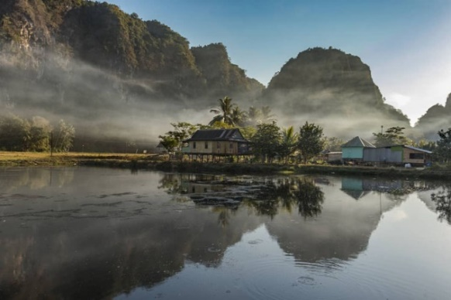 | 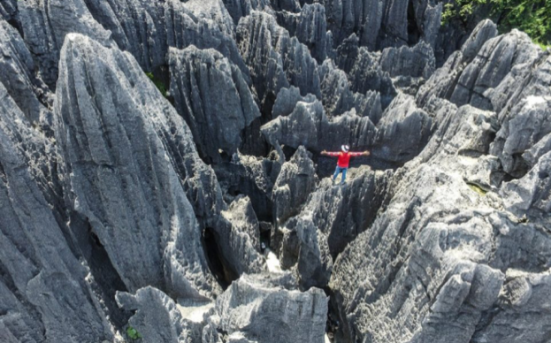
Data 1. Source: https://detik.com | Data 2. Source: https://pegipegi.com

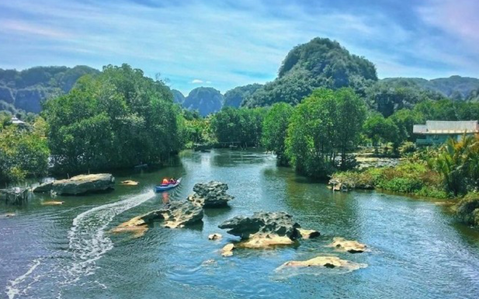 | 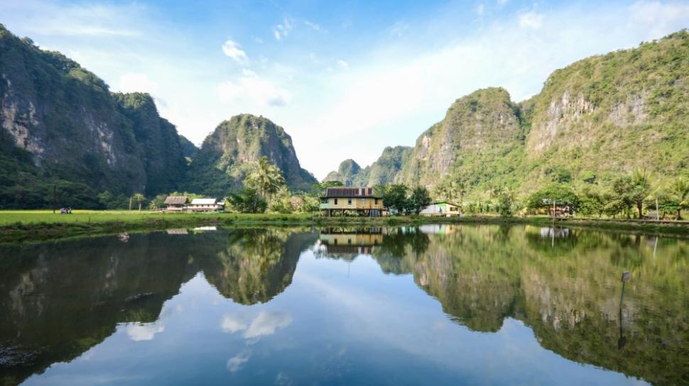
Data 3. Source: https://detik.com | Data 4. Source: https://suara.com

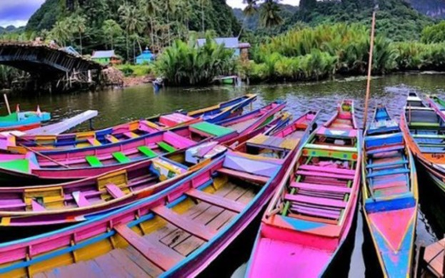 | 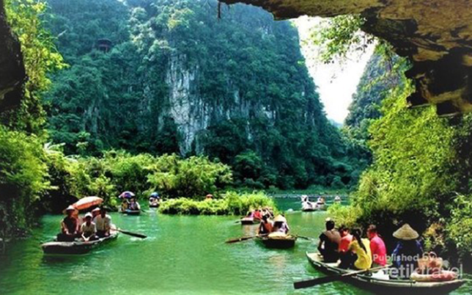
Data 5. Source: https://detik.com | Data 6. Source: https://detiktravel.com
To obtain information about the storytelling of the Rammang-rammang tourist destination, we have also collected data by distributing questionnaires to tourists visiting the area. We did not collect data through interviews because the time spent on the tour by tourists was very short and they were chasing time so that their tour could last until late evening.
The questions given are related to the Rammang-rammang karst story and what activities the tourists want to do in this destination. As many as fifty tourists gave answers to the questions given. Eighty per cent of them are local tourists, and 20 per cent are foreign tourists. The stories about Rammang-rammang they found and the activities they did are following the stories about Rammang-rammang.
RESULT AND DISCUSSION
The Characteristics of Rammang-rammang Karst
Rammang-Rammang Karst tourist destination is one of the tourist destinations that has existed since 2012. Several characteristics attract the attention of tourists to visit Rammang-Rammang karst tourist attraction, namely: 1). Unique karst rock clusters in the form of stalactite and stalagmite; 2). Pute river attraction which is surrounded by trees; 3). Stone forest; 4). Prehistoric caves; 5). Beautiful natural panorama; and 6) Local community wisdom. Based on the results of the observations, it is concluded that Rammang-Rammang karst tourist destination has many prominent attractions and activities so that it is favoured by tourists.
To create a sense of comfort, safety and pleasure for tourists, the local government provides convenience and fulfilment of the needs of tourists in enjoying the tourism products offered by providing facilities, including health facilities, cleanliness, communication, security, hotels/inns, entertainment venues, souvenir shops and restaurants and facilities with common standards for tourists such as lavatory and parking lots. Tourist facilities are provided with the aim that tourists can enjoy the natural beauty or uniqueness of tourist destinations.
Rammang-Rammang karst area has provided adequate tourism facilities and services and is still managed modestly by the local community. Residents' houses function as homestays. There are boats, bamboo gazebos and food served by residents. In principle, the available facilities are expected to support tourism activities.
One of the attractions of Rammang-rammang is that tourists can take a tour along the river by motorboat. This boat will take tourists from the Rammang-rammang pier, along a shallow, calm river surrounded by karst mountains and palm trees. The water is shallow and clear, so tourists can see the small fish swim. Along the side of the river, there are palm trees with the fronds dangling into the water. On the other side, there are karst cliffs. Up there, on the face of those cliffs, the bats made their nests. By late afternoon, thousands of bats will come out of the nest, doing attractions by flying in circles in front of the nest, before flying through the night to find food. At night, tourists can see thousands of fireflies perching on the trees. Boat owners, residents who live in Rammang-rammang, take tourists by motorboat. Another big attraction that makes tourists want to visit is the beauty of Rammang-rammang, which resembles a natural landscape painting.
Rammang-rammang tourist destination also provides views of green rice fields in the middle of a karst forest. Residents' houses stand on the edge of the rice fields. Tourists will also see ducks swimming in the pond. On the side of the village is a rocky hill, leaning right at the foot of a karst cliff. There are small cottages owned by residents where tourists can rest while enjoying young coconuts and amazing natural scenery. This destination also offers ancient caves with stalagmites that shine and glow.
Image Storytelling of Rammang Karts Tourism Destination
Photographic images are storytelling that conveys a message. Storytelling in tourist destination images is built by several elements, namely the sender of the image or the narrator, who makes the story behind the image. Storytelling narrators take pictures, sort, compile and provide comments, then publish them on the internet through the websites of tours and travel companies, government agencies or on social media. The recipients of the messages are internet readers (tourists). Meanwhile, the transmission channels are online media and social media. Storytelling on tourist destination images cannot stand alone. It is built by other structures, namely titles and comments. These two structures (images and titles and comments) work in one system that produces storytelling.
The first structure is an image built on lighting, image viewpoints, composition and moment (Nasution, 2012). The lighting in a tourist destination image can come from the sun and moon. The benefit of light can help create a storytelling effect in the image (Data 1). The point of view is the angle of the picture that can present the sensation of storytelling (data 2). The composition is a technique of taking layout and placing storytelling content in the image. With the technique of The Rule Of Third (Nasution, 2012), image storytelling can be found according to the emphasis of the image message. The result of the composition of the image presents a different message (data 3 & 4) and moments are the delivery of the main image message that can make a great impression (data 5 & 6).
Storytelling by tourists
To get a story about the destination of Rammang-rammang, questionnaires were distributed to tourists who visited the object. We conducted observations of tourist activities and distributed questionnaires that were prepared when they arrived and returned the questionnaires when they finished their tour. In data collection, respondents were asked to identify the stories obtained about Rammang-rammang before visiting the area, what stories they had received and the reasons or motivations for travelling in Rammang-rammang Karst.
The data about the Rammang-rammang story were obtained through a questionnaire. Tourists get information about Rammang-rammang Karst as a tourist destination in Indonesia through the internet, and information from relatives or family who have visited Rammang-Rammang. The story about Rammang-rammang is obtained from word of mouth, especially those who have visited the area. To get more precise and detailed information, tourists look for information through travel agents, such as brochures containing Rammang-rammang tour packages and information about Toraja in the form of videos on Youtube. Information obtained about Rammang-rammang Karst tourist destination is that it is a natural tourist attraction with the characteristics of the karst mountains. The dominant knowledge they get is Rammang-Rammang living culture, mangrove trees, Nipah palms, rivers, boats, karst, caves, fish ponds and traditional Bugis houses.
The results of the questionnaire from visitors showed that the obtained information about the story of Rammang-rammang Karst becomes their motivation to visit this tourist area. The results of the interview can be seen in table 1.

No | Story of Rammang-rammang Karst and activity of tourist | Percentage
1. | It is found in the field that Rammang-Rammang attractions are like a real painting. | 88.7
2. | Rammang-rammang Karst is like an imaginary world in the real world. | 87.6
3. | The tourists get new experiences that have not been obtained before. (Tour by boat along the river with views of palm trees, Bugis traditional houses, and karst mountains.) | 81.4
4. | Their activities are carried out as described in the website about Rammang-rammang Karst. | 90.6
5. | The tourists eat at the Bugis houses around the fish pond | 74.3

Table 1. Story of Rammang-rammang Karst and activity of tourist
Based on Table 1, the tourists commented that the Rammang-rammang story they found was the same as when they visited Rammang-rammang and the Rammang story was not fiction, but a real story and they could directly witness Rammang tourist attraction, enjoy its nature and do various activities to get new experiences. As many as 88.7 per cent of tourists commented on the stories they found that the Rammang-rammang tourist attraction was like a picture painting and this was a fact that was found during the visit. The natural beauty of Rammang-rammang is fantastic, for example, karst, which is displayed on the Internet through tour programs offered by tours and travel, as they find in the field. Thus, as many as 87% of tourists tell stories that Rammang-rammang kars are like an imaginary world found in reality. The beautiful panoramic image of this tourist attraction arouses curiosity and has the motivation to prove directly in the field what is depicted through photographs on the internet. The uniqueness of Rammang-rammang Karst tourist attraction makes as many as 81% of tourists visit to get new experiences that they have never found before, for example watching views of karst mountains, boat tours along the river with views of palm trees, and karst mountain, Bugis traditional houses and prehistoric caves. There are 90.6% of tourists doing all tour activities as told on the website about the Rammang-rammang tourist attraction and the tour programs offered by travel. Another activity carried out by tourists is eating at the traditional Bugis house around the fish pond. As many as 74% of tourists want to enjoy food and drinks at the traditional home while watching the expansive view of the fish pond.
CONCLUSION
The results showed that the storytelling of a tourist destination is a communication system that emphasizes messages. Storytelling has a message that serves as a communication system that motivates tourists to visit the tourist attraction. Storytelling on Rammang-rammang karst tells of a tourist attraction depicted as a beautiful and fantastic painting and presents a dream world with a landscape like a painting. Storytelling in Rammang-rammang is told like stories obtained by tourists and this storytelling gives motivation to tourists to go on tours. Tourists who have visited Rammang-rammang can become 'the storyteller' and they will tell stories about the tourist destination of Rammang-rammang.

REFERENCES

Alber, J.M. PhD MPH, Chari Cohen, C. DrPH MPH, Racho, R. MPAff, Freeland, C. MPH, Ghazvini, S., Brenda Tolentino, B., BS, Silliman, R.A.M. (2020). Exploring the Impact of Storytelling on Storytellers in a Hepatitis B Health Communication Context. Patient Education and Counseling. In Press, Corrected Proof.
Arafah, Burhanuddin, Hasyim, Muhammad. (2019). Linguistic functions of emoji in social media communication. Opción, 35 (24), pp. 558-574.
Ariesta, F.W. (2019). Nilai Moral dalam Lirik Dolanan Cublak-Cublak Suweng. Jurnal Ilmu Budaya, 7 (2), pp. 188-192.
Barthes, Roland. (1957). Mythologies. Paris: Editions de Suil.
Barthes, Roland. (1977). Image Music Text (Trans. Stephen Heath). London: Fontana Press

Boldosova, Valeriia. (2020). Telling stories that sell: The role of storytelling and big data analytics in smart service sales. Industrial Marketing Management, 86, pp. 122-134.
Brazouski, Klatt & Klatt, Mary J. (1993). Children's Books on Ancient Greek and Roman Mythology: An Annotated Bibliography. Greenwood: Annotated edition.

Chen, X., Mak, B., Kankhuni, Z. (2020). Storytelling approach of the self-reported slow adventure to Tibet: Constructing experience and identity. Tourism Management Perspectives, 35, 100679.

Cuthbertson, G. Morris. (1975). Political Myth and Epic. USA: Michigan State University Press.
Danesi, Marcel. (2004). Messages, Signs, and Meanings: A Basic Textbook in Semiotics and Communication Theory. Canada: Canadian Scholars’ Press Inc.
Douglas, M. (1998) Estilos de Pensar: ensayos críticos sobre el buen gusto, Editorial Gedisa, Barcelona.
Eliade, M. (1968) Mito y Realidad, Guadarrama, Madrid.
Eliade, M. (2006) El Mito del Eterno Retorno, Eméce Editores, Buenos Aires.

Encyclopædia Britannica (2020) in https://www.britannica.com/
Evans-Pritchard, E.E. (1977) Los Nuer. Editorial Anagrama, Barcelona.
Finley, M.I. (2002). The World Of Odysseus. new york: NYRB
Frost, W., Jennifer Frost, J., Strickland, P., Maguire, J.S. 2020. Seeking a competitive advantage in wine tourism: Heritage and storytelling at the cellar-door. International Journal of Hospitality Management, 87, 102460.
Griffith, T.H. (2008). The Rámáyan of Válmíki. London: Trübner & Co.

Jäger, Silke, Hinneburg, Iris. (2019). Wissenschafts-und Evidenz-KommunikationWorkshop report: Listening to stories: Using podcasts and storytelling to communicate science and evidence. Zeitschrift für Evidenz, Fortbildung und Qualität im Gesundheitswesen, 144-145, pp. 84-89
Joan Mancuso & Karen Stuth. (2014). Storytelling and Marketing: The Perfect Pairing? Marketing Insights, May/June, 18-19.
José Sanders, J., Kobie van Krieken, K. (2018). Exploring Narrative Structure and Hero Enactment in Brand Stories. Frontiers in Psychology, 9, 1645
Kartika, F. (2020). In https://travel.detik.com/dtravelers_stories/u-4948239/rammang-rammang-hidden-gem-dari-sulawesi/3
Hasyim, Muhammad Dr., Akhmar, A.M., Kuswarini, P., Wahyuddin. (2019). Foreign Tourists' Perceptions of Toraja as a Cultural Site in South Sulawesi, Indonesia. African Journal of Hospitality, Tourism and Leisure, 8 (3)
Hasyim, M., Kuswarini, P., Masdiana. (2020). Toraja coffee and tourism destination: The sustainable development tourism based on identity of region. Proceedings of the International. IEOM Society International: Conference on Industrial Engineering and Operations Management.
Kuswarini, Prasuri, Muhammad Hasyim, M., Chotimah, Irma N.H. (2020). Othering The Self as A Form of Mimicry in The English Translation of Hirata’s Laskar Pelangi. Journal Of Critical Reviews 7 (19), pp. 1286-1295.
Leach, E. (1954) Political System of highland Burma, Editorial Bell-, Londres.
Geertz, C. (1973) The Interpretation of Cultures: Selected Essays, Vol. 5019, Basic Books, New York.
Marthalina. (2019). Pengembangan Kawasan Wisata Karst Rammang-Rammang Di Kabupaten Maros. TRANSFORMASI: Jurnal Manajemen Pemerintahan, 11 (2), 17-41.
Muliana Djafar, Muh. Faisal. M. (2019). Strategi Pengembangan Ekowisata Karst Di Dusun Rammang-Rammang Maros, Sulawesi Selatan The Strategies Of Karst Ecotourism Development In Rammang-Rammang Village Maros, South of Sulawesi. Gorontalo Journal of Forestry Research, 2 (1).
Kern, RA. (1989). I La Galigo. Yogyakarta: UGM Press
Korstanje, M.E. (2015). The media or the message? An examination of myths as resources to understand the tourism phenomenon. Int. J. Tourism Anthropology, Vol. 4, No. 2, 122-140.
Levi-Strauss (2002) Myth and Meaning, Alianza, Madrid.
Maknun, T., Hasjim, M., Muslimat, M., and Hasyim, M. (2020). The form of the traditional bamboo house in the Makassar culture: A cultural semiotic study. Semiotica, 235, pp. 1-12.
Malinowski, B. (1998) Myths in Primitive Psychology, Altalaya, Barcelona
Mossberg, L., Therkelsen, A., Huijbens, H. E., Björk, P., & Olsson, A.K. (2010). Storytelling and Destination Development: Five Nordic Case Stories. Oslo: Nordic Innovation Centre Website. Available on https://www.nordicinnovation.org/2010/ storytelling-and-destination-development.
Mancuso, J. & Stuth, K. Social Media and The Second Screen. (2014). Marketing Insights, 18-19.

Morris, R.C. (1995). All Made Up: Performance Theory and the New Anthropology of Sex and Gender. Annual Review of Anthropology, 24, 567-592

Nasution, Iqbal. (2012). 4 Unsur Penting Dalam Fotografi in https://iqbalnasution.wordpress.com/ 2012/01/06/penting/
R.A., Ira Prayuni. (2013). Perancangan Lanskap Koridor Sungai Pute di Kawasan Karst Rammang-Rammang sebagai Kawasan Geowisata. Prosiding Temu Ilmiah IPLBI. C7-C14.
Setiowati, S. P. (2020). Pembentukan Karakter Anak Pada Lagu Tokecang, Jawa Barat. Jurnal Ilmu Budaya. 8 (1), pp. 172-177.
Sharad Patil, Sharad. (1976). Myth and Reality of Ramayana and Mahabharata. Social Scientist, 4, (8), 68-72.

SMA Moin, Sameer Hosany, Justin O'Brien. (2020). Storytelling in destination brands’ promotional videos. Tourism Management Perspectives, 34, 100639.
Solá, M.D. (2004) Mitología Romana, Editorial Gradifico, Buenos Aires.

Su, Lujun, Cheng, Jin, Swanson, Scott R. (2020). The impact of tourism activity type on emotion and storytelling: The moderating roles of travel companion presence and relative ability. Tourism Management, 81, 104138.
Zivana, Michal, Horowitz-Krausa, Tzipi. (2019). Parent-child joint reading is related to an increased fixation time on print during storytelling among preschool children. Brain and Cognition, 143, 105596.

