**Cargo Delivery web-based Application with Ant Colony Optimization Algorithm for Shortest Route search: A Case Study in the Die Cutting Industry**

Jansen Wiratama1, Santo Fernandi Wijaya2, Idris Tandika3, Hari Santoso4

1,2 Universitas Multimedia Nusantara, Indonesia

3,4 STMIK Dharma Putra, Indonesia

|  |  |  |
| --- | --- | --- |
| **Article Information** |  | **ABSTRACT** |
| Article history  Diterima: 23-10-2023  Disetujui: dd-12-2023  Keywords  Ant Colony Optimization;  Cargo Delivery;  Die Cutting Industry;  Shortest Route Search;  Web-based Application.  Corresponding Author  **Jansen Wiratama,**  Universitas Multimedia Nusantara,  Tel. +62 21 5422 0808  [jansen.wiratama@umn.ac.id](mailto:jansen.wiratama@umn.ac.id) |  | Conventional business processes sometimes lead to negligence and forgetfulness regarding important delivery requests, thereby causing operational disruptions that could impact the company's reputation. The limitations of conventional methods are also faced by CV Karya Pelangi, a company operating in the Die die-cutting industry, where many customer orders are usually submitted orally, causing problems that lead to late deliveries and delays in the production process. This problem is exacerbated by limited resources, for example, a delivery fleet consisting of only two drivers. Focuses on developing web-based applications with prototyping models and implementing the Ant Colony Optimization (ACO) algorithm to overcome delivery route optimization challenges. This research produces a web-based application using a software prototype model. In addition to applying the ACO algorithm to identify optimal delivery routes, the app offers insights into the goods transported, shipper details, and departure and destination times. Simulation results show that CV Karya Pelangi can now determine short circuit paths efficiently, thereby increasing operational efficiency, with a path length of 0.3892 and a pheromone intensity of 2.569. This innovative solution promises to revolutionize cargo shipping operations, ensuring timely and efficient deliveries increasing customer satisfaction and operational efficiency. |

**INTRODUCTION**

In today's business developments, organizing efficient cargo shipping operations has undeniable importance for business processes and, perhaps more importantly, customer satisfaction [1]. Post-purchase shipping and tracking have an impact on customer satisfaction [2]. Based on empirical research in the Die Cut Industry, CV Karya Pelangi, the object of study, a company engaged in the production of cardboard cutting knives, is experiencing increasing demand for goods along with fast and precise delivery. Fast and error-free delivery of goods has become the cornerstone of their business operations, which underlines the importance of this aspect in shaping customer satisfaction [3]. While production flexibility and cost do not significantly impact customer satisfaction, product quality and delivery are significantly and positively associated with customer satisfaction [4].

In the Die die-cut industry sector, CV Karya Pelangi receives many customer orders conventionally conveyed through verbal instructions. Unfortunately, this conventional method sometimes causes negligence or forgetfulness of important delivery requests, causing operational disruptions that can impact the production process and damage the company's reputation. Limited resources are a big challenge in determining delivery route priorities because the fleet only consists of two drivers.

This research will focus on designing a web-based application and implementing the Ant Colony Optimization algorithm to optimize the delivery route problems and find the shortest route recommendations to optimize the delivery of goods [5]. The Ant Colony Optimization (ACO) algorithm is specifically designed to evaluate, compare, and ultimately identify the most efficient route from the origin to the destination, thereby overcoming obstacles related to route prioritization and simplifying the entire process [6]. It is proven by the MATLAB experiment that the improved ant colony algorithm has greatly improved the performance of the route optimization problem [7].

One medium that can make it easier to implement the ACO algorithm so that users can use it is through an application. Several previous studies have succeeded in producing website-based applications for product sales transactions [8] for HR management in a company [9]. With limited time and the need for fast applications, a relevant application development model is the application of a prototyping software system design model [10]. Software prototyping can offer a low-cost way of making a more informed selection of software to use within projects rather than relying solely on reviews and recommendations by others [11].

**METHODOLOGY**

The usage of prototype models in software development has grown in importance as a strategy for ensuring the success of information technology initiatives [12]. This model enables developers to design better, test, and understand user demands before releasing the final version of software [13]. These prototyping models are used to visualize concepts, build user interfaces, and discover potential difficulties early in development. This strategy can save time and resources by allowing developers to modify and improve the design and functioning of the software before it reaches the implementation stage [14].

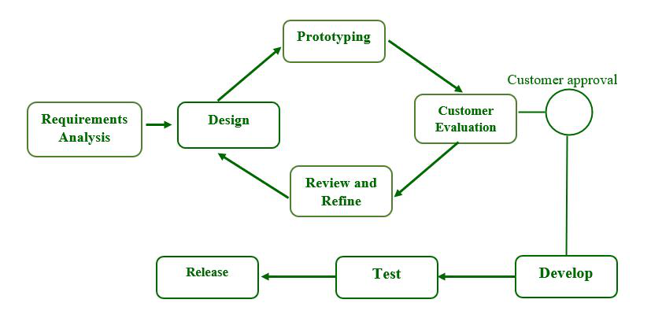

**Figure 1.** Prototyping model with six stages

The stages of requirements engineering in the prototype model method are depicted in Figure 1. A thorough understanding of the procedures involved in a development model is required [15]. The stages of the prototyping model are as follows:

1. ***Stage 1-Gathering and Analyzing Requirements:*** This is the first step in designing a prototype model. Users are asked what they expect or want from the system during this phase.
2. ***Stage 2-Quick Design:*** This is the first stage in creating a mock up web-based application through the Unified Modeling Language (UML), a standardized modeling language. UML was using for visualize, construct, and document web-based application and blueprints [14].
3. ***Stage 3-Create a Prototype:*** This is stage will conduct to creating a mock-up application. The mock-up application will created using tools such as a FIGMA. In this mock-up, the users can see the flow of the application.
4. ***Stage 4-Initial User Evaluation:*** The next step in creating a web-based application. Users will test the application during this phase and give and feedback.
5. ***Stage 5-Refining Prototype:*** System developers utilize the prototype model to design a more complete and complex system after receiving user feedback from the initial user evaluation. If the user provides feedback or makes changes, the final design is authorized by improving the client's response to feedback and comments.
6. ***Stage 6-Implement and Maintain the Product:*** Following the initial user review, system developers use the prototype methodology to design a more complete and sophisticated system. If the user provides feedback or makes changes, the final design is authorized by improving the client's response to feedback and comments.

**Figure 2.** Ant Colony Algorithm path illustration

After developing a web-based application for finding the shortest routes using the prototyping model, the ACO Algorithm was implemented in the shortest routes-finding process. The Ant Colony Optimization (ACO) algorithm is a nature-inspired method for determining the shortest path, which can be used to optimize product delivery routes to customers. It mimics ant foraging behavior by constructing probable delivery routes based on pheromone levels (showing route quality) and a heuristic function (accounting for distance or cost). After several rounds, the program converges on the best route with the highest pheromone levels. The ability of ACO to examine previous data and make intelligent decisions assists logistics organizations and delivery services save time and money by discovering effective routes, resulting in cost savings and enhanced customer satisfaction through timely deliveries [16].

**RESULTS AND DISCUSSION**

Following the systematic and iterative process using the Prototyping model, the research commenced with Stage 1, where requirements were gathered through interviews with users from the logistics department. This critical phase ensured the system's expectations and functionalities aligned with the end-users' needs. Table 1 shows the requirements for developing the web-based application in CV Karya Pelangi:

**Tabel 1.** Requirements gathering and analysis

|  |  |  |
| --- | --- | --- |
| **No.** | **Issues** | **Recommendation** |
| 1. | Customer orders conventionally conveyed through verbal instructions cause negligence or forgetfulness of important delivery requests. | Implement the web-based application with a customer order management feature. |
| 2. | Difficulty in determining delivery route priorities because of limited resources. | Recommend using the Ant Colony Algorithm (ACO) on the web-based application for the shortest route. |

In Stage 2, a quick design was created using Unified Modeling Language (UML) and use case diagrams, focusing on the expected system behavior from an end-user perspective. Use cases were defined, specifying what the system should do rather than how it should be implemented. The use case diagram will only focus on the logistics staff actors in selecting the shortest routes for delivery. Figure 3 shows the primary function of this web-based application through Use Case Diagram.

**Figure 3.** Logistics Staff Use Case Diagram

Use case diagrams in Figure 3 are a valuable tool in web-based application design, offering a visual representation of the interactions between application actors and primary functionalities. In this context, the actor is the logistics staff responsible for managing cargo delivery operations. Two primary use cases are depicted: "Manage Routes" and "Manage Drivers," which encapsulate essential functionalities.

The "Manage Routes" use case encompasses the logistics staff's ability to define and optimize delivery routes, ensuring efficient and timely deliveries. This use case includes sub-functions such as specifying the starting location and up to three destination points, representing the various stops along a delivery route. By utilizing this use case, the logistics staff can systematically plan and streamline delivery routes, allowing for enhanced cargo delivery efficiency. In parallel, the "Manage Drivers" use case empowers the logistics staff to handle the driver workforce effectively. Sub-functions within this use case entail the ability to edit, delete, and add drivers. This comprehensive functionality enables logistics staff to maintain an up-to-date and organized driver roster, edit driver details as needed, remove outdated entries, and onboard new drivers when required. The "Manage Drivers" use case, with its multiple functions, ensures that the delivery fleet remains efficiently managed, contributing to the overall success of the web-based application for cargo delivery operations. Use case diagrams are an invaluable tool for depicting such interactions and functionalities in a clear and easily understandable visual format, aiding in the efficient design and implementation of complex web-based applications.

**Figure 4.** Homepage of Web-based Application of Cargo Delivery

Moving on to Stage 3, the prototype's user interface was developed, yielding a mock-up application with wireframes to simulate the application's flow. The following user interface shown in Figures 4, 5, 6, and 7 is the UI developed to access the main function of the Cargo Delivery web-based application. Figure 4 shows the homepage of the Cargo Delivery web-based application with four menus: Home, Routes, Driver, and Log Out. Some of the words in the Cargo Delivery web-based application are using Bahasa Indonesia because of familiarity with the users.

**Figure 5.** Driver’s data management

Figure 5 showcases the driver data management capabilities of the web-based application. It provides a straightforward interface for logistics staff to edit, delete, and add drivers. With the "Edit Drivers" option, they can update driver information in real time. The "Delete Drivers" feature simplifies the removal of outdated or inactive drivers, maintaining an organized roster. Additionally, the "Add Drivers" function streamlines the onboarding of new drivers, making it easier to expand the delivery team.

**Figure 6.** Delivery orders schedule page

In Figure 6, the delivery schedule is displayed, featuring important details such as driver code, driver name, vehicle type, goods, destination points, and departure times. This straightforward visual allows cargo deliveries to be efficiently managed and tracked by logistics staff. By consolidating all relevant information in one place, coordination is streamlined, and precision in the delivery process is enhanced.

**Figure 7.** Routes determination

In Figure 7, the delivery schedule is displayed, including fields for the starting location and up to three destination points. Users can fill in these details, and upon clicking "Submit," the new routes are made available in the route’s menu. This user-friendly design simplifies route planning and management for logistics staff, allowing for easy input and access to route information. Stage 4 involved an initial user evaluation, during which users conducted testing, providing feedback crucial for refining the application.

User Acceptance Testing (UAT) ensured the functionality met their requirements and expectations. Table 2 in the user acceptance test results presents a significant milestone in evaluating the web-based application's functionality. A panel of users, specifically the logistics staff, conducted the evaluation process, comprising 5 individuals. These users were tasked with executing 8 test cases, which encompassed essential functionalities. Remarkably, all 8 test cases resulted in success. This outcome underscores the robustness and user-friendliness of the web-based application, signifying that it seamlessly fulfills the intended functions. The positive results from this user acceptance testing phase underscore the application's readiness for practical implementation, validating its capacity to streamline and enhance cargo delivery operations effectively.

**Table 2.** Cargo Delivery Web-based Application user Acceptance Test results

|  |  |  |
| --- | --- | --- |
| **No.** | **Test cases** | **Result** |
| 1.  2.  3. | *Driver’s data management:*  Users can edit driver data.  Users can delete driver data.  Users can add driver data. | -Success  -Success  -Success |
| 4.  5.  6.  7.  8. | *Search shortest route:*  Starting location input field  Destination 1 input field  Destination 2 input field  Destination 3 input field  Submit button | -Success  -Success  -Success  -Success  -Success |

At the same time as the Cargo Delivery web-based application design stage, the Ant Colony Optimization (ACO) Algorithm implementation process was also carried out by simulating the calculation of the distance between the CV Karya Pelangi location and the delivery location. Figure 8 is an illustration of the distance between the initial location and several destination points:

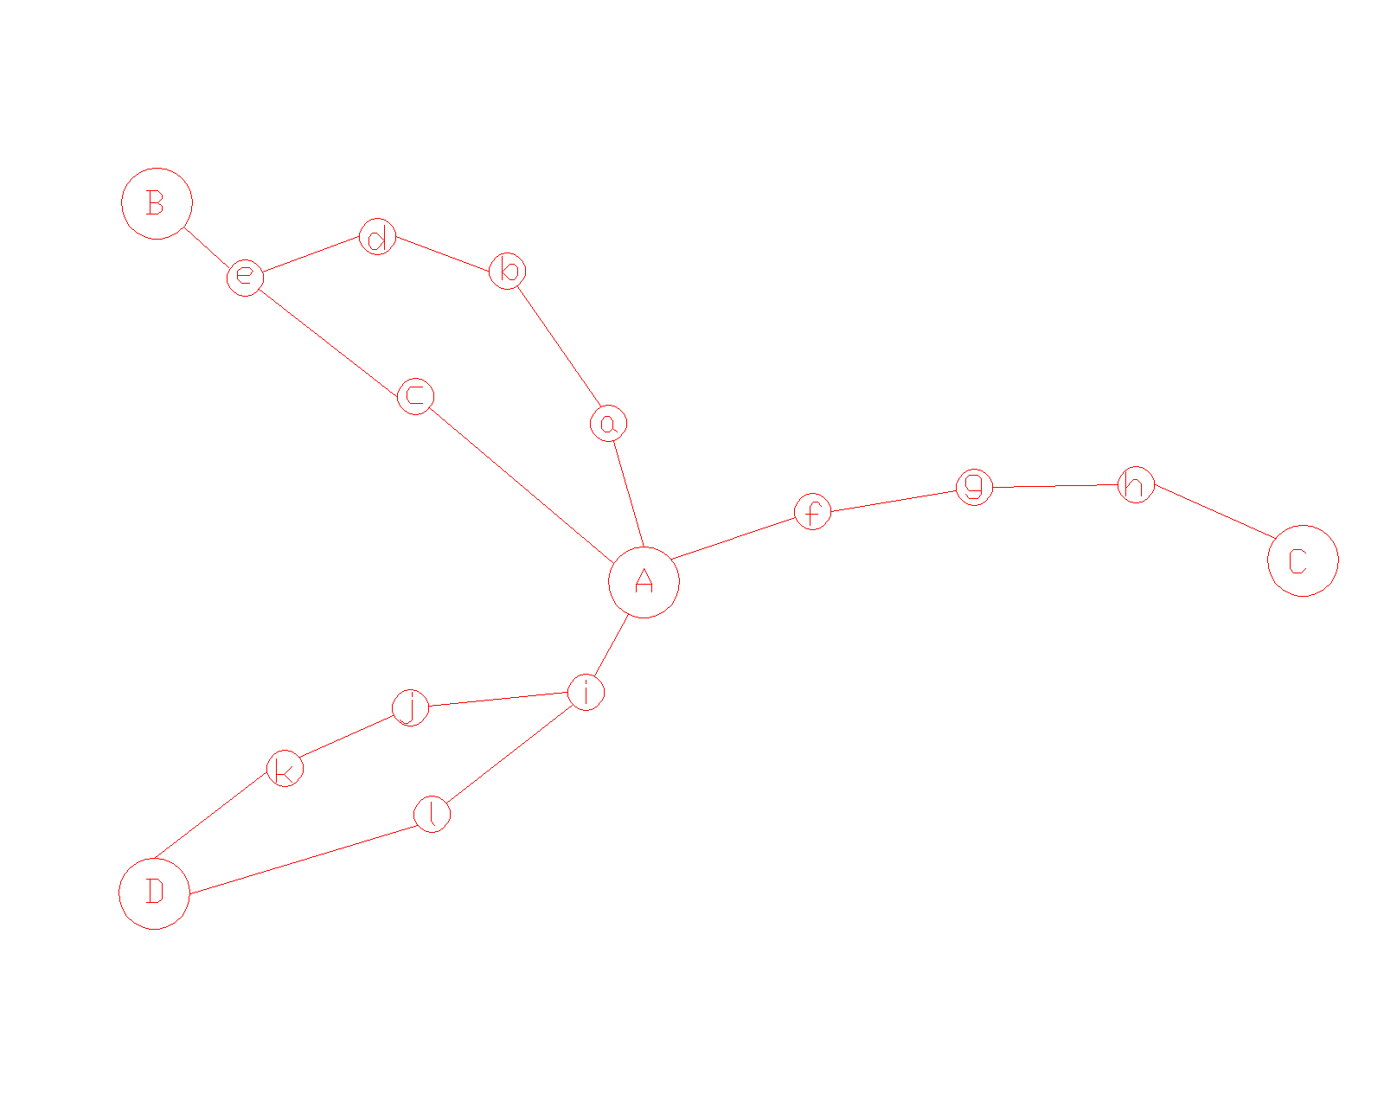

**Figure 8.** Graph routes illustration with 3 destination

A: CV Karya Pelangi (KP)

B: PT Bosung Indonesia (BI)

C: CV Karya Guna Semesta (KGS)

D: PT Indoris Printingdo (IP)

Determining the distance between CV Karya Pelangi (A) and other points is known to have the following length:

1. Search for location coordinates using Google Maps, which then produces the following results:

A: KP (x = 106.560523, y = -6.204242)

B: BI (x = 106.527637, y = -6.141830)

C: KGS (x = 106.60232, y = -6.189946)

D: IP (x = 106.495124, y = -6.217114)

Nodes:

a: PT hasura (x = 106.55031, y = -6.19806)

c: Ching luh (x = 106.52992, y = -6.17706)

b: Surya toto (x = 106.54399, y = -6.18243)

d: Bumi asri (x = 106.53730, y = -6.16439)

e: BCA (x = 106.53107, y = -6.15014)

f: Surya kencana (x = 106.57117, y = -6.20492)

g: Yonif 203 (x = 106.58107, y = -6.19690)

h: Remaja kuring (x = 106.59381, y = -6.18872)

i: Indomaret (x = 106.56195, y = -6.21147)

j: Tol bitung (x = 106.56210, y = -6.22137)

k: Mitra 10 bitung (x = 106.54578, y = -6.22428)

l: Indo stanley (x = 106.50275, y = -6.20636)

1. Calculate the distance to each location and node using the formula:

a. d(A,a) = √(0.010)2 + (0.006)2 = 0.011

b. d(a,b) = √(-0.00632)2 + (0.01563)2 = 0.016

c. d(a,c) = √(-0.0203)2 + (0.021)2 = 0.029

d. d(b,d) = √(-0.0066)2 + (0.01804)2 = 0.019

e. d(d,e) = √(-0.00623)2 + (0.01425)2 = 0.015

f. d(e,B) = √(0.07125)2 + (-0.0398)2 = 0.081

g. d(c,e) = √(0.00114)2 + (0.0269)2 = 0.026

h. d(A,c) = √(-0.0306)2 + (0.02718)2 = 0.04

i. d(A,f) = √(0.0106)2 + (-0.0006)2 = 0.010

j. d(f,g) = √(0.0099)2 + (0.00802)2 = 0.012

k. d(g,h) = √(0.0127)2 + (0.0081)2 = 0.015

l. d(h,C) = √(0.0085)2 + (-0.0012)2 = 0.008

m. d(A,i) = √(0.0014)2 + (-0.007228)2 = 0.007

n. d(i,l) = √(-0.0591)2 + (0.00511)2 = 0.05

o. d(i,j) = √(0.0001)2 + (-0.0099)2 = 0.009

p. d(j,k) = √(0.0163)2 + (-0.00291)2 = 0.01

q. d(k,D) = √(-0.0506)2 + (0.0071)2 = 0.05

r. d(l,D) = √(-0.0001)2 + (-0.0107)2 = 0.01

1. To measure the distance from point A to B using the help point, it can be calculated as follows:

d(A,a)= 0.011

d(a,b) = 0.016

d(A,c) = 0.04

d(b,d ) = 0.019

d(d,e) = 0.015

d(c,e) = 0.026

d(e,B) = 0.081

The first path d (A, B) = d (B, A):

=d(A,a) + d(a,b) + d(b,d) + d(d,e) + d(e,B) =0.011+0.016+0.019+0.015+0.081 = 0.0142

The second path d (A, B) = d (B, A:

=d(A,c) + d(c,e) + d(e,B)

=0.04 + 0.026 + 0.081 = 0.0147

From the two estimated paths d (A, B) = d (B, A), it is known that the shortest distance for path d (A, B) = d (B, A) is path 1.

1. To find out the distance from point A to C via the support point, it can be calculated as follows:

d(A,f) = 0.010

d(f,g) = 0.012

d(g,h) = 0.015

d(h,c) = 0.008

to calculate the distance d(A,C):

=d(A,f) + d(f,g) + d(g,h) + d(h,c)

= 0.010 + 0.012 + 0.013 + 0.008 = 0.048

1. To find out the distance from A to D through the support point, it can be calculated as follows:

First path d(A,D) = d(D,A):

=d(A,i) + d(i,j) + d(j,k) + d(k,D)

=0.007 + 0.009 + 0.01 + 0.05 = 0.076

Second path d(A,D) = d(D,A):

=d(A,i) + d(i,l) + d(i,d)

= 0.007 + 0.05 + 0.01 = 0.067

From the two paths d (A, D) = d(D, A) that have been calculated, it is known that the shortest path is path 2.

1. To find out the distance from B to C via the support point, it can be calculated as follows:

First path d(B,C) = d(C,B):

= d(B,e) + d(e,d) + d(d,b) + d(b,a) + d(a,A) + d(A,f) + d(f,g) + d(g,h) + d(h,C)

= 0.081 + 0.015 + 0.019 + 0.016 + 0.011 + 0.010 + 0.012 + 0.015 + 0.008 = 0.187

Second path d(B,C) = d(C,B):

=d(B,e) + d(e,c) + d(c,A) + d(A,f) + d(f,g) + d(g,h) + d(h,C)

= 0.081 + 0.026 + 0.04 + 0.010 + 0.012 + 0.015 + 0.008

= 0.192

From the two paths d (B, C) = d (C, B) that have been calculated, it is known that path 1 is the shortest.

1. To find out the distance from C to D via the support point, it can be calculated as follows:

First path d(C,D) = d(D,C):

= d(C,h) + d(h,g) + d(g,f) + d(f,A) + d(A,i) + d(i,l) + d(l,D)

= 0.008 + 0.015 + 0.012 + 0.010 + 0.007 + 0.05 + 0.01

=0.184

Second path d(C,D) = d(D,C):

= d(C,h) + d(h,g) + d(g,f) + d(f,A) + d(A,i) + d(i,j) + d(j,k) + d(k,D)

= 0.008 + 0.015 + 0.012 + 0.010 + 0.007 + 0.009 + 0.01 + 0.05

= 0.121

From the two calculated paths d(C, D) = d(D, C), the shortest path is known to be path 2.

1. To measure he distance from B to D via the support point, it can be calculated as follows:

First path d (B, D) = d(D,B):

=d(B,e) + d(e,c) + d(c,A) + d(A,i) + d(i,l) + d(l,D)

= 0.081 + 0.026 + 0.04 + 0.007 + 0.05 + 0.01

= 0.214

Second path d (B, D) = d(D, B):

= d(B,e) + d(e,c) + d(c,A) + d(A,i) + d(i,j) + d(j,k) + d(k,D)

=0.081 + 0.026 + 0.04 + 0.007 + 0.009 + 0.01 + 0.05

= 0.223

Third path d (B, D) = d(D,B) :

=d(B,e) + d(e,d) + d(d,b) + d(b,a) + d(a,A) + d(A,i) + d(i,l) + d(l,D)

= 0.081 + 0.015 + 0.019 + 0.016 + 0.011 + 0.007 + 0.05 + 0.01

= 0.209

Fourth path d (B, D) = d(D,B):

= d(B,e) + d(e,d) + d(d,b) + d(b,a) + d(a,A) + d(A,i) + d(i,j) + d(j,k) + d(k,D)

= 0.081 + 0.015 + 0.019 + 0.016 + 0.011 + 0.007 + 0.009 + 0.01 + 0.05

= 0.218

The calculated path d(B, D) = d(D, B) shows that the shortest path is path 3.

From the equation that has been calculated, it can be written into a table as follows:

**Table 3.** Distance between the nodes

|  |  |  |  |  |
| --- | --- | --- | --- | --- |
|  | A | B | C | D |
| A | 0 | 0.0142 | 0.048 | 0.067 |
| B | 0.0142 | 0 | 0.187 | 0.209 |
| C | 0.048 | 0.187 | 0 | 0.121 |
| D | 0.067 | 0.209 | 0.121 | 0 |

To determine the ant's travel route, this is done by looking for a circuit in a complete graph with n vertices, which is ((n-1)!) / 2. So the graph has ((4-1)!) /2 = 3 circuits as follows:

C1: (A,B,C,D,A) = (A,D,C,B,A)

C2: (A,C,D,B,A) = (A,B,D,C,A)

C3: (A,D,B,C,A) = (A,C,B,D,A)

After knowing the path that all the ants will take, then the length of the path that the ants will take is calculated as follows:

1st ant path:

C1 = AB + BC + CD + DA

= 0.0142 + 0.187 + 0.121 + 0.067

=0.3892

2nd ant path:

C2 = AC + CD + DB + BA

= 0.048 + 0.121 + 0.209 + 0.0139

= 0.3919

3rd ant path:

C3 = AD + DB + BC + CA

= 0.067 + 0.209 + 0.187 + 0.048

= 0.511

**Table 4.** Route length for each ants

|  |  |  |  |  |  |  |
| --- | --- | --- | --- | --- | --- | --- |
| No | Ant route | | | | | Route length |
| 1 | A | B | C | D | A | 0.3892 |
| 2 | A | C | D | B | A | 0.3919 |
| 3 | A | D | B | C | A | 0.511 |

The calculation of pheromone changes in each circuit can be calculated using the formula:

${∆τ}_{rs}^{k}=\frac{Q}{C^{k2}}$ (1)

With the value of Q = 1 and Ck being the number of paths per ant, which has been calculated in Table 4, it can be calculated as follows:

Q / C1 = 1 / 0.3892 = 2.569

Q / C2 = 1 / 0.3919 = 2.551

Q / C3 = 1/ 0.511 = 1.956

After calculating the change in pheromone intensity between points r and s for each ant travel circuit, it was found that the highest number of pheromones was 2,569 on the 1st ant route.

In Stage 5, the prototype was refined based on user feedback, with adjustments made as needed. This iterative approach played a crucial role in fine-tuning the application to better align with user preferences. Furthermore, Stage 6 is proposed for future research and is envisioned to encompass the implementation and maintenance of the final product. In this context, the prototype will be the foundational framework for developing a more comprehensive and sophisticated system in future endeavors. Feedback and comments from users will continue to be integral in shaping the ultimate design, ensuring that it remains responsive to the evolving requirements of the Die Cutting Industry. This structured development approach has proven instrumental in creating an efficient cargo delivery application that optimizes delivery routes effectively, and it holds promise for future research in this domain.

**CONCLUSION AND RECOMMENDATION**

This research produces a Web-based application for finding the shortest routes using a software prototyping model. Apart from implementing the Ant Colony Optimization Algorithm to find the shortest route for each delivery, this application can also see the goods carried by each sender and the destination and departure time. Based on the results of the simulation that has been carried out, the results obtained from CV Karya Pelangi to other customer companies obtained the shortest circuit path, namely: AB+BC+CD+DA=first circuit with a path length of 0.3892 and a pheromone intensity of 2.569.

**ACKNOWLEDGEMENT**

We extend our heartfelt gratitude to Universitas Multimedia Nusantara and CV Karya Pelangi for their invaluable support, pivotal in completing this research endeavor. Their substantial contribution was instrumental in achieving our objectives, and we are deeply grateful for their unwavering assistance.

**REFERENCES**

[1] J. Hong, M. Lee, T. Cheong, and H. C. Lee, “Routing for an on-demand logistics service,” *Transp. Res. Part C Emerg. Technol.*, vol. 103, pp. 328–351, 2019, doi: https://doi.org/10.1016/j.trc.2018.12.010.

[2] Y. Cao, H. Ajjan, and P. Hong, “Post-purchase shipping and customer service experiences in online shopping and their impact on customer satisfaction,” *Asia Pacific J. Mark. Logist.*, vol. 30, no. 2, pp. 400–416, Jan. 2018, doi: 10.1108/APJML-04-2017-0071.

[3] B. D. Engdaw, “The Impact of Quality Public Service Delivery on Customer Satisfaction in Bahir Dar City Administration: The Case of Ginbot 20 Sub-city,” *Int. J. Public Adm.*, vol. 43, no. 7, pp. 644–654, May 2020, doi: 10.1080/01900692.2019.1644520.

[4] R. Chavez, W. Yu, M. Feng, and F. Wiengarten, “The Effect of Customer-Centric Green Supply Chain Management on Operational Performance and Customer Satisfaction,” *Bus. Strateg. Environ.*, vol. 25, no. 3, pp. 205–220, Mar. 2016, doi: https://doi.org/10.1002/bse.1868.

[5] A. Nayyar and R. Singh, “IEEMARP- a novel energy efficient multipath routing protocol based on ant Colony optimization (ACO) for dynamic sensor networks,” *Multimed. Tools Appl.*, vol. 79, no. 47, pp. 35221–35252, 2020, doi: 10.1007/s11042-019-7627-z.

[6] Y.-H. Huang, C. A. Blazquez, S.-H. Huang, G. Paredes-Belmar, and G. Latorre-Nuñez, “Solving the Feeder Vehicle Routing Problem using ant colony optimization,” *Comput. Ind. Eng.*, vol. 127, pp. 520–535, 2019, doi: https://doi.org/10.1016/j.cie.2018.10.037.

[7] X. Mao, “Study on ant colony optimization algorithm for ‘one-day tour’ traffic line,” *Cluster Comput.*, vol. 22, no. 2, pp. 3673–3680, 2019, doi: 10.1007/s10586-018-2217-9.

[8] S. Suryasari, T. J. Wibowo, A. Aribowo, and A. E. Widjaja, “Sistem Informasi Penunjang Proses Pemesanan dan Desain Kue Pada Toko Kue Artisan Online Berbasis Web,” *Ultim. InfoSys J. Ilmu Sist. Inf.*, vol. 10, no. 1, pp. 48–54, 2019, doi: 10.31937/si.v10i1.1048.

[9] L. Listiani and F. Natalia, “Rancang Bangun Aplikasi Manpower Request Bagian Recruitment pada PT Dynapack Asia,” *Ultim. InfoSys J. Ilmu Sist. Inf.*, vol. 10, no. 1, pp. 55–60, 2019, doi: 10.31937/si.v10i1.866.

[10] N. Kunicina, A. Zabasta, A. Patlins, I. Bilic, and J. Peksa, “Prototyping process in education and science,” in *2020 IEEE 61th International Scientific Conference on Power and Electrical Engineering of Riga Technical University (RTUCON)*, 2020, pp. 1–6. doi: 10.1109/RTUCON51174.2020.9316550.

[11] M. Jackson, K. Kavoussanakis, and E. W. J. Wallace, “Using prototyping to choose a bioinformatics workflow management system,” *PLoS Comput. Biol.*, vol. 17, no. 2, pp. 1–13, 2021, doi: 10.1371/JOURNAL.PCBI.1008622.

[12] T. A. D. P. Subianto, J. Wiratama, and F. A. Halim, “The Development of web-based Cashier and Inventory Information Systems using Prototyping Model on Micro, Small, and Medium Enterprise (MSMEs) in Indonesia,” *JOINS (Journal Inf. Syst.*, vol. 8, no. 1, pp. 80–89, 2023, doi: 10.33633/joins.v8i1.7983.

[13] Z. Xiaoshuan, F. Zetian, C. Wengui, T. Dong, and Z. Jian, “Applying evolutionary prototyping model in developing FIDSS: An intelligent decision support system for fish disease/health management,” *Expert Syst. Appl.*, vol. 36, no. 2, Part 2, pp. 3901–3913, 2009, doi: https://doi.org/10.1016/j.eswa.2008.02.049.

[14] D. Dennis, Alan; Wixom, Barbara; David; Tegarden, *Systems Analysis and Design: An Object-Oriented Approach with UML*, Sixth. United States: Wiley, 2020. [Online]. Available: https://umnlibrary.vitalsource.com/books/9781119561217

[15] H. P. Putro and A. F. Wibowo, “Software verification and validation on object oriented software development using traceability matrix,” *Proc. 3rd Int. Conf. Informatics Comput. ICIC 2018*, pp. 1–5, 2018, doi: 10.1109/IAC.2018.8780518.

[16] M. D. Toksari, “A hybrid algorithm of Ant Colony Optimization (ACO) and Iterated Local Search (ILS) for estimating electricity domestic consumption: Case of Turkey,” *Int. J. Electr. Power Energy Syst.*, vol. 78, pp. 776–782, 2016, doi: https://doi.org/10.1016/j.ijepes.2015.12.032.