**Boosting Electronics Manufacturing Efficiency with Automated Data Mining and OEE Process Analytic**

Ruly Sumargo1, Handri Santoso2

Big Data and IoT, Fakultas Teknologi Informasi, Universitas Pradita Tangerang, Indonesia

|  |  |  |
| --- | --- | --- |
| **Article Info** |  | **ABSTRACT** |
| Article history  Received: 25-10-2023  Revides  : 22-02-2024  Accepted: 29-04-2024  Keywords  Process Analytics,  Data Mining;  Elektronics Industry,  OEE;  Optimization  Corresponding Author  **Ruly Sumargo,**  Universitas Pradita  Tel. +62 8881852710  ruly.sumargo@student.pradita.ac.id |  | In the last few decades, the industrial sector has experienced rapid growth, driven by increasing demand and intense competition among manufacturers, especially in the electronics sector. This competition focuses on providing superior products with competitive prices, maintained quality, and optimal delivery times. Optimizing manufacturing processes and effectively utilizing company resources have become key to competitiveness in the manufacturing industry. To ensure comprehensive optimization and smooth manufacturing workflows, it is crucial to engage in systematic evaluation and analytical processes. One of the key performance metrics in assessing manufacturing process efficiency is Overall Equipment Efficiency (OEE), which is used to uncover improvement opportunities and inefficient areas. Accurate OEE measurement requires a data mining systems with automated quantitative data collection methods and real-time calculations. These systems visualize process losses in six (pareto) groups, aiding users in analyzing processes and determining process improvements. The implementation of OEE and alert systems for management can bring an 11.82% increase in overall production efficiency. This achievement can serve as a model for other companies embarking on the initial stages of digital transformation processes. |

**INTRODUCTION**

Industry has grown rapidly in the last decades, driven by the increasing human needs and the competition among industries to produce a better and competitive goods, both in terms of quality and price [1], [2]. Time to market is become an additional factor on winning the competition. Technology has become a huge supporter in the industry growth. The electronics manufacturing industry plays a pivotal role in advancing technology, driving economic growth, nurturing innovation, generating jobs, and improving various aspects of human life[3]. It is importance lies in its ability to shape the present and future of society, making it a key player in the global economy and technological landscape.

In Indonesia, manufacturing sectors contribute for 20% of Gross Domestic Product (GDP), and electronics manufacturing as one of its important sub-sectors[4]. Implementing automation in electronics manufacturing industry become trend to win the competition and shorten the product time to market. Nowadays, governments are increasingly focusing on the adoption of advanced manufacturing technologies, while also emphasizing sustainable and responsible production methods [5].

The use of fully automated machines using PLCs as their controllers is becoming more widespread [6]. This is because the use of PLCs in the industry as the controller for machines is still the best choice [7], [8],[9]. However, even when using fully automated machines with PLCs as their controllers, the performance of the machines that are continuously used will gradually decline. With the decrease in performance, there is a concern that the quality of the products produced will also decrease [10].

To maintain the quality of products to remain competitive in the market, periodic maintenance of production machines is also required, so that the existing machines can be used and remain in good performance to produce products [10],[11]. In addition, maintenance is needed to reduce unexpected damages and extend the lifespan of the machines [12], as poorly maintained machines are inefficient due to frequent downtime caused by breakdowns [13]. Continuous improvement must be carried out to support the production process, and to carry out the improvement process. It is necessary to clearly understand the occurred problems in the machines, to ensure the correct analysis process could be done and optimal improvement can be made [14]. Total Productive Maintenance (TPM) is a maintenance process method which developed to improve productivity by performing maintenance on keeping the machines in good and usable condition. Good maintenance and repair could increase machine efficiency, and also minimize losses [1],[15].

The main goal of TPM is to increase productivity with cost-effective investments [16]. TPM also incorporates quality as a priority, aiming for a flawless production process with no defects, scrap, breakdowns, accidents, or wastage during both operation and changeovers [17]. In TPM methodology, to determine the machine effectiveness or equipment usage, the metric called Overall Equipment Effectiveness (OEE) could be used. The data collection methods in OEE system were using quantitative collective methods during certain period of time, which run automatically from machine to the main database. In this system, OEE is obtained by considering several factors, such as: machine or equipment availability, performance efficiency, and the produced products quality [2],[18],[19].

The standard formula to calculate OEE values from machine or equipment, have been elucidated by the Japan Institute of Plant Maintenance [15],[17]. Nakajima in his book, describes the world class ideal OEE parameters, will be following the illustrated values shown in Table 1.

**Tabel 1.** World class OEE parameters [15]

|  |  |
| --- | --- |
| Description | *Values* |
| Availability (%) | 90% |
| Performance Efficiency (%) | 95% |
| Quality Rate (%) | 99% |
| Ideal OEE | 85% |

|  |  |
| --- | --- |
|  | (1) |
| $$Performance Efficiency \left(\%\right)= \frac{(Design Cycle Time x Equipment Output)}{Operating Time}x 100\%$$ | (2) |
| $$Quality Rate \left(\%\right)= \frac{(\sum{Production Input}-\sum{Quality Defects})}{\sum{Production Input}}x 100\%$$ | (3) |
| $$OEE\left(\%\right)=Availability (\%) x Performance Efficiency (\%) x Quality Rate (\%)$$ | (4) |

Basic formula for “availability” represents the condition of a machine being prepared to produce a product within a specified timeframe. Availability level is determined through dividing process of the machine's operational time for producing products by its total loading time, as shown in equation (1). Performance Efficiency indicates the machine's performance during production, assessing whether it meets the intended production quantity within a designated timeframe, based on the machine's original maximum capacity. Performance efficiency values could be determined by using equation (2). The Quality Products Rates signifies the percentage of acceptable products compared to the total production output. The quality rate can be expressed in equation (3).

From the three elements of “World class OEE parameters”, six major losses in manufacturing activity could be identified and providing a good framework for categorizing existing losses, making it easier to identify which efforts will have a significant impact on increasing the OEE values [14], [20]. The classification of six major losses in OEE measurement were distributed as shown in Figure 1. Furthermore, the data accuracy for measuring OEE depends on the data mining process which being implemented in the manufacturing area, and it is become critical factor for assessing the process efficiency.

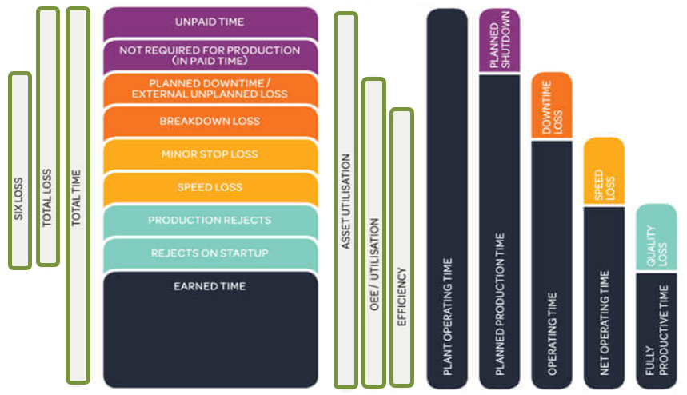

**Figure 1.** Six Big Losses Classification in OEE Measurement

Manufacturing process for electronics industry is a combination between manual process (high human dependency), semi-automatic, and fully automatic process. Human operator become one of the important factor which affecting final OEE result, due to potential human error and fatigue that could lead to equipment idling or equipment minor stoppage [16],[22].

In study conducted by Hedman, mostly manufacturing team will perform data collection manually and recorded in Excel files for OEE calculation [20]. It has a big concern related with data manipulation by human operator, which could lead to a false OEE calculation, analysis, and wrong improvement plan in the production area. Finally, this led to unnecessary expense and resources which occurred due to wrong decision making. To avoid this condition, direct data collection from machines for OEE calculation automatically by utilizing direct communication between PLC controllers on the machines and performed automatic data exchanging through Ethernet ports [18],[21] which will be stored in a database or server. With direct data collection from the machines using PLC controllers, data accuracy expected to be above 90% and the machine maintenance future improvements can be precise.

**METHOD**

This research methodology is arranged with systematic flow that involved identifying issues, studying literature, gathering information, conducting investigations, ultimately formulating the final solution, and evaluating the research as shown in Figure 2.



**Figure 2.** Research Flow Chart [23], [24]

This research will be focusing on data mining process, visualizing the machine data in the dashboard for analysis, and management alert system for the issue with long period. The data mining with process analytics system will use Microsoft SQL Server 2019 for the main database storage, which using quantitative data collection methods. To support the automatic data mining process, a dedicated ethernet port number 1433 (TCP/IP) will be open and utilize for database connection inside this system. To reduce the risk and ensure there is no human dependency in data mining process from the machine and potential virus threat, PLC with direct connection to database will be used as bridging data collector. Custom dashboard and analytics platform will be built under ASP.NET. Figure 3 shows the process flow of the datamining and process analytics system.



**Figure 3.** Flow Chart of Datamining and Process Analytic System

An alert system has been embedded in this system, to ensure once there is an abnormality occurred in the production line, the problem-solving period were optimum and handle effectively by the stakeholder. The alert system rules and escalation level could be seen in Table 2. This system was integrated with Telegram instant messaging and email to trigger the alert to the respective stakeholder.

**Tabel 2.** Alert System Escalation Rules Variable

|  |  |
| --- | --- |
| Stakeholder | Time Losses Limit |
| Supervisor | 30 minutes < Time Losses ≤ 1 hours |
| Manager | 1 hour < Time Losses ≤ 2 hours |
| Division Head | 2 hours < Time Losses ≤ 3 hours |
| Plant Director | Time Losses > 3 hours |

Considering the process in electronics manufacturing are combination between automatic process, semi-automatic process, and manual process (high human dependency), specific function on measuring the process transfer time and operator handling time were being implemented. With this approach, once there is a delay or abnormal time spend during transfer could be suppress and necessary action plan could be defined by stakeholder to reach optimum process flow.

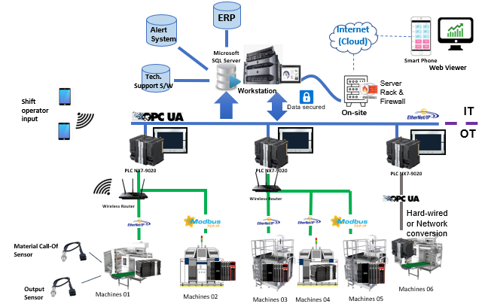

**Figure 4.** System Architecture for Data Mining in Electronics Product Assembly Line

Figure 4 illustrates the overarching system architecture for mining data on the electronics product to assembly line. The implementation of direct Ethernet IP communication between the PLC and the database has significantly reduced the human intervention on data mining process which leads to enhanced data accuracy. To facilitate data sharing between the PLC and the server within the system, Ethernet IP, OPC UA and Modbus TCP protocols were being used. Additionally, a variety of Application Program Interfaces (APIs) were deployed to ensure seamless communication with the factory's ERP system, the maintenance scheduler and technical support software.

The data mining and performance analytics dashboard were required to be accessible to the management team from external locations. To address potential cybersecurity threats, a firewall and redundant server with weekly data backup scheduler were integrated into the system. To support of manufacturing activities, several gadgets in the form of tablet PCs were provided and linked to the main system. These tablets empower assembly line machine’s operators to provide feedback on various conditions not covered by sensors, including acknowledging break times, initiating changeover processes, or reporting issues related to material availability. Generally, in the electronics industry, data will be obtained by utilizing inputs from machine sensors which indicate the machine's condition, as well as data variables or errors generated by the machine. Each of these conditions will be classified into six major losses, which are used as the basis for calculating machine availability, performance rate, and quality rate.

Tabel 3 shows the big losses classification, in correlation with the error code, and root cause of the error. Through this approach, correct calculation to determine the OEE values could be done for the machine plan which has been created. Base on those result, next action plan for improvement could be made effectively, efficient and straight forward to reduce the losses in the next production activities.

**Tabel 3.** Big 6 Losses Classification on OEE Measurement

|  |  |  |  |  |  |  |  |
| --- | --- | --- | --- | --- | --- | --- | --- |
| Loss Category | Parameter Status | | System Code | | Description | | |
| Breakdown Loss | | Breakdown | | 01 | | Time when equipment is not running due to breakdowns, setups, or other unplanned events. |
| Planned downtime / external unplanned Loss | | Planned downtime | | 02 | | Scheduled maintenance and other planned stops that reduce available production time. |
| Changeover time | | 03 | | Time required to switch from producing one product or batch to another. |
| Adjustment time | | 04 | | Time spent making fine-tuning adjustments to optimize production quality and efficiency. |
| Speed Loss | | Speed Losses | | 05 | | Reduced equipment speed or rate compared to its design or maximum capacity. |
| Minor Stop Loss | | Minor Stoppage | | 06 | | Short stops or interruptions that disrupt production but are quickly resolved. |
| Machine Idling duration | | 07 | | Time when equipment is running but not actively producing parts. |
| Production Rejects | | Defective parts | | 08 | | The number of defective or rejected parts produced during a production run |
| Rework and scrap | | 09 | | Additional time and resources required to rework or discard defective products. |
| Reject on Startup | | Defective parts on Startup | | 0A | | The number of defective or rejected parts produced during a start-up process and after maintenance activity |

To evaluate the effectiveness of this new system, comparison of OEE data 6 months before system implementation (July 2022-December 2022) and 6 months after system implementation (February 2023-July 2023) will be performed. This evaluation follow the management decision related with the targeted project schedule.

**RESULTS AND DISCUSSION**

This section will explain the implementation result for the datamining and process analytics system. Figure 5 shown the main dashboard layout, with summarize overall equipment performance, 6 big losses pareto, and line performance. Status of each production line are also founded in the corner of the dashboard. Production quantity gap, the rejected product contributor, and the listed issue from the pareto losses were use by the stakeholder to define the next action items for improvement.

Another important items which being implemented are the monitoring of breakdown happened in the production line. It could use to support the stakeholder on analyzing and finding the pattern of equipment utilization during manufacturing process. Number of alarms, condition of the machine and duration of each down time were recorded automatically and viewing on the data could be adjust accordingly, following the stakeholder intention. To make an easier identification, calculation on OEE, availability, equipment performance, and quality rate were individually shown and indicating the targeted values. All stakeholders might know the gap through this area. Pareto for the equipment which contributing rejected product also giving a clear alert to the stakeholder on defining which equipment to be prioritize for deep analysis and defining the appropriate action items.

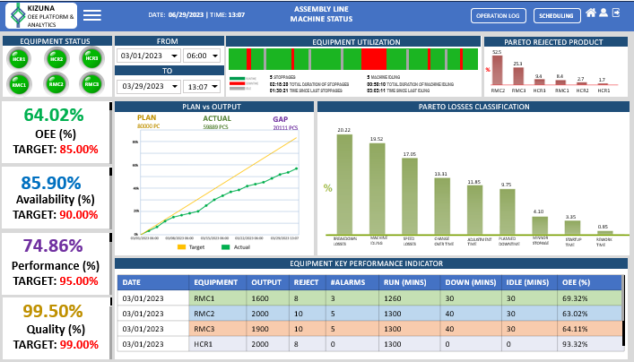

**Figure 5.** OEE Dashboard for Electronics Product Assembly Line

One of important items to run production effectively and improving the OEE level, is to ensure the idling time of machine is minimized. One of the factors which allowing this to happened is transfer process from one machine to another were delayed. The current system has specific analytical function which identifying this concern.

Figure 6 shows the analytical process for transfer product/material in the manufacturing line. The analytics were recording every second to identify whether the operator in charge, is working as required or slower. Once the operator was exceeding the threshold time of 5 seconds from last activities to another activities, system will show purple mark. Every bar equal to 5 seconds delay and with this approach, production supervisor could evaluate and ensure the machine’s operator were working as per requirement. This function also connected to the alert system to support the stakeholder on evaluating the overall process.

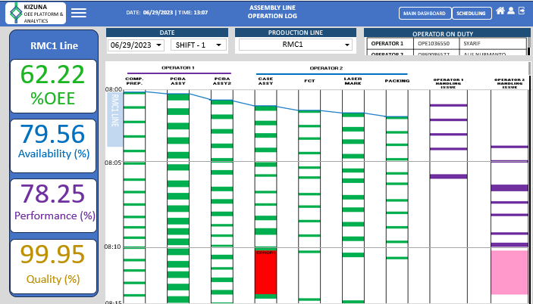

**Figure 6.** Operation Log and Process Analytics Dashboard for Electronics Product Assembly

In the operation log and process analytics dashboard, stakeholder will be able to identify once there’s an issue on the equipment. Error code will be shown to support the stakeholder solving the issue and the time spend will be automatically classified base on the criteria. Pink mark in the dashboard shows the operator were triggering the alarm from his gadget, to request technical support team on troubleshooting the equipment. The system summary dashboard is connected to 6 product assembly lines, each assembly line consists of 7 equipment’s as shown in Figure 6 and being operate by 2 operators.

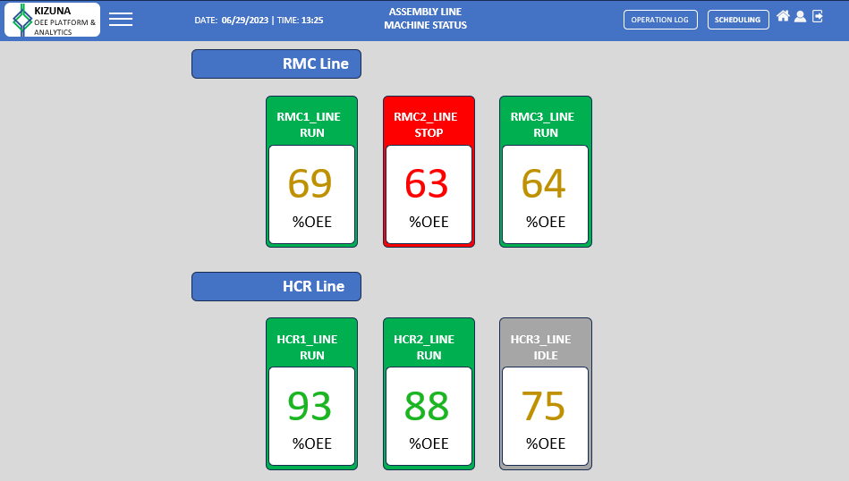

**Figure 7.** OEE Summary Dashboard for Electronics Product Assembly

Figure 7 shows the OEE summary and condition of each assembly line machine. The grouping of the assembly line could help stakeholder on monitoring the activities of equipment runs in production. Specific indication will be shown once the assembly line was offline or running under expected performance level.

**Tabel 4.** Six Big Losses Ratio Comparation on Electronics Assembly Line OEE Measurement

|  |  |  |  |  |  |
| --- | --- | --- | --- | --- | --- |
| OEE Class Category | System Code | Loss Category | Parameter Status | Before Implement  2022  Jul - Dec | After Implement  2023  Feb - Jul |
| Availability | 01 | Breakdown Loss | Breakdown | 4.10% | 0.72% |
| 02 | Planned downtime / external unplanned Loss | Planned downtime | 50.12% | 48.19% |
| 03 | Changeover time | 24.10% | 17.35% |
| 04 | Adjustment time | 21.69% | 13.25% |
| Performance | 05 | Speed Loss | Speed Losses | 8.88% | 5.01% |
| 06 | Minor Stop Loss | Minor Stoppage | 22.78% | 6.83% |
| 07 | Machine Idling duration | 68.34% | 28.52% |
| Quality | 08 | Production Rejects | Defective parts | 0.43% | 0.40% |
| 09 | Rework and scrap | 0.03% | 0.04% |
| 0A | Reject on Startup | Defective parts on Startup | 0.04% | 0.05% |
| Accumulated Loss > 1 hours (hours) | | | | 12.12% | 4.68% |

Table 4 shows the data mining system and process analytics has an impact to six big losses result, before and after system implementation. Majority the losses were reduce significantly. Degraded result on the machine startup happened due to spare part quality issue.

**Tabel 5.** OEE Data Comparison for Electronics Assembly Line Equipment

|  |  |  |
| --- | --- | --- |
|  | Jul – Dec 2022 | Feb – Jul 2023 |
| Availability (%) | 84.80% | 87.33% |
| Performance Efficiency (%) | 81.04% | 92.21% |
| Quality Rate (%) | 99.50% | 99.59% |
| OEE Result | 68.37% | 80.19% |

Table 5 shows the system performance evaluation summary of the OEE measurement from 6 electronics product assembly line, between initial stage and after system implementation. In latest condition, the electronics production line manages to achieve 80.19% overall efficiency.

From the previous study conducted by Wiyatno [14] and Hedman[20], classifying the losses in a good framework will lead on identifying effort with big impact on improving the OEE results. The alert module and process analytics module which embedded in the system has significantly reduce the time spending on handling issue in manufacturing line, through improvement of stakeholder awareness and intension to collaborate together. Base on the latest data shown in Table 4, the total issue which handle more than 1 hours has reduce to 4.68% (improve 7.44% from 12.12%). This part become one of the key successes on improving the handling time on each occurred issue in the production line [14],[20]. The process analytics feature also has significantly improved the line efficiency through 39.82% reduction on equipment idling time. This condition were align with research result performed by Prasetio [16] and Azizah [22]. Overall result shows the datamining system and process analytics has brought significant improvement in most factor of the electronics manufacturing line efficiency, especially in the availability and performance aspect. It made a significant improvement in the final OEE result, which closing the gap to the ideal targeted level 85% (4.81% more to the target). Currently system is limited on analyzing the equipment performance and process analytics related with the electronics manufacturing. The future improvement for this system could be focusing on predictive maintenance and production planning base on AI for market demand .

**CONCLUSION**

The data mining with performance analytics system boasts a user-friendly interface while delivering robust support for enhancing OEE in the electronics manufacturing line. The OEE results in 2023 recorded OEE as 84.86% which close to the ideal target. A significant improvement 11.82% has been achieve, compared to the OEE results in 2nd semester 2022. The process analytics feature has brought significant impact on the equipment availability and performance for the OEE improvement points. The stakeholder alert system also has proven highly effective in minimizing long stand issue in the manufacturing process, resulting in a 7.44% reduction from the 2022 figures. Future research could explore additional facets such inventory management, AI for operator fatigue analysis, and predictive maintenance.

**REFERENCES**

[1] S. D. Cahyono, F. Handoko, and N. Budiharti. (2020). Penerapan Efektivitas Mesin Debarker Menggunakan Overall Equipment Effectiveness (Studi pada PT. Tri Tunggal Laksana Unit Blitar): *J. Teknol. dan Manaj. Ind.*, vol. 6, no. 2, pp. 12–17, doi: https://doi.org/10.36040/jtmi.v6i2.3012.

[2] T. Haddad, B. W. Shaheen, and I. Németh. (2021). Improving Overall Equipment Effectiveness (OEE) of Extrusion Machine Using Lean Manufacturing Approach,” *Manuf. Technol.*, vol. 21, no. 1, pp. 56–64, doi: 10.21062/mft.2021.006.

[3] International Labour Organization. (2019). The electronics industry in Indonesia and Its Integration Into Global Supply Chains: Geneva, [Online]. Available: https://www.ilo.org/wcmsp5/groups/public/---ed_dialogue/---sector/documents/publication/wcms_732119.pdf

[4] N. Amalia. (2022). Electronic Industry in Indonesia: The Challenges and The Opportunities 2022: https://blog.usetada.com/en/electronic-industry-in-indonesia-2022 (accessed Oct. 01, 2023).

[5] M. M. Mubyarto and G. P. D. Sohibien. (2019). Determinan Daya Saing Sektor Manufaktur Unggulan Menuju Program Making Indonesia 4: *Semin. Nas. Off. Stat.*, doi: https://doi.org/10.34123/semnasoffstat.v2019i1.56.

[6] M. G. Hudedmani, S. K. Kabberalli, U. R. M., and R. Hittalamani. (2017). Programmable Logic Controller (PLC) in Automation: *Adv. J. Grad. Res.*, vol. 2, no. 1, pp. 37–45, https://doi.org/10.21467/ajgr.2.1.37-45.

[7] S. S. Khairullah and A.-N. Sharkawy. (2022). Design and Implementation of a Reliable and Secure Controller for Smart Home Applications Based on PLC: *J. Robot. Control*, vol. 3, no. 5, pp. 614–621, doi: 10.18196/jrc.v3i5.15972.

[8] J.-Y. Chen, K.-C. Tai, and G.-C. Chen. (2017). Application of Programmable Logic Controller to Build-up an Intelligent Industry 4.0 Platform: *Procedia CIRP*, vol. 63, pp. 150–155, https://doi.org/10.1016/j.procir.2017.03.116.

[9] G. M. Martinov, I. A. Kovalev, and N. Y. Chervonnova. (2020). Development of a Platform for Collecting Information on The Operation of Technological Equipment with the Use of Industrial Internet of Things: *IOP Conf. Ser. Mater. Sci. Eng.*, vol. 709, no. 4, p. 44063, doi: 10.1088/1757-899X/709/4/044063.

[10] E. K. Karmilawati, K. M. Mulyono, and S. N. Nugroho. (2021). Pendekatan OEE (Overall Equipment Effectiveness) untuk Mengurangi Losses pada Mesin Moulding Cerex: *J. Optimasi Tek. Ind.*, vol. 3, no. 2, p. 46, doi: 10.30998/joti.v3i2.8576.

[11] H. MZ, I. Husin, and A. A. Masruri. (2018). Analisis Efektivitas Mesin Screw Press Dengan Menggunakan Metode Overall Equipment Effectiviness (OEE): *J. Desiminasi Teknol.*, vol. 6, no. 1, pp. 16–25, doi: 10.52333/DESTEK.V6I1.383.

[12] K. Hafiz and E. Martianis. (2019). Analisis Overall Equipment Effectiveness (Oee) Pada Mesin Caterpillar Type 3512b di PT. PLN (Persero) ULPLTD Bagan Besar PLTD Bengkalis: *SINTEK J*, vol. 13, no. 2, pp. 87–96, http://doi.org/10.24853/sintek.13.2.87-96.

[13] P. Hamda. (2018). Analisis Nilai Overall Equipment Effectiveness (OEE) Untuk Meningkatkan Performa Mesin Exuder di PT Pralon: *J. Ilm. Teknol. dan Rekayasa*, vol. 23, no. 2, pp. 112–121, doi: https://doi.org/10.35760/tr.2018.v23i2.2461.

[14] T. N. Wiyatno, M. Fatchan, and A. Firmansyah. (2018). Sistem Informasi Produktifitas Mesin dengan Metode Overall Equipment Efectiveness (OEE): *Jutikomp*, vol. 1, no. 2, pp. 205–214, https://doi.org/10.34012/jutikomp.v1i2.245.

[15] S. Nakajima. (1998). *Introduction to TPM : total productive maintenance*. Cambridge,UK: Productivity Press.

[16] D. E. A. Prasetio and O. Sulistiardi. (2019). Perbaikan ‘Overall Equipment Effectiveness’ (OEE) Pada Line Assembly 3 di PT. Mesin Isuzu Indonesia: *J. Baut dan Manufaktur*, vol. 1, no. 1, pp. 7–16, [Online]. http://uia.e- journal.id/bautdanmanufaktur/article/view/672

[17] Y. K. Hawil and M. M. Abousetta. (2022). The Concept of Computerized Overall Equipment Effectiveness Management in LISCO: *Al Acad. J. Basic Appl. Sci.*, vol. 4, no. 2, pp. 1–13, [Online]. https://ajbas.academy.edu.ly/ar/j/issue-articles/592/download

[18] H. Ariyah. (2022). Penerapan Metode Overall Equipment Effectiveness (OEE) Dalam Peningkatan Efisiensi Mesin Batching Plant: *J. Teknol. dan Manaj. Ind. Terap.*, vol. 1, no. II, pp. 70–77, doi: https://doi.org/10.55826/tmit.v1iII.10.

[19] W. Atikno and H. H. Purba. (2020). Sistematika Tinjauan Literature Mengenai Overall Equipment Effectiveness (OEE) pada Industri Manufaktur dan Jasa: *J. Ind. Eng. Syst.*, vol. 2, no. 1, pp. 29–39, [Online] https://ejurnal.ubharajaya.ac.id/index.php/JIES/article

[20] R. Hedman, M. Subramaniyan, and P. Almström. (2016). Analysis of critical factors for automatic measurement of OEE: *Procedia CIRP 57*, vol. 57, pp. 128–133, https://doi.org/10.1016/j.procir.2016.11.023.

[21] F. I. Gumilang, I. Rokhim, and Y. Erdani. (2015). Rancang Bangun Jaringan Komunikasi Multi PLC dengan Platform Sistem SCADA-DCS Terintegrasi: pp. 1–9, [Online]. http://repository.polman-bandung.ac.id/file_publikasi/45383847_ferdina_Rancang_Bangun Jaringan Komunikasi Multi PLC.pdf

[22] F. N. Azizah and D. N. Rinaldi. (2022). Effort to Improve Overall Equipment Effectiveness Performance with Six Big Losses Analysis in the Packaging Industry PT BMJ: *IJIEM (Indonesian J. Ind. Eng. Manag.*, vol. 3, no. 1, pp. 26–34, [Online]. https://publikasi.mercubuana.ac.id/index.php/ijiem/article/view/13508/0

[23] C. R. Kothari. (2004). Research Methodology Methods & Techniques: 2nd Editio. New Delhi: NEW AGE INTERNATIONAL PUBLISHERS.

[24] K. A. Adams and E. K. Lawrence. (2019). Research Methods, Statistics, and Applications, 2nd Edition. Los Angeles: SAGE.