**Enhancing Sales Prediction for MSMEs: A Comparative Analysis of Neural Network and Linear Regression Algorithms**

Rahmad Taufiqih 1, Rita Ambarwati 2

Faculty of Business, Law and Social Sciences, University of Muhammadiyah Sidoarjo, Indonesia

|  |  |  |  |
| --- | --- | --- | --- |
| **Article Info** |  |  | **ABSTRACT** |
| Article History  Received: 17-12-2023  Revised : 17-01-2024  Accepted: 26-01-2024  Keywords  Prediction;  Sales;  Neural Network;  Linear Regression;  Corresponding Author  **Rita Ambarwati,**  Faculty Business, Law and Social Sciences, Universitas Muhammadiyah Sidoarjo, Indonesia  Tel. +62 8113400992  ritaambarwati@umsida.ac.id |  |  | The increasingly fierce competition in the Micro, Small, and Medium Enterprises (MSME) industry has made business actors predict sales to find out future sales predictions and prepare strategies to deal with market trends that will occur in the future. Most MSMEs still do not have a prediction system. So, to set sales targets each year, they always use manual estimates by reviewing the previous year's sales data. Therefore, this research aims to predict sales and analyze the error value of sales data forecasting so that it can provide recommendations for strategies to increase sales. This research will apply neural network and linear regression algorithms to predict sales from 2020 to 2022. Based on the results of method testing, the artificial neural network algorithm is more suitable for forecasting sales than the linear regression algorithm. The test results obtained an RMSE value of 40,070 in the neural network method using one hidden layer and an RMSE value of 66,998 derived from the feature selection T-test and iterative T-test with a minimum tolerance value of 0.05 in the linear regression method. |

**INTRODUCTION**

Along with the development of technology, especially in the field of information technology, it is a factor that can trigger a change in human mindset about how to get information quickly and precisely. Information technology is generally utilized in processing, obtaining, manipulating, storing, and displaying data to produce high-quality and reliable information. The role of technological progress is inseparable from understanding and having the ability to forecast future conditions, especially sales in an MSME. Every MSME targets the sales it wants to achieve annually, so every MSME certainly needs a sales forecast. MSMEs and manufacturing companies need to be able to understand and predict future conditions in terms of production and sales. To overcome these problems, a prediction or forecasting method is required.

Prediction is one of the uses of data mining, which performs forecasting based on processed data to obtain information that can be used in the future if something happens based on existing data [1]. The purpose of prediction is to estimate better what will happen in the future and minimize uncertainty, so with a prediction, an MSME can evaluate the future sales level using sales data from the previous year.

Various types of prediction models have undergone rapid development, which can be applied in various fields of life, such as artificial neural networks and linear regression. Neural Networks is one of the fields of study that gains knowledge by mapping and studying data in a way similar to the human brain [2]. The network is interconnected through various nodes known as neurons. Then, linear regression is used to measure and model the relationship between the independent and dependent variables [3]. There are previous studies that use Neural Network and Linear Regression algorithms. Data mining research related to sales prediction, researched by Kristian Nugroho, implements using the Neural Network algorithm in deciding products of interest to various segments in online stores. Compared to the Random Forest and AdaBoost methods, the Neural Network method best builds a sales prediction model. Sales forecasting models using neural networks show performance results with an MSE of 0.831, RMSE of 0.911, and MAE of 0.650 [4]. In addition, research conducted by Hamzah Lazuardi examined the prediction of the rupiah exchange rate against the US Dollar. The study obtained accurate results in the Linear Regression method of 95% with a threshold value of 30 rupiahs, and the RMSE value obtained was 14.951 [5]. Furthermore, Muhartini (2021) conducted a study entitled "Forecasting Analysis of the Number of New Student Admissions Using the Simple Linear Regression Method." Getting the test results of an error rate of 3.444% and an accuracy rate of 96.556%, obtained a prediction of the number of new students for the Management Study Program [6].

This study will compare using the neural network and linear regression algorithms to measure the level of sales in MSMEs, precisely at UD. Tiga Putra. The purpose of this research is to predict sales at UD. Tiga Putra and analyze the error value of sales data forecasting so that it can provide recommendations for strategies to increase sales by using sales forecasting algorithms in the machine learning application RapidMiner. RapidMiner is a data science platform that offers various tools and operators for predictive modeling, including data preparation, modeling, validation, and deployment [7].

UD. Tiga Putra is an MSME engaged in the cracker manufacturing industry and markets its products in various places. UD. Tiga Putra currently does not have a prediction or forecasting system, so in making sales targets each year, it still uses manual estimates by looking at sales data from sales in the previous year. So that UD. Tiga Putra cannot obtain accurate sales forecasts or prepare human and financial resources according to company needs. Therefore, a forecasting system that is easy to use and can assist in forecasting sales is needed.

**METHOD**

This research uses a quantitative approach by using RapidMiner software to calculate predictions with neural networks and linear regression algorithms in data processing. RapidMiner is an open-source software [8] [9]. Types and sources of data, namely secondary data obtained from interviews and documents at UD. Tiga Putra, which is processed for analysis. This study presents the results of predictions and comparisons or comparative studies of Neural Network and Linear Regression algorithm calculations in predicting sales from 2020 to 2022. This research is organized based on systematic stages that aim to make the research carried out directed. The research stages are in Figure 1 :

Phenomena and Introduction

Research Methodology

Data

Pre-processing

Secondary Data Collection at UD. Tiga Putra

Conclusion

Evaluation

Testing

Machine Learning Methods

* Neural Network
* Linear Regression

**Figure 1.** Research Stages

**Data Collection**

The source of collection taken in this study is secondary data. To obtain secondary data, namely, data received both in the form of numbers and the form of descriptions, and both processed and unprocessed [10]. Data was obtained from interviews and documents at UD. Tiga Putra is collected based on the topic of the problem, which is the object of research. Based on the data collection carried out, it was successful in obtaining a sales dataset from 2020 to 2022, which contained 3882 data records and ten attributes, including date, type of crackers, size, color, quality, brand packaging, net weight (kg), total purchases (ball), total sales, and destination.

**Data Pre-processing**

This stage is some of the steps taken before processing data using the two prediction methods:

1. **Data Cleaning**

In this stage, data processing is carried out to clean invalid data or missing values because data is often incomplete, lost, or defective, and noise is eliminated to avoid data duplication. Checking conflicting data and errors in the data to correct print errors so that the data can be processed and data mining [11]. In the data cleaning stage, the initial data amounted to 3882 data to 3831 data because of some noise and missing data.

1. **Data Transformation**

The data transformation process is done with the following blocks [12] :

1. “Set Role”.The role of this attribute describes how other operators handle this attribute. The data set to be processed can have many unique attributes, but each special role can only appear once. This operator can select this particular role for each attribute in the data.
2. “Nominal to Numerical”*.* Is applied to convert letter attribute types to number types. The sales data used in this study will be converted into numbers or numeric so that the data can be processed during testing.
3. “Split Data”. Data is converted from mixed form into training and testing data at the data transformation stage. In this study, researchers made an 80:20 data split. Specifically, starting from the original dataset, a training dataset containing 80% and a testing dataset containing 20% were created. The testing dataset is used to test the accuracy of the developed model.

**Machine Learning Methods**

**Table 1**. Explanation of Machine Learning methods

|  |  |  |
| --- | --- | --- |
| **Methods** | **Components** | **Process** |
| Neural Network  Are a specific category of models that take their cues from the physical makeup and operational logic that continually attempt to mimic the learning process of the human brain.[13][14]. | 1. Input, 2. Activation function, 3. Neurons, 4. Bias or threshold, 5. Hidden layer, 6. Output. | To build a model that correctly maps inputs to outputs using training data so that the model can then assist in predicting outputs when the desired output is uncertain. [15]. |
| Linear Regression  Is a method that estimates the amount of unknown data values (independent) by using other known data values (dependent) based on the relationship patterns of relevant data in the past [5] [16]. | 1. Dependent variable (Y), 2. Independence variable (X), 3. Constant, 4. Regression Line Function, 5. Error (ε). | Used to understand and model the linear relationship between variables by predicting quantity and quality characteristics and helps determine whether changes in the dependent variable can be achieved by adding independent variables [17] [18] [19]. |

**Testing**

Testing will be done using the Neural Network and Linear Regression methods on the sales dataset of UD. Tiga Putra. The available data will then be processed to see the RMSE value of each algorithm used. RMSE (Root Mean Square Error) is also called the magnitude of the error value in prediction. RMSE is used to calculate the distance between the predicted value and the original value [20]. Smaller RMSE values result in more accurate predictions [17]. Here is the formula for RMSE :

RMSE = $\sqrt{\frac{1}{n} ∑(Yt- Ŷt)²}$ (1)

**Evaluation**

This stage analyzes the test results using the Neural Network and Linear Regression algorithms by looking at the value of RMSE. The goal is to determine the performance of the two forecasting methods in predicting sales at UD. Tiga Putra.

**RESULTS AND DISCUSSION**

This study uses a 2020–2022 sales dataset, which is proposed to predict sales value using neural networks and linear regression methods. This study uses a test model to get excellent and maximum research results.  [21].

**Data Collection**

This study uses data on the sales value of crackers at UD. Tiga Putra has an interval of three years, from January 2, 2020, to December 30, 2022. This research uses 10 attributes, namely : date, type of crackers, size, color, quality, brand packaging, net weight (kg), total purchases (ball), total sales, and destination. These attributes will be used as datasets [22]. The total sales attribute will be a label for the prediction target. Table 2 shows the explanation for each attribute used in this study.

**Table 2.** Explanation of Attributes

|  |  |  |
| --- | --- | --- |
| **No** | **Data Attributes** | **Attribute Explanation** |
| 1 | Date | Sales transaction time |
| 2 | Type of crackers | Selected various types of crackers |
| 3 | Size | Product size shape |
| 4 | Color | Color on crackers |
| 5 | Quality | Product quality |
| 6 | Brand packaging | Packaging used on products |
| 7 | Net weight (kg) | Product weight of each package |
| 8 | Total purchases (ball) | The number of products purchased is calculated based on the packaging |
| 9 | Total sales | The number of products sold at each time which is calculated based on (kg) |
| 10 | Destination | Customers who buy the product |

**Testing**

Testing using neural network and linear regression algorithms. Rapidminer provides simple steps by running the generated process diagram to display the prediction results using neural networks and linear regression methods [23]. The neural network in this study is used to determine the value of the training cycle, learning rate, and momentum to find the best RMSE value evaluation results. Seven tests will be given with different training cycles and learning speeds to improve the accuracy of the neural network. Each improved and tested model was used to estimate the trend [24]. Then, in linear regression, determine the type of feature selection and min-tolerance value to get the best RMSE value [25]. Figure 2 shows the design of the neural network testing process, and Figure 3 shows the layout of the linear regression testing.

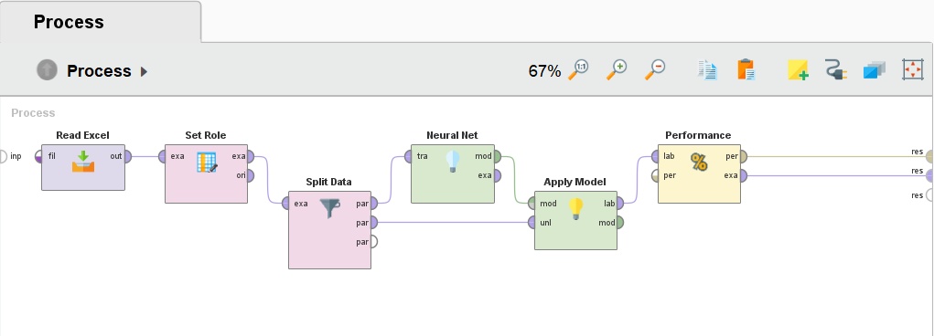

**Figure 2.** Neural Network Testing Design

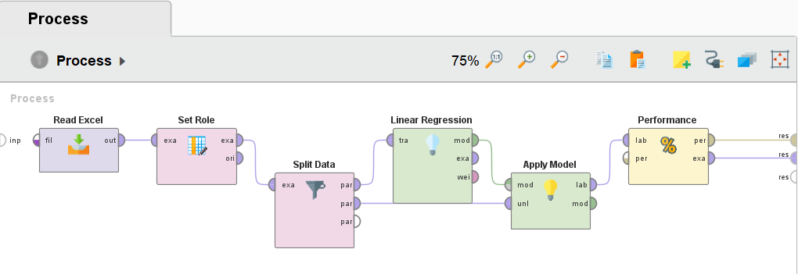

**Figure 3.** Linear Regression Testing Design

After model design, the dataset is divided using a split data operator with a division ratio of 0.8 training data and 0.2 testing data with an automatic sampling type. The following data division can be seen in Figure 4. The dataset in the testing will be processed to produce outputs that can be used as predictive results [26].

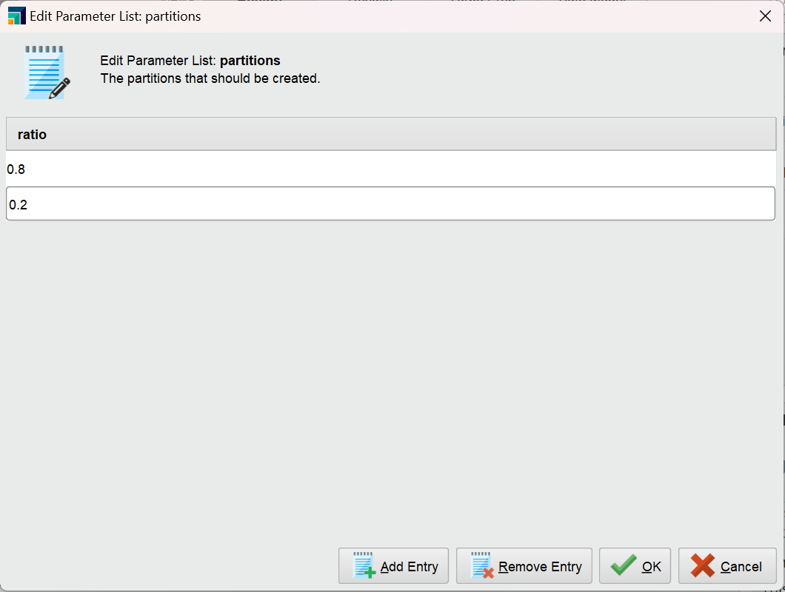

**Figure 4.** Division of Training and Testing Data

The results of sales predictions using neural networks and linear regression algorithms can be seen in Figures 5 and 6. This process produces 766 examples of prediction data with two unique attributes and nine regular attributes. Prediction results are obtained for every date from sales data using the RapidMiner application.

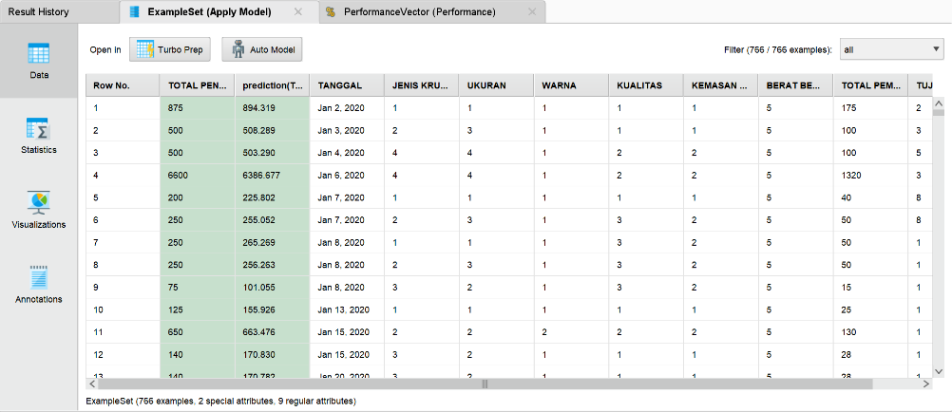

**Figure 5.** Neural Network Prediction Results

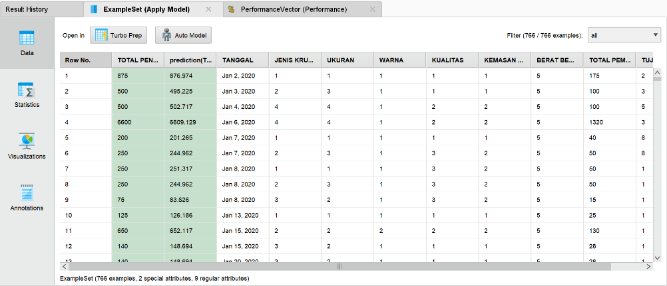

**Figure 6.** Linear Regression Prediction Results

For total sales prediction data based on modeled tests and test data to be easily understood, it is necessary to visualize the data in a dashboard diagram or graphic display [21]. Data visualization using Linear Regression can be seen in Figure 7, and data visualization using Neural Network can be seen in Figure 8.

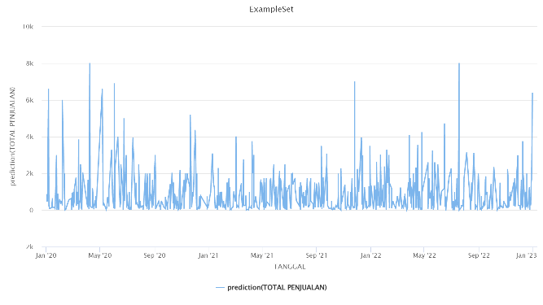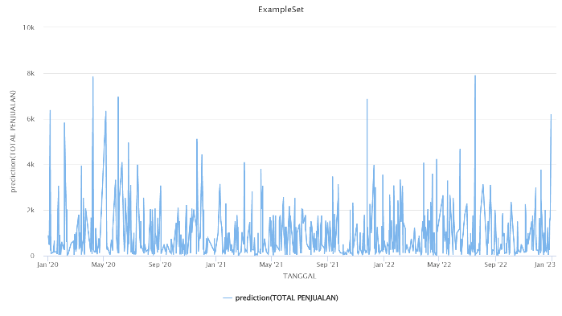

**Figure 8.** Data Visualization Results Using Neural Network

**Figure 7.** Data Visualization Results Using Linear Regression

**Evaluation**

Furthermore, from testing sales data, the performance accuracy value is obtained using RMSE (Root Mean Square Error) [27]. The following are the results of testing the accuracy performance on sales of UD. Tiga Putra by using the Neural Network and Linear Regression methods.

**Neural Network**

Neural Network algorithm is used for the first test. In the test, the process of determining the value of the training cycle, learning rate, and momentum is carried out and uses one hidden layer, which has a size of 2, to find the best RMSE value. The neural network configuration values and RMSE results from the tests conducted by the author in Table 3.

**Table 3.** RMSE Testing Results of Configuration Value Determination Using Neural Network

|  |  |  |  |
| --- | --- | --- | --- |
| **Training Cycle** | **Learning Rate** | **Momentum** | **RMSE** |
| 200 | 0.1 | 0.1 | 61.312 +/- 0.000 |
| 200 | 0.2 | 0.2 | 56.982 +/- 0.000 |
| 200 | 0.3 | 0.3 | 50.221 +/- 0.000 |
| 200 | 0.4 | 0.4 | 44.449 +/- 0.000 |
| 200 | 0.5 | 0.5 | 40.070 +/- 0.000 |
| 200 | 0.6 | 0.6 | 55.093 +/- 0.000 |
| 200 | 0.7 | 0.7 | 82.114 +/- 0.000 |

It is known based on table 3 that the results of testing the Neural Network algorithm obtained different RMSE values. The best RMSE is 40,070 from the results of seven trials that have been tested. It is said to be the best RMSE because the resulting value is smaller than the other RMSE values so as to produce more accurate predictions. It can be seen that a learning rate value that is too large can cause training to be unstable or even divergent, while if the value is too small it can make training take a long time or get stuck in a local minimum. Therefore, the value of 0.5 is the best trial, which is neither too large nor too small. While momentum helps speed up learning, especially when there is a consistent but weak gradient or a noisy gradient. It also prevents the model from getting stuck in a local minimum and can help speed up training on problems related to flat load spaces. Therefore, different numbers of Learning Rate and Momentum in each trial can have a significant effect on the resulting performance.

**Linear Regression**

Linear Regression algorithm is used for the second test. In testing, different feature selection processes such as M5 prime, Greedy, T-Test, and iterative T-Test all use a min-tolerance value of 0.05 which has been determined. The test results of the linear regression algorithm in Table 4.

**Table 4.** Test Results Using Linear Regression

|  |  |  |
| --- | --- | --- |
| **Feature Selection** | **Min-Tolerance** | **RMSE** |
| M5 prime | 0.05 | 67.134 +/- 0.000 |
| Greedy | 0.05 | 67.015 +/- 0.000 |
| T-Test | 0.05 | 66.998 +/- 0.000 |
| Iteratif T-Test | 0.05 | 66.998 +/- 0.000 |

From table 4, it can be seen that the test results of the Linear Regression algorithm obtained RMSE values that are not much different. The best RMSE is 66.998, which comes from feature selection T-Test and Iterative T-Test, from four trials that have been tested. It is said to be the best RMSE because the resulting value is smaller than the RMSE value in feature selection M5 prime and Greedy, resulting in more accurate predictions. In general, feature selection and minimum tolerance in Linear Regression algorithms are important for creating accurate and stable models. Feature selection helps select the most suitable independent variables, while minimum tolerance helps detect multicollinearity in the data.

It can be seen in the results of predicting market trends at UD. Tiga Putra experiences significant market fluctuations in cracker sales. The increase in sales of crackers in certain months occurs because there are big days in that month, such as the increase in sales in July 2022, when there was an Eid al-Adha holiday. Cracker sales were sold out with the Eid al-Adha holiday that month, causing a drastic increase.

With a very high market trend, a sales strategy is needed to increase sales at UD. Tiga Putra. So, the recommendation for a sales improvement strategy is to implement a marketing mix strategy or marketing mix in months that experience a decline in sales. The marketing mix is a means to achieve marketing objectives by satisfying the needs and desires of consumers through the exchange of goods and services [28]. Marketing mix strategy is a combination of variables or activities that are at the heart of a marketing system, variables that can be controlled by an MSME or company to influence the response of buyers or consumers. These variables include product, price, promotion, and distribution or place (4P) [28]. This strategy involves determining how the company presents its products along with other supporting strategies in the form of price strategies, promotions and distribution channel strategies, in certain market segments.

The strategy of each of the marketing mix can be applied is

* 1. Products,Products include everything that provides value to satisfy a need or desire [29]**.** Quality is very important for producers in producing a product [30]. Good quality will gain the trust of consumers, making it easier to market. UD. Tiga Putra can focus on product quality both in terms of good taste and quality ingredients. UD. Tiga Putra can implement a strategy in this element by developing in terms of new flavors in existing crackers and healthier cracker products without using preservatives. With new innovations in products, consumers will be interested in buying these products.
  2. Price,Price is the amount of money paid in exchange for goods and services or the amount of money spent by consumers to buy or use a product or service [31]. Price plays an important role in the process of making an agreement in buying and selling. In making choices, price is certainly one of the factors that must be taken into account [32]. At UD. Tiga Putra,the pricing of crackers is adjusted to the market price. In this case, competition in the business world of an MSME is required to offer products, of course, they must be of high quality but at affordable prices so that consumers like them. In the price strategy UD. Tiga Putra can implement a strategy of providing discounts when purchasing in large quantities or to subscription consumers who buy in bulk. Providing discounts and purchase promos is very necessary at certain times, such as during the holiday season or during major celebrations.
  3. Place, Place refers to various marketing activities such as facilitating the delivery or distribution of goods and services from producers to consumers [31]. UD. Tiga Putra can sell its products in more strategic places such as traditional shops or markets, tourist attractions and even souvenir centers which can be an effective point of sale strategy for cracker products. This can be a key factor in increasing sales by collaborating with local stakeholders [30]. And can sell products online through e-commerce platforms so that products from UD. Tiga Putra can expand market share.
  4. Promotion, Promotional activities are one of the marketing mix variables that include efforts to demonstrate product superiority [33]. In a marketing strategy, the promotion mix includes instruments such as advertising, personal selling, sales promotion, public relations, direct marketing, and online marketing [34]. In this promotion strategy UD. Tiga Putra can promote its products through advertisements in mass media and also on social media in order to interact with potential consumers. By utilizing social media such as Instagram, Facebook, and Tiktok shop as a promotional tool for the sale of cracker products, where the promotion tells the advantages crackers of UD. Tiga Putra so that consumers are interested in buying them.

MSMEs that are able to incorporate the marketing mix as a marketing tool and attract consumers to choose their products can be a source of competitive advantage for the MSME itself. Even requiring the integration of MSME skills and abilities to support MSME strategies through the marketing mix. Along with the development of marketing towards consumer-oriented concepts, such as creating superior value for consumers for products purchased or consumed, the basic concept of the marketing mix itself cannot be ignored as the basis for developing customer value as a marketing strategy. Previous research on the application of marketing mix strategies conducted by Neili Sabila (2021) shows that the marketing mix strategy applied to the Dwi Djaya Rambak Crackers small business in Kendal Regency can help small businesses face a significant decline in sales [35].

**CONCLUSION**

This study aims to predict sales at UD. Tiga Putra and analyze the error value of sales data forecasting. This study can provide recommendations for strategies to increase sales using neural network algorithms and linear regression. Based on the results of test analysis using neural network and linear regression algorithms with rapidminer software, it can be concluded that: 1) Application of data mining to do forecasting at UD. Tiga Putra helps predict future sales levels so the company can know and take essential steps to deal with them. 2) The neural network algorithm is more suitable for forecasting the total sales of UD. Tiga Putra compared to the linear regression algorithm. Test results using the neural network method have a lower error rate, which can be seen from the RMSE value, which is 40,070. It can be concluded that the neural network algorithm provides better predictions than the linear regression algorithm.

The limitation of this research is the need for more data to be obtained from a small number of MSMEs because MSMEs are at UD. Tiga Putra still enters cracker sales data manually every year. So that all data is used during data testing. Furthermore, this study only uses two algorithms to compare, namely, neural network and linear regression, to determine the performance evaluation of these algorithms. Suggestions for further research are looking for large-scale research objects to get a broader range of data with a more significant number and adding several other forecasting algorithms to be compared to find out which is better at predicting performance.

**REFERENCES**

[1] Iriane, R. (2023). CLICK: Scientific Review of Informatics and Computers Application of Data Mining for Sales Prediction of Animal Food Products Using the K-Nearest Neighbor Method. *Media Online*, vol. 3, no. 5, pp. 509–515 [Online]. Available: https://djournals.com/klik.

[2] T, k,. Wadhawa, M. (2016). Analysis and Comparison Study of Data Mining Algorithms Using Rapid Miner. *Int. J. Comput. Sci. Eng. Appl*, vol. 6, no. 1, pp. 9–21. doi: 10.5121/ijcsea.2016.6102.

[3] Widiastuti, F., Murniati, W., Saikin. (2022). Application of Data Mining to Predict Sales of Woven Fabrics Using Linear Regression Case Study: Ud.Bintang Remawe Sukarare. *J. Ilm. Tek. Mesin, Elektro, dan Komput*, vol. 2, no. 1, pp. 27–39, 2022.

[4] Nugroho, K., Hadi, W., Kurniawati., Herdian Bhakti, R. M. (2022). Designing Sales Prediction Model Using Neural Network Method. *J. Ilm. Intech Inf. Technol. J. UMUS*, vol. 4, no. 02, pp. 153–160. doi: 10.46772/intech.v4i02.870.

[5] Yasin, M. (2023). Comparison Of The Application Of Linear Regression Method Estimation Using Rapidminer And Ms. Excel. vol. 8, pp. 17–29.

[6] Sebayang, W. B. (2022). Adolescent Childbirth with Asphyxia Neonatorum. *J. Aisyah J. Ilmu Kesehat.*, vol. 7, no. 2, pp. 669–672. doi: 10.30604/jika.v7i2.1507.

[7] Access, O., Sciences, C. (2023). Soil Ph Prediction Using Rapid Miner And Machine Learning Algorithms. no. 04, pp. 6503–6509.

[8] Sunardi, S., Fadlil, A., Kusuma, N. M. P. (2023). Comparing Data Mining Classification for Online Fraud Victim Profile in Indonesia. *INTENSIF J. Ilm. Penelit. dan Penerapan Teknol. Sist. Inf.*, vol. 7, no. 1, pp. 1–17. doi: 10.29407/intensif.v7i1.18283.

[9] Supendar, H., Rusdiansyah, R., Suharyanti, N., Tuslaela, T. (2023). Application of the Naïve Bayes Algorithm in Determining Sales Of The Month. *SinkrOn*, vol. 8, no. 2, pp. 873–879. doi: 10.33395/sinkron.v8i2.12293.

[10] Minta, S., Suriani., Meutia, R. (2022). The Effect of Income and Population on Public Consumption in Aceh Province with Panel Data Regression. *J. Ilm. Basis Ekon. dan Bisnis*, vol. 1, no. 1, pp. 1–17. doi: 10.22373/jibes.v1i1.1577.

[11] Adjie Setyadj, M., Faqih, A., Arie Wijaya, Y. (2023). Forecasting Rice Commodity Prices in East Kalimantan Using Neural Network Algorithm. *JATI (Jurnal Mhs. Tek. Inform.*, vol. 7, no. 1, pp. 320–324. doi: 10.36040/jati.v7i1.6327.

[12] Massaro, A., Maritati, V., Galiano, A. (2018). Data Mining Model Performance of Sales Predictive Algorithms Based on Rapidminer Workflows. *Int. J. Comput. Sci. Inf. Technol.*, vol. 10, no. 3, pp. 39–56. doi: 10.5121/ijcsit.2018.10303.

[13] Lahindah, L., Sudirman, I. D. (2023). Classification Approach To Predict Customer Decision Between Product Brands Based on Customer Profile and Transaction. *J. Theor. Appl. Inf. Technol.*, vol. 101, no. 9, pp. 3362–3370.

[14] Tiara, B. (2018). Sales Prediction Using Neural Network Algorithm: Case Study at PT Balaraja Food Makmur Abadi. *Insa. Pembang. Sist. Inf. dan Komput. …*, vol. 6, no. 1, [Online]. Available: https://ojs.ipem.ecampus.id/ojs_ipem/index.php/stmik-ipem/article/viewFile/93/10

[15] Kovács, L., Ghous, H. (2020). Efficiency comparison of Python and RapidMiner. *Multidiszcip. Tudományok*, vol. 10, no. 3, pp. 212–220. doi: 10.35925/j.multi.2020.3.26.

[16] Batubara, A. S., Dafitri, H., Faisal, I. (2022). Analysis Of Linear Regression And Trend Moment Methods In Predcting Sales Using MAPE. *J. Sist. Inf. dan Ilmu Komput. Prima*, vol. 6, no. 1, pp. 75–81.

[17] Pradito, B., Purnia, D. S. (2022). Comparison of Linear Regression and Neural Network Algorithms for Predicting Currency Exchange Rates. *EVOLUSI J. Sains dan Manaj.*, vol. 10, no. 2, pp. 64–71. doi: 10.31294/evolusi.v10i2.13284.

[18] Ryantika, H. A., *et al.* (2023). Linear Regression Method Application To Predict Cimory Milk. vol. 7, no. 1, pp. 1–7.

[19] Haryadi, D., Marini, D., Atmaja, U., Hakim, A. R. (2023). Regression Algorithm. vol. 1089, no. June, pp. 1–12.

[20] Utomo, W. C., History, A., Utomo, C. (2023). Journal of Information Technology and Management Prediction of BBRI Stock Movement amid the Issue of 2023 Recession Threat with Machine Learning Approach. vol. 9, no. 1, pp. 20–27. [Online]. Available: http://http//jurnal.unmer.ac.id/index.php/jtmi.

[21] Wahyudi, T., Arroufu, D. S. (2022). Implementation of Data Mining Prediction Delivery Time Using Linear Regression Algorithm. *J. Appl. Eng. Technol. Sci.*, vol. 4, no. 1, pp. 84–92. doi: 10.37385/jaets.v4i1.918.

[22] Sidabutar, M. M. (2023). Comparison Of Linear Regression , Neural Net , And Arima Methods For Sales Prediction Of Instrumentation And Control Products In Pt . Sarana Instrument. vol. 02, no. 8, pp. 1694–1705. doi: 10.59141/jrssem.v2i08.397.

[23] Kurniawan, F., Miftachul, Y., Nugroho, F., Ikhlayel, M. (2023). Comparing neural network with linear regression for stock market prediction. vol. 7, no. 1, pp. 8–13.

[24] Izzah, N., Mohd, A., Shafii, N. H., Fauzi, N. F., Nasir, D. S. (2023). Prediction of Future Stock Price Using Recurrent Neural Network. vol. 8, no. 2, pp. 103–111.

[25] Ramadhan, V. P., Pamuji, F. Y. (2022). Comparative Analysis of Forecasting Algorithms in LQ45 Stock Price Prediction PT Bank Mandiri Sekuritas (BMRI). *J. Teknol. dan Manaj. Inform.*, vol. 8, no. 1, pp. 39–45. doi: 10.26905/jtmi.v8i1.6092.

[26] Saputra, M. J., Herdiansyah, M. I. (2022). Application of Naive Bayes in Predicting Sales and Inventory of Jumputan Fabric at Batiq Colet Shop Tuan Kentang Palembang. *J. Mantik*, vol. 6, no. 2, pp. 2502–2507.

[27] Muliawan, A. (2023). Experiment Time Series Forcasting Using Machine Learning ( Case study : Stock Value Prediction ). pp. 834–839.

[28] Jhon, F., Ahmad, A. S. (2023). The Effect of Marketing Mix on Consumer Purchase Interest in the Lapai Honey Donut Shop. *J. Valuasi J. Ilm. Ilmu Manaj. dan Kewirausahaan*, vol. 3, pp. 593–604.

[29] Saputra, G. R., Roswaty, R. (2020). The Effect of 4P Marketing Mix on Retail Fertilizer Purchasing Decisions at Toko Tani Makmur Pagar Alam South Sumatra. *J. Nas. Manaj. Pemasar. SDM*, vol. 1, no. 2, pp. 32–45. doi: 10.47747/jnmpsdm.v1i2.125.

[30] Citra, Y., Nurwahidah, S., Wrtiningsih, A., Belakang, L. (2023). Marketing mix of krupuk atum saleng beme business in sampar layang hamlet, pemanto village, empang sub-district. vol. 3, no. 1, pp. 62–71.

[31] Sofiah, M., Ramadhani, S., Bi Rahmani, N. A. (2023). Analysis Of The Influence Of The 4p Marketing Mix (Product, Price, Promotion, And Place) On Purchasing Decisions In Micro, Small And Medium Enterprises (Umkm). *J. Ris. Ekon. dan Bisnis*, vol. 16, no. 2, p. 122. doi: 10.26623/jreb.v16i2.7288.

[32] Ilmiah, J., Islam, E. (2020). 4P Marketing Mix Strategy in Determining the Source of Islamic Business Capital for Market Traders in Sidoarjo. *J. Ilm. Ekon. Islam*, vol. 6, no. 03, pp. 693–702 [Online]. Available: http://jurnal.stie-aas.ac.id/index.php/jie

[33] Dihuma, L. R., Din, M., Lamusa, F. (2023). Marketing Mix (4P) on Coconut Oil Products ‘Lanarasa’ in Tambu Village, Balaesang District. vol. 2, no. 1.

[34] Triyawan, A., Prastyaningsih, I., Pradhistya, M. (2023). The Effect of Islamic Marketing Mix (4P) on Consumer Loyalty Mangrove Corporation (Ummilovely). *J. Sharia Econ.*, vol. 4, no. 1, pp. 29–52. doi: 10.22373/jose.v4i1.2517.

[35] Sabila, N. (2021). Analysis Of Marketing Strategies In Small Businesses Rambak Crackers Dwi Djaya Kendal District In The Perspective Of Business Riyadhoh. *Pap. Knowl. . Towar. a Media Hist. Doc.*, vol. 3, no. 2, p. 6.