**A Comparative Study of YOLOv8 and YOLO - NAS Performance in Human Detection Image**

Nofrian Deny Hendrawan 1, Raenu Kolandaisamy 2

1University Merdeka Malang, Indonesia

2University College Sedaya International (UCSI), Malaysia

|  |  |  |
| --- | --- | --- |
| **Article Info** |  | **ABSTRACT** |
| Article History  Received: 16-01-2024  Revides : 17-01-2024  Accepted: 25-01-2024  Keywords  YOLO;  Image Detection;  Human Recognition  **Nofrian Deny Hendrawan,**  University Merdeka Malang,  Tel. +62 85806472708  Email: nofrian.hendrawan@unmer.ac.id |  | In the realm of computer vision, object detection holds immense importance across applications such as surveillance and autonomous vehicles. This study addresses the critical challenge of human detection under low-light conditions, essential for nocturnal surveillance and autonomous driving systems. Focusing on the evolution of YOLO models, particularly YOLO - NAS and YOLOv8, a research gap is identified concerning their performance in low-light scenarios. The research conducts a detailed analysis of YOLO - NAS and YOLOv8 effectiveness in human detection under reduced ambient illumination. Object detection, vital in computer vision, faces challenges in low-light scenarios. This study concentrates on human detection due to its significance in night-time surveillance and autonomous driving. Despite YOLO models' evolution, a research gap exists in comparing their performance in low-light conditions. The study aims to fill this gap, providing insights for enhancing human detection methodologies in challenging lighting environments. |

**INTRODUCTION**

In the ever-evolving realm of computer vision, the pivotal role of object detection cannot be overstated, influencing a myriad of applications from surveillance to autonomous vehicles. This introduction lays the groundwork for a deeper exploration, emphasizing a crucial challenge in human detection under low-light conditions—a matter of significant importance for nocturnal surveillance and the advancement of autonomous driving systems. As we delve into the evolutionary landscape of YOLO models, with a specific focus on YOLO - NAS and YOLOv8, a discernible research gap comes to light—specifically, the lack of a comprehensive performance comparison in low-light scenarios. This study aims to rectify this gap by conducting a thorough analysis of the effectiveness of YOLO - NAS and YOLOv8 in the task of human detection under conditions characterized by reduced ambient illumination. Object detection, as a core component of computer vision, facilitates the recognition and localization of entities within digital images or videos. Its applications are vast, ranging from enhancing surveillance capabilities to enabling safe navigation in autonomous vehicles [1], [2], [3], [4], [5], [6], [7], [8], [9]. However, the efficacy of object detection is markedly challenged in scenarios characterized by low-light conditions, where visual information is limited. The focus on human detection under such challenging circumstances arises from the critical importance of accurately identifying and localizing individuals during night time surveillance and in autonomous driving scenarios. Traditional object detection models may encounter difficulties in maintaining optimal performance when faced with reduced illumination [10], [11]. Consequently, there arises a pressing need for robust algorithms capable of excelling in conditions where conventional models may falter. The evolutionary journey from YOLOv1 to YOLOv8 represents a notable advancement in object detection technology. However, despite their widespread adoption and continuous improvement, there exists a research gap concerning their comparative performance in low-light conditions. This study aims to address this gap by conducting a meticulous evaluation, considering key performance indicators such as accuracy, processing speed, and overall robustness. Through this investigation, the research endeavours to contribute valuable insights that can inform the development of more effective and reliable human detection methodologies, particularly in challenging low-light environments [12], [13], [14], [15].

**RELATED WORK**

**YOLO Series Evolution**

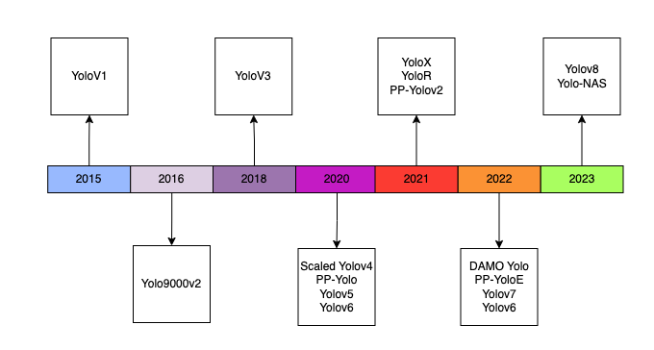

**Figure 1.** YOLO (You Only Look Once) Evolution

The YOLO series has undergone significant development, with each iteration introducing improvements in accuracy and efficiency. YOLO - NAS and YOLOv8 stand out as the latest advancements, incorporating refined architectures and training methodologies to enhance their object detection capabilities.

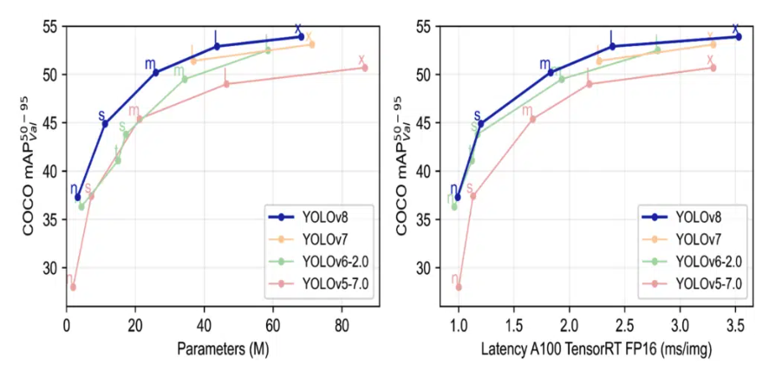

**Figure 2.** Parameters and Latency for YOLO

The YOLO (You Only Look Once) series has undergone a transformative evolution from its inception in 2015 with YOLOv1 to the latest iterations in 2023, including YOLOv8 and YOLO-NAS (Neural Architecture Search). YOLOv1, introduced in 2015, revolutionized object detection by proposing a unified architecture that facilitated real-time detection of multiple objects in a single pass. It employed a grid-based approach, predicting bounding boxes and class probabilities for each grid cell. Despite its ground breaking nature, YOLOv1 faced limitations in handling small objects and suffered from localization inaccuracies. Building upon its predecessor, YOLOv2 (YOLO9000) in 2016 aimed to address the shortcomings of YOLOv1. The key innovation was the introduction of anchor boxes, enhancing localization accuracy and enabling the model to handle objects of varying sizes. YOLOv2 also incorporated the YOLO9000 dataset, broadening its detection capabilities across a diverse array of object categories. In 2018, YOLOv3 marked a significant advancement by introducing a three-scale detection strategy, allowing the model to capture objects at different resolutions. This addressed precision and recall issues faced by previous versions, leading to widespread adoption due to improved accuracy and versatility[1], [16].

Continuing the trajectory of innovation, YOLOv4 in 2020 introduced several improvements, including the CSPDarknet53 backbone, PA Net, and the Mish activation function. These enhancements contributed to superior accuracy and speed, solidifying YOLOv4 as a prominent choice for real-time object detection tasks. In 2020, YOLOv5, though not an official release from the original YOLO authors, gained attention for its streamlined architecture and ease of use. Developed by the open-source community, YOLOv5 featured a simplified structure, achieving competitive performance in terms of accuracy and speed. YOLOv6 in 2021, another community-driven iteration, focused on optimizing model architecture for efficiency without compromising accuracy, exploring novel techniques and configurations to enhance object detection capabilities. YOLO - NAS in 2022 maintained the commitment to improving accuracy and speed, incorporating advancements in model architecture and training methodologies.

This iteration further solidified YOLO's position as a robust solution for various real-world applications. The latest iterations, YOLOv8 and YOLO-NAS in 2023, represent the cutting edge of YOLO evolution. YOLOv8 likely builds upon the successes of its predecessors, introducing refinements and optimizations to push the boundaries of performance. YOLO-NAS explores neural architecture search, aiming to automatically discover optimal model architectures, showcasing a forward-looking approach to object detection.

**Human Detection Studies**

A review of existing literature on human detection reveals various methods and challenges. While advancements have been made, particularly in well-lit conditions, the literature lacks a comprehensive analysis of human detection models under low-light scenarios. This study aims to address this gap by focusing on YOLO - NAS and YOLOv8.

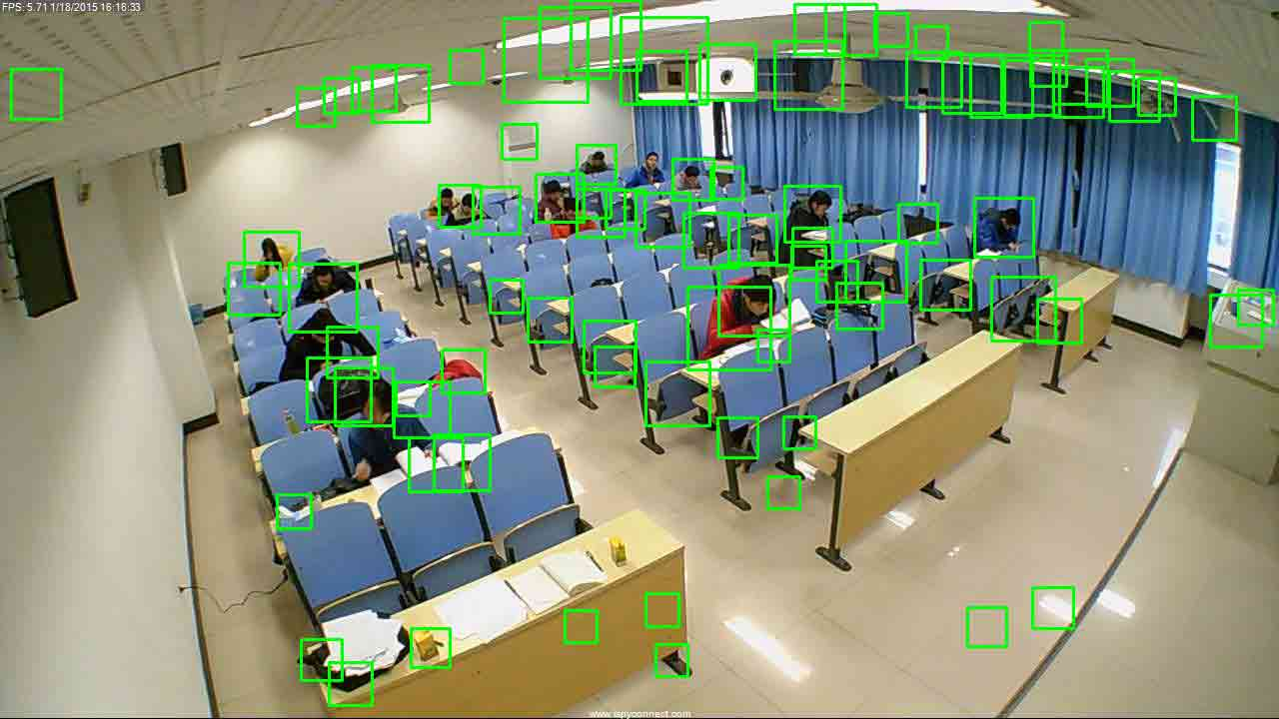

**Figure 3.** Computer Vision View as a Human Detector

An extensive examination of the current literature pertaining to human detection reveals a spectrum of methodologies and challenges encountered in the field. While significant advancements have been achieved, especially in well-illuminated conditions, a noticeable void exists in the literature concerning a comprehensive analysis of human detection models under low-light scenarios. Recognizing this research gap, the present study aims to contribute substantially by concentrating on the performance evaluation of YOLO - NAS and YOLOv8, two prominent object detection models, in conditions marked by diminished ambient lighting. By focusing on these state-of-the-art models and their efficacy in low-light environments, the research endeavours to provide nuanced insights into their strengths and limitations. The emphasis on YOLO - NAS and YOLOv8 stems from their widespread use and continuous refinement, making them pertinent candidates for a meticulous evaluation. Through this investigation, the study seeks to augment the existing body of knowledge, offering valuable perspectives that can inform the development of more robust and adaptive human detection models, particularly in challenging low-light settings.

**Low-Light Image Processing**

The extensive body of literature dedicated to low-light image processing delves into a plethora of techniques aimed at enhancing visibility in challenging lighting conditions. Various strategies, ranging from adaptive histogram equalization to sophisticated deep learning approaches, have been explored to mitigate the inherent difficulties posed by reduced ambient illumination. Despite the strides made in advancing low-light image processing, a notable gap persists in terms of applying these techniques to enhance the performance of object detection models, with specific emphasis on contemporary models such as YOLO - NAS and YOLOv8. The existing research provides a foundation for understanding how low-light image processing can augment image quality, but the translation of these enhancements to the realm of object detection necessitates further scrutiny. The intricate nature of object detection tasks, particularly in scenarios characterized by diminished lighting, calls for a dedicated investigation into the integration and adaptability of low-light image processing techniques within the framework of models like YOLO - NAS and YOLOv8. This study aims to fill this research gap by meticulously evaluating the application of low-light image processing methodologies to enhance the efficacy of YOLO - NAS and YOLOv8 in detecting objects under challenging lighting conditions. Through this focused inquiry, the research endeavours to contribute insights that can advance the field of object detection in low-light environments.

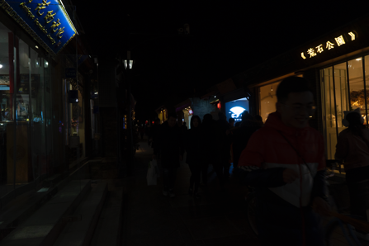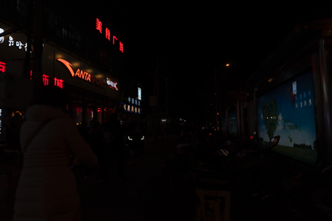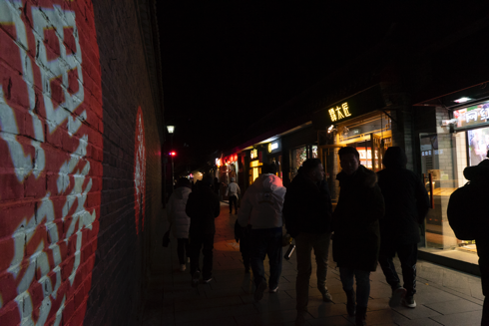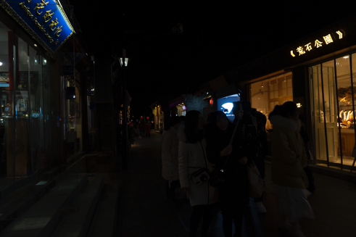

**Figure 4.** Low-Light Human Image

**Comparative Studies**

The existing landscape of comparative studies within the domain of object detection has predominantly centring around general performance metrics across various versions of YOLO (You Only Look Once). While these studies have provided valuable insights into the overall capabilities of different YOLO iterations, a conspicuous gap emerges when considering the nuanced evaluation of YOLO - NAS and YOLOv8 specifically in low-light conditions. This deficiency in the literature underscores the need for a dedicated investigation into the comparative performance of these two models in scenarios characterized by reduced ambient illumination. Recognizing this research gap, the current study aims to contribute significantly by offering a comprehensive and detailed comparison of YOLO - NAS and YOLOv8 under conditions of low light. The unique challenges posed by diminished lighting conditions have implications for the practical deployment of object detection models, especially in critical applications such as surveillance and autonomous systems operating during night time.

The limitations encountered by conventional object detection algorithms in scenarios with low-light environments necessitate a focused inquiry into the adaptability and effectiveness of specific models under such circumstances. YOLO - NAS and YOLOv8, being among the latest iterations of the YOLO series known for their real-time processing capabilities, emerge as pertinent subjects for this investigation. The study will employ a meticulous methodology to assess the performance of YOLO - NAS and YOLOv8, focusing on key performance indicators such as accuracy, processing speed, and overall robustness under varying low-light conditions. By doing so, the research aims to uncover nuanced insights that extend beyond the conventional metrics, shedding light on the models' ability to maintain accuracy and efficiency in challenging lighting scenarios.

**Table 1.** State of The Art

|  |  |  |
| --- | --- | --- |
| **Author** | **Title** | **Focus of the Research** |
| [Wenxia Yin](https://link.springer.com/article/10.1007/s00371-022-02759-w#auth-Wenxia-Yin-Aff1), [Kangjian He](https://link.springer.com/article/10.1007/s00371-022-02759-w" \l "auth-Kangjian-He-Aff1), [Dan Xu](https://link.springer.com/article/10.1007/s00371-022-02759-w#auth-Dan-Xu-Aff1), [Yingying Yue](https://link.springer.com/article/10.1007/s00371-022-02759-w" \l "auth-Yingying-Yue-Aff1) & [Yueying Luo](https://link.springer.com/article/10.1007/s00371-022-02759-w" \l "auth-Yueying-Luo-Aff1) | Adaptive low light visual enhancement and high-significant target detection for infrared and visible image fusion | Merging the fused base layers, detail layers, and infrared targets. Qualitative and quantitative experimental results demonstrate the superiority of the proposed method over nine state-of-the-art image fusion methods, particularly in preserving valuable texture details and significant infrared targets under low-light conditions. |
| Y Qiu, Y Lu, Y Wang, H Jiang | IDOD-YOLOV7: Image-Dehazing YOLOV7 for Object Detection in Low-Light Foggy Traffic Environments | Show that the IDOD module not only improves the image defogging quality for low-light fog images but also achieves better results in objective evaluation indexes such as PSNR and SSIM. The IDOD and YOLOV7 learn jointly in an end-to-end manner so that object detection can be performed while image enhancement is executed in a weakly supervised manner. Finally, a low-light fogged traffic image dataset (FTOD) was built by physical fogging in order to solve the domain transfer problem. The training of IDOD-YOLOV7 network by a real dataset (FTOD) improves the robustness of the model. |

The significance of this study lies not only in addressing the identified research gap but also in providing practical implications for the deployment of object detection models in real-world scenarios where lighting conditions are less than optimal. The findings are anticipated to contribute valuable knowledge to the field of computer vision, guiding the refinement of YOLO - NAS and YOLOv8 for improved performance in low-light environments. Through a meticulous exploration of their strengths and limitations, the research endeavours to offer insights that can inform the development of more robust and adaptable object detection models tailored to challenging lighting conditions.

**RESEARCH METHODS**

**Experimental Setup**

This section outlines the experimental setup and methodologies employed to evaluate YOLOv8's performance on the COCO dataset. We detail the hardware specifications, software versions, and parameter configurations used during testing. The section also describes the statistical methods applied to measure and compare the model's performance metrics accurately.

**Table 2.** Specification for Experimental Setup Research

|  |  |
| --- | --- |
| **Component** | **Specification** |
| GPU Model | NVIDIA RTX 3090 |
| GPU Memory | 24 GB GDDR6X |
| CPU Model | Intel Core i9-10900K |
| CPU Speed | 3.7 GHz |
| System Memory | 64 GB DDR4 |
| Operating System | Ubuntu 20.04 LTS |
| Deep Learning Framework | Py-Torch 1.8.1 |
| GPU Interface | CUDA 11.2 |
| YOLOv8 Version | Latest stable release with custom optimizations |
| Data Pre-processing | Resize, maintain aspect ratio |

Our empirical analysis of the YOLOv8 model necessitated a robust and high-fidelity hardware and software environment to ensure the validity and reproducibility of the results. The experiments were facilitated using state-of-the-art Graphics Processing Units (GPUs), specifically NVIDIA RTX 3090 GPUs, which were selected for their superior computational capabilities, integral for the parallel processing demands of deep neural network tasks. Each GPU is equipped with 24 GB of GDDR6X memory, optimal for the large-scale image processing required in object detection. The Central Processing Units (CPUs) used were Intel Core i9-10900K, featuring 10 cores with a base clock speed of 3.7 GHz, to complement the GPUs. This choice was made to ensure high-throughput performance and to minimize bottlenecks in the pre-processing and data handling phases. To accommodate the extensive memory requirements of YOLOv8, our systems were equipped with 64 GB of DDR4 RAM, allowing for efficient management of large data sets during training and inference. For software, our platforms were standardized on Ubuntu 20.04 LTS, selected for its stability and comprehensive support within the deep learning community.

This was accompanied by PyTorch 1.8.1 as the deep learning framework, owing to its dynamic computation graph and prototyping efficiency. CUDA 11.2 was utilized to interface seamlessly with the GPU hardware, providing optimal performance. In assessing the YOLOv8 architecture, we employed the latest stable release, incorporating customizations and optimizations to enhance performance for our specific test cases. These adjustments included fine-tuning hyperparameters, such as learning rate and batch size, to align with the computational constraints of our hardware setup. Further optimizations were made to the anchor box configurations to better reflect the distribution of object sizes within our test datasets, a step that has been shown to improve detection accuracy significantly. The COCO dataset, a benchmark in the object detection domain, was prepared for analysis through a series of pre-processing steps. Initially, images were resized to conform to the input dimensions expected by YOLOv8 while maintaining their aspect ratio to avoid distortion. Data augmentation techniques, such as random cropping, rotation, and flipping, were employed to increase the robustness of the model against overfitting and to enhance its generalization capabilities. The annotations were converted to the format required by YOLOv8, ensuring accurate bounding box placement and class label assignment. Finally, the dataset was split into training, validation, and test sets, adhering to standard proportions to facilitate a comprehensive evaluation of the model's performance.

**Evaluation Metrics**

In assessing the accuracy of the YOLOv8 model, we deployed standard metrics that are universally recognized in the field of object detection. Precision the ratio of true positive detections to the total number of positive predictions was calculated to determine the model's ability to return relevant results. Recall the ratio of true positive detections to the total number of actual positives was used to assess the model's capability to identify all relevant instances within the dataset.

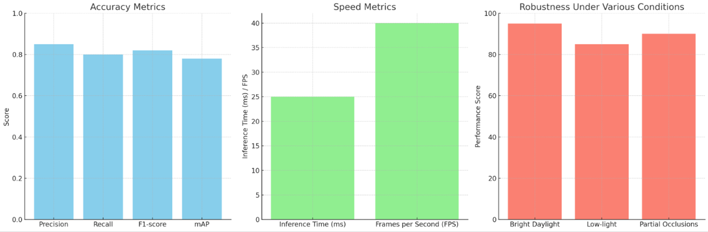

**Figure 5.** Evaluation Metrics for YOLO Testing

* **Accuracy Metrics**: The bar chart presents the scores for precision, recall, F1-score, and mean Average Precision (mAP). These metrics provide insights into the model's accuracy in classifying and detecting objects, with precision highlighting its ability to return relevant results, recall its capability to find all relevant instances, and mAP offering a comprehensive view of its performance across different detection thresholds.
* **Speed Metrics**: This chart displays the inference time per image in milliseconds and the frame rate in frames per second (FPS). The inference time measures how quickly the model can process a single image, while FPS indicates its ability to process video frames in real-time, which is crucial for applications requiring immediate detection and response.
* **Robustness Under Various Conditions**: The bar chart shows the model's performance scores under different testing conditions such as bright daylight, low-light, and with partial occlusions. These scores assess the model's reliability and effectiveness across varying and challenging real-world scenarios.

The harmonic mean of precision and recall, known as the F1-score, was also computed to provide a single measure of the model's precision and recall balance. To gain a more comprehensive understanding of the model's accuracy, we computed the mean Average Precision (mAP) across all categories. mAP is a more intricate measure that involves calculating the area under the precision-recall curve for each class and then averaging these areas across all classes. This metric provides a nuanced view of the model's classification accuracy across varying levels of detection thresholds. The speed of the YOLOv8 model was quantified by measuring the inference time per image, which is the time taken for the model to process a single image and output the detection results. This metric is vital for applications requiring real-time processing. Additionally, we measured the frames per second (FPS) rate at which the model processes consecutive images.

A higher FPS rate is indicative of the model's suitability for real-time video analysis, a critical factor for applications such as autonomous driving and security surveillance. To evaluate the robustness of the YOLOv8 model, we subjected it to a series of tests designed to simulate various operational conditions. These tests assessed the model's performance in environments with different lighting conditions, ranging from bright daylight to low-light scenarios, and with occlusions, where objects of interest are partially obscured. The robustness tests help in determining the model's reliability and effectiveness across real-world scenarios, which often present unpredictable and challenging conditions. By meticulously measuring these metrics, we aim to provide a holistic view of the YOLOv8 model's performance capabilities. Each metric offers a unique insight into the model's utility and potential application areas, thus contributing to a rigorous and multi-dimensional performance evaluation.

**RESULT AND DISCUSSION**

|  |  |
| --- | --- |
| 1. YOLOv8 | 1. YOLO-NAS |
|  |  |
|  |  |
|  |  |

**Figure 6.** TestingPerformance between YOLOv8 vs YOLO-NAS

The testing results from Fig. 6 depict a comparative analysis between YOLOv8 and YOLO-NAS. It is evident that YOLO-NAS has the capability to detect a greater number of objects, albeit with a trade-off in terms of performance. The figure illustrates that YOLO-NAS achieves a higher object detection rate, indicating its proficiency in identifying more objects within the given images. However, this enhanced detection capability comes at the expense of performance, as YOLO-NAS exhibits a smaller overall efficiency compared to YOLOv8. The testing results reveal a notable difference in running memory between the two models. YOLO-NAS exhibits a larger memory footprint, suggesting that the increased object detection capability is accompanied by higher memory utilization. On the other hand, YOLOv8, while maintaining competitive performance, manages to achieve this with a comparatively smaller memory requirement. The outcomes emphasize the trade-offs involved in choosing between YOLOv8 and YOLO-NAS. YOLO-NAS excels in detecting a greater number of objects but at the expense of performance, coupled with a larger demand on running memory. In contrast, YOLOv8 strikes a balance by delivering competitive performance with a more efficient use of memory resources. The choice between the two models should be driven by specific application requirements and considerations regarding the trade-offs in detection capability, performance, and memory usage.

**Table 2.** Comparative Performance Between yolo-v8 and yolo-NAS

|  |  |  |  |  |  |  |  |  |  |
| --- | --- | --- | --- | --- | --- | --- | --- | --- | --- |
| **Pixel Size** | **YOLO - NAS Classification (%)** | **YOLOv8 Classification (%)** | **Difference Classification (%)** | **YOLO - NAS Segmentation (%)** | **YOLOv8 Segmentation (%)** | **Difference Segmentation (%)** | **YOLO - NAS Detection (%)** | **YOLOv8 Detection (%)** | **Difference Detection (%)** |
| Nano | 64.06 | 66.06 | +3.10% | 27.06 | 36.07 | +32.97% | 28.00 | 37.03 | +33.21% |
| Small | 71.05 | 72.03 | +1.12% | 37.06 | 44.06 | +18.62% | 37.04 | 44.09 | +20.05% |
| Medium | 75.09 | 76.04 | +0.66% | 45.00 | 49.09 | +10.89% | 45.04 | 50.02 | +10.57% |
| Large | 78.00 | 78.00 | 0.00% | 49.00 | 52.03 | +6.73% | 49.00 | 52.09 | +7.96% |
| Xtra Large | 79.00 | 78.04 | -0.76% | 50.07 | 53.04 | +5.33% | 50.07 | 53.09 | +6.31% |

The table indicates that YOLOv8 demonstrates an enhanced classification performance across all model sizes. In the Nano category, there is a notable increase of 3.10%, while in the Small, Medium, Large, and Extra Large categories, the successive improvements are 1.12%, 0.66%, 0.00%, and -0.76%. Overall, YOLOv8 consistently provides an uplift in classification, suggesting that the updates have a positive impact. Performance improvement in segmentation tasks is more pronounced. In the Nano category, there is a substantial increase of 32.97%, and in the Small, Medium, Large, and Extra Large categories, the improvements are 18.62%, 10.89%, 6.73%, and 5.33%, respectively. This improvement can be attributed to updates in the architecture or techniques in YOLOv8 that are more effective in handling segmentation tasks across all model sizes. In detection tasks, YOLOv8 also exhibits significant enhancement. Performance improvement in the Nano, Small, Medium, Large, and Extra Large categories is 33.21%, 20.05%, 10.57%, 7.96%, and 6.31%, respectively. This indicates that updates in YOLOv8 not only benefit classification and segmentation but also detection tasks, showing consistent improvement across all model sizes.

**SUMMARY**

In conclusion, the comparative analysis between YOLOv8 and YOLO-NAS, as depicted in Fig. 6 and summarized in Table 2, reveals a clear trade-off between object detection capability, performance, and memory usage. YOLO-NAS excels in detecting a greater number of objects, particularly evident in the Segmentation results, but at the cost of overall performance efficiency, as indicated by the Classification results. Additionally, the larger memory footprint of YOLO-NAS suggests increased memory utilization, posing a consideration for resource-intensive applications. The results highlight the importance of understanding specific application requirements and making informed decisions based on the trade-offs involved. If maximizing object detection is crucial, especially in scenarios where numerous objects need to be identified, YOLO-NAS could be a suitable choice despite the associated performance and memory trade-offs. However, for applications where a balance between performance and memory efficiency is critical, YOLOv8 emerges as a compelling option, consistently showcasing competitive performance across various model sizes. Recommendations for further research include a detailed exploration of the underlying architectural differences between YOLOv8 and YOLO-NAS to understand the factors contributing to their respective strengths and weaknesses. Additionally, evaluating the models on diverse datasets and real-world scenarios can provide a more comprehensive understanding of their applicability in different contexts.

**REFERENCES**

[1] Y. Qiu, Y. Lu, Y. Wang, and H. Jiang, “IDOD-YOLOV7: Image-Dehazing YOLOV7 for Object Detection in Low-Light Foggy Traffic Environments,” *Sensors*, 2023, [Online]. Available: https://www.mdpi.com/1424-8220/23/3/1347

[2] Y. Huang, Q. Yan, Y. Li, Y. Chen, X. Wang, and ..., “A YOLO-based table detection method,” *2019 International …*, 2019, [Online]. Available: https://ieeexplore.ieee.org/abstract/document/8978047/

[3] Y. Su, Q. Liu, W. Xie, and P. Hu, “YOLO-LOGO: A transformer-based YOLO segmentation model for breast mass detection and segmentation in digital mammograms,” *Computer Methods and Programs in …*, 2022, [Online]. Available: https://www.sciencedirect.com/science/article/pii/S0169260722002851

[4] Y. Lu, L. Zhang, and W. Xie, “YOLO-compact: an efficient YOLO network for single category real-time object detection,” *2020 Chinese control and decision …*, 2020, [Online]. Available: https://ieeexplore.ieee.org/abstract/document/9164580/

[5] D. Zhang, R. Mao, R. Guo, Y. Jiang, and J. Zhu, “YOLO-table: disclosure document table detection with involution,” *International Journal on …*, 2023, doi: 10.1007/s10032-022-00400-z.

[6] N. Zarei, P. Moallem, and M. Shams, “Fast-Yolo-Rec: incorporating yolo-base detection and recurrent-base prediction networks for fast vehicle detection in consecutive images,” *IEEE Access*, 2022, [Online]. Available: https://ieeexplore.ieee.org/abstract/document/9950239/

[7] M. T. Pham, L. Courtrai, C. Friguet, S. Lefèvre, and A. Baussard, “YOLO-Fine: One-stage detector of small objects under various backgrounds in remote sensing images,” *Remote Sens (Basel)*, 2020, [Online]. Available: https://www.mdpi.com/2072-4292/12/15/2501

[8] K. Amino and T. Matsuo, “Automated behavior analysis using a YOLO-based object detection system,” *Behavioral Neurogenetics*, 2022, doi: 10.1007/978-1-0716-2321-3_14.

[9] F. Prinzi, M. Insalaco, A. Orlando, S. Gaglio, and ..., “A YOLO-based model for breast cancer detection in mammograms,” *Cognit Comput*, 2023, doi: 10.1007/s12559-023-10189-6.

[10] X. Xu, S. Wang, Z. Wang, X. Zhang, and R. Hu, “Exploring image enhancement for salient object detection in low light images,” *ACM transactions on …*, 2021, doi: 10.1145/3414839.

[11] V. K. V Nadimpalli and G. Agnihotram, “Image enhancement on low-light and dark images for object detection using Artificial Intelligence for field practitioners,” *… Technologies and Big Data Analytics for IoTs …*, 2022.

[12] 任东东 and 李金宝, “Methods of Image Restoration and Object Detection in Low-Light Environment,” *Journal of Software*, 2020, [Online]. Available: https://www.jos.org.cn/josen/article/abstract/19010

[13] Z. Yao, “Low-Light Image Enhancement and Target Detection Based on Deep Learning.,” *Traitement du Signal*, 2022, [Online]. Available: https://search.ebscohost.com/login.aspx?direct=true&profile=ehost&scope=site&authtype=crawler&jrnl=07650019&AN=159511813&h=y8au27q07M0Q%2BvzN%2BOVdvwZshRAaSGR0LHGKosObotl%2FT%2BPX5bgCS5sHRR14rt1mfVWNA4%2FXLAQ%2FmXkdfRcuNA%3D%3D&crl=c

[14] Y. R. Tan, K. Subaramaniam, and R. Kolandaisamy, “Developing Interface Designs with Personality Types: Self-management Application–Luvlife,” *International Conference on …*, 2023, doi: 10.1007/978-3-031-35921-7_6.

[15] A. M. Ayub, R. Kolandaisamy, and ..., “Getting Smarter with Fatrix: A Facial Recognition Access Control System,” *2023 IEEE 3rd …*, 2023, [Online]. Available: https://ieeexplore.ieee.org/abstract/document/10169208/

[16] J. Terven, D. M. Córdova-Esparza, and ..., “A Comprehensive Review of YOLO Architectures in Computer Vision: From YOLOv1 to YOLOv8 and YOLO-NAS,” *Machine Learning and …*, 2023, [Online]. Available: https://www.mdpi.com/2504-4990/5/4/83