**Development and Evaluation of Android-based Infrastructure Rental Application: A Design Science Research Approach**

Joshua Hans Kandami1, Dedi Iskandar Inan2, Ratna Juita3, Lorna Yertas Baisa4, Marlinda Sanglise5, Muhamad Indra6

Teknik Informatika, Universitas Papua, Indonesia

|  |  |  |
| --- | --- | --- |
| **Article Info** |  | **ABSTRACT** |
| Article history  Received: 16-05-2024  Revides  : 04-06-2024  Accepted: 10-06-2024  Keywords  Design Science Research;  Information System;  Infrastructure Rental;  Mobile  Corresponding Author  **Joshua Hans Kandami,**  Universitas Papua,  Tel. +62 82199236501  [joshuakandami.joka@gmail.com](mailto:joshuakandami.joka@gmail.com) |  | This study developed and evaluated a mobile application for infrastructure rental at the Quality Assurance Agency for Education (BPMP) in West Papua using the Design Science Research (DSR) approach in the field of Information Systems (IS). This application, the first designed specifically for the needs of BPMP West Papua and integrated with the existing system, was assessed based on usability and user acceptance through interviews, black box testing, and effectiveness testing using Structural Equation Modeling (SEM) with the Technology Acceptance Model (TAM) approach. The black box testing results indicated successful application development. Evaluation with 64 respondents through hypothesis testing showed that social influence and technological anxiety significantly affect attitudes toward accepting the use of the application. This highlights the importance of considering these factors for the successful implementation of the mobile application at BPMP West Papua, potentially enhancing the efficiency of infrastructure rental. |

**INTRODUCTION**

In this digital era, the advancements in information and communication technology are undeniably intertwined with human life. The presence of smartphones as the primary means to access fast and accurate information can assist society in achieving effective and efficient processes, as well as faster service delivery [1]. Therefore, government agencies continue to fulfill their information technology needs, which initially were done manually or offline, sometimes making the process more complicated and less straightforward. Hence, they are integrated into smartphones, which offer a more efficient process.

Similar to the infrastructure rental system in several government agencies, which generally still rely on manual or offline processes, the shortcomings of manual systems include delays, inefficiencies, susceptibility to errors, and lack of flexibility. An institution responsible for ensuring the quality of education in the West Papua region, the West Papua Education Quality Assurance Institute (BPMP), also faces issues with its manual rental system. Firstly, there are problems with data collection from renters, which currently experience significant obstacles due to manual processes. This results in a considerable amount of time being required for data collection, which is not optimal. Secondly, the current rental of facilities is limited to individuals familiar with the existing rental procedures. Limited access to information and lack of socialization regarding rental procedures pose significant challenges, restricting effective utilization of the facilities to only a small portion of the community. Thirdly, in seeking information about the facilities, many individuals still rely on conventional methods of directly visiting the relevant location. This approach often consumes time and energy and may not be efficient in gathering necessary information. Limited access to information online or through electronic media is also a primary factor influencing the decision to use direct methods [2]. To address this issue, the development of an Android-based system containing necessary functions is required. The selection of a mobile system is due to the higher prevalence of Android users in West Papua. This is aimed at enhancing productivity, efficient accessibility, and user convenience.

Therefore, the importance of this research lies in addressing the challenges present in the manual infrastructure rental system at the West Papua BPMP. This will be achieved through the development of a mobile device-accessible infrastructure rental system and the evaluation of the application [3]. Thus, this research will provide an overview of the development and evaluation of information technology implemented at the West Papua Education Quality Assurance Institute (BPMP) and its surrounding areas.

This research utilizes the Design Science Research (DSR) methodology in the field of Information Systems (IS), which combines two words: "Design Science" and "Research Methodology". This aims to understand the concept that connects research with information systems and computer science as a methodology [4]. DSR method is essentially utilized to address existing problems [5], Hence, it is suitable for use in this research. This is because DSR in IS requires ICT artifacts to be produced/developed as an innovative solution that can significantly contribute to solving previously formulated problems. Furthermore, the evaluation process must follow the development process that can be conveyed. The evaluation process aims to describe the impact of IS innovation on individuals, groups, or organizations using it. The goal is to align usage plans and allocations. [6].

**RELATED WORK**

The research conducted by Nurul Huda Mahmud, Dedi Iskandar Inan, and Irfan Yusuf, titled "Development and Evaluation of the Utilization of Augmented Reality to Enhance the Physics Teaching and Learning Process Using the Design Science Research Method," employs the DSR method. It involves the development (build) of Augmented Reality (AR) Enhancing the instruction and comprehension of physics, as well as the evaluation (evaluate) of the Hedonic Motivation System Adoption Model (HMSAM) to assess the acceptance of the developed system. This study involved the distribution of questionnaires to 184 students enrolled in the Faculty of Teacher Training and Education (FKIP) at UNIPA who had completed basic physics courses. The research conducted tests to ensure validity and reliability, examined the inner model's structural aspects, and evaluated hypotheses using Smart-PLS software. The evaluation results using the HMSAM model reveal that students are receptive to AR technology, with 53.5% falling into the moderate category. This suggests that AR technology has significant potential to enhance learning outcomes and boost student engagement in physics education [7].

The next research conducted by Endi Lastyono Putra, Jenar Suseno, and Darmawan Napitulu with the title "Development of an Application Using Design Science Research (DSR) Method Based on Analysis of Technology Readiness Index (TRI) and Technology Acceptance Model (TAM)" utilizes the DSR method. They administered a questionnaire survey utilizing the Technology Readiness Index (TRI) and Technology Acceptance Model (TAM) frameworks through Google Forms, involving 36 respondents. This was aimed at evaluating the level of readiness and the factors impacting the intention to use the application. The prototype development process aimed to streamline data search and enhance features to facilitate the donation process. User feedback was gathered through questionnaire surveys and interview sessions with representatives. Additionally, validity, reliability, and significance tests were conducted using Smart-PLS software. The evaluation results revealed several significant and non-significant indicators affecting the dependent variable. Hence, it can be concluded that users of the SANDRA fundraising application are confident and skilled in using technology, thereby prioritizing the usefulness and utility of the application over the ease of use aspect [6].

The research conducted by Untung Subagyo and Faiz Ibnu Sholeh, titled "Design and Development of Academic Information System Module for Multiplatform Students," employs the DSR methodology. It involves several stages: problem identification to generate a system requirements list, defining the goals of the solution through observation and interviews with staff and some students, determining the solution, development stage (building) of the user interface design, demonstration stage, and evaluation stage through questionnaires provided to academic staff and several students, followed by collecting feedback and inputs. The evaluation result indicates that the developed application for all identified issues has been approved by users [8].

**RESEARCH METHODS**

**Design Science Research (DSR) Method**

The Design Science Research (DSR) methodology is a research approach focused on developing new products or artifacts, evaluating them, and assessing their effectiveness in fulfilling their intended purpose. In practice, DSR emphasizes two main phases in artifact development: construction and evaluation. If a product can contribute to new research outcomes, it is considered adequately evaluated by DSR [7], ensuring that the produced product not only solves emerging problems but also contributes to knowledge [9].

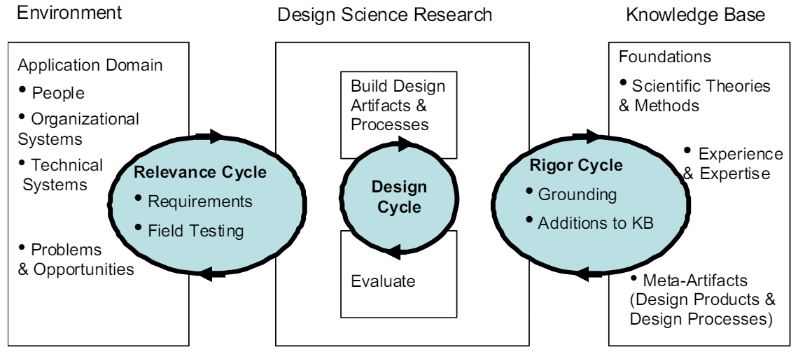

**Figure 1.** Stages of Research in Information Systems Design Science

Design Science Research (DSR) consists of two stages: build and evaluate [9].

* 1. **Build**

In the build stage, researchers design, develop, and construct the planned solutions or artifacts to solve the identified problems. Thus, it involves a structured process. The artifact built here is a system utilizing an Android platform. Developers utilized data collected from interviews with relevant parties to create the new system they needed. With the gathered data, developers constructed a Infrastructure rental application system containing a collection of functions for the Infrastructure rental process, namely;

* Viewing infrastructure information

In this function, users will be able to view all the contents of the available infrastructure information.

* Booking Facilities

In this function, users will make reservations for facilities.

* Viewing Infrastructure Reservation Data

In this function, users will be able to view the data of reservations that have been made earlier.

The rental process in this application begins with viewing infrastructure data, followed by placing an infrastructure order. Next, users contact the admin for approval. If approved, both the admin and the user proceed with the payment process.

* 1. **Evaluate**

This research utilizes a quantitative evaluation methodology, wherein researchers employ quantitative data to assess the artifacts or solutions developed within the research framework. This approach emphasizes the collection and analysis of numerical data to measure the performance, effectiveness, and efficiency of the solution. The quantitative evaluation approach is utilized to propose research, develop processes, and formulate hypotheses. It also encompasses data collection, analysis, and conclusion drawing. This method relies on numerical measurements and follows statistical principles [10].

Evaluation was conducted using two procedures: black box testing and testing with inferential statistics utilizing the Structural Equation Modeling-Partial Least Square (SEM-PLS) approach. The black box testing phase involved three (3) individuals from the West Papua Education Quality Assurance Institute (BPMP), while the evaluation with SEM-PLS was conducted using the Technology Acceptance Model (TAM) theory [6], which was then translated into a questionnaire and distributed to various stakeholders who potentially utilize BPMP's facilities. From the distributed questionnaires, a total of 64 valid and reliable responses were obtained, which could be processed using the SEM-PLS statistical application, namely smartPLS 3.0.

* Black Box Testing:

In this testing, system evaluation is conducted without deep knowledge of the internal structure or source code of the application [11]. The team from BPMP West Papua conducted functional testing of the application without considering the implementation details within it. They tried various inputs and checked the system's outputs to ensure that the application functions according to the specified specifications. The results of the Black Box testing are shown in Table 1.

**Table 1.** Black Box Testing

|  |  |  |  |
| --- | --- | --- | --- |
| Case Tested | Expected Activities | Observation | Conclusion |
| Register | Users Register with name, email, and password | Registered account | Succeed |
| Login | User Enter email and password correctly | Users can enter the main page | Succeed |
|  | If the email and password are incorrect | Users cannot enter the main page | Succeed |
| Home Menu | The first display when the user logs in | The home menu is displayed | Succeed |
| Add Data | Admin can add infrastructure data | Display form to add infrastructure data | Succeed |
| Edit infrastructure data | Admin can edit infrastructure data | Display form for changing infrastructure data | Succeed |
| Delete infrastructure data | Admin can delete infrastructure data | Display options for deleting infrastructure data | Succeed |
| Infrastructure details | Users can see details of infrastructure data | A detailed view of the infrastructure is displayed | Succeed |
| Order infrastructure | Users can order services | Display form for ordering infrastructure | Succeed |
| Contact Menu | Users can see admin contacts and contact admin | The contact menu is displayed, and can be clicked | Succeed |
| History Menu | Admin can see all orders and users can see their orders | Order list view | Succeed |
| Delete message data | User can Delete order | Display options for deleting orders | Succeed |
| Message Details | User can view order details | The order details view is displayed | Succeed |

* Evaluation with the TAM model: The authors utilized the Structural Equation Modeling-Partial Least Squares (SEM-PLS) technique to analyze the integrated technology adoption model related to the tested application. SEM-PLS is a statistical technique employed to assess and quantify the associations among variables within a model. In this context, the variables under investigation may include factors influencing the adoption and acceptance of the application, such as usefulness, user satisfaction, and other relevant factors. The TAM research model is depicted in Figure 2.

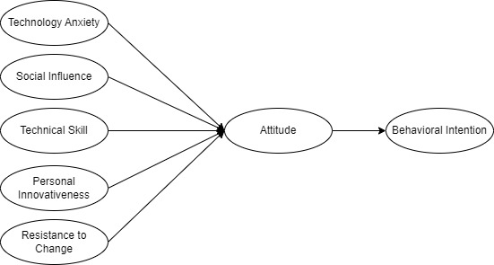

**Figure 2.** Research Model

The data previously obtained will undergo validity and reliability testing. This is to measure whether it is valid and reliable as a data collection tool and can reveal true information from the field based on a questionnaire result. After going through the analysis calculation stage, it will enter the hypothesis stage which identifies the influence of each other whether it affects.

**Research Stages**

To ensure that the three-cycle DSR perspective can be strictly realized, it is elaborated into seven stages of research as outlined in Table 2.

**Table 2.** Development of artifacts based on the DSR framework

|  |  |
| --- | --- |
| Design Science Research Guidelines | Our Artefact Design |
| Relevance cycle: identifying  problems and the artefact type | Stage 1: Design as an artefact  This research seeks to create a rental infrastructure application to streamline the rental procedures at the West Papua Quality Assurance Education Center (BPMP).  Stage 2: Problem Relevance  The current system for Infrastructure rental applications is typically manual, with renters often limited to those in the vicinity who are familiar with the rental procedures. They usually access information about facilities by physically visiting the relevant location, which can lead to errors, especially in the reporting of each Infrastructure rental, causing losses for various parties involved. Therefore, this issue serves as the motivation for researchers to conduct this study. |
| Design Cycle: developing and  evaluation the artefact | Stage 3: Design evaluation  DSR evaluation involves gauging the efficiency and effectiveness of the Information Systems artifacts produced. Its aim is to determine if the developed application aligns with the specified requirements or not.  Stage 5: Research rigor  The application is developed based on an Android-based system. Following its development, the next step involves evaluation, which is carried out comprehensively. Both the development process and evaluation are efficiently executed, yielding valuable feedback to enhance the application.  Stage 6: Design as a search process  DSR stands as the default iterative research methodology, signifying that the development and evaluation phases persist until all previously specified detailed requirements are fulfilled within the application. This iterative journey is steered by feedback garnered from preceding conditions. |
| Rigor cycle: research  contribution and communicating  of the developed artefact | Stage 4: Research contribution  This research contributes to the development of the infrastructure rental system at the West Papua Education Quality Assurance Institute (BPMP), making it more effective in informing people about the rental procedures and quickly accessing information about the facilities without physically visiting the location, solely through the application. Additionally, this paper can contribute to and provide new innovations in further related research development.  Stage 7: Communication of research  At this stage, this research will be presented to the West Papua BPMP through system testing and journals. This includes initial developments as presented in this paper. The aim is also to gather feedback for the refinement of the artifact to be developed later. |

**RESULTS AND DISCUSSION**

**System Design and Development**

This Infrastructure Rental application utilizes Firebase as its database. It consists of four menus accessible to all users: Home, displaying available facilities; Contact, showcasing admin contacts; History, presenting past Infrastructure bookings; and Profile, exhibiting user account data. The application serves three main functions:

1. Viewing infrastructure information

The initial interface shown in Figure 3 contains various information about the facilities available for rent by the West Papua Education Quality Assurance Institute (BPMP). In the user application, users can view details such as the name of the Infrastructure, description, amenities, and pricing. The admin, on the other hand, has the capability to modify, add, and delete Infrastructure data.

|  |  |
| --- | --- |
|  |  |

**Figure 3.** Infrastructure Information Display

1. To reserve facilities

In the message display shown in Figure 4, users can book facilities by selecting Infrastructure information, and within it, there will be a button directing them to the reservation data entry page to be submitted.

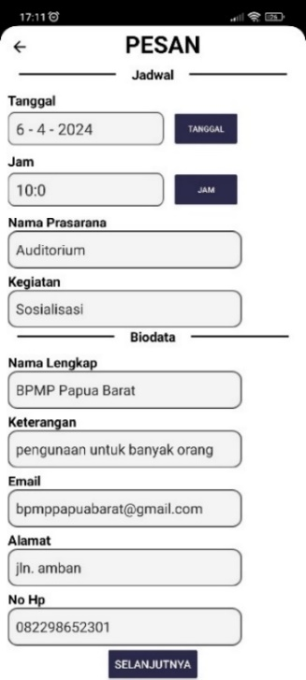

**Figure 4.** Message Display

1. Viewing infrastructure booking data

In Figure 5, each account can only view the data of their own sent orders, unlike the admin who can see all the data of sent orders.

|  |  |
| --- | --- |
|  |  |

**Figure 5.** Order Data Display

The Android application developed in this research is not yet available on the Play Store at the moment. To conduct evaluations, users will receive the application directly from the author for initial use. Afterward, they will be asked to fill out a provided questionnaire, the data from which will then be used in the SEM-PLS testing process.

**Evaluation**

1. Black Box Testing

The black box method enables the author to determine whether the software functions properly merely by observing the system's execution results [12]. West Papua Education Quality Assurance Institute (BPMP) participated in the testing of the system. The testing results can be implemented because its functionality can achieve the application's intended objectives. The findings from the black box testing are depicted in the aforementioned Table 1.

1. SEM-PLS Test Results

The author utilizes this model to examine and elucidate its influence on attitudes and behavioral intentions. This is accomplished through questionnaire distribution, and conducting validity testing, reliability testing, and hypothesis testing using Smart-PLS software.

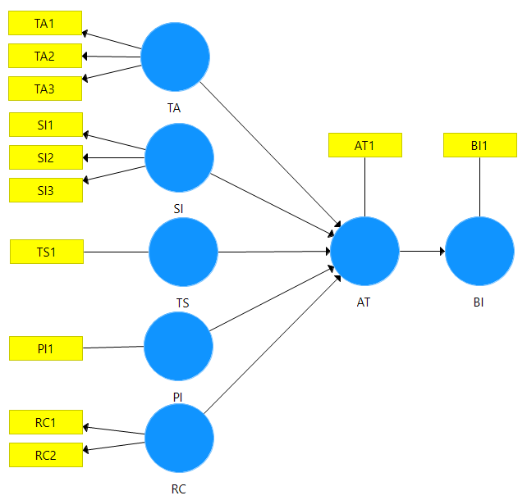

**Figure 6.** SEM-PLS

From the model presented in Figure 6, the following hypotheses are obtained:

H1 = TA Has a significant influence on AT

H2 = SI Has a significant influence on AT

H3 = TS Has a significant influence on AT

H4 = PI Has a significant influence on AT

H5 = RC Has a significant influence on AT

H6 = AT Has a significant influence on BI

* Validity test

Validity testing is conducted to determine the degree of validity of the research results used. A study is considered valid when it measures what it intends to achieve and accurately captures data from the variables under investigation [13]. By testing Convergent Validity and Discriminant Validity.

* Convergent Validity Test

Convergence validity is determined by examining the outer loading values, as shown in Table 3, where each latent variable is already above 0.7. Therefore, the model meets the criteria and can be considered valid [14].

**Table 3.** Outer Loading Value

|  |  |  |  |  |  |  |  |
| --- | --- | --- | --- | --- | --- | --- | --- |
|  | AT | BI | PI | RC | SI | TA | TS |
| AT1 | 1.000 |  |  |  |  |  |  |
| BI1 |  | 1.000 |  |  |  |  |  |
| PI1 |  |  | 1.000 |  |  |  |  |
| RC1 |  |  |  | 0.792 |  |  |  |
| RC2 |  |  |  | 0.981 |  |  |  |
| SI1 |  |  |  |  | 0.811 |  |  |
| SI2 |  |  |  |  | 0.879 |  |  |
| SI3 |  |  |  |  | 0.893 |  |  |
| TA1 |  |  |  |  |  | 0.913 |  |
| TA2 |  |  |  |  |  | 0.914 |  |
| TA3 |  |  |  |  |  | 0.837 |  |
| TS1 |  |  |  |  |  |  | 1.000 |

* Discriminant Validity Test

The Discriminant Validity Test here can be observed through the value of Heterotrait-Monotrait Ratio (HTMT) [15]. The indicators are considered to meet discriminant validity if the value is less than 0.90, as shown in Table 4, indicating that the test results prove no issues in the Heterotrait-Monotrait Ratio (HTMT) testing [7].

**Table 4.** The results of HTMT Disriminant Validity Test

|  |  |  |  |  |  |  |  |
| --- | --- | --- | --- | --- | --- | --- | --- |
|  | AT | BI | PI | RC | SI | TA | TS |
| AT |  |  |  |  |  |  |  |
| BI | 0.069 |  |  |  |  |  |  |
| PI | 0.050 | 0.545 |  |  |  |  |  |
| RC | 0.173 | 0.767 | 0.797 |  |  |  |  |
| SI | 0.817 | 0.047 | 0.034 | 0.224 |  |  |  |
| TA | 0.172 | 0.658 | 0.630 | 0.827 | 0.364 |  |  |
| TS | 0.201 | 0.696 | 0.484 | 0.539 | 0.201 | 0.749 |  |

* Reliability Test

Reliability testing was conducted by calculating Cronbach's alpha, which indicates that the variables used to measure the concepts in this study are highly reliable [13]. Based on the data presented in Table 5, it is evident that the obtained data is reliable. According to Cronbach's alpha and composite, it should be greater than 0.7 to be considered reliable [7].

**Table 5**. Construct Validity and Reliability

|  |  |  |  |
| --- | --- | --- | --- |
|  | Cronbach's Alpha | Composite Reliability | Average Variance Extracted (AVE) |
| AT | 1.000 | 1.000 | 1.000 |
| BI | 1.000 | 1.000 | 1.000 |
| PI | 1.000 | 1.000 | 1.000 |
| RC | 0.793 | 0.884 | 0.794 |
| SI | 0.834 | 0.896 | 0.742 |
| TA | 0.871 | 0.918 | 0.790 |
| TS | 1.000 | 1.000 | 1.000 |

* Hypothesis Testing

Hypothesis testing is conducted using the bootstrap method. To assess the acceptance or rejection of a hypothesis, one can utilize significance values among constructs, t-statistics, and p-values [14]. A hypothesis is accepted if the p-value is less than 0.005 or if the t-statistic is greater than 1.96 [10].

**Table 6.** Hypothesis Test Results

|  |  |  |  |  |  |  |
| --- | --- | --- | --- | --- | --- | --- |
| Hypothesis | Track  Coefficient | Original Sample (O) | Sample Mean (M) | Standard Deviation (STDEV) | T Statistics (O/STDEV) | P Values |
| H1 | AT → BI | -0.069 | -0.064 | 0.193 | 0.357 | 0.721 |
| H2 | PI → AT | -0.093 | -0.074 | 0.103 | 0.899 | 0.369 |
| H3 | RC → AT | -0.064 | -0.042 | 0.164 | 0.388 | 0.698 |
| H4 | SI → AT | 0.835 | 0.818 | 0.115 | 7.287 | 0.000 |
| H5 | TA → AT | 0.330 | 0.265 | 0.160 | 2.067 | 0.039 |
| H6 | TS → AT | -0.219 | -0.191 | 0.123 | 1.783 | 0.075 |

Based on the structural test results as shown in Table 6 above, it can be seen that out of the 6 hypotheses tested, only 2 hypotheses were accepted and statistically significantly influenced the acceptance of the utilization of the mobile-based infrastructure rental application for BPMP in West Papua. Hypotheses H4 and H5 can be accepted because they meet the established statistical criteria, with t-statistic values of 7.287 and 2.067, and p-values of 0.000 and 0.039, respectively. On the other hand, hypotheses H1, H2, H3, and H6 were rejected as they did not show a statistically significant influence. This indicates that social influence and technology anxiety affect an individual's attitude towards the mobile-based infrastructure rental application for BPMP in West Papua. Users state that social influence and technology anxiety influence increasing the acceptance of the utilization of the mobile-based infrastructure rental application for BPMP in West Papua.

**CONCLUSION**

This research successfully developed an Android-based infrastructure rental application for BPMP West Papua. The application categorizes users into two groups: administrators and renters, aiming to improve service delivery efficiency. The application is based on three main processes: viewing infrastructure information, booking facilities, and viewing booking data. Evaluation results from black-box testing and SEM-PLS calculations on the TAM research model show that only technological anxiety and social influence significantly affect users' acceptance attitudes towards the BPMP West Papua infrastructure rental application.

With the ease of booking and access to information, this application has the potential to enhance productivity and user satisfaction at BPMP West Papua. It is expected that the application will improve the efficiency and effectiveness of infrastructure rental services at BPMP West Papua. Although the research results show promising potential, further studies with larger sample sizes and testing on more diverse user groups are recommended to strengthen the findings. Additionally, the development of a multi-platform application is highly anticipated to increase flexibility and user acceptance, enabling access across various operating systems, not just Android. This will expand the application's user base and enhance its overall benefits.

**REFERENCES**

[1] S. Agustami and R. Mutu Manikam. (2021). Perancangan Aplikasi Sistem Informasi Penyewaan Gedung Serbaguna Wilayah Jakarta Barat: *J. Ilm. FIFO*, vol. 12, no. 2, p. 149, doi: 10.22441//fifo.2020.v12i2.004.

[2] S. Subari and A. Ramadhan. (2022). Penerapan Aplikasi Android E-Payment dan Pemesanan Layanan Pujasera: *J. Teknol. dan Manaj. Inform.*, vol. 8, no. 1, pp. 46–55, doi: 10.26905/jtmi.v8i1.7780.

[3] F. Hazami and F. Natsir. (2021). Perancangan Aplikasi Penyewaan Gor Cilandak di Jakarta Selatan Berbasis Android: *J. Sist. Inf. dan Teknol. Perad.*, vol. 2, no. 1, pp. 48–52, [Online]. Available: www.journal.peradaban.ac.id

[4] R. Andrian. (2020). Sistem Informasi Tunjangan Kinerja Untuk Menentukan Tambahan Penghasilan Pegawai Negeri Sipil Menggunakan Metode Design Science Research: *JTIM J. Teknol. Inf. dan Multimed.*, vol. 2, no. 1, pp. 1–11, doi: 10.35746/jtim.v2i1.78.

[5] E. Putra, J. Suseno, and D. Napitupulu. (2023). Meningkatkan Kualitas Aplikasi Dengan Menggunakan Metode Design Science Research (DSR) Berdasarkan Analisis TRI dan TAM: *J. Pekommas*, vol. 8, no. 2, pp. 137–148, doi: 10.56873/jpkm.v8i2.5254.

[6] D. Inan and P. Korespondensi. (2023). Kapan Evaluasi Sebuah Artefak Sistem Informasi Dianggap Cukup? Perspektif Design Science Research: vol. 4, no. 1, pp. 11–18.

[7] N. Huda Mahmud, D. Iskandar Inan, and I. Yusuf. (2024). Development and Evaluation of the Utilization of Augmented Reality to Enhance the Physics Teaching and Learning Process Using the Design Science Research Method: *J. Ris. Sist. Inf. Dan Tek. Inform. (JURASIK*, vol. 9, no. 1, pp. 223–234, [Online]. Available: https://tunasbangsa.ac.id/ejurnal/index.php/jurasik

[8] U. Subagyo and F. I. Sholeh. (2023). Rancang Bangun Sistem Informasi Akademik Modul Mahasiswa Multiplatform: *J. Inform. Komputer, Bisnis dan Manaj.*, vol. 21, no. 1, pp. 60–68, doi: 10.61805/fahma.v21i1.25.

[9] D. I. Inan, K. T. Win, and R. Juita. (2019). MHealth medical record to contribute to noncommunicable diseases in Indonesia,” *Procedia Comput. Sci.*, vol. 161, pp. 1283–1291, doi: 10.1016/j.procs.2019.11.243.

[10] S. M. Rahakbauw, D. I. Inan, and R. Juita. Analyzing Privacy Concern and Technology Anxiety as Determinants of Web-Based Laporkitong Adoption Level : UTAUT 2 Perspective: pp. 1–10.

[11] M. Zidan, S. Nur’aini, N. C. H. Wibowo, and M. A. Ulinuha. (2022). Black Box Testing pada Aplikasi Single Sign On (SSO) di Diskominfostandi Menggunakan Teknik Equivalence Partitions: *Walisongo J. Inf. Technol.*, vol. 4, no. 2, pp. 127–137, doi: 10.21580/wjit.2022.4.2.12135.

[12] E. Saputra, D. I. Inan, R. Juita, L. F. Marini, C. D. Suhendra, and B. Pangaribuan. (2023). Tanda Tangan Elektronik Menggunakan Laravel 9 : Pengembangan dan Evaluasi: *J. Tecnoscienza*, vol. 7, no. 2, pp. 252–267, doi: 10.51158/tecnoscienza.v7i2.923.

[13] M. M. Sanaky. (2021). Analisis Faktor-Faktor Keterlambatan Pada Proyek Pembangunan Gedung Asrama Man 1 Tulehu Maluku Tengah: *J. Simetrik*, vol. 11, no. 1, pp. 432–439, doi: 10.31959/js.v11i1.615.

[14] M. Fakhriansyah, L. D. Fathimahhayti, and S. Gunawan. (2022). G-Tech : Jurnal Teknologi Terapan: *G-Tech J. Teknol. Terap.*, vol. 6, no. 2, pp. 295–305, [Online]. Available: https://ejournal.uniramalang.ac.id/index.php/g-tech/article/view/1823/1229

[15] A. Rangkuti, M. Fuad, and M. Dewi. (2023). Analisis Faktor-Faktor Yang Mempengaruhi Perilaku Masyarakat Dalam Mengelola Keuangan Dengan Niat Sebagai Variabel Intervening: *Jursima*, vol. 11, no. 2, pp. 265–276, doi: 10.47024/js.v11i2.626.