**Analysis power communication actors Cash Social Support Program For Citizen Who Impacted by COVID-19 Pandemic in Batu City with social network analyisis**

**Klara Kumalasari 1* , Ali Hanafiah 2**

Departement of public administration, Sekolah Tinggi Ilmu Adminstrasi Malang, Indonesia **12**

Correspondence: Klarakumala06@gmail.com

**Abstract**

Government as an important body in the framework of governance. The government must pay attention to peace and public order, the demands and expectations as well as the opinions of the people, the needs and interests of the community, environmental influences, communication and coordination arrangements, the participation of all levels of society and the existence of legitimacy. Because government programs are made for the needs of the community, it is very important to know the communication of government programs. This study aims to analyze actor relationships by analyzing aspects of social network analysis calculations such as actor popularity (degree), actor closeness to other actors (closeness), and which actor functions as a liaison between one actor and another (betweenness).

The mix-method approach is used to answer the problem formulation. Data were obtained through interviews and collecting questionnaires from the actors involved in implementing the cash direct social assistance distribution program in Batu City. Data were analyzed through an interactive analysis model using an analytical tool using social network analysis. The results of this study indicate that each actor involved in implementing the social assistance distribution program for people affected by Covid-19 in Batu City has different networking patterns. The strategic actor in the implementation network for the distribution of social assistance programs for people affected by Covid-19 is the social service. Each actor has their own role, namely the Covid-19 task force unit acts as a program maker. By analyzing communication relationships through social network analysis by focusing on public actor communication, we can find out the actor's communication relationship in the Covid-19 social assistance program.

**Key Word : Government, public programs, social assistance, covid-19, social network analysis.**

**INTRODUCTION**

The social assistance program for people affected by COVID-19 is the government's response to the COVID-19 pandemic, especially for people who have experienced decreased income or even lost their jobs. Providing social assistance to the community is actually not something the government has just done. In the event of a disaster in an area, the government's efforts to provide social assistance are often carried out by the central government or local government, but the community's response to the realization that occurs still causes a lot of disappointment with the distribution.

As in research (Rahmansyah et al, 2020) in distributing social assistance to the community, it is known that there are residents in Jakarta who return social assistance, because they feel that the assistance is not on target. Meanwhile, in several areas in Jakarta, there are residents who are not recorded who should be entitled to receive assistance. then in Bali, there are residents who have died, but are still listed as beneficiaries. Meanwhile in Padang, there were complications related to the database of beneficiaries, even after being repaired, there were still errors in the beneficiary data (Dewi, 2020)

In addition, the implementation of the direct cash assistance program turned out to be widely rejected by the community. Research conducted by Hirawan (2020) found that the distribution of social assistance to the community was not optimal due to the government's unpreparedness and the unprepared decision support system to determine which poor families should be given assistance. The COVID-19 pandemic outbreak requires academics to play an active role, one of which is in the field of research, such as research conducted by Herdiana, (2020) entitled ''collaborative supervision in the implementation of social assistance programs affected by COVID-19'' which revealed that the implementation of the distribution of social assistance to the community Those affected by COVID-19 empirically face problems, especially with distribution that is not on target, some people belonging to Target Households (RTS) do not receive social assistance, while people who are classified as capable and not being Target Households (RTS) actually receive assistance.

One of the causes of these problems is the absence of collaborative supervision, the monitoring process for the distribution of social assistance programs for people affected by COVID-19 is carried out using closed internal supervision where other parties including the community do not have access to carry out this supervision.

From several previous studies it can be concluded that in fact the social assistance program is still not effective, there are many obstacles that must be resolved by the government. Therefore, when the government makes a public program, it must pay attention to the target recipients of the public program, including at the time of making the program, so as to minimize the occurrence of mistargeting social assistance program recipients. This also includes coordination with stakeholder actors in providing social assistance. Basically, when making a public program, there needs to be cooperation from several competent actors and organizations in running the program. In the implementation of the actor network program which involves the coordination of several actors is needed.

Regional governments are required to pay greater attention to providing services to the public and their respective regions and how to increase regional independence in implementing a program. To improve the quality of implementing public programs, it is necessary to optimize their potential, and inter-regional cooperation can be an alternative innovation or concept based on considerations of efficiency and effectiveness, synergy and mutual benefit, especially in areas involving cross-regional interests. Inter-regional cooperation can only be formed and run if it is based on the awareness that these regions need each other to achieve one goal

Programs created by governments certainly have a wide scope. Network analysis is very useful for further analyzing government programs because it can predict variations by simply mapping the entire network and highlighting the program process, in which actors convince others to join their cause. Basically, in order to run a public program, there needs to be cooperation from several actors and organizations that are competent in handling this case. If there is strong cooperation, there will be intense and widespread relations and social capital. in public programs is a concept that has now begun to be adopted by developing countries

In the network concept, the government no longer acts as a single actor, there are actors outside the government, such as NGOs, professional groups, communities and other stakeholders who interact, communicate and cooperate with each other in order to achieve goals. Thus, public programs are made in accordance with expectations and accommodate the values of the interests of other actors. The government will survive more by adopting the network concept. Limited resources owned can be overcome through the network (Taufik, 2017).

Government involves various actors or stakeholders. However, coordination in governance tends to always focus on patterns of interdependent relationships between various actors, including various institutions, both government and non-government, in the management of a country. Apart from that, in the Governance paradigm, the government only acts as a directive, not as an executor (Rohman, 2019). This requires the government to reduce its role and provide opportunities for the public and the private sector to play a role. In the concept of governance, previously the actors who had influence in public programs were the government (government), but now the government is starting to invite non-state actors such as the private sector and the community to help them (Utoyo, 2017).

The capacity of these actors is urgently needed, with the hope of complementing the capacities of other actors. The characteristics of this pattern of government are characterized by a democratic character, transparency, humanism, participatory, efficient and accountable. Concepts and theories of governance always prioritize the development and empowerment of inter-agency cooperation capacities in overcoming various public problems. This pattern of cooperation can be called the networking concept in public programs.

**Literature Review**

**Social Network Analysis**

Network is defined as a set of actors/nodes connected by ties/links. Actors/nodes are us, individuals who are involved in a network and ties/links are the relationships and interactions that occur between us and other individuals in a network. In the network there are several dots and lines. Dots can describe many things and lines describe a relationship. According to Prabowo (2016) social network (social network) is a social structure that is formed from a finite set of individuals or organizations with a form of relationship / connection between them. Basically a social network is a map consisting of many people in which there are relationships between individuals. Since network analysis focuses on the relationship between members in the network, the data collected is displayed and analyzed using a matrix, which reflects the relationship of each organization or individual with other organizations in a network.

Program networks involving several actors provide the possibility of communication between different actors on an ongoing basis. Networks can consist of formal organizations, various government agencies, local activists and international support groups (Mark, 1995 in Gedeona (2013)). These groups will interact with one another in making a government program.

The network concept developed by Mark concludes that there are various actors involved in it. In this network approach, it shows that there is no government as the sole actor in making a program. There is a distribution of power and relations between actors that are interdependent on each other. So that in this approach power is not only concentrated in groups of state actors, but rather the distribution of power between actors in a network of public programs (Mark, 1995 in Gedeona (2013)). Program networks are needed to answer complex social problems.

Network theory can be used at various levels in public service programs effectively and efficiently through the utilization of various resources that are available together (sharing resources). The use of resources together can only be found in network-based organizations. The nature of this network allows for the creation of effectiveness and efficiency in the use of resources in order to achieve organizational goals such as in the process of program implementation

Rhodes (2015) defines program networks as one of a collection of concepts that focus on relations with the government and dependence on state actors and other community actors. Rhodes (2015) says that the European literature on networks focuses less on sub-governments and pays more attention to interorganizational analysis. Therefore, Rhodes (2015) emphasizes that the structural relationship between political institutions is an important element in program networks rather than interpersonal relationships between individuals in these institutions. The program network facilitates coordination of public and private interests, as well as resources, in this case increasing efficiency in program implementation.

**Strategic Actors in the Program Implementation Network**

One of the important questions when analyzing social networks is which actor has the most important position in the network. According to Eriyanto (2014) to determine the position of strategic actors in the network refers to three aspects of social network analysis calculations such as actor popularity (degree), actor's closeness to other actors (closeness), and which actor functions as a liaison between one actor and another (betweenness), there is also an explanation as to what is meant;

1. Degree Centrality

According to Andi et al (2012), degree Centrality is defined as a measurement of the number of connections a node has or the number of relations connected to a node. But then Kretschmer, a researcher from the Department of Library and Information Science, Humboldt University Berlin Germany, in his research stated that every relationship formed in the case of social networks always has a weight that represents the level of closeness or intensity and interaction between actors.

2. Closeness centrality

Closeness centrality is one of the methods used to calculate centrality values, closeness centrality is the distance that connects a node to other nodes in a network (Setatama, 2012) Closeness centrality is the closeness of the actor, in the sense of how far or close the actor can contact other actors in the network, the speaker has good affinity if the actor can establish close relationships with all the actors in the network, proximity is different from popularity, if popularity refers to how often the actor makes contact with other actors. while proximity relates to how closely related actors are to each other, actors can be popular but may not necessarily have closeness to every actor in the network

3. Betweenness Centrality

Betweenness Centrality is a measure indicating that actors who have high scores have a role as a liaison between actors on the network. According to Freeman (1979) in Pratama (2018), states that betweenness is a measure to see the frequency of actors who are among the paths of other actors. Betweenness Centrality marks the importance of a node based on the number of routes or the shortest path through it. If there are two nodes that are close to each other, for example b and c want to interact and a is on the path of the relationship between b and c, then a has control over the interaction of the two and betweenness measures that control.

**RESEARCH METHODS**

The location of this research is Batu City, on the basis of the consideration that, first, the number of Covid-19 patients in Batu City is the highest compared to other cities in East Java. Second, Batu City is an active city in providing social assistance to the Covid-19 community. Third, the reason for choosing this research location is Batu City, on the basis of the consideration that, firstly, the number of Covid-19 patients in Batu City is the highest compared to other cities in East Java. Second, Batu City is an active city in providing social assistance for the Covid-19 community. enough to do with policy. Policies for Handling Covid-19 in and Kota Batu. Fourth, the research location can receive researchers in sufficient time and easy access to obtain and collect data.

**Method**

The research method used is multi-method. According to Creswell (2009) in Sugiyono (2012) multi-method research is an approach in research that links quantitative and qualitative research methods. In more detail, Sugyiono (2012) also added that in multimethodology the data obtained is more comprehensive, valid, reliable and objective. Multiple methods are used to describe and explain the data that the researcher obtained, so that the researcher can analyze the data using both methods. Both qualitative and quantitative methods are to strengthen the data that has been analyzed and in the end produce a conclusion and suggestions.

The data analysis used in this study uses the Social Network Analysis technique. Social Network Analysis has emerged as a key technique in today's modern life to map various actor network patterns. Network (network) is defined as a set of actors/nodes connected by ties/links. the most popular software packages within the SNA community: Pajek, UCINET 6, NetDraw, Gephi,E-Net, KeyPlayer, StOCNET (Majeed, 2020). The Social Network Analysis technique in this study uses the UCINET algorithm tool. The social networking analysis techniques in the UCINET program are: a. Creating network data in the form of a relationship matrix between actors using Microsoft excel and the UNCINET program. b. Interpret the images from the UCINET software with the results of observational data in the field c. Calculating Degree Centrality.

**Result and Discussion**

In the implementation of a program, a relationship is established between the actors involved, the relationship has a continuous interaction between two or more people which facilitates the process of implementing the program. by the following staff in the Batu city secretariat

‘’ in implementing this social assistance program, all power is delegated to the social service because the social service is the service responsible for the social assistance program, other services are only helping the implementation of the program.’ Interview results on June 21, 2021 at 08.00 at Among Tani City Hall

In addition, in an interview with the Head of the Batu City Social Service, he confirmed this statement as in the interview below

‘’ if according to the structure of distribution of social assistance the relationship with other actors is only work professionalism because the purpose of the actor's involvement is to help run the program.’’ Interview results on June 21, 2021 at 09.55 at Among Tani City Hall. Researchers found supporting data on implementing actors who were involved in the co-19 social assistance program;

Tabel 1. implementing actors involved in the covid-19 social assistance program

Source: Researcher (2021)

|  |  |  |
| --- | --- | --- |
| **Number** | **Actor** | **Role** |
| 1. | Covid-19 task force units | Policy makers |
| 2. | Social services Batu City | Program facilitator, monitoring and evaluation, policy formulation maker |
| 3. | Village head (Kepala Desa) In batu city | Submitting prospective recipients of social assistance to social services, |
| 4. | Neighborhood  Association and Resident Community Unit in Batu City (Rukun Tetangga dan rukun Warga) | Input data on prospective social assistance recipients and propose prospective social assistance recipients to the village |
| 5. | Field coordinator team | Assist social services in monitoring the implementation of programs in the village |
| 6. | Civil registry office (Dinas kependudukan catatan sipil) | Verification of prospective beneficiary data |
| 7. | Bank Local East Java (Bank Jatim) | Cash social assistance providers |
| 8. | Civil Sercvice (Police) | Security for the community when distributing social assistance |

Table 1. shows that the roles of each of these actors have different interactions with the eight actors in implementing the social assistance distribution program for people affected by Covid-19. The following is a pattern of networking between actors in the implementation of social assistance distribution programs for people affected by Covid-19 in Batu City. The following is an analysis of the SNA on the Covid-19 assistance program in Batu City:

1. **Analysis *centrality***

Tabel 2.Analyisis *degree centrality*

Source: Researcher (2021)

|  |  |  |
| --- | --- | --- |
| **Actor** | **Outdegree** | **Indegree** |
| Covid-19 task force units | 1.00 | 1.00 |
| Social services Batu City | 6.00 | 7.00 |
| Village head (Kepala Desa) In batu city | 4.00 | 3.00 |
| Neighborhood Association and Resident Community Unit in Batu City (Rukun Tetangga dan rukun Warga) | 3.00 | 5.00 |
| Field coordinator team | 3.00 | 4.00 |
| Civil registry office (Dinas kependudukan catatan sipil) | 2.00 | 1.00 |
| Bank Local East Java (Bank Jatim) | 3.00 | 3,00 |
| Civil Sercvice (Police) | 4.00 | 2.00 |

Table 2 shows that actors have different centrality scores, the highest centrality score is obtained by social service actors with a total Outdgree score of 6.00, and an indegree of 7.00. social assistance to people affected by Covid-19. Table 1 shows that each actor has a different centrality score, the highest centrality score is obtained by a social service actor with a total Outdgree score of 6.00, and an indegree of 7.00. social assistance distribution program to communities affected by Covid-19.

**2. Between Centrality**

Beetweenness Centrality is group centrality which is used to measure the proportion of connecting actors and non-group member pairs that pass through a group in a graph. From the research results there are eight actors involved. The following is an analysis between centrality in social assistance distribution programs for people affected by Covid-19

Table 3. *Analysis Between Centrality*

Source: Researcher (2021)

|  |  |  |
| --- | --- | --- |
| **Actor** | ***Betwenness*** | ***nBetweenness*** |
| Social services | 24.33 | 57.937 |
| Field Coordinator Team | 1.833 | 4.365 |
| Village head (Kepala Desa) In batu city | 1.500 | 3.571 |
| Neighborhood Association and Resident Community Unit in Batu City (Rukun Tetangga dan rukun Warga) | 1.333 | 3.175 |
| Bank Local East Java (Bank Jatim) | 1.000 | 2.381 |
| Civil Sercvice (Police) | 0.500 | 1.190 |
| Civil registry office (Dinas kependudukan catatan sipil) | 0.500 | 1.190 |
| Covid-19 task force units | 0.000 | 0.00 |

Table 3. The results of the analysis between centrality show that social service actors have the highest score of 24.33 on betwenness and 57.937 on nbetweenness. This shows that the social service is a liaison actor in the network.

**3.*****Analysis* Closness centrality**

*Closeness Centrality* adalah jarak rata-rata antara node dengan semua node yang lain di jaringan. Ukuran ini menggambarkan kedekatan node ini dengan node lain. Semakin dekat, semakin terhubung orang tersebut dengan lainnya. Berikut ini adalah analisis *Closenness Centrality* pada program penyaluran bantuan sosial untuk masyarakat terdampak covid-19

Tabel 4. *Analysis* Closness centrality

Source: Researcher (2021)

|  |  |  |
| --- | --- | --- |
| **Aktor** | **Incloseness** | **outCloseness** |
| Social services | 100.00 | 87.500 |
| Field Coordinator Team | 77.778 | 63.636 |
| Village head (Kepala Desa) In batu city | 63.636 | 63.636 |
| Neighborhood Association and Resident Community Unit in Batu City (Rukun Tetangga dan rukun Warga) | 63.636 | 70.00 |
| Bank Local East Java (Bank Jatim) | 63.636 | 63.636 |
| Civil Sercvice (Police) | 58.333 | 70.00 |
| Civil registry office (Dinas kependudukan catatan sipil) | 53.846 | 50.00 |
| Covid-19 task force units | 53.86 | 58.33 |

The eight actors who have the highest Closenness Centrality score are social services with 100.00 for Incloseness and 87.500 for outcloseness. This shows that social services are actors who have the closest relationship with other actors.

**DISCUSSION, AND ANALYSIS**

Social network theory is becoming increasingly significant in the social sciences, and measures of centrality are underlying this evolving theory. In the perspective of social networks, individuals, organizations, companies etc. are like nodes in a network, and centrality is used to measure these nodes namely degree centrality, betweenness centrality and closeness centrality

**1. *Degree centrality***

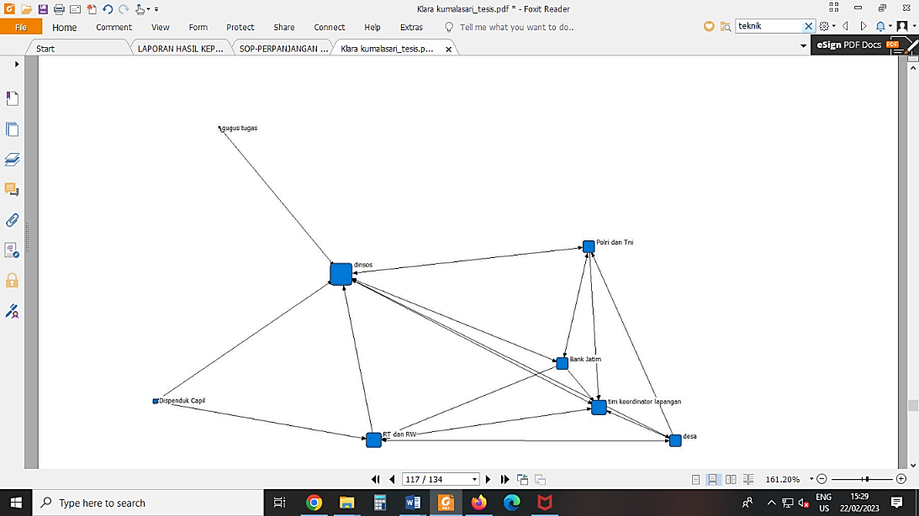 Social network theory is becoming increasingly significant in the social sciences, and measures of centrality are underlying this evolving theory. In the perspective of social networks, individuals, organizations, companies etc. are like nodes in a network, and centrality is used to measure these nodes namely degree centrality, betweenness centrality and closeness centrality

**Figure. 1 Degree centrality**

Source: Researcher (2021)

Figure 1. Explains that the eight actors in the social assistance distribution program for people affected by Covid-19 who have the greatest degree of centrality are social service actors because these actors have stronger interactions than other actors who are also involved in social assistance distribution programs for people affected by Covid -19. After a social actor gets higher centrality, it means he is getting closer to the center of the network, power, influence, higher comfort from the network he gets. (Sparwe et al, 2001; Lou 2017)

**2. Beetween Centrality**

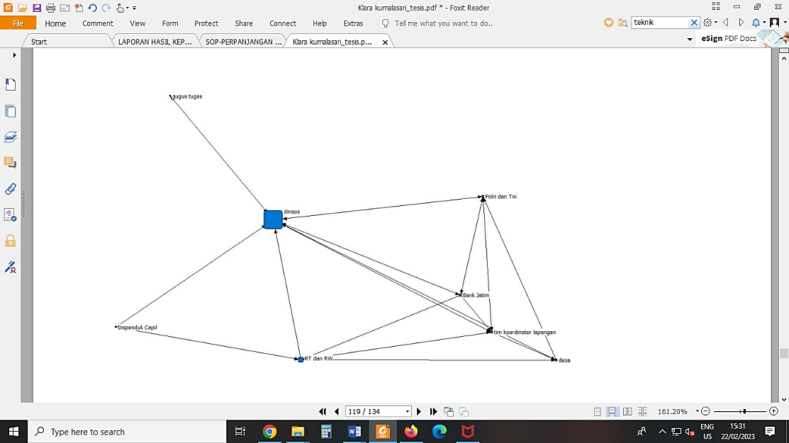 Beetweenness Centrality is group centrality which is used to measure the proportion of connecting actors and pairs of non-group members who pass through a group in a graph. From table 2. It is known that the social service is a liaison actor in the network

**Figure 2. Between Centralities**

Source: Researcher (2021)

Eight actors involved in the distribution of social assistance programs for people affected by Covid-19. Social service actors act as a liaison (between centrality) in program implementation Social service actors are also directly involved in making program policy regulations, distributing social assistance and monitoring and evaluation.

**3. Closness centrality**

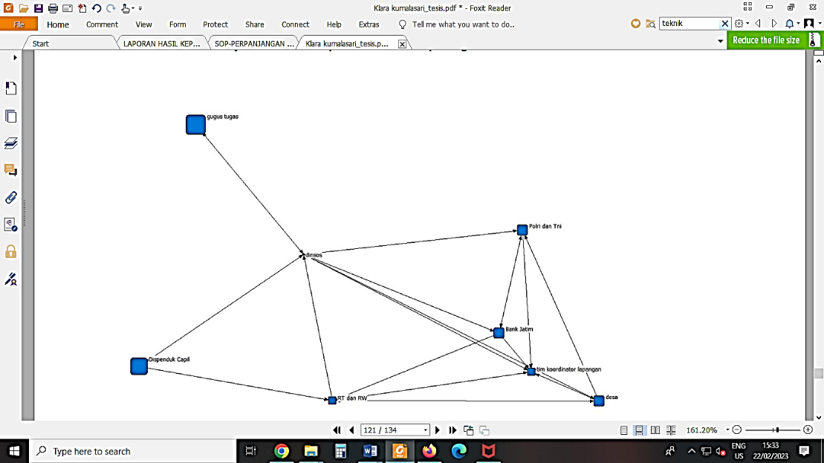From the results of the Closness centrality analysis, social services are the central actor and have the closest relationship, but it is different from the Covid-19 task force unit actor who has the farthest relationship with other actors. Batu, the actors of the Covid-19 task force are only related to social services.

***Figure 3. Closeness centrality***

Source: Researcher (2021)

Centrality is an algorithmic tool to measure the extent to which an actor occupies a prominent position or is an important actor in a network. It can be concluded that the actors involved in the social assistance distribution program for people affected by Covid-19 in Batu City, where there are several actors who do not have networks with each other. from the results of the centrality analysis that has the greatest centrality are social service actors. In addition, the network pattern while the line with one arrow reflects a relationship or bond. Circles or dots represent actors and lines represent ties or relationships

**Conclusion**

There are eight network patterns found in the implementation of the direct cash social assistance distribution program for people affected by COVID-19 in Batu City. The eight network patterns are social service actor networks, task force unit team actor networks, village government actor networks, community institution actor networks, field coordinating team actor networks, civil registration service actor networks, East Java bank actor networks, and community safety actor networks.

The network pattern in the implementation of the direct cash social assistance distribution program for people affected by COVID-19 in Batu City uses work agreement patterns, this is because work agreements are carried out by several related actors or communities who are members of and have responsibility for their performance in providing community services. The results of mapping the relationship patterns of actors in the direct cash social assistance distribution program to communities affected by COVID-19 in Batu City using SNA show a strong relationship between the actors involved who have dependence on other actors, meaning that even though social service actors are strategic actors, there are other actors. who participate actively so that it makes it easier for social service actors to carry out direct cash social assistance distribution programs to people affected by COVID-19 in Batu City

Apart from that, from the seven dimensions of the program network in the implementation of the distribution of social assistance for COVID-19 in Batu City, it is known that these dimensions have not been fulfilled, it can be seen that the actors tend to be dominated by the government, even though the characteristic of Waarden's (1992) public network is that it involves many actors. The actors referred to here are the government (public organizations), then interest groups, parties, social groups, the business world (private organizations) and other entities in society as well as the citizens themselves (individuals).

**References**

Adiyoso, W. (2022). Assessing governments’ emergency responses to the COVID-19 outbreak using a social network analysis (SNA). *Sage Open*, *12*(2), 21582440211071101.

Borgatti, S. P., & Ofem, B. (2010). Overview: Social network theory and analysis. In A. J. Daly (Ed.), The ties of change: Social network theory and application in education (Vol. 8, pp. 17–29). Harvard Press.

Coles, A.-M., Piterou, A. & Genus, A. (2016) Sustainable energy projects and the community:Mapping single-building use of microgeneration technologies in London,Urban Studies, 53,pp. 1869–1884.

Czischke, D. (2015)Social Housing Organisations in England and The Netherlands: Between theState, Market and Community(Delft: Technical University of Delft).

Elsinga, M. & Wassenberg, F. (2007) Social housing in The Netherlands, in: C. Whitehead &K. Scanlon (Eds)Social Housing in Europe, pp. 130–147 (London: London SchoolEconomics)

Gedeona, Hendrikus Triwibawanto. 2013. "Tinjauan teoritis pengelolaan jaringan (networking management) dalam studi kebijakan publik." Jurnal Ilmu Administrasi: Media Pengembangan Ilmu dan Praktek Administrasi 10.3.360- 372

Herdiana, Dian. 2020 . "Pengawasan kolaboratif dalam pelaksanaan kebijakan bantuan sosial terdampak COVID-19." Jdp (jurnal dinamika pemerintahan) 3.2 85-99.

Majeed, S., Uzair, M., Qamar, U., & Farooq, A. (2020, November). Social Network Analysis Visualization Tools: A Comparative Review. In *2020 IEEE 23rd International Multitopic Conference (INMIC)* (pp. 1-6). IEEE.

Mullins, D. & Pawson, H. (2010) Housing Associations: Agents of Policy or Profits inDisguise?,Hybrid Organizations and the Third Sector: Challenges for Practice, Theory andPolicy, in D. Billis (Eds)

Sparrowe, Raymond T., R. C. Liden, and S. J. Wayne. "Social Networks And The Performance Of Individuals And Groups." Academy of Management Journal 44.2(2001):316-325.

Sugiyono. 2012. Metode Penelitian Kuantitatif Kualitatif dan R&B. Bandung: Alfabeta

Van den Broeck, K., Haffner, M. & Winters, S. (2016)An Evaluation Framework for MovingTowards More Cost-Effective Housing Policies(Leuven: HIVA. Research Institute for Workand Society).

Wahab, S. A. (2012). Analisis kebijakan: dari formulasi ke penyusunan model-model  
implementasi kebijakan publik. Jakarta: Bumi Aksara, 77.

Zhou N, Xiao X, Feng F. Citizen Participation in the Public Policy Process in China: Based onPolicy Network Theory. Public Administration Research. 2014 Nov 1;3(2):91