**Relationship between the actors of the cash social assistance program for residents affected by Covid-19**

**Klara Kumalasari 1 , Ali Hanafiah 2**

Departement of public administration, Sekolah Tinggi Ilmu Adminstrasi Malang, Indonesia **12**

Klarakumala06@gmail.com

**Abstract**

A crucial component of the governance structure is the government. The government must take into account the following factors: legitimacy, peace, and public order, citizen demands and expectations, community needs and interests, environmental influences, communication and coordination channels, and participation at all societal levels. Given that government initiatives are designed to satisfy community needs, understanding how they are communicated is essential. This study attempts to assess actor relationships by studying elements of social network analysis calculations such as actor popularity (degree), actor closeness to other actors (closeness), and which actor acts as a bridge between one actor and another (betweenness).

The mix-method methodology is used to handle the problem formulation. Surveys and interviews were conducted with the participants in Batu City's cash-direct social assistance distribution program to acquire information. A social network analysis analytical tool and an interactive analysis model were used to analyze the data. According to the study's findings, each actor involved in implementing the social assistance program for Covid-19 victims in Batu City has a distinctive pattern of networking. The main strategic participant in the network of organizations that distributes social support programs for Covid-19 victims is social services. Each player takes on a particular role; the Covid-19 task force unit, for instance, develops programs. Social network study of communication relationships with a focus on public actor communication, we can find out the actor's communication relationship in the Covid-19 social assistance program.

**Key Word: Government, public programs, social assistance, covid-19, social network analysis.**

**INTRODUCTION**

The social support program for COVID-19 victims is the government's response to the epidemic, especially for individuals who have suffered a decrease in income or even lost their jobs. The government hasn't just started handing out social assistance to the neighborhood. When a disaster strikes a place, the local or federal government frequently attempts to provide social assistance, but the community's response to the realization still leads to a lot of unhappiness with the distribution. According to research (Rahmansyah et al., 2020) on the provision of social support to the community, there are residents of Jakarta who return social aid because they think it is not being used effectively. In the meanwhile, some people who live in several Jakarta neighborhoods who are not on the list yet should be qualified for assistance. Then others resided in Bali and are no longer listed as beneficiaries. While this was going on, in Padang, there were problems with the beneficiary database; even after these problems were resolved, the beneficiary data still contained errors (Dewi, 2020).

In addition, the approval of the direct financial support program was met with strong opposition from the community. The community's distribution of social assistance was not optimal, according to a study by Hirawan (2020), because neither the government nor the decision-support system was ready to determine which low-income families should receive aid. One way that academics must actively participate in the COVID-19 pandemic outbreak is through research. For instance, Herdiana's (2020) study, "Collaborative Supervision in the Implementation of Social Assistance Programs Affected by COVID-19," showed that rigorous control is required when distributing social assistance to the community. Issues arise for those who are affected by COVID-19, certain Target Households (RTS) members do not receive social assistance, whereas others who are deemed capable but not members of Target Households (RTS) do receive aid, especially when the distribution is off-target.

One of the reasons for these problems is the absence of collaborative supervision; instead, social support programs for COVID-19 victims are distributed under closed internal supervision, to which other parties, including the community, are not granted access. The social assistance program is still ineffective and confronts several difficulties that the government must address, according to multiple past studies. The government must be mindful of the target recipients of the public program when it creates it, especially at that time, to lessen the possibility of recipients of social assistance programs being unintentionally targeted. Collaboration with stakeholder actors is necessary for providing social support. Many qualified people and organizations must participate in the development and administration of a public program. It is necessary to coordinate several actors to implement the actor-network program.

In addition to how to give services to the general public and their particular regions, regional governments must concentrate more on how to promote regional independence while putting a program into action. To enhance the effectiveness of public initiatives, their potential must be fully realized. Especially in fields with cross-regional interests, interregional cooperation can be a different invention or concept focused on efficiency and effectiveness, synergy, and mutual benefit. Only when there is an awareness that these regions depend on one another to accomplish a shared goal can interregional cooperation be developed and maintained.

Undoubtedly, there is a wide range of themes covered by government-produced programs. Network analysis is a potent method for investigating government programs further since it only requires sketching the entire network and illustrating how the players influence others to support their purpose. To execute a public program, various individuals and organizations with competence in managing this problem must participate. Strong cooperation creates a network of close contacts and social capital. The concept of in-public initiatives is starting to catch on in developing countries.

Under the network model, the government no longer functions in a vacuum; additional actors, including NGOs, trade associations, communities, and other stakeholders, link, communicate, and work together to achieve objectives. As a result, public programs are created to meet needs and consider the beliefs and objectives of other players. Adopting the network concept will increase the government's chances of survival. Utilizing the network allows one to overcome limited resources (Taufik, 2017).

Several parties or stakeholders are involved in governance. However, coordination in governance typically touches on the interdependence between various government and non-government parties that are active in governing a nation. Furthermore, the role of the government in the Governance paradigm is more that of a directive than that of an executor (Rohman, 2019). To achieve this, less government involvement is required, and chances for participation from the general public and business sector must be made available. In the notion of governance, the government (government) used to be the only actor that could have an impact on public programs, but today the government is beginning to ask for assistance from non-state players such as the business sector and the community (Utoyo, 2017). It is necessary for these players' capacities to supplement those of other actors. Democratic characteristics like openness, humanism, involvement, efficiency, and accountability describe this type of government. Concepts and theories of governance constantly place a priority on the development and empowerment of inter-agency cooperation capacities in addressing a variety of social concerns. In public programming, the networking concept can be used to express this cooperative pattern.

**Literature Review**

**Social Network Analysis**

A network is a group of participants or nodes connected by ties or links. Actors/nodes are each of us, the nodes in a network, and ties/links are the relationships and interactions between each of us and the other nodes in the network. The network is made up of a lot of dots and lines. Dots can represent a multitude of objects, whereas lines describe a link. A social network, as defined by Prabowo (2016), is a social structure made up of a small number of individuals or groups that are connected in some way. A social network is essentially a map of many different people that shows their connections to one another. Since network analysis focuses on the relationship between members in the network, the data collected is displayed and analyzed using a matrix, which reflects the relationship of each organization or individual with other organizations in a network.

In program networks with numerous actors, the capacity for ongoing communication between diverse individuals is offered. Networks may consist of formal organizations, several governmental agencies, local activists, and foreign aid organizations, according to Mark (1995 in Gedeona (2013). These organizations will work together to develop a government initiative.

There are many actors involved in it, in Mark's network notion. This network approach shows that there are other actors involved in program formulation than the government. There is a hierarchy of power and interdependent interactions among the actors. In this sense, rather than being centralized in teams of state actors, authority is dispersed among participants in a network of public programs (Mark, 1995 in Gedeona, 2013). Complex socioeconomic challenges require networks of initiatives to be addressed.

Network theory can be used at many levels in public service programs effectively and efficiently by utilizing a variety of resources that are available collectively (sharing resources). Organizations that operate as networks can only pool resources for utilization. The network's structure enables effective and efficient resource utilization to meet corporate goals, such as those program implementation.

According to Rhodes (2015), program networks are a collection of ideas centered on interactions with the government and reliance on state actors and other community stakeholders. Rhodes (2015) asserts that the research on networks in Europe places more attention on inter-organizational analyses rather than sub-governments. Rhodes (2015) emphasizes that a crucial element of program networks is the structural relationship between political institutions, not the human interactions taking place within these organizations. The effectiveness of program implementation is increased by the program network's facilitation of the coordination of both public and private interests and resources.

**Strategic Actors in the Program Implementation Network**

One of the important things to ask when analyzing social networks is who the most important player is within the network. Eriyanto (2014) uses three aspects of social network analysis calculations, including actor popularity (degree), actor closeness to other actors (closeness), and which actor acts as a mediator between one actor and another (betweenness), with an explanation of what is meant, to determine the position of strategic actors in the network;

1. Degree Centrality: According to Andi et al. (2012), degree centrality is a measurement of how many connections or linkages there are between nodes. Kretschmer, a researcher from the Department of Library and Information Science at the Humboldt University in Berlin, Germany, asserted in his research, however, that each relationship forged in the context of social networks always carries a weight that symbolizes the level of intimacy or intensity and interaction between actors.
2. Closeness centrality: According to Setatama (2012), one way of calculating centrality values is "closeness centrality," which gauges how remote a node is from other nodes in a network. Due to closeness centrality, which gauges how near one actor is to other players in the network, the speaker has a strong affinity for them. If an actor can establish close relationships with every other actor in the network, proximity can be distinguished from popularity. How frequently an actor interacts with other performers serves as a gauge of popularity. Popular people may not necessarily be close to all of the other actors in the network, even though proximity describes how closely related participants are to one another.
3. Betweenness Centrality: According to a statistic termed betweenness centrality, players who perform well operate as a link between other network participants. Betweenness is a statistic used to gauge how frequently actors cross the paths of other actors, according to Pratama (2018) and Freeman (1979). Betweenness Centrality assesses the importance of a node based on the number of paths or the shortest path via it. When two nodes, such as b and c, are close to one another and an is on the path that connects them, then a has control over how the two interact, and betweenness measures that control.

**RESEARCH METHODS**

Due to several reasons, including the fact that Batu City has the highest percentage of Covid-19 patients when compared to other East Java cities, Batu City was chosen as the study's location. The Covid-19 neighborhood is strongly supported by Batu metropolis, a thriving metropolis. Among the East Javan cities, Batu City had the highest population of Covid-19 patients, which was one of the numerous factors that led to the choice of location for this study. Second, Batu City actively provides social assistance to the Covid-19 neighborhood. The connection to policy is sufficient. Covid-19 Management Guidelines in Batu City. Fourth, the research site may easily and quickly accept researchers, allowing them to gather and acquire data.

**Method**

There is multi-method research going on. According to Creswell (2009) in Sugiyono (2012), multi-method research is a research strategy that integrates quantitative and qualitative research approaches. Sugyiono (2012) continued by stating that multi-methodology data is more detailed, valid, reliable, and objective. Many approaches are utilized to describe and explain the data that the researcher obtained for them to study the data in both directions. Both qualitative and quantitative approaches must be used to support the data that has been investigated, provide a conclusion, and provide recommendations.

The study's data were analyzed using the social network analysis method. Social network analysis has become a vital technique for mapping various actor network patterns in the modern world. A network (network) is a collection of participants or nodes connected by ties or links. Among the most popular pieces of software in the SNA community are Pajek, UCINET 6, NetDraw, Gephi, E-Net, KeyPlayer, and StOCNET (Majeed, 2020). The social network analysis technique in this study makes use of the UCINET algorithm tool. The UNCINET application and Microsoft Excel are used to generate a data network between actors in the form of a relationship matrix as one of the social networking analysis techniques used by the UCINET software. b. Apply the findings of field observations to the images produced by the UCINET software. c. Calculating Degree Centrality.

**Result and Discussion**

A bond is created between the participants when a program is put into action. It is simpler because there is constant contact between two or more parties in this connection. by the following staff in the Batu City secretariat

"All power is delegated to the social service in implementing this social assistance program because the social service is the service responsible for the social assistance program, and other services are only assisting in the implementation of the program," the statement states. The interviews' results will be made public at Among Tani City Hall on June 21, 2021, at 8:00.

In an interview with the director of the Batu City Social Service, which is published below, he also reaffirmed this claim.

The social assistance distribution structure states, "if," adding that "the relationship with other actors is only work professionalism because the actors' involvement is for program administration." The interviews' results will be made public at Among Tani City Hall on June 21, 2021, at 9:55. Researchers found supporting data on implementers who participated in the COVID-19 social assistance program;

**Tab**le 1. Implementing actors involved in the covid-19 social assistance program

Source: Researcher (2021)

|  |  |  |
| --- | --- | --- |
| **Number** | **Actor** | **Role** |
| 1. | Covid-19 task force units | Policymakers |
| 2. | Social Services Batu City | Program facilitator, monitoring and evaluation, policy formulation maker |
| 3. | Village head (Kepala Desa) In batu city | Submitting prospective recipients of social assistance to social services, |
| 4. | Neighborhood  Association and Resident Community Unit in Batu City (Rukun Tetangga dan rukun Warga) | Input data on prospective social assistance recipients and propose prospective social assistance recipients to the village |
| 5. | Field coordinator team | Assist social services in monitoring the implementation of programs in the village |
| 6. | Civil registry office (Dinas kependudukan catatan sipil) | Verification of prospective beneficiary data |
| 7. | Bank Local East Java (Bank Jatim) | Cash social assistance providers |
| 8. | Civil Service (Police) | Security for the community when distributing social assistance |

The roles that each of these actors played in various interactions with the other eight actors while carrying out the social assistance distribution program for Covid-19 victims are shown in Table 1 below. The pattern of cooperation between individuals concerned in providing social support to Batu City residents who were affected by Covid-19 follows. The following is a study of the SNA for the COVID-19 assistance program in Batu City:

**DISCUSSION, AND ANALYSIS**

The concept of social networks, which is gaining ground in the social sciences, is based on measures of centrality. In social networks, nodes include people, groups, and organizations. To evaluate these nodes, centrality—more specifically, the degree of centrality, betweenness centrality, and closeness centrality—is utilized.

**1. *Degree centrality***

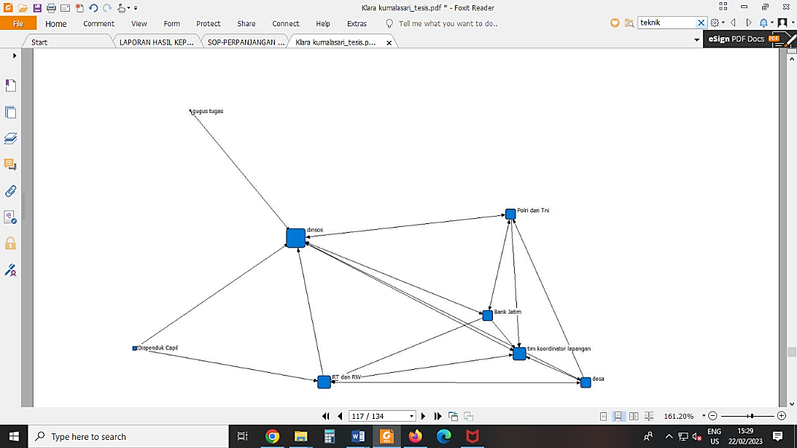 The concept of social networks, which is gaining ground in the social sciences, is based on measures of centrality. Social networks are thought of as having nodes, which are represented by people, groups, organizations, etc. Centrality is a measure of these nodes, specifically their degree of centrality, betweenness centrality, and closeness centrality.

**Figure. 1 Degree centrality**

Source: Researcher (2021)

Because they contact with one another more frequently than other players who are also involved in these programs, the eight actors in the social assistance distribution program for Covid-19 victims who have the greatest degree of centrality are social service actors, according to Figure 1. A social actor's increased centrality suggests that he is approaching the network's center, gaining strength and influence, and feeling more at home there. Sparwe et al., 2001; Lou 2017;

**2. Between Centrality**

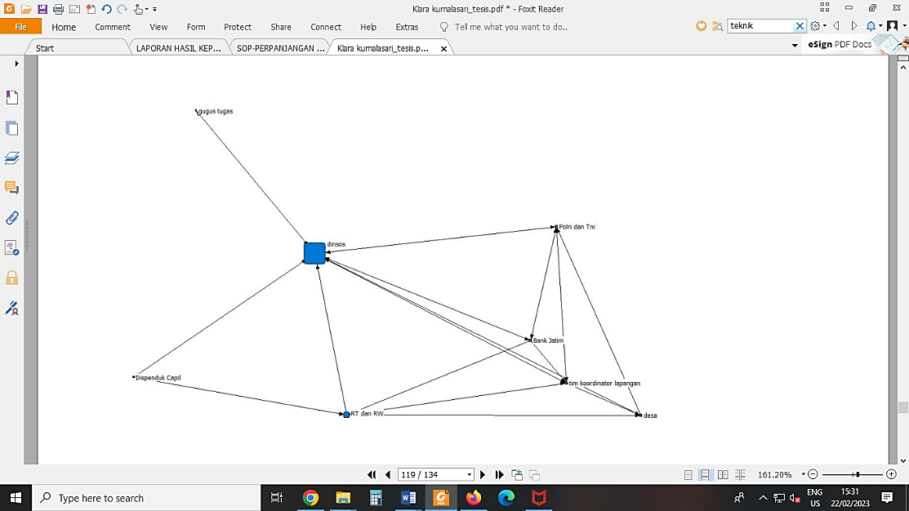 Beetweenness Centrality is used to calculate the proportion of linking actors and non-group member pairs that pass through a group in a graph. according to Table 2. The social service functions as a network actor interaction is a well-known fact.

**Figure 2. Between Centralities**

Source: Researcher (2021)

Communities impacted by Covid-19 are receiving social assistance services from eight actors. Social service actors operate as a liaison (between centralities) during the program's implementation. Social service providers are also intimately involved in developing, reviewing, and overseeing program guidelines.

**3. Closeness centrality**

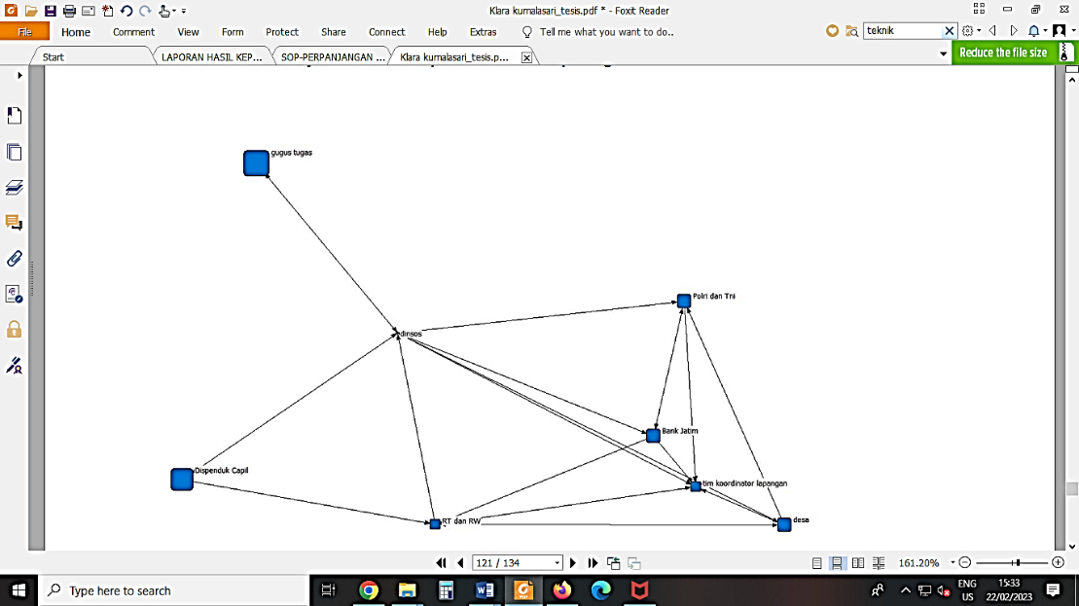Social services are the key actor and have the closest link to other actors, according to the results of the closeness centrality study, however, this is different from the Covid-19 task force unit actor, who has the furthest relationship. The Covid-19 task force participants, Batu, are primarily interested in social services.

***Figure 3. Closeness centrality***

Source: Researcher (2021)

To determine how prominent or important a role an individual plays inside a network, one might use an analytical method called centrality. One can draw the conclusion that the participants in Batu City's social support program for Covid-19 victims are unrelated. According to the results of the centrality analysis, social service actors are most crucial. The line with one arrow does not represent a relationship or bond, however the network structure does. While dots or circles indicate actors, lines depict connections or relationships.

**Conclusion**

The direct cash social assistance distribution scheme for COVID-19 affected individuals in Batu City has identified eight network patterns. Task force unit team actor networks, village government actor networks, community institution actor networks, field coordinating team actor networks, civil registration service actor networks, East Java bank actor networks, and community safety actor networks are the eight network patterns.

Work agreements are carried out by several related actors or communities who are members of and have responsibility for their performance in providing community service, which is why the network pattern used to implement the direct cash social assistance distribution program for COVID-19-affected individuals in Batu City uses work agreement patterns. The results of using the SNA to map the relationship patterns of actors in the direct cash social assistance distribution program to communities in Batu City affected by COVID-19 show a strong relationship between the actors involved who depend on other actors, demonstrating that there are other actors present even though social service actors are strategic actors. who actively participates so that it makes it easier for social service actors to carry out direct cash social assistance distribution programs to people affected by COVID-19 in Batu City

In addition to this, it is known that the seven network program dimensions have not been met in the implementation of the distribution of social assistance for COVID-19 in Batu City. It is also evident that the government tends to dominate the actors, even though Warden's (1992) public network has a large number of actors involved. Actors in this context include the government (public organizations), followed by interest groups, political parties, social groupings, the business world (private organizations), other societal components, and people.

**References**

Adiyoso, W. (2022). Assessing governments’ emergency responses to the COVID-19 outbreak using a social network analysis (SNA). *Sage Open*, *12*(2), 21582440211071101.

Borgatti, S. P., & Ofem, B. (2010). Overview: Social network theory and analysis. In A. J. Daly (Ed.), The ties of change: Social network theory and application in education (Vol. 8, pp. 17–29). Harvard Press.

Coles, A.-M., Piterou, A. & Genus, A. (2016) Sustainable energy projects and the community: Mapping single-building use of microgeneration technologies in London, Urban Studies, 53, pp. 1869–1884.

Czischke, D. (2015)Social Housing Organisations in England and The Netherlands: Between the State, Market, and Community(Delft: Technical University of Delft).

Elsinga, M. & Wassenberg, F. (2007) Social housing in The Netherlands, in C. Whitehead &K. Scanlon (Eds)Social Housing in Europe, pp. 130–147 (London: London SchoolEconomics)

Gedeona, Hendrikus Triwibawanto. 2013. "Tinjauan teoritis pengelolaan jaringan (networking management) dalam studi kebijakan publik." Jurnal Ilmu Administrasi: Media Pengembangan Ilmu dan Praktek Administrasi 10.3.360- 372

Herdiana, Dian. 2020 . "Pengawasan kolaboratif dalam pelaksanaan kebijakan bantuan sosial terdampak COVID-19." Jdp (jurnal dinamika pemerintahan) 3.2 85-99.

Majeed, S., Uzair, M., Qamar, U., & Farooq, A. (2020, November). Social Network Analysis Visualization Tools: A Comparative Review. In *2020 IEEE 23rd International Multitopic Conference (INMIC)* (pp. 1-6). IEEE.

Mullins, D. & Pawson, H. (2010) Housing Associations: Agents of Policy or Profits in disguise?, Hybrid Organizations and the Third Sector: Challenges for Practice, Theory, and policy, in D. Billis (Eds)

Sparrow, Raymond T., R. C. Liden, and S. J. Wayne. "Social Networks And The Performance Of Individuals And Groups." Academy of Management Journal 44.2(2001):316-325.

Sugiyono. 2012. Metode Penelitian Kuantitatif Kualitatif dan R&B. Bandung: Alfabeta

Van den Broeck, K., Haffner, M. & Winters, S. (2016)An Evaluation Framework for MovingTowards More Cost-Effective Housing Policies(Leuven: HIVA. Research Institute for Work and Society).

Wahab, S. A. (2012). Analisis kebijakan: dari formulasi ke penyusunan model-model

implementasi kebijakan publik. Jakarta: Bumi Aksara, 77.

Zhou N, Xiao X, Feng F. Citizen Participation in the Public Policy Process in China: Based onPolicy Network Theory. Public Administration Research. 2014 Nov 1;3(2):91