|  |  |
| --- | --- |
|  | Local Wisdom Scientific Online Journal, in press  ISSN: 2086-3764 (online)    Copyright@Local Wisdom Press, Malang |
| **Distribution Patterns and Spatial Relationships in the Perspective of Tourism Destination Typology** | |
|  | |
|  | |

**Abstract**

Gianyar Regency, as one of Bali’s leading tourist regions, continues to develop tourism destinations in support of the regional tourism development plan and vision of “Realizing High-Quality, Competitive, Sustainable, and Prosperous Cultural Tourism.” The development of Gianyar Regency’s tourism potential requires an understanding of the spatial relationships based on the typology and distribution patterns of tourism destinations. This research aimed to reveal the typology of tourism destinations in Gianyar Regency, determine the distribution patterns of tourism destinations in Gianyar Regency, and assess spatial relationships in Gianyar Regency based on the typology and distribution patterns of tourism destinations. The research method employed in this study is qualitative descriptive, Near Neighbour Analysis (NNA), and Linkage system analysis. The typology of tourism destinations in Gianyar Regency includes cultural tourism, marine tourism, and natural reserve tourism. The distribution pattern of cultural and marine tourism destinations is clustered, while natural reserve tourism exhibits a random distribution pattern. Overall, tourism destinations in Gianyar Regency have a clustered distribution pattern. Spatial relationships in Gianyar Regency, based on the typology and distribution patterns of tourism destinations, are visually characterized by linear elements such as roads, corridor elements like buildings and trees, and side elements consisting of variations in tourism typology. The collective spatial relationships found in Gianyar Regency fall into an open-ended group form. The policy implications of this research suggest the need for improvements in tourism infrastructure and the development of spatial relationships to enhance the tourist experience, supporting sustainable tourism development in Gianyar Regency.

**Keywords**: Distribution Patterns, Spatial Relationships, Tourism Typology.

# INTRODUCTION

The tourism industry has become one of the largest economic sectors worldwide, serving as the primary source of foreign income in various countries. Indonesia, with its thousands of islands, possesses diverse potential and attractions in each of its regions (Supriyatama & Wesnawa, 2019). Each province in Indonesia has distinct regional characteristics with their own resources and potentials (Yuendini et al. 2019). Bali, as one of the islands in Indonesia, boasts unique charm with its natural beauty and rich cultural heritage. (Suartana, 2018). As a tourism magnet in Indonesia, several areas in Bali have been developed as tourist zones.

In the course of tourism development, it can enhance economic progress and bring about change, such as changes that may affect the quality of life of the local population and the environment (Dendo, 2021). In the management of tourist attractions in Bali, the concept of Tri Hita Karana can help maintain a balance between humans, nature, and culture, while building sustainable and environmentally friendly tourism destinations (Gorda, A. N. E. S., & Wardani, K. D. K. A., 2020). The local wisdom of the Balinese community shapes their social order, as it emphasizes harmonious relationships with the Almighty, interpersonal relationships, and environmental interactions, all of which are directly related to the Tri Hita Karana concept, influencing spatial patterns that provide significant benefits to villages and communities(Widyastuty, 2018). In the Regional Spatial Plan for Gianyar Regency 2012-2032, there are 32 tourist destinations consisting of 11 natural attractions and 21 man-made attractions. These tourist destinations are spread across all districts in Gianyar Regency and are managed by the government, private sector, and local communities. The distribution of these tourist destinations forms a pattern and typology that has not been studied. The development of tourist destinations will serve as a crucial foundation for managing tourism resources in the Gianyar Regency (Sumitapradja, A. M., & Anom, I. P., 2020). Research on tourism destination typology can help enhance the attractiveness of a region by identifying the position of tourist destinations in their life cycle and developing them according to the conditions of the destination. Moreover, it can aid in identifying the characteristics of tourists who visit a tourist destination and understanding their perceptions of that destination (Keylavanda, E. F., 2022).

# METHODS

The typology of tourist destinations in Gianyar Regency was determined using a qualitative descriptive analysis method. Qualitative descriptive research is a type of study that focuses on gaining an in-depth understanding of the quality of relationships, activities, situations, or various materials by prioritizing a holistic descriptive approach, providing detailed explanations of ongoing activities or situations, rather than comparing the effects of specific treatments (Adlini, M. N., 2022). Descriptive analysis was used to describe the typology of tourist destinations in Gianyar Regency based on the main attractions, which include natural attractions, marine tourism, and cultural tourism.

The theory employed to explain the distribution pattern in general is the nearest neighbour analysis theory, first formulated by J. Clark and F.C. Evans (Sitompul, L. A., 2022). The nearest neighbour analysis is a method used to explain the distribution pattern of several object points by considering the distance, the number of location points, and area size (Permana & Widyastuty, 2021). The final result of this analysis is an index (T). The nearest neighbour spread index itself is calculated using formulas as found in equations 1, 2, 3, and 4 (Pelambi in Dian Permana et al., 2021).

* 1. Calculating Ju

Ju = $\frac{∑J}{∑N}$.........................(1)

Ju : The average distance calculated between a point and its nearest neighbour.

∑ I : The sum of distances between a central point and the others.

∑ N : The total number of central points in each region

* 1. Calculating point Density P

P = $\frac{N}{A}$.............................(2)

P : Point density

N : The number of central points in each region

A : The area size

* 1. Calculating Jh

Jh = .........................(3)

* 1. Calculating Nearest Neighbour Index (T)

T = $\frac{ꭍu}{ꭍh}$...........................(4)

T = Nearest neighbour spread index

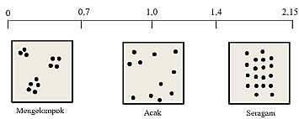

*Figure 1.* Nearest Neighbour Analysis

If the value of T is in the range of 0 to -0.7, then the pattern of the tourist objects is clustered. If the value of T falls within the range of 0.71 to 1.4, the pattern of the tourist objects is considered random. Meanwhile, if the value of T falls within the range of 1.41 to 2.15, the pattern of the tourist objects is considered uniform. In the analysis of the distribution pattern of tourist destinations using ArcMap 10.2 software, the following steps were taken: inputting the data of the location points of each tourist destination and the study area’s geographical extent using the ArcToolbox menu - Spatial Statistic Tools - Analyzing Pattern - Nearest Neighbour Analysis. This process allowed for the identification of the distribution patterns of tourist destinations in Gianyar Regency, whether they were clustered, random, or uniform.

The spatial interrelationships between tourist destinations are analyzed using the linkage system, which provides a comprehensive macro-level examination of a tourist object as a system. This system is represented in a diagram that illustrates the elements within the system, including inputs and outputs, as well as interactions among the system’s components (Wicaksono & Sugiarto, 2001). Through this analysis, various issues and shortcomings within the system connecting these tourist objects can be identified, enabling the determination of directions for improvement. There are two approaches to linkage in this study: (1) Visual Linkage and (2) Collective Form Linkage.

1. Visual Linkage

In visual linkage, two or more urban areas are combined into a unit with visual capabilities to integrate the urban area on various scales.

1. Collective Form Linkage

Linkage theory observes the structural relationships between various urban parts. In linkage theory, the focus is on the connections of movements that play a crucial role. Linkage observes and emphasizes relationships and changes in urban spatial structures (urban fabric)

# RESULTS

## Typology of Tourist Characteristics in Gianyar Regency

In its development, tourism in Gianyar Regency is internalizing all the traditions, norms, arts, and culture rooted in Hinduism, earning it the nickname “Gumi Seni” or “Bumi Seni,” which translates to the “Land of Arts.” This title is clearly the result of Gianyar Regency’s ongoing efforts to preserve the uniqueness of its art and culture, which has been its hallmark since ancient times (Yasintha, P. N., 2022). According to Putri (2022), the culture and lifestyle of the community based on Tri Hita Karana serve as a magnet for international tourists visiting Gianyar Regency. The natural beauty, historical heritage, and highly attractive historical tourist attractions also contribute as supporting factors. Moreover, the availability of adequate tourism facilities plays a crucial role in attracting tourists. The following is the typology of characteristics of tourist attractions in Gianyar Regency.

1. Culural Tourism
2. Tirta Empul offers attractions such as archaeological relics, sacred springs, traditional purification ceremonies, and a place of worship. Various amenities, including shops, places of worship, security posts, electricity networks, clean water supplies, drainage systems, waste management, as well as accessibility through roads and parking areas, are available. The destination is managed by the Gianyar Regency government and the traditional village.
3. Goa Gajah features attractions including archaeological relics, sacred springs, and traditional purification ceremonies. Amenities at this site include shops, places of worship, security posts, electricity networks, clean water supply, drainage systems, waste management, as well as road access and parking areas. The destination is managed by the Gianyar Regency government and the traditional village.
4. Gunung Kawi Sebatu offers attractions such as sacred springs, traditional purification ceremonies, and a place of worship. Amenities at this site include accommodations, shops, places of worship, security posts, electricity networks, clean water supplies, drainage systems, and waste management. Road access and parking areas are also available. The destination is managed by the Gianyar Regency government and the traditional village.
5. Yeh Pulu presents attractions like archaeological relics, sacred springs, and traditional purification ceremonies. Amenities include accommodations, shops, places of worship, security posts, electricity networks, clean water supply, drainage systems, and waste management. The only available access is through public roads. The destination is managed by the Gianyar Regency government and the traditional village.
6. Candi Tebing Tegallinggah offers attractions in the form of archaeological relics. Facilities at this location include accommodations and places of worship. Accessibility is provided through public roads. The destination is managed by the Gianyar Regency government and the traditional village.
7. Mengening offers attractions such as archaeological relics, sacred springs, traditional purification ceremonies, and a complex of worship. The available facilities include accommodations, shops, places of worship, security posts, electricity networks, clean water supply, drainage systems, and waste management. Accessibility is provided through public roads. The destination is managed by the Gianyar Regency government and the traditional village.
8. Goa Garba features attractions in the form of archaeological relics. Amenities include accommodations, places of worship, security posts, electricity networks, clean water supply, drainage systems, and waste management. Road access and parking areas are available. The destination is managed by the Gianyar Regency government and the traditional village.
9. Taman Nusa offers attractions related to Indonesian art and culture. The available facilities encompass shops, places of worship, security posts, electricity networks, clean water supply, drainage systems, and waste management. Good road accessibility and parking areas facilitate visitor access to this location. Taman Nusa is managed by a private entity.
10. Museum Rudana is an art museum featuring painting exhibits. Facilities include accommodations, shops, places of worship, medical facilities, security posts, electricity networks, clean water supply, drainage systems, and waste management. Good road accessibility and parking areas are available for visitor convenience. Museum Rudana is operated by a private entity.
11. Museum Neka is an art museum offering exhibits of paintings and sculptures. Available facilities include accommodations, shops, places of worship, medical facilities, security posts, electricity networks, clean water supply, drainage systems, and waste management. Good road accessibility and parking areas are provided. Museum Neka is managed by a private entity.
12. Museum Arma is an art museum featuring exhibits of paintings and sculptures. Facilities available include accommodations, shops, places of worship, medical facilities, security posts, electricity networks, clean water supply, drainage systems, and waste management. Accessibility is provided through roads, and parking areas are available. This attraction is managed by a private entity.
13. Museum Puri Lukisan is an art museum offering painting attractions. Available facilities include accommodations, shops, places of worship, medical facilities, security posts, electricity networks, clean water supply, drainage systems, and waste management. Good road accessibility and parking areas are also provided. Museum Puri Lukisan is operated by a private entity.
14. Museum Antonio Blanco is an art museum featuring painting exhibits. Facilities available include accommodations, shops, places of worship, medical facilities, security posts, electricity networks, clean water supply, drainage systems, and waste management. Good road accessibility and parking areas are available for visitors. Museum Antonio Blanco is managed by a private entity.
15. Museum Arkeologi Gedong Arca is a museum that primarily showcases archaeological relics as its main attraction. Facilities provided include accommodations, shops, places of worship, medical facilities, security posts, electricity networks, clean water supply, drainage systems, and waste management. Good road accessibility and parking areas are also available. This museum is managed by the Office of Cultural Heritage Preservation.
16. Maritime Tourism

Maritime tourism in Gianyar Regency consists of 2 tourist destinations: Mason Rafting Adventure and Rafting Sobek. The main attraction at Mason Rafting Adventure and Rafting Sobek is white-water rafting. Both have comprehensive facilities, including accommodations, shops, places of worship, medical facilities, security posts, electricity networks, clean water supply, drainage systems, and waste management. Accessibility to Mason Rafting Adventure and Rafting Sobek can be reached by land transportation, and both have parking areas as well as tourist transport. Mason Rafting Adventure and Rafting Sobek are managed by private entities.

1. Natural Reserve Museum
2. Bali Bird Park offers an attractive collection of birds as its main attraction. Facilities available include accommodations, shops, places of worship, security posts, electricity networks, clean water supply, drainage systems, and waste management. Road accessibility, parking areas, and tourist transport are available. Bali Bird Park is operated by a private entity.
3. Bali Zoo showcases a variety of fauna and allows interaction with animals. Available facilities include accommodations, shops, places of worship, security posts, electricity networks, clean water supply, drainage systems, and waste management. Road accessibility, parking areas, and tourist transport are also provided. Bali Zoo is operated by a private entity.
4. Elephant Safari Park offers interactions with elephants. Facilities provided include accommodations, shops, places of worship, security posts, electricity networks, clean water supply, drainage systems, and waste management. Good road accessibility, parking areas, and tourist transport are also available. This destination is managed by a private entity.
5. Bali Safari And Marine Park showcases a variety of fauna and allows interaction with animals. Facilities provided include accommodations, shops, places of worship, security posts, electricity networks, clean water supply, drainage systems, and waste management. Road accessibility, parking areas, and tourist transport are available. This destination is managed by a private entity.
6. Tegenungan Waterfall offers the attraction of a beautiful waterfall. Facilities available include accommodations, shops, places of worship, medical facilities, security posts, electricity networks, clean water supply, drainage systems, and waste management. Road accessibility and parking areas are provided. Tegenungan Waterfall is managed by the traditional village.
7. Blangsinga Waterfall offers the attraction of a beautiful waterfall. Facilities available include accommodations, shops, places of worship, medical facilities, security posts, electricity networks, clean water supply, drainage systems, and waste management. Road accessibility and parking areas are provided. Blangsinga Waterfall is managed by the traditional village.
8. Monkey Forest Ubud features attractions involving interactions with monkeys. Facilities provided include accommodations, shops, places of worship, medical facilities, security posts, electricity networks, clean water supply, drainage systems, and waste management. Road accessibility, parking areas, and tourist transport are available. This destination is managed by the traditional village.
9. Hidden Canyon Guwang offers the attractions of canyons and artistic cliffs. Facilities available include accommodations, shops, places of worship, medical facilities, security posts, electricity networks, clean water supply, drainage systems, and waste management. Road accessibility and parking areas are provided. This destination is managed by the traditional village.
10. Ceking Rice Terrace offers the attraction of beautiful terraced rice fields. Facilities provided include accommodations, shops, places of worship, medical facilities, security posts, electricity networks, clean water supply, drainage systems, and waste management. Good road accessibility and parking areas are available. This destination is managed by the traditional village.

**Cultural Tourism**

Cultural tourism has a broader nature than merely consuming cultural products from the past, such as visiting historical sites or museums, but also encompasses experiencing the “way of life” of a community or region being visited (Luh et al., 2021). The heritage of skills, lifestyles, and customs that are handed down while adhering to social norms and religious norms represent the local wisdom firmly held by the community (Widyastuty & Widiana, 2022). The analysis of the characteristics of tourism indicates that the attractions offered at cultural tourist destinations in Gianyar Regency include archaeological remains, religious complexes, sacred springs, the tradition of “melukat,” and art museums.

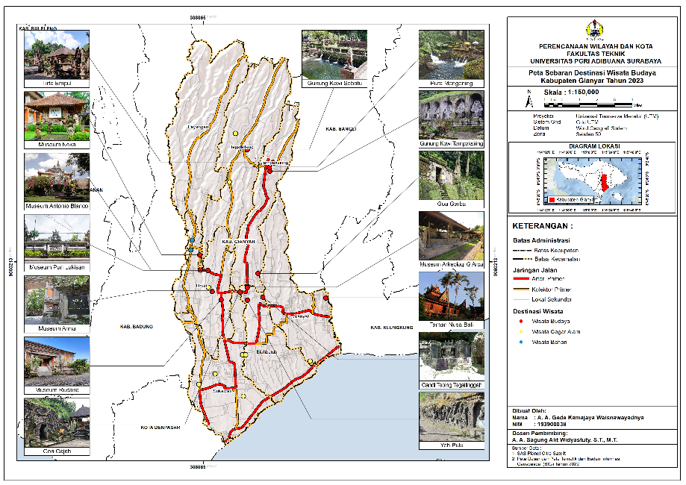

*Figure 2.* Map of the Distribution of Cultural Tourist Destinations in Gianyar Regency

Grounded in the Tri Hita Karana philosophy, destinations featuring traditional attractions and archaeological sites are managed by traditional villages. As explained by Adi, I. N. R., & Mulyadi, M. (2019), traditional villages play a crucial role in managing tourist attractions, preserving culture and traditions, conserving the environment, and generating income for the welfare of the community.

**Maritime/Nautical Tourism**

Maritime/nautical tourism in Gianyar Regency consists of two tourist destinations: Mason Rafting Adventure and Rafting Sobek. Maritime tourist destinations are exclusively located in the Ubud District. The attractions offered by Mason Rafting Adventure and Rafting Sobek are water rafting sports. Both destinations are fully equipped and accessible by land transportation, featuring parking areas and tourist transport facilities.

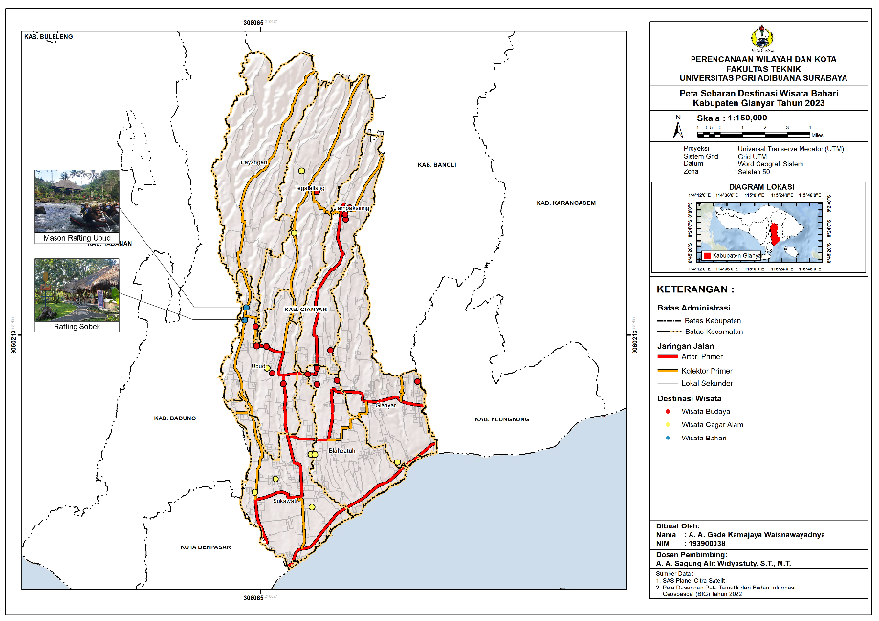

*Figure 3.* Map of the Distribution of Maritime Tourist Destinations in Gianyar Regency

These two destinations make use of the potential of the Ayung River, known as the longest river in Bali. This exceptional characteristic acts as a magnet for tourists, making it a priority tourist attraction with a high number of visitors (Soehardjoepri, S., 2022). Due to their proximity and similar tourism products, they share common characteristics.

**Natural Reserve Tourism**

There are nine natural reserve tourist destinations in Gianyar Regency, namely Bali Bird Park, Bali Zoo, Elephant Safari Park and Lodge, Bali Safari And Marine Park, Tegenungan Waterfall, Blangsinga Waterfall, Monkey Forest Ubud, Hidden Canyon Guwang, and Ceking Rice Terrace.

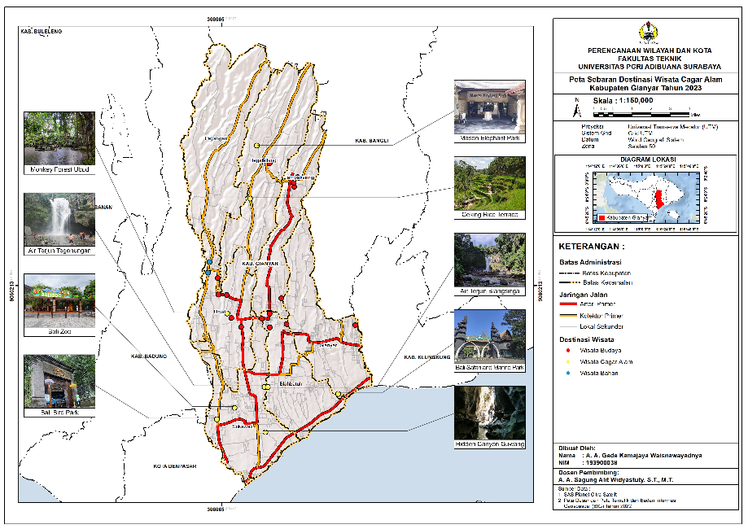

*Figure 4.* Map of the Distribution of Natural Reserve Tourist Destinations in Gianyar Regency

Modern tourist destinations tend to be privately managed, while traditional tourism is managed by traditional villages. This distinction arises because modern tourism places a greater emphasis on providing comfortable experiences and well-facilitated accommodations. In contrast, traditional tourism focuses more on providing experiences that are closer to local culture, the environment, and daily life. As explained by Nuurlaily, S. (2020) rural communities continue to maintain their unique traditions and customary norms.

## Distribution Patterns of Tourist Destinations in Gianyar Regency

1. Distribution Pattern of Gianyar Regency’s Tourist Destination

The tourist destinations in Gianyar Regency, comprising a total of 26 sites, are distributed across all the districts within the regency. The closest distance between tourist destinations in Gianyar Regency is between Tegenungan Waterfall and Blangsinga Waterfall, with a distance of 0.27 kilometres. In contrast, the farthest distance between destinations is observed between Hidden Canyon and Mason Elephant Park and Lodge, spanning a distance of 24.20 kilometres.

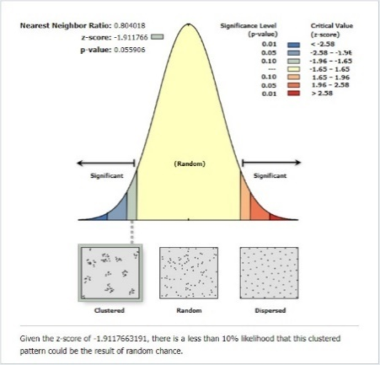

*Figure 5.* Distribution Pattern of Tourist Destinations in Gianyar Regency

Based on the Nearest Neighbour Analysis, the distribution pattern of tourist destinations in Gianyar Regency exhibits a clustered pattern with a nearest neighbour ratio value of 0.80. Cultural destinations tend to cluster around areas with historical significance and archaeological sites, while maritime destinations cluster along riversides and coastlines. Furthermore, the involvement of stakeholders and tourism managers who strive to develop sustainable tourist destinations that respect the local environment and culture contributes to the formation of the clustered distribution pattern of tourist destinations in Gianyar Regency (Wijaya, N. S., 2019).

1. Distribution Pattern of Cultural Tourist Destinations in Gianyar Regency.

Of the 26 tourist destinations in Gianyar Regency, 15 of them fall under the typology of cultural tourist destinations. The average distance between cultural tourist destinations is approximately 6.61 kilometres. The nearest location between cultural tourist destinations can be observed between Gunung Kawi Tampaksiring and Pura Mengening, separated by a distance of 0.33 kilometres. On the other hand, the farthest distance between cultural tourist destinations is found between Gunung Kawi Sebatu and Taman Nusa Bali, with a span of 15.39 kilometres. The analysis of the distribution pattern of cultural tourist destinations in Gianyar Regency is depicted in Figure 6.

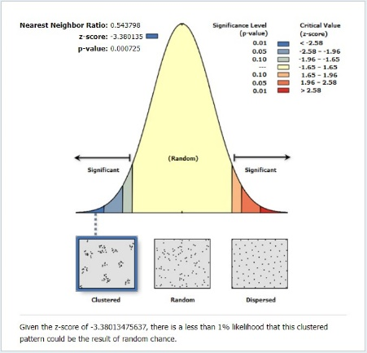

*Figure 6.* Distribution Pattern of Cultural Tourist Destinations in Gianyar Regency

The distribution pattern of cultural tourist destinations in Gianyar Regency exhibits a clustered pattern with a nearest-neighbour ratio of 0.54. Cultural tourism sites in Gianyar Regency tend to cluster in the Ubud District and the Pakerisan Watershed Area. The Ubud District is renowned as the epicentre of arts and culture in Bali. Communities of artists and cultural practitioners have cultivated traditions of painting, dance, music, and handicrafts in this region (Widiari, N.K., 2022). Meanwhile, the Pakerisan Watershed boasts numerous sacred places and historically significant sites that hold great importance in Balinese religion and culture (Luxiana, I.W., 2022). The holy temples, statues, and other places of worship in this area serve as attractions for both domestic and international tourists.

1. Distribution Pattern of Maritime Tourist Destinations in Gianyar Regency

There are 2 maritime tourist destinations in Gianyar Regency, namely Mason Rafting Ubud and Rafting Sobek. The distance between these maritime tourist destinations is 1.11 kilometres. The analysis of the distribution pattern of maritime tourist destinations in Gianyar Regency can be observed in Figure 7.

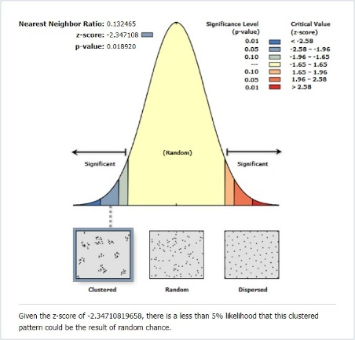

*Figure 7.* Distribution Pattern of Maritime Tourist Destinations in Gianyar Regency

The distribution pattern of maritime tourist destinations in Gianyar Regency presents a clustered distribution pattern. This is due to the fact that maritime tourist destinations in Gianyar Regency are exclusively situated along the Ayung River in the Ubud District. The Ayung River is strategically located and attracts a considerable number of domestic and international tourists, making it an appealing prospect for entrepreneurs to develop white-water rafting tourism activities on the Ayung River (Brahmana, I. B. I., & Anom, I. G. N., 2023).

1. Distribution Pattern of Nature Reserve Tourist Destinations in Gianyar Regency

Gianyar Regency is home to 9 tourist destinations falling under the category of nature reserve tourism. The average distance between these nature reserve tourist destinations is approximately 10.90 kilometres. The closest locations are found between Tegenungan Waterfall and Blangsinga Waterfall, separated by a mere 0.27 kilometres, while the farthest destinations are Mason Elephant Park and Lodge and Hidden Canyon Guwang, with a distance of 24.20 kilometres. The analysis of the distribution pattern of nature reserve tourist destinations in Gianyar Regency is depicted in Figure 8.

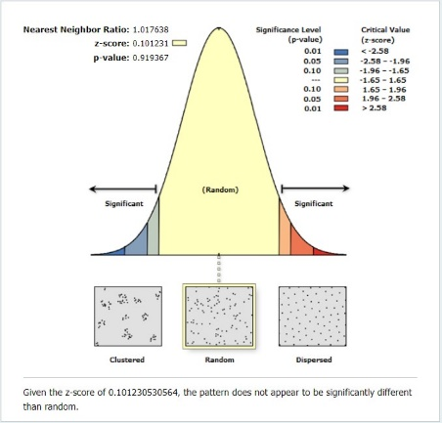

*Figure 8.* Distribution Pattern of Nature Reserve Tourist Destinations in Gianyar Regency

The distribution pattern of nature reserve tourist destinations in Gianyar Regency exhibits a random distribution pattern. Gianyar Regency possesses significant geographical and topographical variations, including variations in soil types, vegetation, and relief. Widyastuty (2021) indicates that the Balinese ideology of Tri Hita Karana influences spatial patterns by promoting balance and harmony among three main elements, one of which involves the relationship between humans and the environment. The physical characteristics of the region and its adherence to local wisdom contribute to the random distribution pattern observed in nature reserve tourist destinations.

## Interconnectivity of space among tourist destination

The analysis of the linkage system is employed to comprehend the interconnectivity of spatial elements. The concept of linkage, in this context, emphasizes the connections and movements between various regions within a city, such as the relationships between different locations within the city (Trancik, as cited in Nusyawal, M. F., 2020). The discussion of spatial interconnectivity in Gianyar Regency is divided into two categories: visual linkage and collective linkage

1. Visual Linkage

Based on the findings of our identification, the visual linkage connecting various tourist destinations comprises line elements in the form of roads, corridor elements in the shape of buildings and trees, and side elements embodying the typological variability of tourism sites.

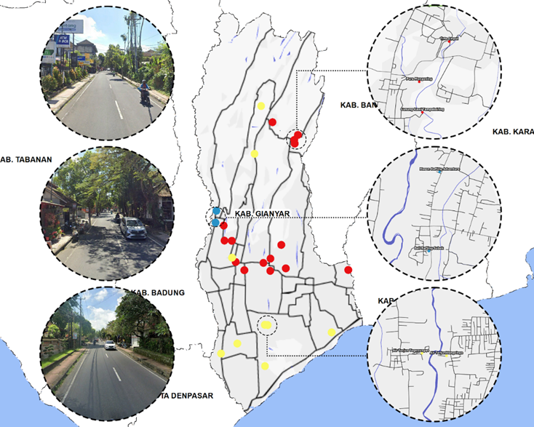

*Figure 9.* Visual Linkages Among Tourist Destinations in Gianyar Regency

The line element consists of the road network in Gianyar Regency, serving as a connector between distant tourist destinations, whether cultural, maritime, or natural. Meanwhile, the corridor element is formed by two sets of masses, encompassing buildings or trees, creating a spatial interrelation.

1. Collective Linkage

Viewing the collective linkage present in Gianyar Regency, it can be classified as groupform connecting structures such as linear sequences or a grid. This interconnectivity is open-ended, implying the potential for further development (Nurhikmah S, N., 2023). Within the groupform, structures are linked to a linear framework or straight line, forming natural interconnections. The linkages formed among tourist destinations in Gianyar Regency include the connection of various tourist destination points with different typologies, facilitating connectivity between these points. This includes the Pakerisan River and Petanu River connecting cultural and natural tourism, the Ayung River linking maritime and cultural tourism, and the road network connecting maritime, cultural, and natural tourism.

# CONCLUSION

Gianyar Regency boasts a total of 26 tourist destinations, comprising cultural, maritime, and natural tourism. In Gianyar Regency, there are 16 cultural tourist destinations (58%), 2 maritime tourist destinations (8%), and 8 natural tourist destinations (34%).

Cultural tourist destinations offer a diverse range of attractions, including archaeological remains, religious complexes, sacred springs, purificatory traditions, painting, sculpture, carving, and traditional irrigation systems. Destination facilities are categorized into two groups: complete facilities and incomplete facilities. Among these destinations, 10 have complete facilities (67%), while 5 are yet to have adequate facilities (33%). Accessibility to tourist destinations, in general, can be reached by land transportation, with parking areas available at 11 destinations (73%), although 4 destinations do not yet have adequate parking facilities (27%). Eight tourist destinations are jointly managed by Gianyar Regency and traditional villages (53%), while 6 tourist destinations are managed by the private sector (40%), and 1 tourist destination is overseen by the Bali Cultural Heritage Preservation Center (7%).

Maritime tourism in Gianyar Regency consists of two destinations. Both destinations are managed by the private sector and offer whitewater rafting attractions. Comprehensive tourist support facilities are easily accessible via land transportation, and there are parking areas and tourist transport available. In Gianyar Regency, natural tourism destinations with scenic attractions are presented in 4 destinations (44%), while 5 destinations offer interactions with various fauna and conservation efforts (56%). All destinations offer complete facilities (100%), are accessible via land transportation (100%), and provide parking areas (100%), with tourist transport available at 5 destinations (56%), while the remaining 4 are not served by tourist transport (44%). The institutional management of natural tourism destinations varies, with 5 destinations managed by the private sector (56%) and 4 destinations managed by traditional villages (44%).

The results of the Nearest Neighbour Analysis indicate that cultural and maritime tourism destinations in the Gianyar Regency exhibit a clustered distribution pattern, while natural tourism destinations in Gianyar Regency show a random distribution pattern. Overall, tourist destinations in Gianyar Regency demonstrate a clustered distribution pattern with a nearest neighbour ratio of 0.80.

Based on the identification results, the visual linkage connecting tourist destinations consists of line elements, such as road networks, corridor elements composed of buildings and trees, and side elements embodying typological variability. The collective linkage found in Gianyar Regency is classified as a group form linking structures in the form of linear sequences or a grid. This linkage has the potential to further develop. The results of the linkage analysis fulfil the criteria for tourism package development. Tourism package development in Gianyar Regency takes into account the previous analyses, including the typology of tourist destinations, distribution patterns of tourist destinations, and spatial interconnectivity.

# REFERENCES

Adi, I. N. R., & Mulyadi, M. (2019). “Mediasi Community Based Tourism Pada Pengaruh Peran Desa Adat Terhadap Pembangunan Pariwisata Berkelanjutan di Desa Penglipuran Kabupaten Bangli”. *Jurnal Media Bina Ilmiah*, 14(3), 2267-2280.

Adlini, M. N., Dinda, A. H., Yulinda, S., Chotimah, O., & Merliyana, S. J. (2022). “Metode Penelitian Kualitatif Studi Pustaka”. *Edumaspul: Jurnal Pendidikan*, 6(1), 974-980.

Brahmana, I. B. I., & Anom, I. G. N. (2023). “Perlindungan Hukum Bagi Wisatawan Pada Objek Wisata Tirta Arung Jeram Sungai Ayung di Kabupaten Gianyar”. *Jurnal Hukum Mahasiswa*, 3(1), 626-640.

Dendo, H. J. T., Djoko, R., & Budiyono, D. (2021). “Strategi Pengembangan Wisata Berkelanjutan Di Pantai Kita” *Doctoral dissertation, Fakultas Pertanian dan Universitas Tribhuwana Tungga Dewi Malang*.

Dian Permana, R., & Agung Sagung Alit Widyastuty, A. (2021). “Pola Persebaran Wisata Taman Dan Lingkungan Di Kota Surabaya”. *Jurnal Plano Buana*, 1(2).

Gorda, A. N. E. S., & Wardani, K. D. K. A. (2020). “Refleksi Nilai Kearifan Lokal Masyarakat Hindu Bali Dalam Pengelolaan Lingkungan”. *Ettisal, Jurnal Of Communication*, 91-107.

Luh, N., Purnawan, R., Gede Pitana, I., Nyoman, I., & Putra, D. (2021). “Cultural Landscape: Brand Knowledge Wisatawan tentang Bali dalam Online Travel Review Communication Platform”. *Jurnal Seni Budaya*, 36(2), 254–263.

Luxiana, I.W., Parwata, I.W., & Kurniawan, A.E. (2022). “Identifikasi Pengembangan Ekowisata di Desa Bukian, Kecamatan Payangan, Kabupaten Gianyar”. *WICAKSANA: Jurnal Lingkungan dan Pembangunan*. 6(2), 60-72.

Nurhikmah S, N., M Ichsan Ali, A., Abidah, A. (2023). “Konsep Wisata Budaya Pada Kawasan Delta Lakkang, Kecamatan Tallo, Kota Makassar”. *PINISI Joural of Art, Humanity, & Social Studies*, 3(3), 216–227.

Nuurlaily, S., Widyastuty, A. A. S. A., & Tribhuwaneswari, A. B. (2020). “Penguatan Promosi Desa Wisata Berbasis Kearifan di Desa Pujon Kabupaten Malang”. *Jurnal Penamas Adi Buana*, 4(1), 5-12.

Putri, D. A. P. A. G. (2022). “Green Tourism Sebagai Kunci Pariwisata Berkelanjutan”. *Pariwisata Nusantara*, *49*.

Nusyawal, M. F., & Purwantiasning, A. W. (2020). “Kajian Konsep Linkage Pada Kawasan TOD (Transit Oriented Development) West Kowloon, Hong Kong”. *Nature: National Academic Journal of Architecture*, 7(1), 125-142.

Sitompul, L. A., Budiman, J., Labaro, I. L., Sitanggang, E. P., & Silooy, F. (2022). “Pola Sebaran Bagan Dan Adaptasi Nelayan Dalam Operasi Penangkapan Di Perairan Desa Tateli Weru Kabupaten Minahasa”. *Jurnal Ilmu dan Teknologi Perikanan Tangkap*, 7(1), 40-46.

Soehardjoepri, S., Widyastuti, A. A. S. A., Balafif, M., Karsam, K., & Widiana, M. E. (2022). *Manajemen Wisata Indonesia*. Pena Persada Kerta Utama, Surabaya

Suartana, K., Swara, W., & Sudiana, I. (2018). “Pengaruh Kunjungan, Lama Tinggal, Pengeluaran Wisatawan, Hunian Hotel, dan Kurs Dollar Terhadap PDRB Provinsi Bali*”. E-Jurnal Ekonomi Pembangunan Universitas Udayana*, 7(10).

Sumitapradja, A. M., & Anom, I. P. (2020). “Analisis Prioritas Pengembangan Pariwisata di Desa Wisata Lebih, Kecamatan Gianyar, Kabupaten Gianyar”. *Jurnal Destinasi Pariwisata*, *8*(1), 92.

Supriyatama, P. E., & Wesnawa, I. G. A. (2019). “Pemetaan Distribusi Objek Wisata Dan Potensi Wisata Di Kecamatan Sukawati”. *Jurnal Pendidikan Geografi Undiksha*, 7(1).

Keylavanda, E. F. (2022). “Pengembangan Fasilitas Wisata Di Destinasi Pantai Berawa Tibubeneng Kuta Utara Kabupaten Badung Provinsi Bali”. *Turn Journal*, *2*(1), 31-46.

Widiari, N. K. A. S., Widiati, I. A. P., & Suryani, L. P. (2022). “Pelaksanaan Pengelolaan Objek Wisata Mandala Suci Wenara Wana oleh Desa Adat Padangtegal, Kecamatan Ubud, Kabupaten Gianyar”. *Jurnal Preferensi Hukum*, 3(1), 223-228.

Widyastuty, A. A. S. A., & Dwiarta, I. M. B. (2021). “Perencanaan dan Pengembangan Desa Wisata Kaba–Kaba Berbasis Kearifan Lokal”. *Jurnal Kawistara*, 11(1), 87-101.

Widyastuty, A. A. S. A., & Widiana, M. E. (2022). “Strengthening Natural Tourism Empowerment Construction through Brand Strategy-Based Online Marketplace”. *Journal of Environmental Management & Tourism*, *13*(6), 1557-1564.

Wijaya, N. S., & Sudarmawan, I. W. E. (2019). “Community Based tourism (CBT) sebagai strategi pengembangan pariwisata berkelanjutan di DTW Ceking Desa Pekraman Tegallalang”. *Jurnal Ilmiah Hospitality Management*, 10(1), 77-98.

Yasintha, P. N., Gelgel, N. M. R. A., Sukadi, B. D. N. R., Sari, N. P. M., & Pinatih, D. A. A. I. (2022). “Resiliensi pemerintah Kabupaten Gianyar dalam mewujudkan pariwisata berkelanjutan di tengah pandemi covid-19”. *Jurnal Transformative*, 8(1), 57-80.

Yuendini, E. P., Rachmi, I. N., Aini, N. N., Harini, R., & Alfana, M. A. F. (2019). “Analisis Potensi Ekonomi Sektor Pertanian dan Sektor Pariwisata di Provinsi Bali Menggunakan Teknik Analisis Regional”. *Jurnal Geografi: Media Informasi Pengembangan Dan Profesi Kegeografian*, 16(2), 128-136.